Animal Licensing Star Rating System:  Request for Re-Inspection for Re-Rating Purposes |  | 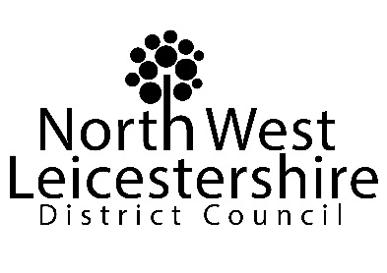

Notes for businesses:

- As the business operator of the establishment you have a right to request a re-inspection for the purposes of re-rating if you have taken action to rectify the non-compliances identified at the time of inspection.
- There is no limit on the number of requests you may make, however there will be a fee for each inspection.
- You must provide details of the improvements made with your request, including supporting evidence where appropriate.
- If the local authority considers that you have provided sufficient evidence that the required improvements have been made, the local authority will make an unannounced visit within three months of the request. The re-visit will be carried out within three months of the receipt of your request and payment of the fee.
- The local authority officer will give you a ‘new’ star rating based on the level of compliance that is found at the time of the re-inspection - you should be aware that your rating could go up, down or remain the same.
- To make a request for a re-inspection please use the form below and return it to licensing@nwleicestershire.gov.uk.

Business details
Business operator/proprietor

Business name

Business addresses

Business tel. number |  | Business email

Inspection details
Date of inspection |  |  |  |  | Star rating given

Action taken
Please describe the remedial action you have taken with reference to the issues identified in the inspection letter/report provided to you by your local authority with your score:
Higher Standards

Minimum Standards

Please provide any other supplementary evidence (e.g. photographs, invoices, copies of relevant documentation etc.).

Signature
Name in capitals

Position |  | Date

Please now return this form to licensing@nwleicestershire.gov.uk

