DETAILS OF COFFIN AND MEMORIAL

Please complete all the details below as soon as practicably possible but no later than 4 working days before the funeral is due to take place

Please email the completed form to cemetries@nwleicestershire.gov.uk.

DETAILS OF FUNERAL

Name of deceased
Date of Funeral
Time of Funeral
Cemetery

DETAILS OF COFFIN

Please state the type of container  Please delete as appropriate | Coffin / Casket / Baby / Wicker / Other
Dimensions of Container | Please use the diagram below to provide the dimensions of the container at its longest and widest as per the diagram below
Type and size of handles  Please delete as appropriate | Bar / Static / Bow / Rope / Other
Number of webs required
Any other details we need to be made aware of.

In order to accurately prepare the burial plot we will require the exact dimensions of the longest and widest part of the coffin / casket / baby coffin / wicker coffin.

Please provide dimensions A and B on the diagram below.

Please Note: Measurement B must be taken at the widest part of the coffin.

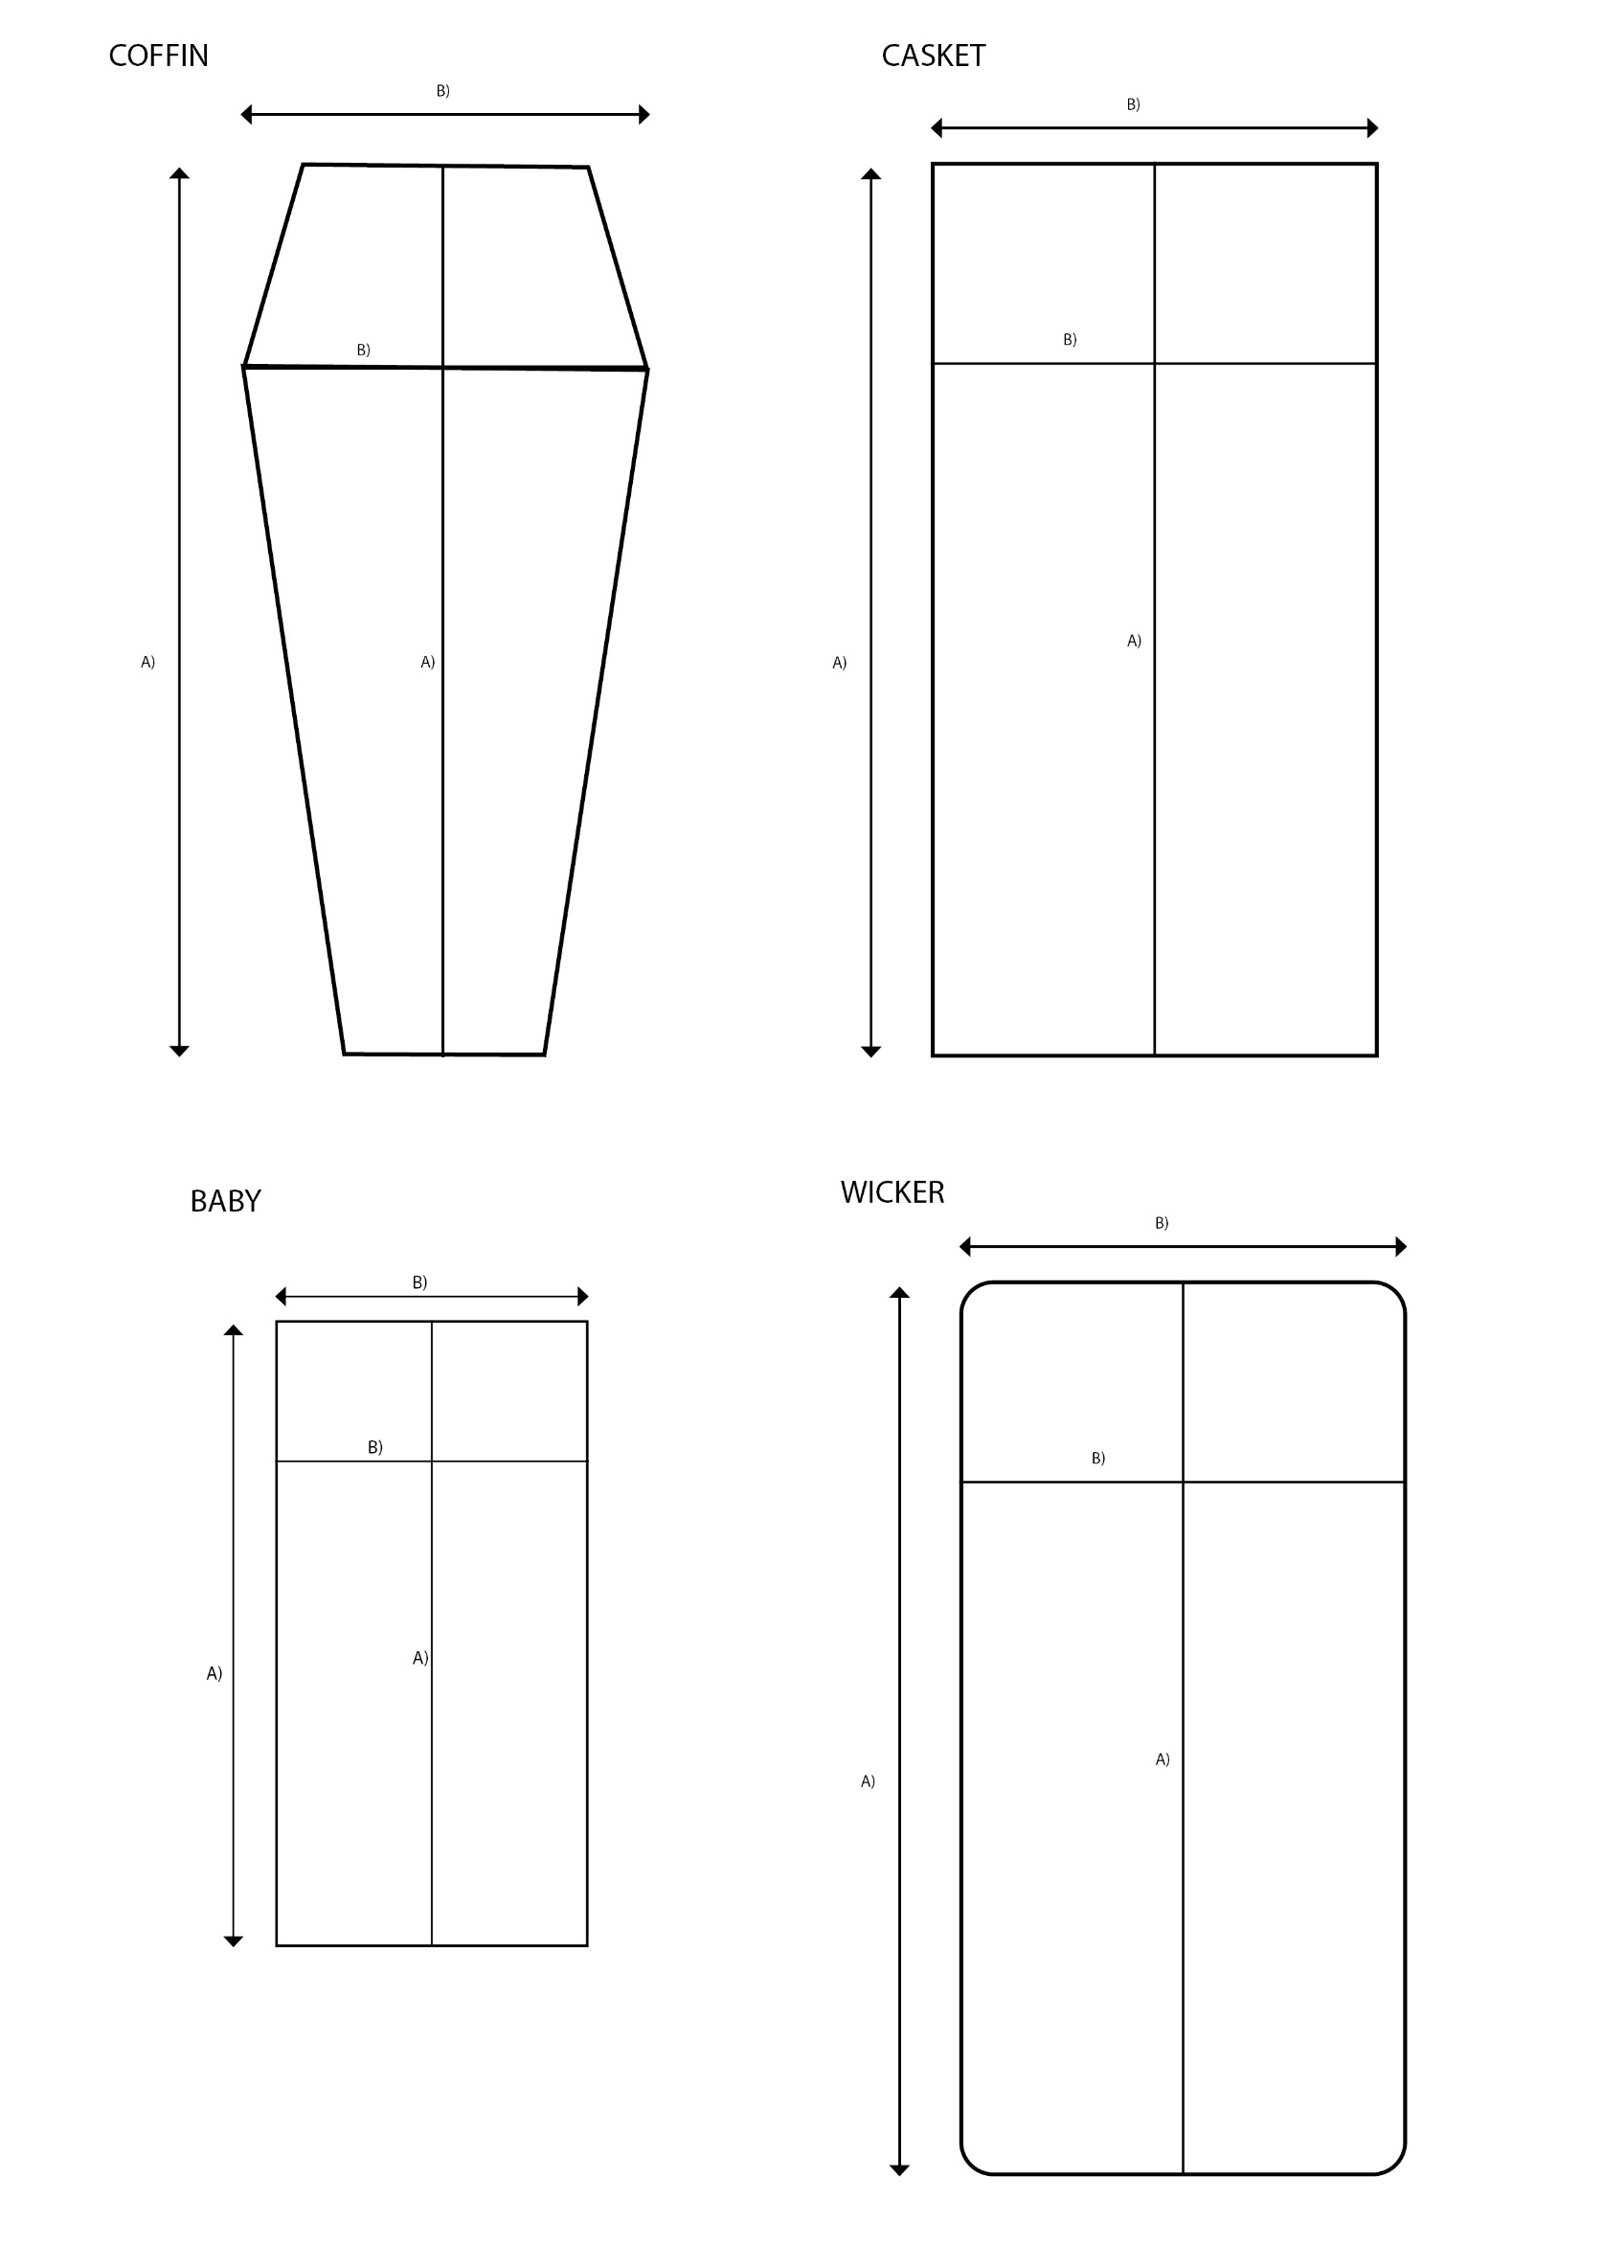

DETAILS OF MEMORIAL (if required)

Date memorial is to be removed

The memorial must be removed as soon as practically possible but no longer than 2 working days before the funeral is due to take place.
Please contact the cemeteries office cemetries@nwleicestershire.gov.uk to confirm the memorial has been removed.

It is the responsibility of the Funeral Director to ensure the smooth running of the funeral service at North West Leicestershire District Council Cemeteries. The Sexton will be available for advice but will not take an active part in the proceedings at grave side. A small wooden marker will be placed at the head of the plot to denote which way the coffin needs to be laid.

I hereby declare that the information provided is correct.

Name of Funeral Director / Agent: …………………………………………………………………

Signed by: ………………………………………………………………………………………….

Print Name: ………………………………………………………………………………………….

Date: ...……………………………………………………………………………………….

FOR OFFICE USE | DATE | ANY ADDITIONAL INFORMATION
Date received from Funeral Director / Agent
Date returned for amendments
Date received from Funeral Director / Agent
Date passed to sexton
Date attached to file

