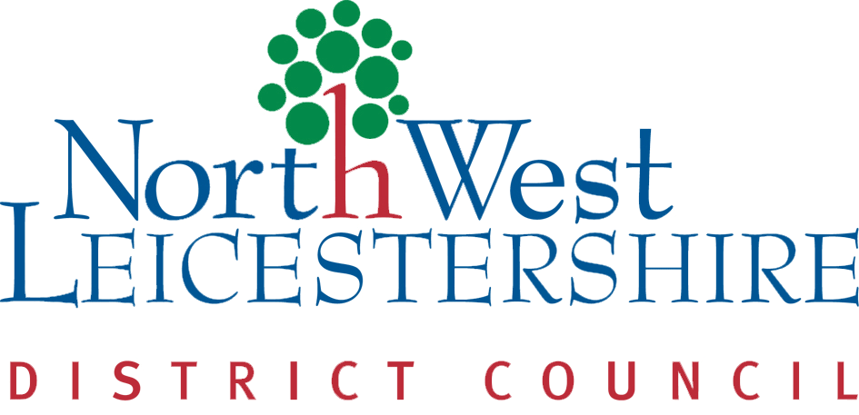

North West Leicestershire Landlord Forum
27th September
5.30pm -7pm
Marlene Reid Centre, 85 Belvoir Road, Coalville, LE67 3PH

Find out about:
DASH
Landlord membership and accreditation scheme. DASH supports landlords with information and guidance on changes in legislation as well as sharing best practice. Since 2008 over 1000 landlords have registered with us and gone on to receive their Accredited Landlord status.
EMPO
Established in 1942, East Midlands Property Owners Ltd (EMPO) is a not-for-profit Landlords Association that represents the need of Residential Landlords across the East Midlands. EMPO works with Government, Local Authorities and Industry to provide the best deal possible for independent landlords in this region.

Legal Update
Linda from the DASH scheme will provide an update on recent legislation affecting landlords.
Fire Safety - Leicestershire Fire and Rescue Service
A question and answer session from the Leicestershire Fire and Rescue Service will help you understand your fire safety responsibilities and how you can better protect your property.

Buffet and refreshments provided

Anyone who would like to attend or would like more information should contact Zoe Davies in the council’s housing service on 01530 454812 or email zoe.davies@nwleicestershire.gov.uk

