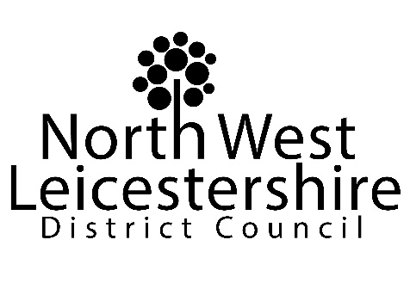
AUDIT OF ACCOUNTS FOR YEAR ENDED 31 MARCH 2021
– NOTICE OF PUBLIC RIGHTS

Local Audit and Accountability Act 2014 Section 26
Accounts and Audit Regulations 2015 Part 5

As amended by:
The Accounts and Audit (Amendment) Regulations 2021

Our accounts are subject to external audit by Mazars LLP of 45 Church Street, Birmingham, B3 2RT. The public inspection period will run from Friday 30 July to Friday 10 September inclusive (excluding Saturdays and Sundays) between 9:30am and 4:30pm. An unaudited statement of accounts for the year ended the 31 March 2021 are published on the council’s website at:
https://www.nwleics.gov.uk/pages/annual_accounts_and_governance_reports.

Members of the public and local government electors have certain rights in the audit process.
During the inspection period:
- Members of the public may inspect the accounts of the council for the year ended 31 March 2021 and certain related documents (comprising books, deeds, contracts, bills, vouchers and receipts);
- Members of the public may make copies of all or any part of those records or documents;
- Local government electors for the area of the council, or their representative, may ask the auditor questions about the accounts.

Certain restrictions are in place however, including protection of commercially sensitive documents and/or documents containing personal information.

During the inspection period, local government electors, or their representatives, also have a right to make an objection to the local auditor providing:
- The objection concerns a matter in respect of which the auditor could issue a report in the public interest; or could apply to the court for a declaration that an item in the accounts is contrary to law (under Sections 26 and 27 of the Local Audit and Accountability Act 2014);
- The objection is made in writing to the auditor using the contact details below; and
- A copy of the objection is sent to the Council using the contact details below.

To make arrangements to inspect the accounts for the council for the year ended 31 March 2021 please contact us. To make arrangements to ask the auditor questions about the accounts please contact the auditor directly.

Dan Bates, Interim Head of Finance and Section 151 Officer
Dated: 30 July 2021
CONTACT DETAILS

Council
Anna Wright
Finance Team Manager and Deputy S151 Officer
North West Leicestershire District Council
Council Offices
Coalville
Leicestershire
LE67 3FJ
Email: finance@nwleicestershire.gov.uk

External Auditors
Mazars LLP
45 Church Street
Birmingham
B3 2RT
Telephone: 0121 232 9500

