COMMUNITIES SCRUTINY COMMITTEE – 22nd March 2011

Title of report | QUARTER 3 PERFORMANCE MANAGEMENT REPORT
Contacts | Councillor Trevor Pendleton  01509 569746  trevor.pendleton@nwleicestershire.gov.uk  Councillor Roger Bayliss  01530 411055  roger.bayliss@nwleicestershire.gov.uk  Director Steve Bambrick  01530 454555  steve.bambrick@nwleicestershire.gov.uk
Purpose of report | This is the performance report for the third quarter (October to December) of 2010/2011.  The report provides members of the Communities Scrutiny Committee with information on the performance and progress made against the Council Delivery Plan objectives, targets and Performance Indicators (PIs)
Strategic aims | The report addresses performance against two of the Council’s Strategic Aims of :  - Stronger and Safer Communities  - Prosperous Communities
Implications:
Financial/Staff | The report contains summary performance data on financial management and staff management.
Link to relevant CAT | The report links to the work of:  - Stronger CAT  - Safer CAT  - Children and Young People CAT  - Older Persons CAT.
Risk Management | Risk management is applicable to all areas of the Council’s statutory duties and service provision, and forms an important element of good governance.
Equalities Impact Assessment | Equality Impact Assessments to be undertaken during 2010/11.
Human Rights | No direct implications.
Transformational Government | No direct implications.
Consultees | Corporate Leadership Team
Background papers | (1) Council Delivery Plan 2010-2014  (2) Annual Performance Plan 2010-2011  (3) SMART Plans – Leisure and Culture; Neighbourhood and Communities; Housing (incl Housing futures) 2010-2014  (4) Change Control Documents  - Copies of each are held by the Service Transformation Unit.
Recommendations | IT IS RECOMMENDED THAT THE COMMUNITIES COMMITTEE RECEIVES AND COMMENTS ON THE QUARTER 3 PERFORMANCE REPORT.

Quarter 3 Performance Report incorporating Finance information for the Community Services.

Section  Number |  |  | Page No.
1 | Performance Summary |  | 3
2 | Council Delivery Plan - Graphs |  | 4
 | Council Delivery Plan - Commentary |  | 6
3 | Service Delivery Plan - Graph |  | 10
 | Service Delivery Plan | Housing Services | 11
 |  | Housing Future | 13
 |  | Leisure Services | 15
 |  | Community Safety | 17
4 | Management of Absence |  | 18
5 | Financial Performance |  | 19
6 | Health & Safety |  | 21
APPENDIX
1 | ASB & Crime Dashboards. |  | 22

Performance Summary

1.1 Following the restructure of the Council's senior management team, Housing Future & Community Safety services are now the responsibility of Sue Haslett – Head of Planning & Engagement.

1.2 Quarter 3 has been very busy for the Leisure services, with recent Active People Survey results placing NW Leicestershire second highest in the county for the number of residents engaged in physical activity and ClubAciv8 visits to leisure centres have made a significant increase of 340% on the same period in 2009/10.

1.3 Financially, the Community Directorate shows a projected underspend of £39k at quarter 3. Although the bad weather particularly impacted on the Housing repairs service leading to a significant increase in costs, this has been balanced out by savings made in the Leisure & Culture and Neighbourhood & Community services.

However, despite the poor weather, the number of Housing customer complaints have remained very low during this period.

1.4 The Housing Services has also submitted a Decent Homes Bid to Government for approximately £20.78 million. A decision from Government to determine whether the bid is successful is anticipated in February.

1.5 Sickness at quarter 3 for the Community directorate is 4.9 days per Full Time Equivalent (FTE), which is lower than the same period last year of 5.75 days. This is also providing a positive contribution to the overall Council performance of 5.86 days per FTE.

2. Performance Against Council Delivery Plan

2.1 The following chart shows the Q3 status of milestones attached to actions for each service within the Directorate, which are contained within the Council Delivery Plan 2010 - 2014.
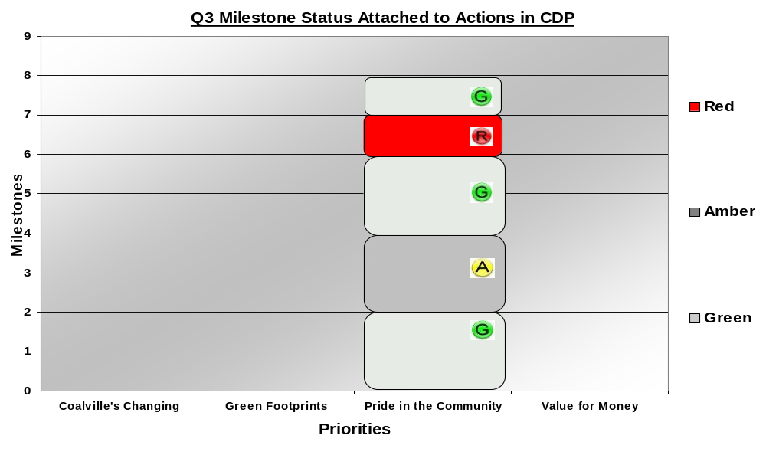

  - The following chart shows the Q3 status of performance indicators measuring outcomes and actions for each service within the Directorate, which are contained within the Council Delivery Plan 2010 - 2014.
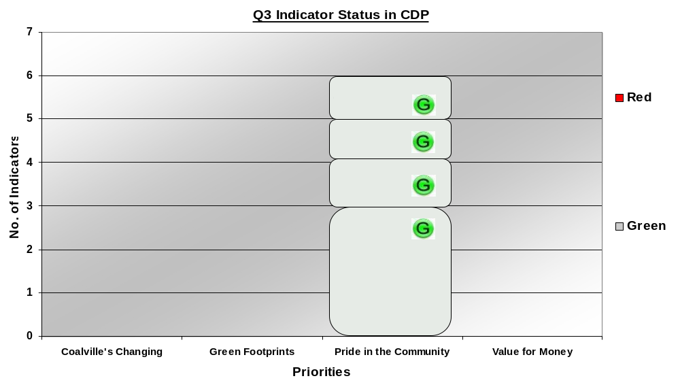

2.3 Priority – Pride in our Community
- Provide more places, spaces and activities for children and young people.
- Reduce fear of crime and anti-social behaviour Increase quality employment remises and decrease long term unemployment.
- Provide decent and affordable homes.
- Support elderly and vulnerable people to live independently and/or in settled accommodation.
- Involve people in decisions in their neighbourhood.
- Increase adult participation in sport and active recreation.

2.3.1 Pride in our Community – Milestone Progress contained within the CDP

Action | Milestone –  Q3 2010/11 | Progress | Status
HFIA11 - Maximise delivery of affordable housing through partnership working | Explore possibility of private sector landlords letting properties at sub-market rents. | Analysis of Private Sector Housing "available properties" website, which seeks to match landlords, properties and tenants, indicates that the rent levels in the District are aligned to the Local Housing Allowance (LHA) rather than market rents. The LHA level for the District is lower than market rents charged.  Successful partnership working between Private Sector Housing and local landlords has resulted in a pool of properties becoming available at rents lower than market rents, though not necessarily at social rented levels. However the introduction of "Affordable Rented" properties (available at up to 80% open market levels and for fixed tenancy periods) could result in more of the privately rented properties falling into affordable housing bands. The precise Affordable Rented level for the various settlements in the District is not yet known
HIA12 - Complete preparations for retendering of the Older Persons Service (Supporting People) funded services | As per County Action Plan - Q3 | Draft report written and circulated to providers for feedback. On target for sign off in Jan 2011. Work will then commence on service specification and retendering process will begin in Feb/Mar 2011.
HIA15 - Deliver Housing Planned Investment Programme 2010-11 | Completion of all contractors’ selection. Contractors commenced works. | All contractors selected and awaiting signed contract documents to be returned. Roofing programme has commenced with others to follow in quarter 4.
HIA17 - Significantly improve performance in the delivery of Disabled Facility Grants and Aids and Adaptations. | TBC subject to RIEP project to review Disabled Facilities Grants | Range of cross county groups continues to meet to develop shared service, joint procurement and standard specifications as well as other initiatives. Deadlines for completion of various work streams not yet established. C Lambert now leading following departure of A Nickels.
LCIA18 - Increase 16+ Physical Activity uptake | Trial an incentive scheme to engage and encourage residents not achieving 3x30mins of physical activity to access discounted leisure centre provision and physical activity sessions. | Active Together have openly promoted discounted sessions in all leisure centre facilities within all promotional material. In addition to this we have run various events to encourage uptake of sessions within leisure centres e.g. Danceathon - to encourage attendance to community and leisure centre classes, Swimming - Active Together offered subsidised swimming lessons for adults aged 16+, Run In England sessions have been offered at district venues promoting links to local running clubs based at the centres (e.g. Ivanhoe and Hermitage Harriers), and the necessary steps are being taken to improve that within 2011. No strings badminton has also been ongoing offering discounted opportunities to participate. Recent Active People Survey results show an increase in the number of residents engaged in physical activity with NW Leics second in the whole County.
LCIA20 - Develop places, spaces and activities for Children & Young People | Facilitate round 3 play builder bids and work with Ellistown PC and young person action group in Ellistown for development of St Christopher's play area for 13 yr+ provision | Playbuilder funding has been re-established in Measham and Oakthorpe and projects are continuing with the expectation that they will be completed by end of March 2011. Ellistown Parish Council have offered a tender opportunity to local landscaping companies for work at St Christopher’s Play area and Ellistown School Council are working with Children's Services Coordinator and Parish Council rep to develop 3 further play areas in Ellistown with pending S106 money from local housing development.
SAFIA01 - Work with partners to improve levels of public confidence | ASB Roadshow and consult residents regarding service standards | ASB standards were developed but no roadshow was delivered due to reduced capacity within the team. However, the standards were widely publicised through the July edition of Vision magazine.
SAFIA02 - To make local communities safer by delivering the key objectives in the Community Safety Strategy and reducing overall crime by 5% by March 2012 | Tracking overall crime reduction rates and monitoring delivery of the four priorities identified in the Community Safety Strategy refresh to ensure any necessary corrective action is taken to address underperformance. Annual priorities are refreshed. | The four community safety priorities are assessed at quarterly Partnership meetings.  Crime data is available presently until end Nov 2010.

2.3.2 Pride in our Community – Performance Indicators measuring Outcomes & Actions contained within the CDP.

Performance Indicators | Target | Actual |  | Status
Housing & Customer Services
HFPI06 - Number of prevention cases approaching the council. | 120 | 160
HPI26 - Increase in customer satisfaction for A&A. Joint indicator with DFG and A&A.  Targets to be determined on release of Adam Integra report asap | Joint indicator with DFG and A&A. Targets to be determined on release of Adam Integra report asap | 92% (A&A Outcome)  93% (DFG outcome.)
NI 142 - Percentage of vulnerable people who are supported to maintain independent living. | 98.50% | 99.2%
Community Services
LPI14 - More community venues, sports facilities and play areas. | 1 | 13
SAFPI01 - Total recorded crime figures and the Crime Dashboard per crime category. | 4,312 | 3,896
NI 155 - Number of affordable homes delivered. | 43 | 44

3. Performance against Service Delivery Plan

3.1 The following chart shows the Q3 milestone status for each service, identified within their Service Delivery Plan, excluding all CDP milestones.
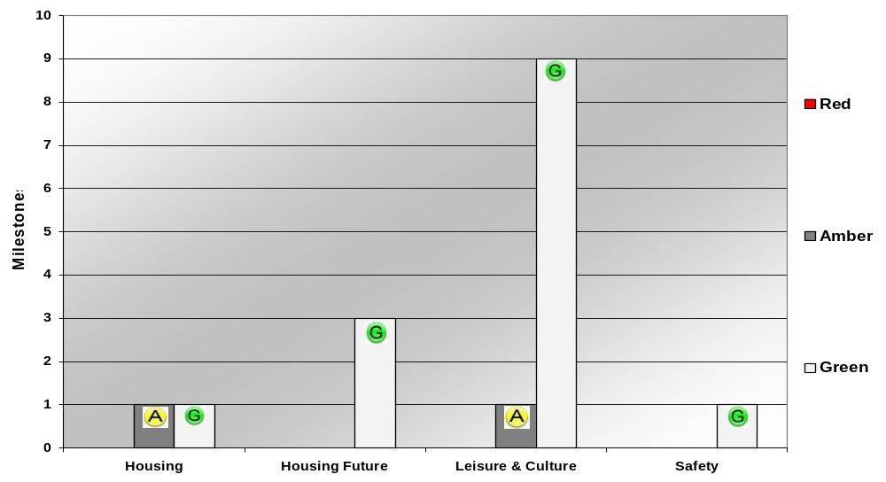

3.2 Housing & Customer Services Performance Summary

3.2.1 Housing - Actions/Milestones Performing Well & On Track within the Service Development Plan

Owner: - Head of Housing & Customer Services - Chris Lambert
Key Actions: - | Q3 Milestones | Status
HIA13 Play a leading role in the Review of Customer Services provision, with a view to potentially producing an integrated Customer Services Team provision, to a timetable that is to be agreed. | TBC6

3.2.2 Housing - Actions/Milestones that are under control

Key Action | Milestone | Progress | Status
HIA14 Conduct ICT system review, to ascertain the most effective solution for supporting the housing service over the next 5 years, including review of IBS (Specifically the Housing Contractor and Housing Management modules)/Mobile working/DIP and Workflow. | Development of project timetables for key projects and identification of key implications for 2011/12 planning. | Workshops for key service areas undertaken and a detailed timetable for procurement under development. The Decent Homes Funding bid temporarily took precedent over this action, work on this will resume in Jan 2011 to get this back on track.

    - Housing Tenants Top Ten performance indicators contributing to Key Actions within the Service Delivery Plan.

Tenants Top Ten Performance Indicator |  | Q3 Target | Actual | Status
HPI27 | All new customers to have a support plan in place within 2 weeks of moving in. | 95% | 100%
HPI28 | Quality of call response by Control Centre | 96% | 99%
HPI08 | Amount of rent loss through properties becoming vacant | £76,000 | £47,593
HPI29 | Former Tenant arrears collection rate - monetary value at month end (Cumulative) | £13,500 | £17,637
HPI30 | Total value (£) of former tenants rent written off. | £11,250 | £1,268
HPI31 | Total arrears (£) for current tenants at end of month | £284,371 | £229,447
HPI32 | % of customers who rated the overall satisfaction of the Housing Response team (integration of reception, control centre & repairs) as good/satisfied or above. | 85% | 99%
HPI23 | % of Emergency repairs completed on time (within 24 hours) | 98% | 99%
HPI16 | Average number of working days to resolve stage 1 complaints | 10 | 7
HPI25 | % of Routine repairs completed on time (within 28 days) | 93.7% | 98.9%

3.3 Housing Futures
Actions/Milestones Performing Well & On Track within the Service Development Plan.

Owner: - Head of Planning & Engagement Services – Sue Haslett
Key Actions: - | Q3 Milestones | Status
HFIA08 Implement Choice Based Lettings by Dec 2010 | Choice Based Lettings introduced.
HFIA09 Appraise the most efficient way of delivering required outcomes for the strategic housing service. | Preferred option developed.
HFIA10 Develop new Housing Strategy Action Plan. | Consult on proposed new strategy.

3.3.1 Indicators On or Above Target for Quarter 3 contributing to Key Actions within the Service Delivery Plan.

Indicator | Q3 Target | Q3 Actual | Status
HFPI02 - Gross Monthly cost of B & B (excl HB) | 14,500 | 11,777
HFPI04 - Average time taken in days to make homeless decision | 21 | 18
NI156 - Number of households living in temporary accommodation (Quarterly) | 8 | 6

3.3.3 Indicators Below Target for Quarter 3

Indicator | Comments | Q3 Target | Q3 Actual | Status
HFPI01 - Total Number of Homeless Declarations Taken | The number of Homeless declarations taken this month is higher than expected due to the Severe weather experienced in December and the requirement to accommodate Rough Sleepers when temperatures fall below zero for 3 consecutive nights. | 20 | 27
HFPI03 - Number of cases where advice casework prevented homelessness | Another good quarter although the figure is a little less than anticipated. This is due to the increase in homeless applications taken within this quarter. | 37 | 33
HFPI05 - Number of responses to planning enquiries within 10 working days expressed as a % | 25 requests received 23 responses within 10 working days.  Cumulative figure 48 requests received, 46 responses within 10 working days = 95.8% | 95.00% | 92.00%

  - Leisure –
Actions/Milestones Performing Well & On Track, contained within the Service Development Plan.

Owner: - Head of Community Services - John Richardson
Key Actions: - | Q3 Milestones | Status
LCIA11 Undertake and develop Leisure & Culture Future Direction programme as part of the Value For Money programme | To review all Leisure & Culture services for cash savings for 2011/2012 budget.
LCIA12 Deliver community facility improvements | To support changing room and playing pitch development projects at Heather St Johns FC and Ibstock United FC
LCIA13 Undertake Leisure Centre business improvements | In conjunction with the School Sport Partnership and Local Sports Alliance, extend and develop the Club Activ8 scheme to encourage more children within NWL to participate in sporting activities in leisure centres
LCIA14 Improve leisure centre building energy efficiency | Install energy efficient lighting where appropriate i.e. Floodlit Astroturfs
LCIA15 Deliver Coalville Town Centre entertainment programme | Deliver Christmas in Coalville event and Remembrance Parade
LCIA16 Attract external community Cultural investment | Secure funding to deliver Coalville and Ashby Town Centre Christmas events and 2011 Orchestral Concert
LCIA17 To improve the health and wellbeing of residents through reducing health inequalities. | To write funding proposals in conjunction with PCT to submit to their funding board for targeted locality projects in 2011/12.
LCIA19 Reduce Anti-Social Behaviour through Positive Futures | To promote the Positive Futures brand and Mobile Skate Park as 'Available for hire' district and countywide.
LCIA22 To increase the voice and volunteering of Children & Young People | Deliver Local Democracy Week initiatives to increase political awareness amongst young people. Support and work with young people to deliver annual Voice of Youth Conference on 2010 11 million takeover day.

3.4.1 Leisure Actions/Milestones – Under Control
Key Action | Milestone | Progress | Status
LCIA21 To drive forward the development of Children's Centres, Extended Services and Integrated Youth Support Services in NWL. | To confirm the resource allocations for 2011/12 and manage the process of reviewing funding allocations for projects against locality need. | Still awaiting decision from County Council regarding PAYP and REIP funding due to County Council spending review.

3.4.2 Leisure - Indicators On or Above Target for Quarter 3 contributing to Key Actions within the Service Delivery Plan.

Indicator | Q3 Target | Q3 Actual | Status
LPI08 - Total number of Club Activ8 attendances | 2,800 | 3,438
LPI18 - Number of leisure centre users and basic demographic profile. | 215,000 | 229,871
LPI21 - Approximate number of attendances at Coalville Town Centre Cultural events. | 4,000 | 5,000
LPI22 - Average satisfaction rating of 'Good' or 'Excellent' for all Coalville Town Centre Cultural events. | Good | Good
LPI23 - Amount of external funding secured for Cultural facilities, projects and events.- Goff | 4,000 | 10,000
LPI24 - Number of attendances at well families clinics. - Goff | 120 | 152
LPI25 - Number of referrals to health intervention services ie smoking cessation, GP surgeries | 35 | 63
LPI27 - Participation in diversionary/positive activities organised by leisure and cultural services. | 150 | 401
LPI28 - Number of young people participating in school holiday sports programmes. | 375 | 445
LPI29 - Number of NEETs in NWL | 4.1% | 3.9%
LPI30- Number of NEET or unemployed, involved in sports volunteering, training or placements. | 6 | 8

3.4.3 Leisure - Indicators Below Target for Quarter 3

Indicator | Comments | Q3 Target | Q3 Actual | Status
LPI06 - Total CO2 equivalence for HLC and HPLC | The target for Q3 has failed to be met. The reason for this predominantly is the excessively cold weather throughout late November and December - it was the coldest December on record. This consequently led to significantly increased usage of gas at both HLC and HPLC to heat the buildings and water.  Providing the weather doesn't continue to be excessively cold, then we are confident with the measures in place - energy efficient lighting, the CHP at HPLC now in operation - we will hit our Q4 and annual targets. | 309.00 | 341.00
LPI26 - Number of GP referrals reporting an increase in physical activity levels at end of 12 week course. | Due to the nature of the clientele this is always a challenging target, however, the poor weather in November and December restricted a number of referrals attending classes and sessions and thus their physical activity levels dropped off. It is hoped that better weather in Q4 will lead to an upturn in attendance and activity. | 50 | 35
3.5 Community Safety
Actions/Milestones Performing Well & On Track contained within the Service Development Plan.

Owner: - Head of Community Services - John Richardson
Key Actions: - | Q3 Milestones | Status
SAFIA03 Identify the most efficient way of delivering required outcomes of the Community Safety Strategy | Options have been progressed via dialogues with partners, principally the Police and Charnwood Borough Council, in relation to a shared service. In Q1 the option of having an integrated community safety team model with the Police is favoured. The feasibility of this was further explored in Qtrs 2 & 3 but also has to take account of the senior and service manager reviews due to conclude in Q4.

Management of Absence - Community
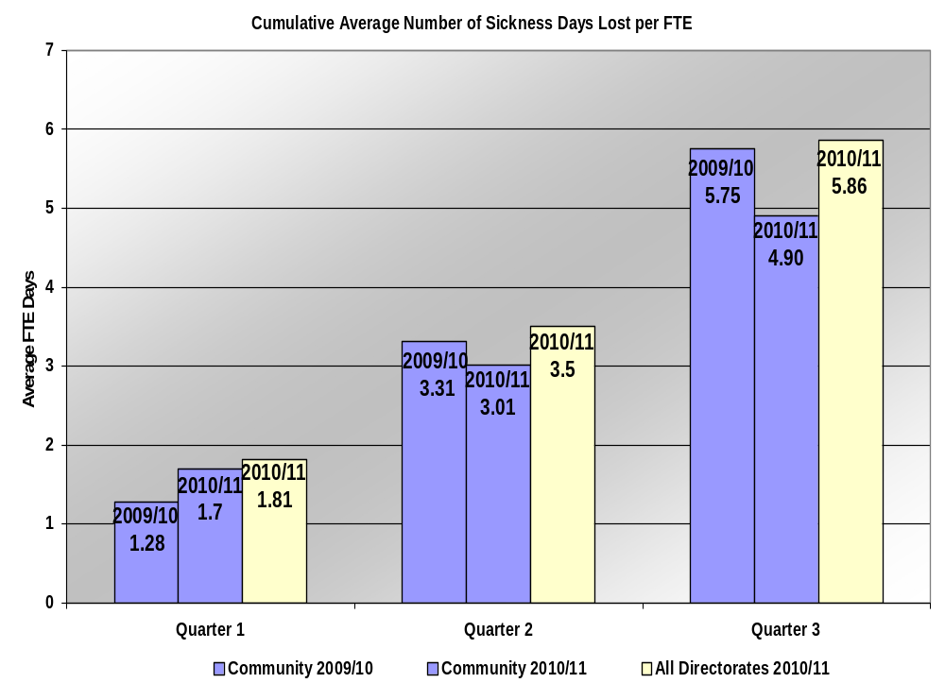
4.1 The proactive management of sickness absences has continued to contribute to a reduction in the number of days lost per FTE, with support being given to employees with serious long-term conditions and, where appropriate, actions taken in accordance with the Attendance Policy.

  - During Q3 there has been 7 employees returned to work following long-term absences, 3 on managed phased returns.

  - Five sickness meetings/home visits have been conducted. 105 return to work interviews have been completed, 2 with HR support and 4 HR review/employee support meetings have taken place in addition to regular line manager support meetings with 4 attendance review meetings completed.

  - One risk assessment has been conducted and temporary reasonable adjustments made whilst the employee awaits an Access to Work assessment. Additionally there have been 2 HR advice meetings with Managers regarding managing sickness issues.

4.5 Currently there is 1 case of long-term absence being proactively managed.

HR Management of Absence QUARTER 3 (October - December) 2010/2011
 | Ave. No of FTE per Qtr |  |  |  |  | Number of Days Lost per Quarter |  |  |  |  | Cumulative |  |  | No of days lost per FTE
 | Q1 | Q2 | Q3 | Q4 |  | Q1 | Q2 | Q3 | Q3  Long | Q3 Short |  | Days lost (Q1+Q2+Q3) |  | Q1 | Q2 | Q3 | Q4
Directorate | 175.98 | 169.11 | 172.57 |  |  | 298.34 | 211.00 | 336.20 | 139.80 | 196.40 |  | 845.54 |  | 1.70 | 3.01 | 4.90
All Directorates | 475.93 | 466.22 | 466.88 |  |  | 863.47 | 768.80 | 1103.0 | 554.49 | 548.51 |  | 2735.27 |  | 1.81 | 3.50 | 5.86

- Financial Performance

5.1 Community Directorate Summary of Expenditure – Quarter 3 2010/11

 | ORIGINAL BUDGET | FORECAST OUTTURN | FORECAST VARIANCE
 | NET | NET | NET
 | £ | £ | £
Community Director | 68 | 61 | -7
Leisure & Culture | 1,509 | 1,466 | -43
Neighbourhoods & Communities | 398 | 348 | -50
Housing | 257 | 318 | 62
Total Community Services | 2,231 | 2,193 | -39

* Please note that the ‘Forecast Variance Net’ figures highlighted above, are made up of an accumulation of under/over spends within the service, with commentary focusing on the major variances for the quarter.

5.2 Community Director

5.2.1 Savings of £7k achieved due to secondment of Directors Secretary to Human Resources.

5.3 Leisure and Culture

5.3.1 Rateable value at the Hood Park Leisure centre has been re assessed recently resulting in savings of £82k.

5.3.2 Direct Leisure services have a deficit of 110k. This is after taking into account the increased support service recharge of £264k (compared to £141k budgeted), without this additional charge the account would have been in surplus by £23k (this compares favourably to a deficit of 108k at the same period in 2009/10 at the pre-increase level of support service recharges).The position at period has not been helped by the recent poor weather and closure of the pools at Hermitage Leisure centre. The forecast overspend as at year end is £50k.

5.3.3 There are also underspends of some £24k on leisure and culture management and sports services but offset by some overspends on Tourism £4k and Physical health £2k.

5.4 Neighbourhood and Communities

5.4.1 Salary savings on various posts £50k.

5.5 Housing

5.5.1 Salary savings of £8k.

5.5.2 Forecast Housing benefit receivable on bed and breakfast expenditure has reduced by £43k. There is a matching reduction in housing benefit expenditure in the Corporate Directorate figures

5.5.3 An incorrect income line of £24k was included in the Budget which will not be achieved now.

6. Health & Safety Monitoring

  - Training

The Community Directorate have had 32 officers attend training up to the end of quarter 3.

6.2 Accidents

6.2.1 There have been 2 reported accidents in quarter 3 for the Community Directorate, 1 incident relating to the leisure service and one in the maintenance service.

Quarter 2 Comparative

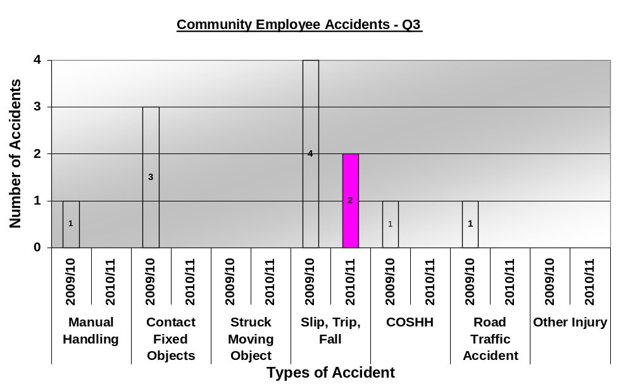

6.2.1 Quarterly meetings are held at Service, Directorate & Executive level, to discuss reported accidents and to establish preventive measures to be actioned.
APPENDIX 1


