Accessing Remote Login Using Swivel
1) Visit the secure swivel login site – https://access.nwleicestershire.gov.uk
2) You will be presented with the secure login page. Enter your username and password as usual. In the “OTC Code” box enter the 4 digit code you received via text message from swivel security.
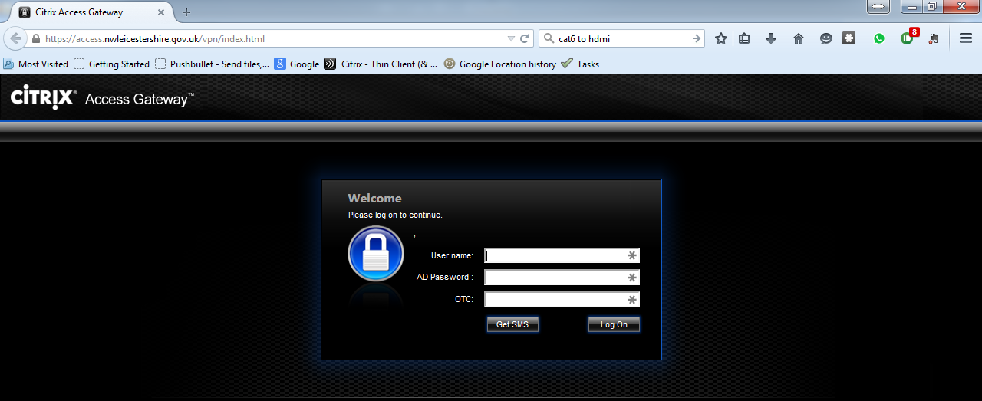
3) Your swivel security text message will contain two lines of numbers, each line contains 10 digits. During the initial setup of swivel you will choose a unique 4 digit pin code. Locate your unique code within the top line of digits. Once you have located your unique digits enter the numbers located directly below from the second line of digits, into the “OTC Code” box.
Example text message from swivel security.
Example – When first setting up your swivel account with ICT, you setup a unique code of 1357 your mobile phone number registered to swivel will have received a text message from swivel security. Locate your unique pin within the text message.
Locate your code in the top line - 1234567890
Enter the digits from the bottom line - 8731592406
- Find your unique code (in this example 1357) from the top line of digits.
- Enter the digits directly below (in this example 8352) into the “OTC Code” box on the secure login page.
4) Once logged into the secure login site using swivel, you will automatically receive a new text message from swivel security containing two new lines of numbers. Do not delete this text message. Refer to this text message next time you login securely using swivel.

