Animal Licensing Star Rating Scheme:  Appeal Form |  | 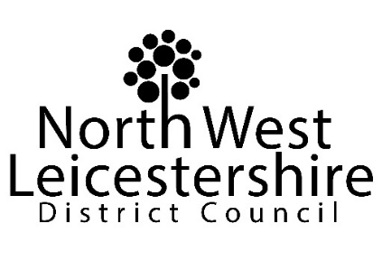

Notes for businesses:

- As the business operator of the establishment you have a right to appeal the star rating given following your inspection if you do not agree that the rating reflects the animal welfare standards found at the time of the inspection.
- You have 21 days (including weekends and bank holidays) from the date of receipt of the notification letter to lodge an appeal.
- Please use the form below and return it to licensing@nwleicestershire.gov.uk.
- Your rating will be reviewed and the outcome of your appeal communicated to you within 21 days.

Business details
Business operator/licence holder

Business name

Business addresses

Business tel. number |  | Business email

Inspection details
Date of inspection |  |  |  |  | Star rating given
Date notified of rating

Appeal
I do not agree with the star rating given by the officer because (please explain below).

Higher Standards

Minimum Standards

Signature
Name in capitals

Position |  | Date
Please now return this form to: licensing@nwleicestershire.gov.uk

