Appendix 4

Blackfordby Local area Neighbourhood Plan
Housing Needs Report
January 2018
Prepared by YourLocale

BLACKFORDBY LOCAL AREA NEIGHBOURHOOD PLAN
HOUSING NEEDS

Introduction
This report provides an analysis of housing issues in the Blackfordby local area to support its Neighbourhood Plan policies. The report draws on the latest available data from the Census, Land Registry, Valuation Office Agency, Office for National Statistics, small area model-based income estimates and local consultation exercises. The results outlined in this Housing Needs Survey Report and any future Housing Needs Survey will influence the policies of the Blackfordby local area Neighbourhood Plan.

Population Age Profile
According to the 2011 Census, the Blackfordby local area had an estimated population of 1,450 residents living in 650 households dispersed across 315 hectares, equating to a population density of 4.6 persons per hectare. This compares with 3.3 for NW Leics, 2.9 for East Midlands and 4.1 for England as a whole. There were 23 vacant dwellings representing a 3.4% vacancy rate. There were no communal establishments situated in the local area boundary. Since 2001 the number of residents living in the local area is estimated to have fallen by around 4% (57 people) whereas the number of dwellings (occupied and vacant) increased, rising by 7 (1.1%).
At the time of the 2011 Census around 14% of residents were aged under 16 which was below the borough (19%), regional (18%) and national (19%) rates. Around 58% of residents were aged between 16 and 64 which was lower than the England (65%), borough and regional (64%) rates
There is an over representation of older people (aged 65+) accounting for 28% of total residents which was significantly higher than the borough, regional (17%) and national (16%) rates. The median age of people living in the local area was 54 which is older than the borough (42), region (40) and national (39) rates.

Table 1: Usual Residents by Age Band, 2011
 | Blackfordby |  | NW Leics | East Midlands | England
 | No | % | % | % | %
Aged 0-4 | 60 | 4.1 | 5.9 | 6.0 | 6.3
Aged 5-15 | 143 | 9.9 | 13.1 | 12.5 | 12.6
Aged 16-64 | 841 | 58.0 | 63.7 | 64.5 | 64.8
Aged 65+ | 406 | 28.0 | 17.4 | 17.1 | 16.3
All Usual Residents | 1,450 | 100.0 | 100.0 | 100.0 | 100.0
Median age | 54 |  | 42 | 40 | 39
Source: Census 2011, KS102

A more detailed breakdown of age bands reveals that at the time of the 2011 Census, Blackfordby had a particularly high representation of residents aged 60 to 79 when compared with the national average. It has a lower share of people aged been 20 and 39 which may reflect lack of affordable and suitable accommodation for young people entering the housing market.

Figure 1 Population by 10 year age bands, 2011
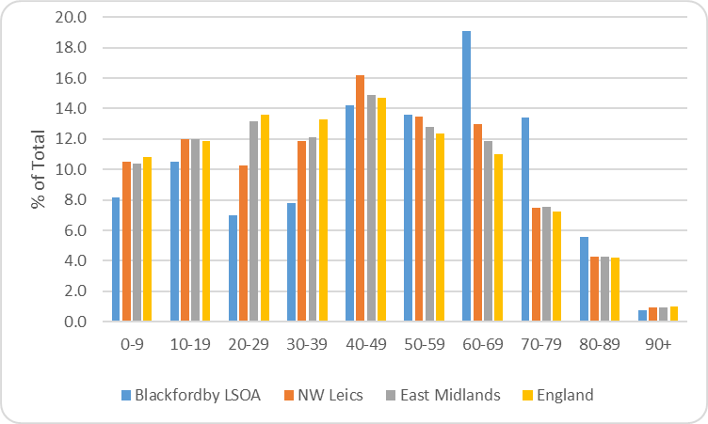
Source: Census 2011, QS103

There is further evidence of an ageing population with the proportion of residents aged 65 and over increasing from 18% in 2001 to 39% in 2011. The Census shows the number of residents aged 65+ rose by 28% (135 people) during this period.

Research shows the number of older people will grow significantly in the future and relative growth will be highest in older cohorts. Latest available population projections suggest that NW Leicestershire’s 65 plus age group is forecast to grow by around 55% between 2014 and 2034.

Deprivation
The English Indices of Deprivation measure relative levels of deprivation in 32,844 small areas or neighbourhoods, called Lower-layer Super Output Areas (LSOAs) in England. The Blackfordby local area comprises one LSOA (E01025952) and the overall Index of Multiple Deprivation Decile (where 1 is most deprived 10% of LSOAs) (IMD) shows that on the whole the local area displays relatively low levels of deprivation ranking in the 7th decile on the overall 2015 Index. On closer inspection of the IMD sub domains, this area ranks relatively high (3rd decile) on the Barriers to Housing and Services domain which may indicate difficulty to access owner-occupation or the private rental market. The following map illustrates overall Index of Multiple Deprivation deciles within the NW Leics borough. The Blackfordby local area is denoted by a purple boundary to the west of the borough.

Figure 2 Index of Multiple Deprivation Deciles, 2015,
NW Leicestershire Borough Council
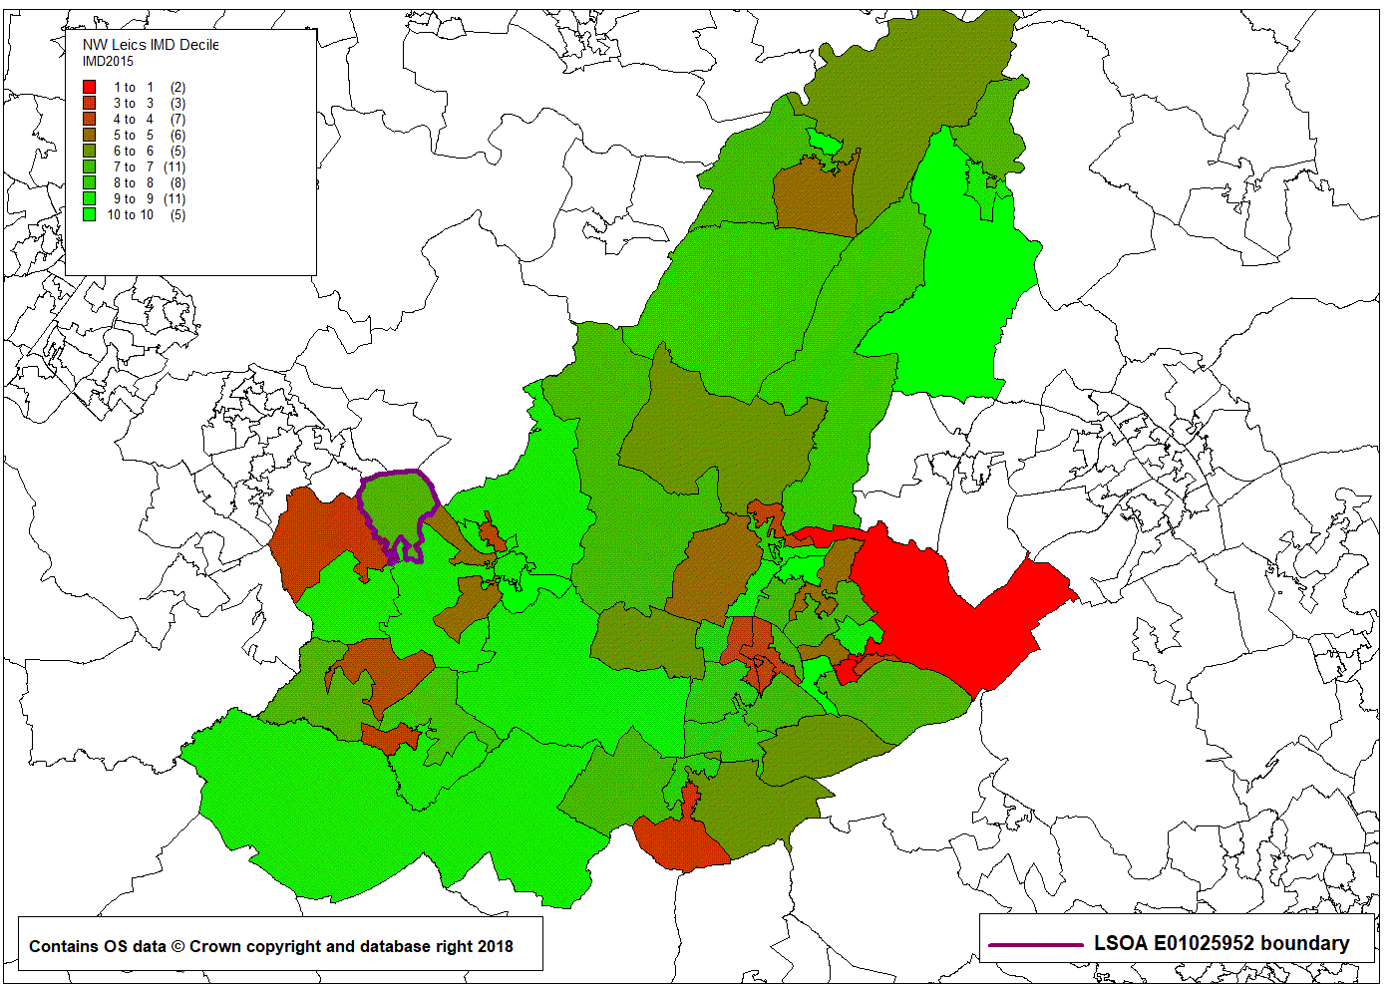

Economic Activity
The following table illustrates the working status of residents aged 16 to 74. In the Blackfordby local area this accounts for 74% of the population. At 62% Blackfordby’s economic activity rate is somewhat lower than the borough (73%), regional (69%) and national (70%) rates. It has a higher than average share of retired residents which reflects the higher prevalence of older residents.

Table 2: Economic Activity and Inactivity, 2011
 | Blackfordby |  | NW  Leics | East  Midlands | England
 | No | % | % | % | %
All Usual Residents Aged 16 to 74 | 1,074 | 100.0 | 100.0 | 100.0 | 100.0
Economically Active Total | 666 | 62.0 | 71.5 | 69.3 | 69.9
Employee, Part-time | 147 | 13.7 | 14.4 | 38.8 | 38.6
Employee, Full-time | 364 | 33.9 | 42.0 | 14.4 | 13.7
Self Employed | 97 | 9.0 | 9.3 | 8.7 | 9.8
Unemployed | 34 | 3.2 | 3.4 | 4.2 | 4.4
Full-time Student (econ active) | 24 | 2.2 | 2.4 | 3.3 | 3.4
Economically inactive Total | 408 | 38.0 | 28.5 | 30.7 | 30.1
Retired | 282 | 26.3 | 16.1 | 15.0 | 13.7
Student (including Full-Time Students) | 42 | 3.9 | 3.8 | 5.8 | 5.8
Looking After Home or Family | 27 | 2.5 | 3.8 | 4.0 | 4.4
Long-Term Sick or Disabled | 43 | 4.0 | 3.4 | 4.1 | 4.0
Other | 14 | 1.3 | 1.4 | 1.9 | 2.2
Source: Census 2011, QS601E

Household Size
At the time of the 2011 Census, the average household size in the Blackfordby Local area was 2.2 people which was below the region (2.3) and the national and borough (2.4) rates. The average number of rooms per household stood at 5.9 which was in line with the borough average and above the regional (5.6) and England (5.4) rates.
The average number of bedrooms per household stood at 2.9 which was and higher than the region (2.8) and England (2.7) rates.

Housing Characteristics
Tenure
Home ownership levels are high with around 81% of households owning their homes outright or with a mortgage or loan. This is somewhat higher than the borough (72%), regional (67%) and national (63%) rates. Just 4% of households live in private rented accommodation which is lower than the borough (11%), region (15%) and national (17%) rates. Around 13% of households live in social rented accommodation which was lower than the borough (14%), regional (16%) and national (18%) rates.

Table 3: Tenure, 2011
 | Blackfordby |  | NW Leics | East  Midlands | England
 |  |  |  | % | %
All occupied Households | 650 | 100.0 | 100.0 | 100.0 | 100.0
Owned; Owned Outright | 326 | 50.2 | 34.7 | 32.8 | 30.6
Owned; Owned with a Mortgage or Loan | 202 | 31.1 | 37.8 | 34.5 | 32.8
Shared Ownership (Part Owned/Part Rented) | - | 0.0 | 0.8 | 0.7 | 0.8
Social Rented; Rented from Council (Local Authority) | 80 | 12.3 | 10.7 | 10.1 | 9.4
Social Rented; Other | 4 | 0.6 | 3.6 | 5.7 | 8.3
Private Rented; Private Landlord or Letting Agency | 23 | 3.5 | 10.2 | 13.6 | 15.4
Private Rented; Other | 4 | 0.6 | 1.1 | 1.3 | 1.4
Living Rent Free | 11 | 1.7 | 1.2 | 1.3 | 1.3
Source: Census 2011, KS402EW

Accommodation Type
Data from the 2011 Census shows that the majority (54%) of residential dwellings were detached which is somewhat higher than the borough (39%), regional (32%) and national (22%) shares. Semi-detached housing accounted for 38% of the housing stock against 35% for the borough and the region and 31% nationally. Terraced housing, flats and apartments provide just 8% of accommodation spaces which is lower than the borough (25%), region (32%) and national (47%) shares.

Table 4: Accommodation Type, 2011
 | Blackfordby |  | NW Leics | East  Midlands | England
 | No | % | % | % | %
All household spaces  (occupied + vacant) | 673 | 100.0 | 100.0 | 100.0 | 100.0
Detached | 363 | 53.9 | 38.8 | 32.2 | 22.3
Semi-Detached | 256 | 38.0 | 35.2 | 35.1 | 30.7
Terraced | 47 | 7.0 | 18.2 | 20.6 | 24.5
Flat, Maisonette or Apartment | 6 | 0.9 | 7.0 | 11.7 | 22.1
Caravan or Other Mobile or Temporary Structure | 1 | 0.1 | 0.9 | 0.4 | 0.4
Source: Census 2011, KS405EW

Number of Bedrooms and Occupancy Rates
Around 20% of households live in houses with four or more bedrooms which is in line with the regional rate and close to the national (19%) rate but lower than the 23% borough average. There is an under representation of housing for single people with just 3% of dwellings having one bedroom against 6% for the borough, 8% for the region and 12% for England as a whole.

Table 5 Households by number of bedrooms, 2011
Bedrooms | Blackfordby |  | NW Leics | East Midlands | England
All occupied Household Spaces | 650 | 100.0 | 100.0 | 100.0 | 100.0
No Bedrooms | - | 0.0 | 0.2 | 0.2 | 0.2
1 Bedroom | 17 | 2.6 | 5.6 | 8.1 | 11.8
2 Bedrooms | 185 | 28.5 | 23.3 | 26.5 | 27.9
3 Bedrooms | 319 | 49.1 | 47.4 | 45.4 | 41.2
4 Bedrooms | 105 | 16.2 | 19.0 | 15.4 | 14.4
5 or More Bedrooms | 24 | 3.7 | 4.5 | 4.4 | 4.6
Source: Census 2011, LC4405EW

There is evidence of under occupancy in the local area (having more bedrooms than the notional number recommended by the bedroom standard). Analysis of the 2011 Census shows that around 45% of all occupied households in the Blackfordby local area have two or more spare bedrooms and around 40% have one spare bedroom. Under occupancy is higher than borough, regional and national averages.

Figure 3: Bedroom Occupancy Rates, All Households, 2011
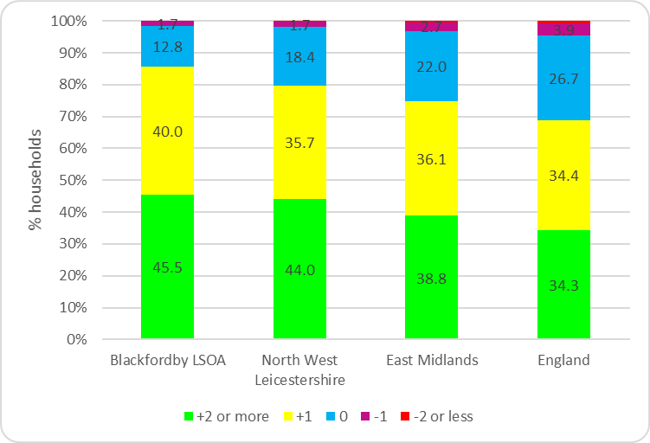
Source: Census 2011, QS412EW

Under occupancy in the local area is particularly evident in larger properties with more than half (52%) of households with 4 or more bedrooms occupied by just one or two people. This is above borough (44%), regional (43%) and England (41%) rates.

Table 6 Household with 4 or more bedrooms by household size, 2011
 | Blackfordby |  | NW Leics | East Midlands | England
HHs with 4 or more bedrooms | 129 | 100.0 | 100.0 | 100.0 | 100.0
1 person in household | 18 | 14.0 | 10.4 | 10.4 | 10.6
2 people in household | 49 | 38.0 | 33.2 | 32.3 | 30.3
3 people in household | 19 | 14.7 | 18.4 | 18.8 | 18.3
4 or more people in household | 43 | 33.3 | 38.1 | 38.5 | 40.8
Source: Census 2011, LC4405EW

Census data also suggests that older person households are more likely to under-occupy their dwellings. Data from the 2011 Census allows us to investigate this using the bedroom standard. In total, around 53% of pensioner households have an occupancy rating of +2 or more (meaning there are at least two more bedrooms that are technically required by the household) and is somewhat higher than the 42% non-pensioner household rate.

Figure 4: Bedroom Occupancy rating of Older Person Households,
Blackfordby Local area, 2011
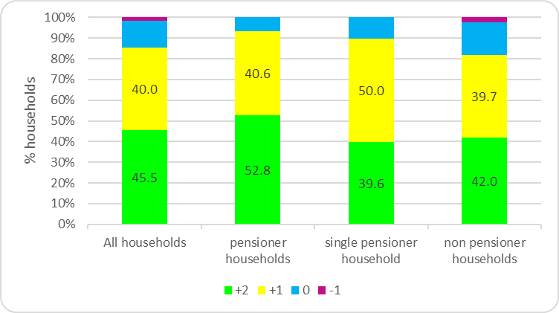
Source: Census 2011, LC4105EW

Overcrowding is not a significant issue in the local area, however, research shows that households with dependent children are more likely to be overcrowded. The Census implies there is some evidence of a small number of families with dependent children living in overcrowded households in Blackfordby.

Figure 5: Bedroom Occupancy rating of Family Households
Blackfordby Local area, 2011
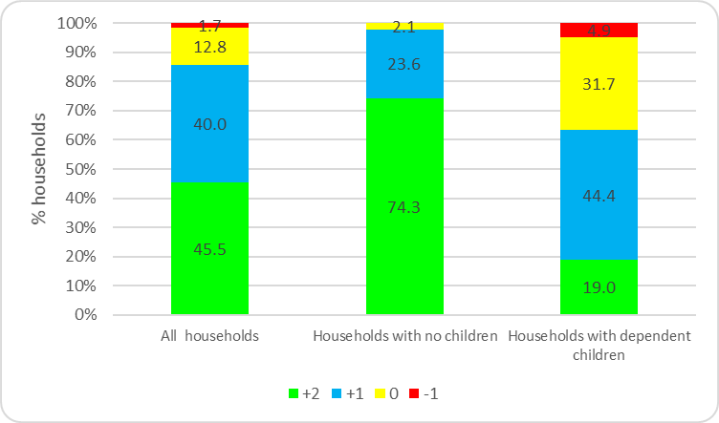
Source: Census 2011, LC4105EW

Housing Market

Council Tax Bands
The chart below provides a breakdown of the proportion of dwellings in the Blackfordby LSOA (E01025952) by council tax band compared to the district, region and national averages at 2017. Domestic properties with Council Tax Band B make up the largest group (approximately 31% of the total) in the area. It has a lower proportion of properties with high value council tax bands with 10% of dwellings having a Council Tax Band E or above against 15% for the borough, 11% for the region and 19% for England as a whole.

Figure 6: Dwelling Stock by Council Tax Band
Blackfordby LSOA 2017
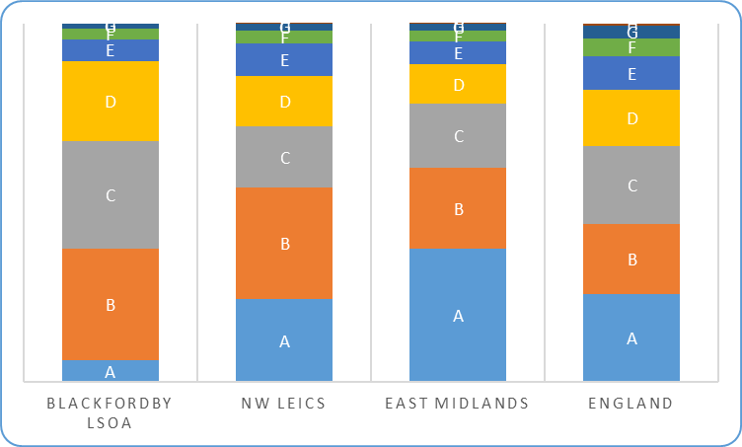
Council Tax: Table CTSOP 4.1, Stock of Properties, England and Wales, 2017 VOA

An analysis of annual data from the Valuation Office Agency (VOA) which provides a series of tables on the number of properties by Council Tax band for each property type and indicates that domestic properties built between 1965 and 1972 were the largest group in the Blackfordby local area, with 24% (160 homes) (10% England). Domestic properties built between 1973 and 1982 were the 2nd largest with 13% of homes built during this period (9% England).

Figure 7 provides a breakdown of properties by built period and shows evidence of a small number of new homes being built between 2010 and 2017. This is also reflected in the residential sales section below which draws on Land Registry price paid data. There are no records of dwellings having been built between 1939 and 1945 due to the Second World War. In some cases, the period when the property was built has not been recorded on the VOA system.

Figure 7 Build Period of Property in the Blackfordby LSOA
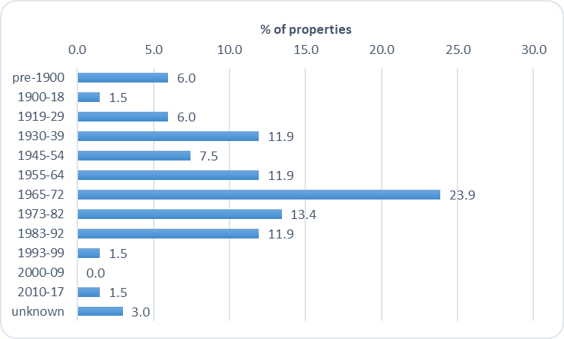
Council Tax: Table CTSOP 4.1, Stock of Properties, England and Wales, 2017 VOA

Residential Sales
Land Registry price paid data shows around 492 residential property sales were recorded in the Blackfordby local area between 1995 and 2017. At 60% detached housing accounted for the majority of sales, 32% were semi-detached and 8% terraced. It should be noted that all sales are not captured by the Land Registry, for example properties that were not full market value, right to buy and compulsory purchase orders will be excluded.

Figure 8
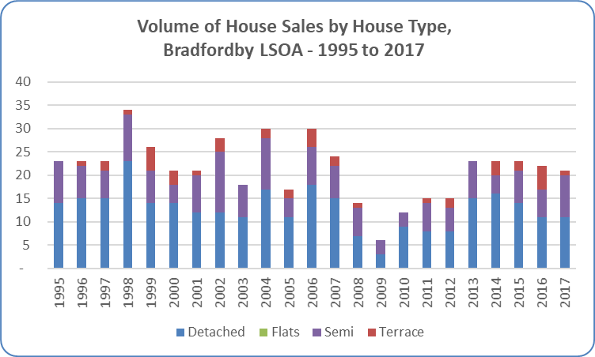
Data produced by Land Registry © Crown copyright 2017 (data available at 19.1.18)

As outlined above, there is evidence of a small supply of new build housing in the local area with 10 new build residential sales recorded between 1995 and 2016, representing just 2% of total sales recorded by the Land Registry in the area. Figure 9 below shows the volume of sales together with the overall annual average house price.

Figure 9:
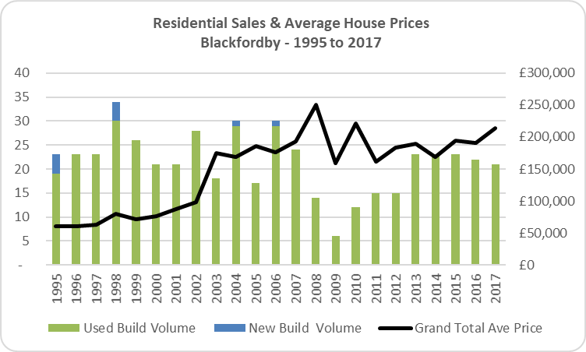
Data produced by Land Registry © Crown copyright 2017 (data available at 21.11.17)

During this period, the majority (90%) of new build residential sales were detached (Figure 10). It should be noted that not all new builds will be captured in the Land Registry price paid data, eg some conversions and social housing units will be excluded.
Figure 10:
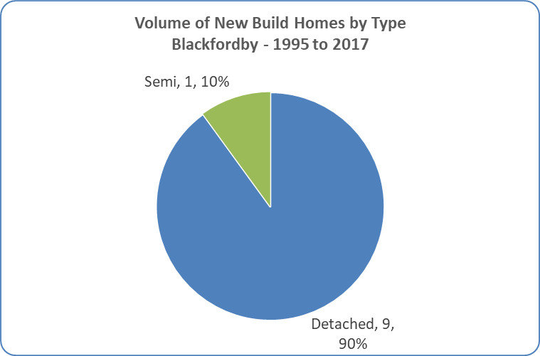
Data produced by Land Registry © Crown copyright 2017 (data available at 21.11.17)

Housing Affordability

The publication of ONS House Price Statistics for Small Areas presents an opportunity for housing affordability analysis.

The data reveals the cost of an entry-level property on average across England and Wales has increased by almost 20% in the last decade, to £140,000 (year ending June 2016). For new properties, the price was nearly £180,000. The data also shows that home-ownership prospects vary across the country.

In the Blackfordby local area area a low to mid-priced property costs on average £135,950 which is lower than the national average. Assuming a 15% deposit, those entering the property market in the area would require a household income of £25,679 (£26,444 E&W average) and savings of £22,612.

Prospective buyers would require an estimated £2,000 for legal and moving costs and £20,392 for a 15% deposit, £219 for stamp duty coming to £22,612 in total which is a challenge for many entry level households.
Summary of Future Housing Need
At the time of the 2011 Census, Blackfordby was home to around 1,450 residents living in 650 households. Analysis of the Census suggests that between 2001 and 2011 the local area population decreased by around 4% (57 people). During this period, the number of dwellings rose by 1% (7).

There is evidence of a higher than average representation of older residents living in the local area with 28% of residents aged 65 which is significantly higher than the borough, region and national averages. There is also evidence that the population is ageing with the share of residents aged 65 and over increasing from 18% of the total population in 2001 to 28% in 2011. The Census shows that the number of residents aged 65+ rose by 50% during this period. In line with national trends the local population is likely to get older as average life expectancy continues to rise.
Home ownership levels are very high with around 81% of households owning their homes outright or with a mortgage or loan and at 4% the share of households living in private rented accommodation is very low when compared with borough, regional and national rates.
There is evidence of under occupancy suggesting a need for smaller homes of one to two bedrooms which would be suitable for residents needing to downsize, small families and those entering the housing market. Providing suitable accommodation for elderly residents will enable them to remain in the local community and release under-occupied larger properties onto the market which would be suitable for growing families.
There is a predominance of detached housing and an under representation of housing for single people with just 3% of dwellings having one bedroom.
Land Registry and council tax data indicates there has been very little new build housing market activity over recent years.
Deprivation is not a significant issue in the local area but the area’s relatively high ranking in the Barriers to Housing and Services domain of the 2015 Indices of Deprivation suggests that some residents may find it difficult to access owner-occupation or access the private rental market.

Subnational Population Projections for Local Authorities in England: 2014 based
The term ‘entry level’ or ‘low to mid-priced property’ refers to the lower quartile price paid for residential properties. If all properties sold in a year were ranked from highest to lowest, this would be the value half way between the bottom and the middle.
Property price data are for year ending June 2016 and are from House Price Statistics for Small Areas. Income data are for financial year ending 2014 and are from small area model-based income estimates.
The Blackfordby Local area area is based on MSOA best fit (E02005404) which also takes in some neighbouring villages (Norris Hill, Moira, Donisthorpe and Oakthorpe).
Data from the Council of Mortgage Lenders suggest that the average deposit paid by first-time buyers in the UK was around 18% in December 2016.

