Blackfordby Neighbourhood Plan – Appendix 8
Description of Community Facilities

St. Margaret’s Primary School
The primary school sits high on the hill forming a tight group of village assets that include the Parish church, the small public playing field and a redundant Scout hut. The school is a classic Victorian building, having had a hall, library and classroom extension added recently. It is a Church of England aided school. The built space and fabric in very good order and the pupil numbers are currently at 98% of the 110-pupil capacity. The catchment of Blackfordby & Boothorpe accounts for 32% of pupil numbers. Of the 68% non-County/Blackfordby pupils a high proportion come from Derbyshire and Woodville, over the County boundary. There are currently 6 full time and 6 part time staff.
The small walled playground is only suitable for playtime activities. Use of the public, insecure, sloping playing field adjacent to the school for sporting activities in the summer. There is a lack of vehicle parking for staff and/or visitors anywhere near the school and very restricted vehicle access to the school itself. To overcome the issues with restricted access and parking on this busy narrow lane outside the school, the staff use a walking bus to transfer pupils from the most convenient drop off point (400 meters from the access lane).
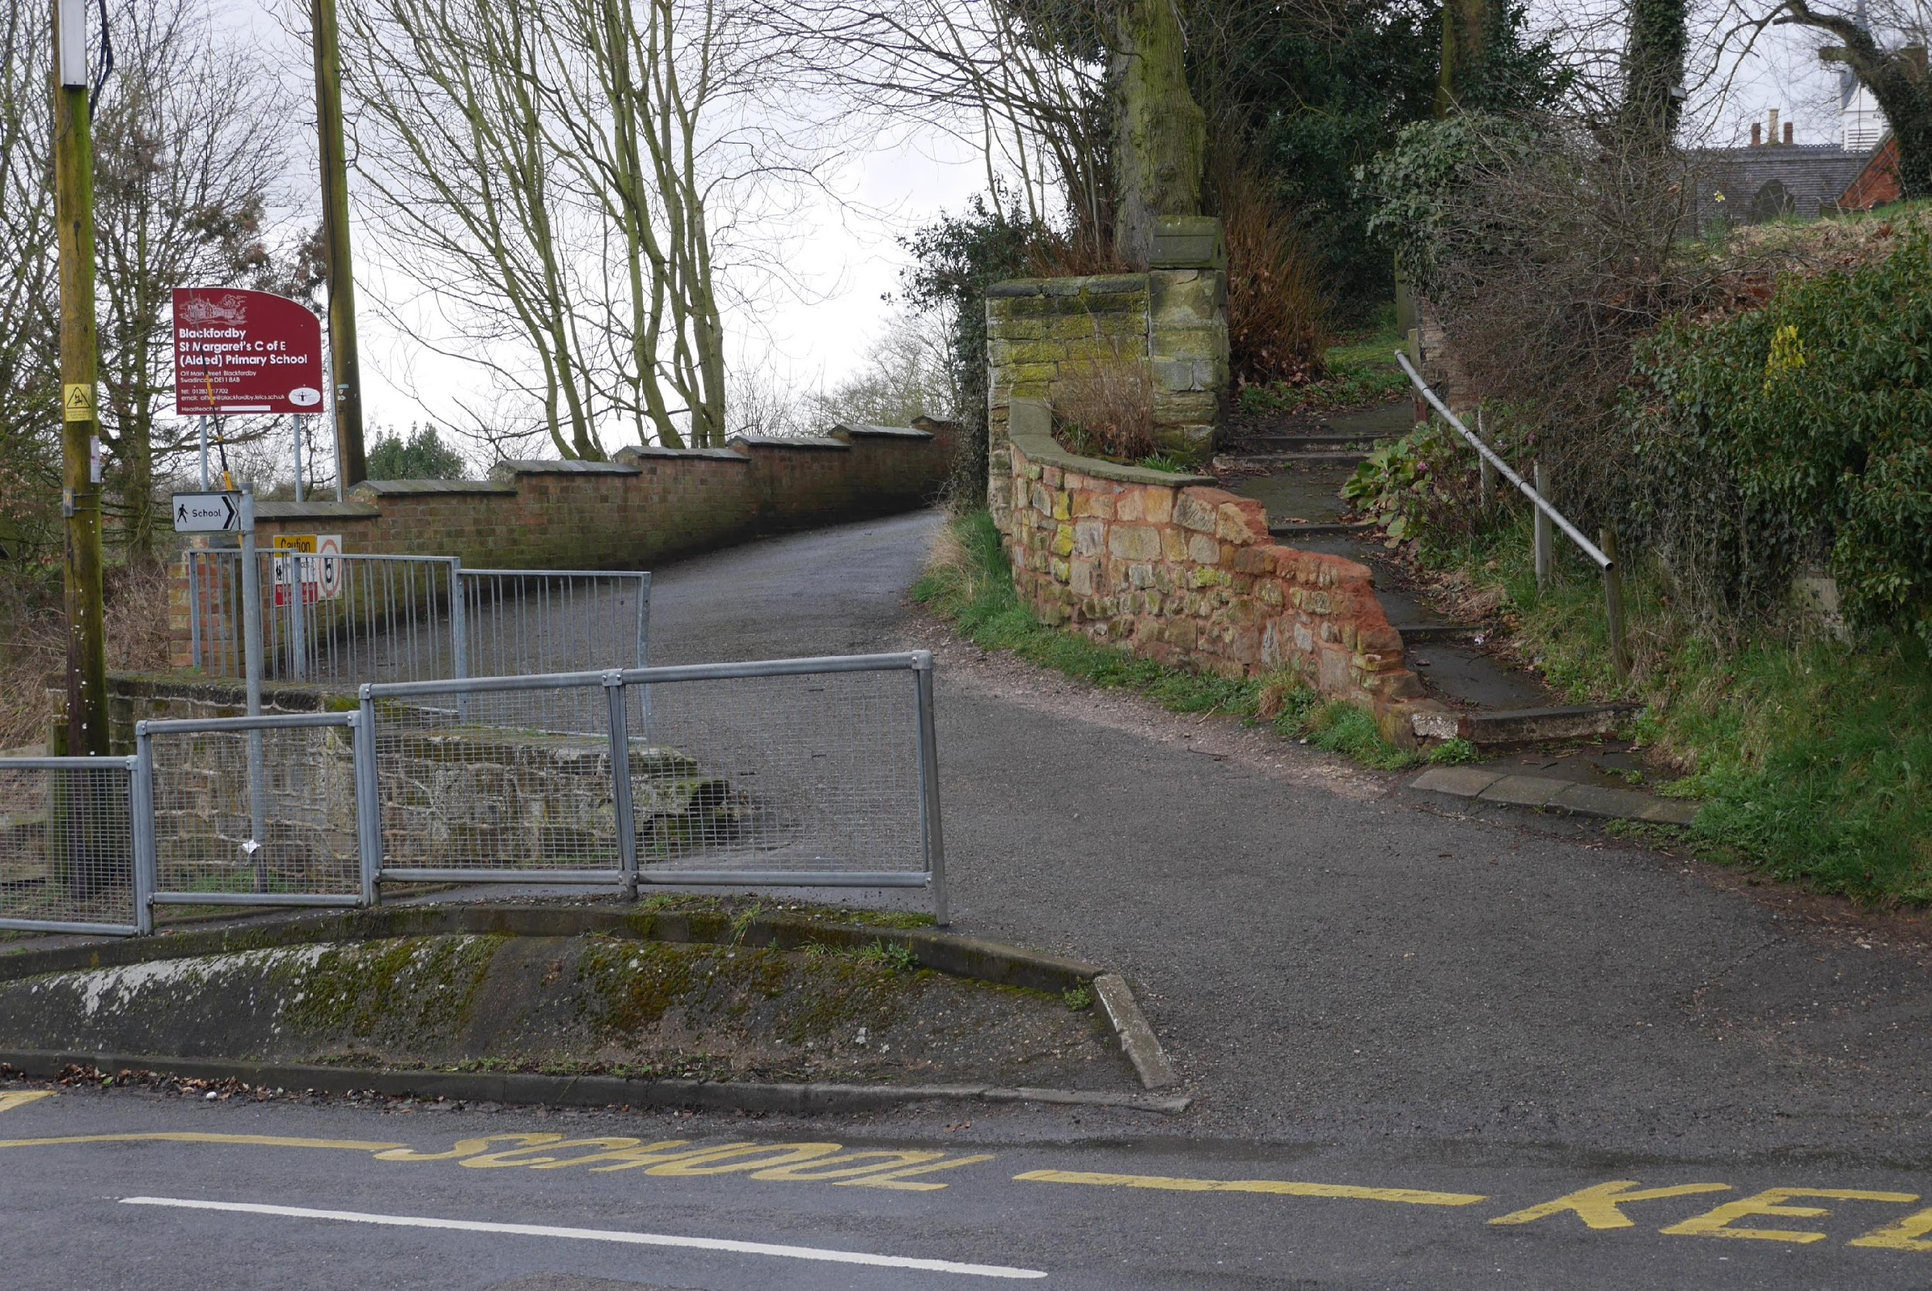 |  | 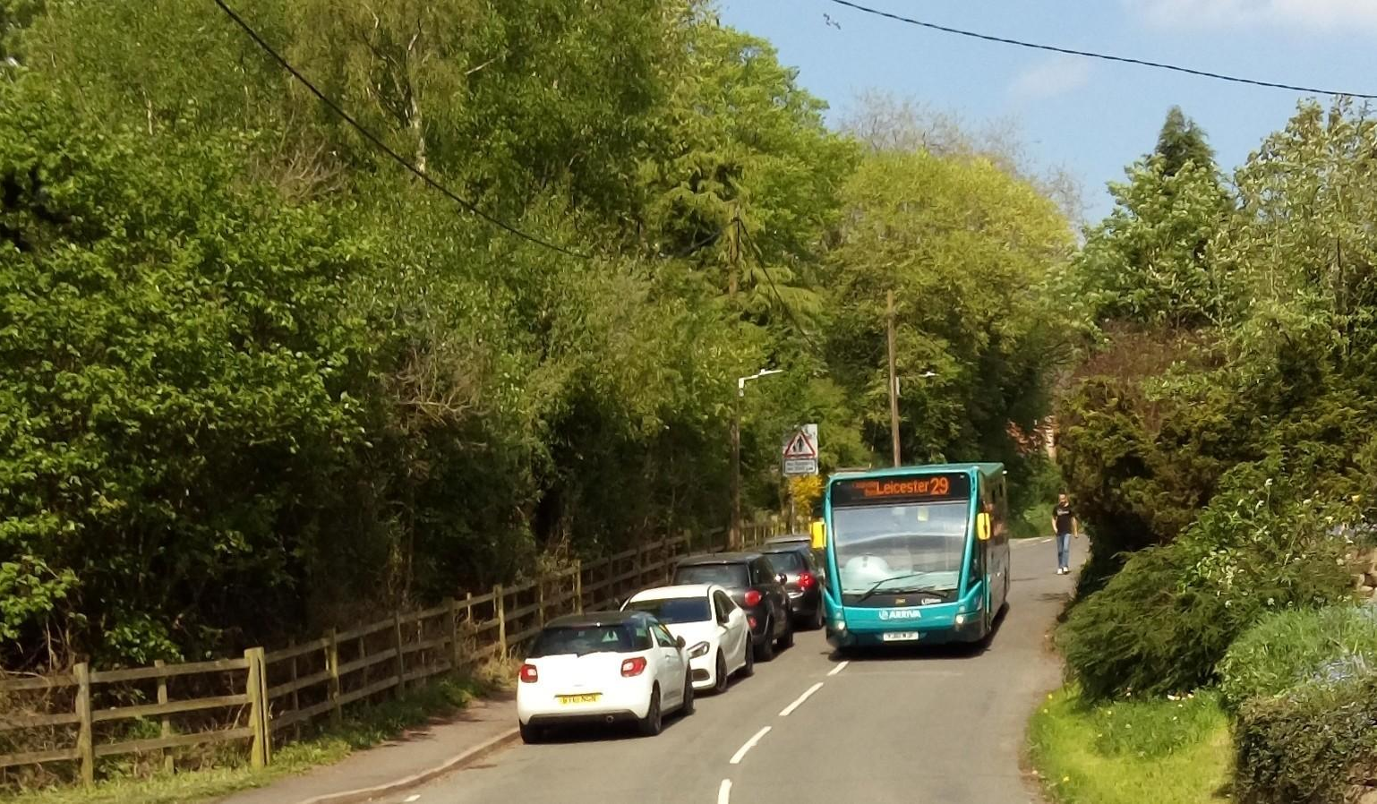
Access road to school off Main Street | Location of school, church, playing field and scout hut | Main Street looking up to the school entrance. Only close car parking plus walking bus route

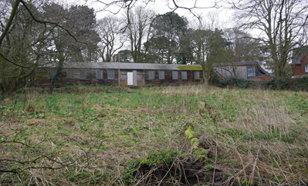
There is suitable land abutting the north west of the school with potential for developing into a secure and purpose made activity space. This is understood to be owned by the Church and managed by the Parochial Church Council (PCC). At the time of writing this document the school has requested the PCC to grant permission to use this land; the decision is awaited. This land includes an old wooden Scout hut which is currently unusable. The playing field and/or the Scout hut grounds are essential for the school’s activities.

Parish Church of St Margaret of Antioch
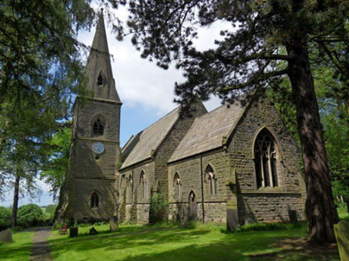
The Ecclesiastical Parish includes Blackfordby, Boundary, Norris Hill, Boothorpe and Albert Village in Leicestershire plus Woodville in Derbyshire, crossing County and Government Parish boundaries.
Worship has taken place on this site for 1,000 years and the present building replaced an ancient Chapel of Ease. The present Church was built in 1858, it is Grade 2 listed, with a capacity of 132. This is an active Church, two services are performed each Sunday plus a weekly Sunday School, although the average age of the congregation is 75. Currently Church Wardens perform unpaid full-time function supported by three locally retired Vicars. As at July 2018 it is understood that a new Vicar has been appointed whose arrival is imminent.
The Church has only one bell, which is not workable. The mechanically wound Church clock is Blackfordby’s War Memorial with a further two years funding left at present.
Although the Chancel roof has been restored within the last 10 years, the other half of the roof and the spire are of concern mainly due to plants growing between the stones. There are only 8 burial plots remaining but sufficient room for ashes in the area of the old cottages’ footings. There is no real vehicular access to the Church and access is either via narrow, steep steps or a very steep and short drive up to the graveyard gates from a dangerous part of the main road through the village. Church properties include the village school’s grounds, the New Vicarage (in Vicarage Close) the unused and partly derelict Scout’s hut and grounds. Please refer to notes in the Primary School section for information on the Scout hut and land status.

Blackfordby Methodist Church
The chapel was built in 1929 on a field of around 2 acres given to them by the Joyce family. It is not a listed building but is in the conservation area. It is one of ten such Churches in a South Derbyshire circuit. They have small regular congregation of about 15 people. Coffee & Chat events are held monthly, they are quite popular and have raised substantial funds for the Chapel.
The building consists of a kitchen, toilets and a disabled toilet, also a schoolroom. There is no graveyard. There is very limited parking close to the church.
The chapel features a war memorial plaque and Roll of Honour dedicated to 28 WW1 fallen. It was the first plaque to be unveiled in the village on 20th October 1920. The Chapel also owns land to the rear of the Church that is leased out to a plant nursery and a seven-aside football pitch to Blackfordby School.

Village Hall
The hall was opened in 1971 after 11 years of fund raising by a village committee. It has been very much a part of village life for both the young & the elderly of the community and is still very heavily in use today. It is hired out for parties, both adult and children’s, and is used every week for activities. At weekends it is hired out weddings and private functions and a monthly dance is organised.
It also has the only car park in the village, the site of the village defibrillator and the junior school walking bus point.

Village Institute/ “The Old School Room”
This was the original school room for the village and was built in 1790. It is managed as a charitable trust and there has recently been a change of executors, along with re-branding and a change of name to the “Old School Room” to reflect the history of the building. The plan is to fund raise to update and potentially extend the building so that it can be used for all sectors of the community.
The Village Spring
Outside of the old school rooms is a paved area with a historic spring and a second war memorial

Village pubs
There are two public houses in the village, one a great success and extremely well run and patronised and one that has been closed for some time, with notice of being for sale.
- The Black Lion – Located at the heart of the village, and central to the community, It has a great reputation for beer, ciders & gins. There are regular events such as quiz nights, pizza nights, dominoes team, plus occasional live music and it is the place to share in key televised sporting events. Opening hours in the week are currently 4pm-11pm, although at weekends the doors are open from 12pm and close later. Whilst sandwiches and cheese/meat platters are available, it is not a food pub.
- The Bluebell – Until recently this was owned by Punch Taverns but was recently listed for sale and has been sold.

Defibrillator
There is a defibrillator located on the left-hand side wall of the Village Hall, fixed there early 2018. One public training session was carried out in May 2018, with a possible further course for later in the year.
Football field
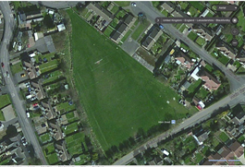
Ashby de la Zouch Town Council own a village football field, this is situated between Main Street, Butt Lane, South Close and Strawberry Lane. There are no changing facilities on this field. It is used by local clubs on Friday evenings, alternate Sunday mornings between September and March, with postponed matches being played through to May. It cannot be used in July and August when the grass is reseeded.

