Appendix 9 – Additional Transport Analysis

Roads and Pavements
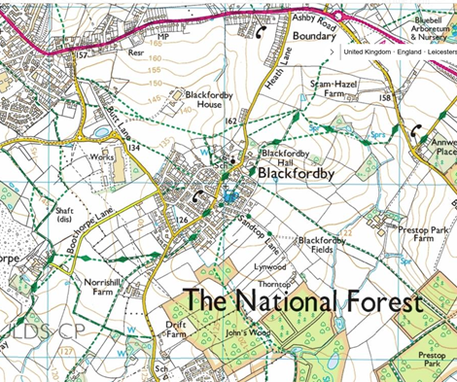
  - The A511 to the north of the village provides East and West directions of travel. On the east side of the village, the A511 is accessed via Heath Lane which its self, an extension of Main Street. The other end of Main Street leads onto Drift Side, which heads South-westerly, and leads to Norris Hill, to a junction with Ashby de la Zouch to the east (a left turn and Moira to the west, (the right turn). Butt Lane leads from the junction of Main Street and Drift Side, in a north-westerly direction. Butt lane is now truncated by a traffic island after leaving the main part of the village. The upper section is now a cul de sac. At the traffic island a left turn onto Forrest Way and a short distance along here is met another Traffic island on Hepworth Road. The Left turn takes you to the A511, now also the junction with High Street in Woodville and travelling nominally West. The Right turn at this junction (A511) now takes you Eastwards. One other Lane within the village is Boothorpe Lane which leaves Butt Lane in a South-easterly direction to the hamlet of Boothorpe. It is a single-track lane with no footpaths but does have reasonable grass verges for most of its length
Police Speed Survey
In 2015 Leicestershire and Rutland Constabulary carried out covert speed monitoring on Heath Lane, Drift Side, Main Street and Butt Lane. This Police survey highlighted serious and dangerous persistent excessive speeds in particularly on the following 30 mph limited roads. A more detailed extract from these survey results is included in the Appendices. The main concerns are noted here:
- Drift Side – 57% above the speed limit, with 6% well over 40 mph
- Butt Lane – 81% above the speed limit, with 17% well over 40 mph
- Heath Lane – an astounding 94% above the limit, some over twice this limit at 60+ and an overall mean speed of almost 40 mph (not just a few in this range)
No such recent survey is known of for the main A511 Ashby Road, but there is a Speed Safety Camera located on the Leicestershire side between Heath Lane and Field Lane. This camera is not currently operational, it is not currently known when it last worked, what results it produced and if/when it will be re-instated.

A511
The main 40/30 mph route through from the east to Swadlincote and Burton upon Trent areas. It forms the north side of Blackfordby and is part of the County Boundary between Leicestershire and Derbyshire, the north side being Derbyshire and south Leicestershire. It is a very busy and heavily used road, especially at peak work and school times. This road carries a lot of heavy goods traffic. Leading from this are four roads in Blackfordby: Ashby Road, Heath Lane, Field Lane (unadopted), and indirectly Butt Lane via Hepworth Road and Forrest Way.

Ashby Road
This was the original A50 but the section within Blackfordby between the A511 and Annswell has now been superseded as the main route by the by-pass. It has a narrow footpath on the north side only. It is one of the main traffic routes out of west Ashby de la Zouch towards Swadlincote and Burton upon Trent. There is a noticeably blind entrance on to the A551 by-pass island from both A511 and Ashby Road traffic, as is evident by the frequent car trim parts scattered there. It has a 40-mph speed limit, though thought to be often exceeded.

Heath Lane
This road is very narrow and dangerous. Although this road is a 30mph zone from its junction with the A511 at Boundary, a large amount of traffic totally ignores this speed restriction. Speeds of 70mph and above have been recorded. Heath Lane has a very narrow pavement on one side that terminates before the narrow, high banked S bend section. There are two areas of housing along the west side of road, most are grouped at the A511 end with a few abutting Main Street at the other end. Large vehicles such as school buses and lorries have difficulty passing each other and regularly need to mount the small pavement to pass. This road is also used regularly during rush hours as a short cut and rat run around the hold ups and speed camera on the A511.
The junction of Heath Lane to A511 Ashby Road is Give Way only, traffic regularly queues for 5 minutes to exit on to Ashby Road at peak times, often blocking traffic (especially buses) coming in to Heath Lane from Swadlincote direction.
Heath Lane and Main Street were part of the hourly Arriva route 29 bus route between Leicester and Burton upon Trent, this moved to Drift Side and Butt Lane on 19th November 2019.
Police survey results confirm that nearly all traffic exceeds the limit here, with speeds more than twice the 30mph limit on this road are common.
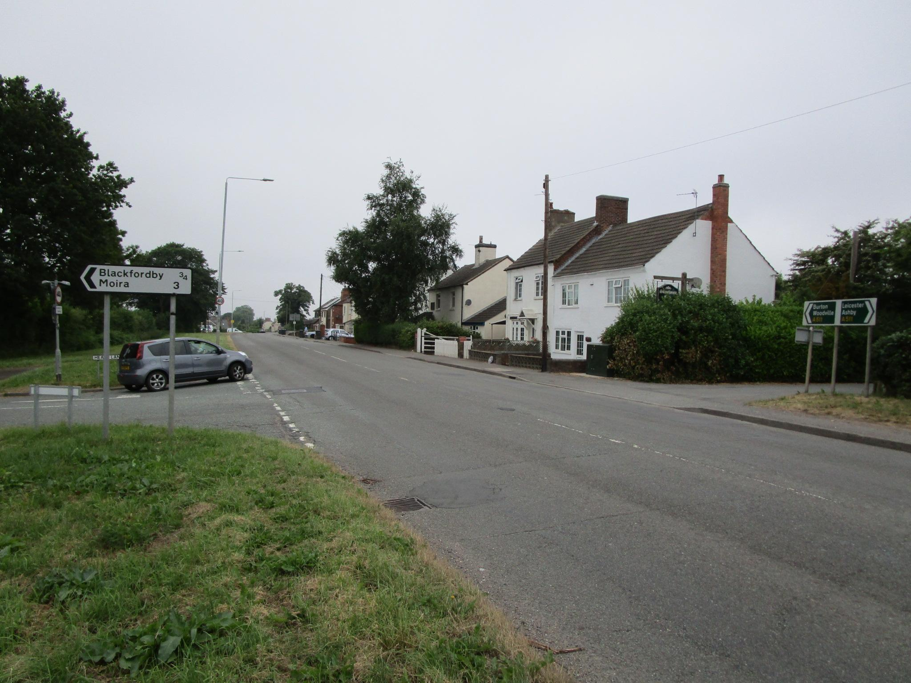 | 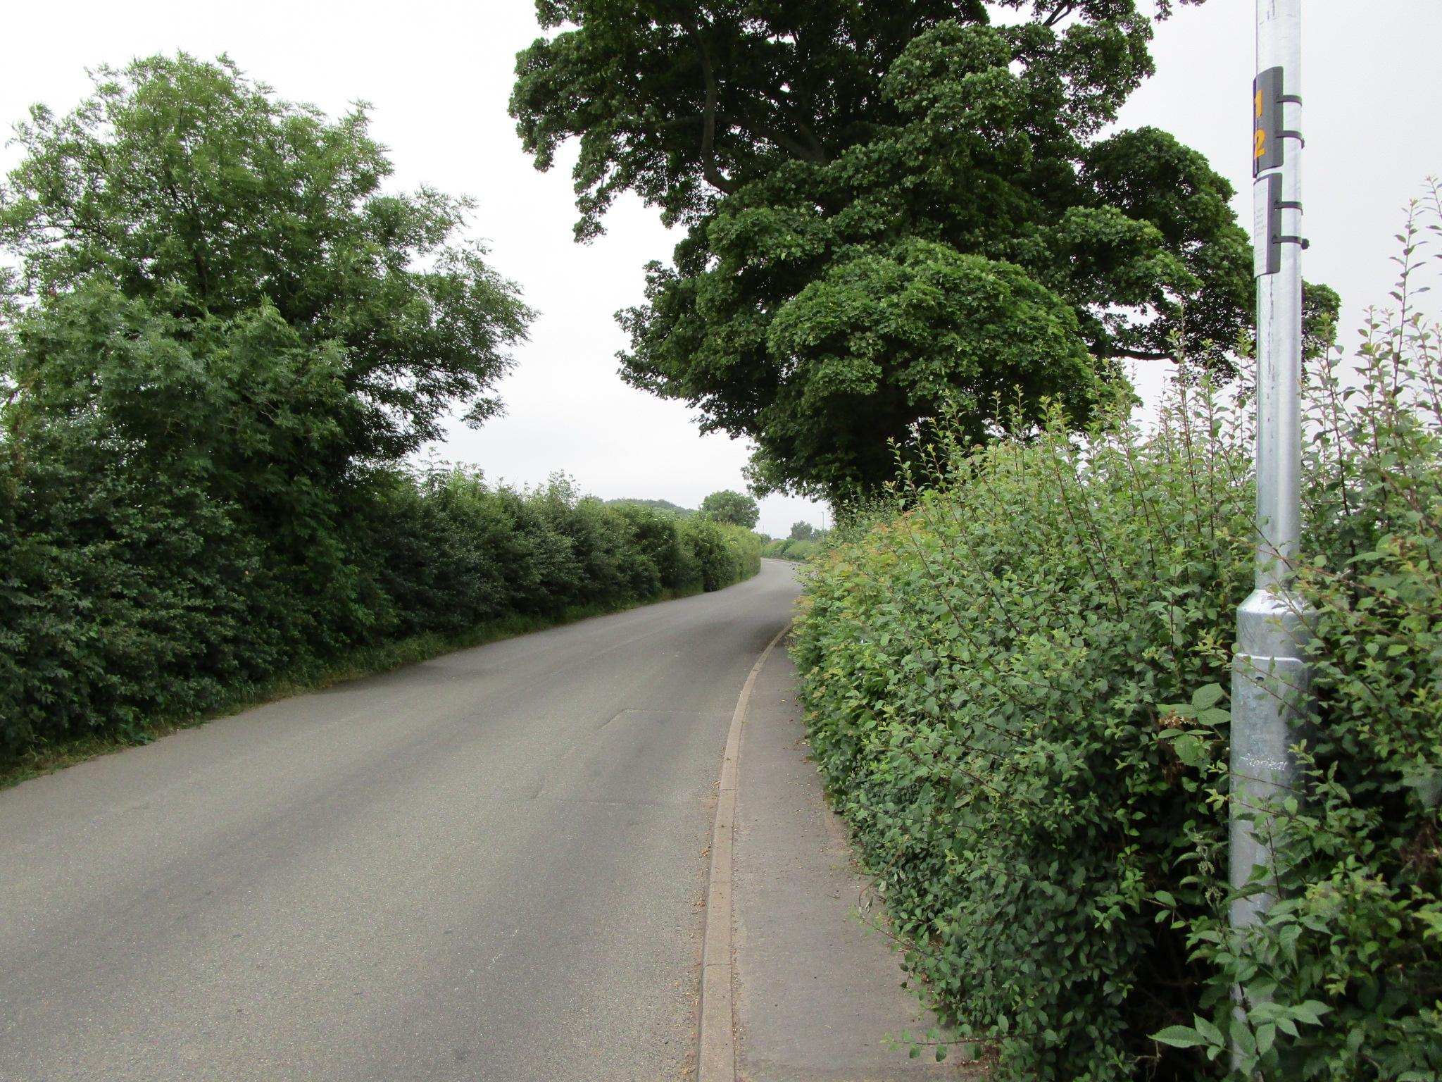
A511 Ashby Road (40mph) at junction with Heath Lane (30mph). Frequent minor accident area. | Long run of Heath Lane. Open country section between the two housing areas. 30 mph area.
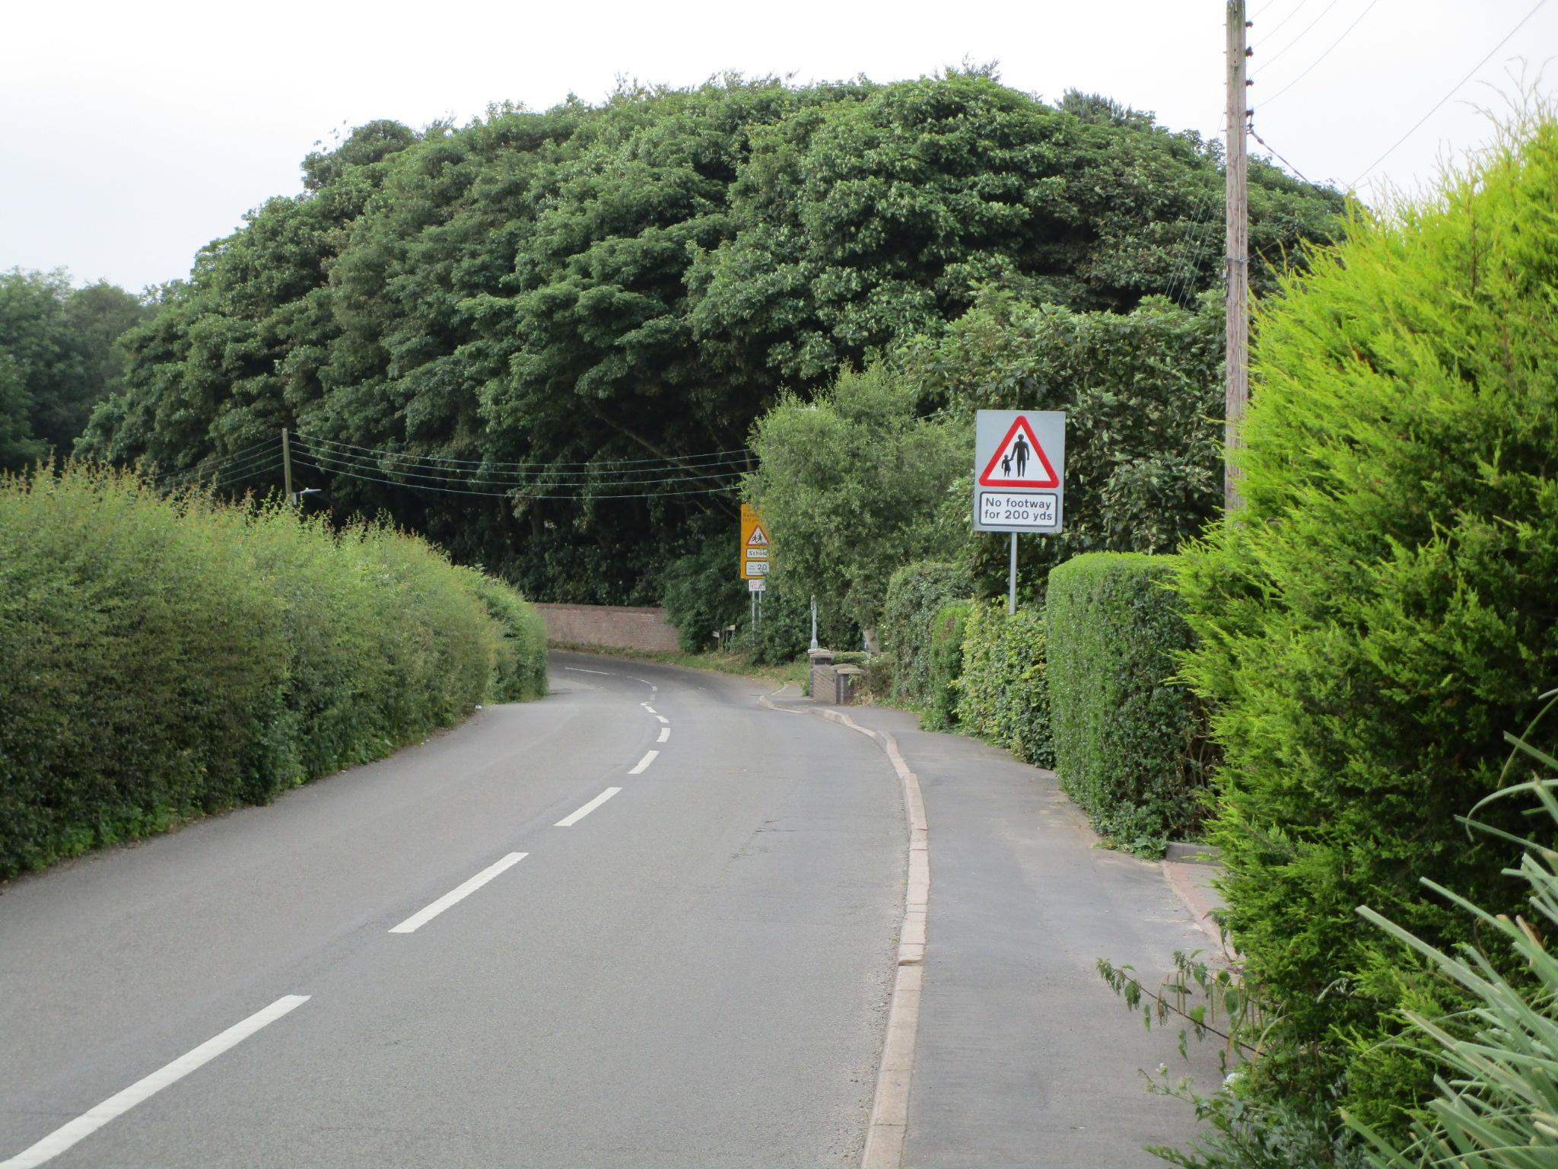 | 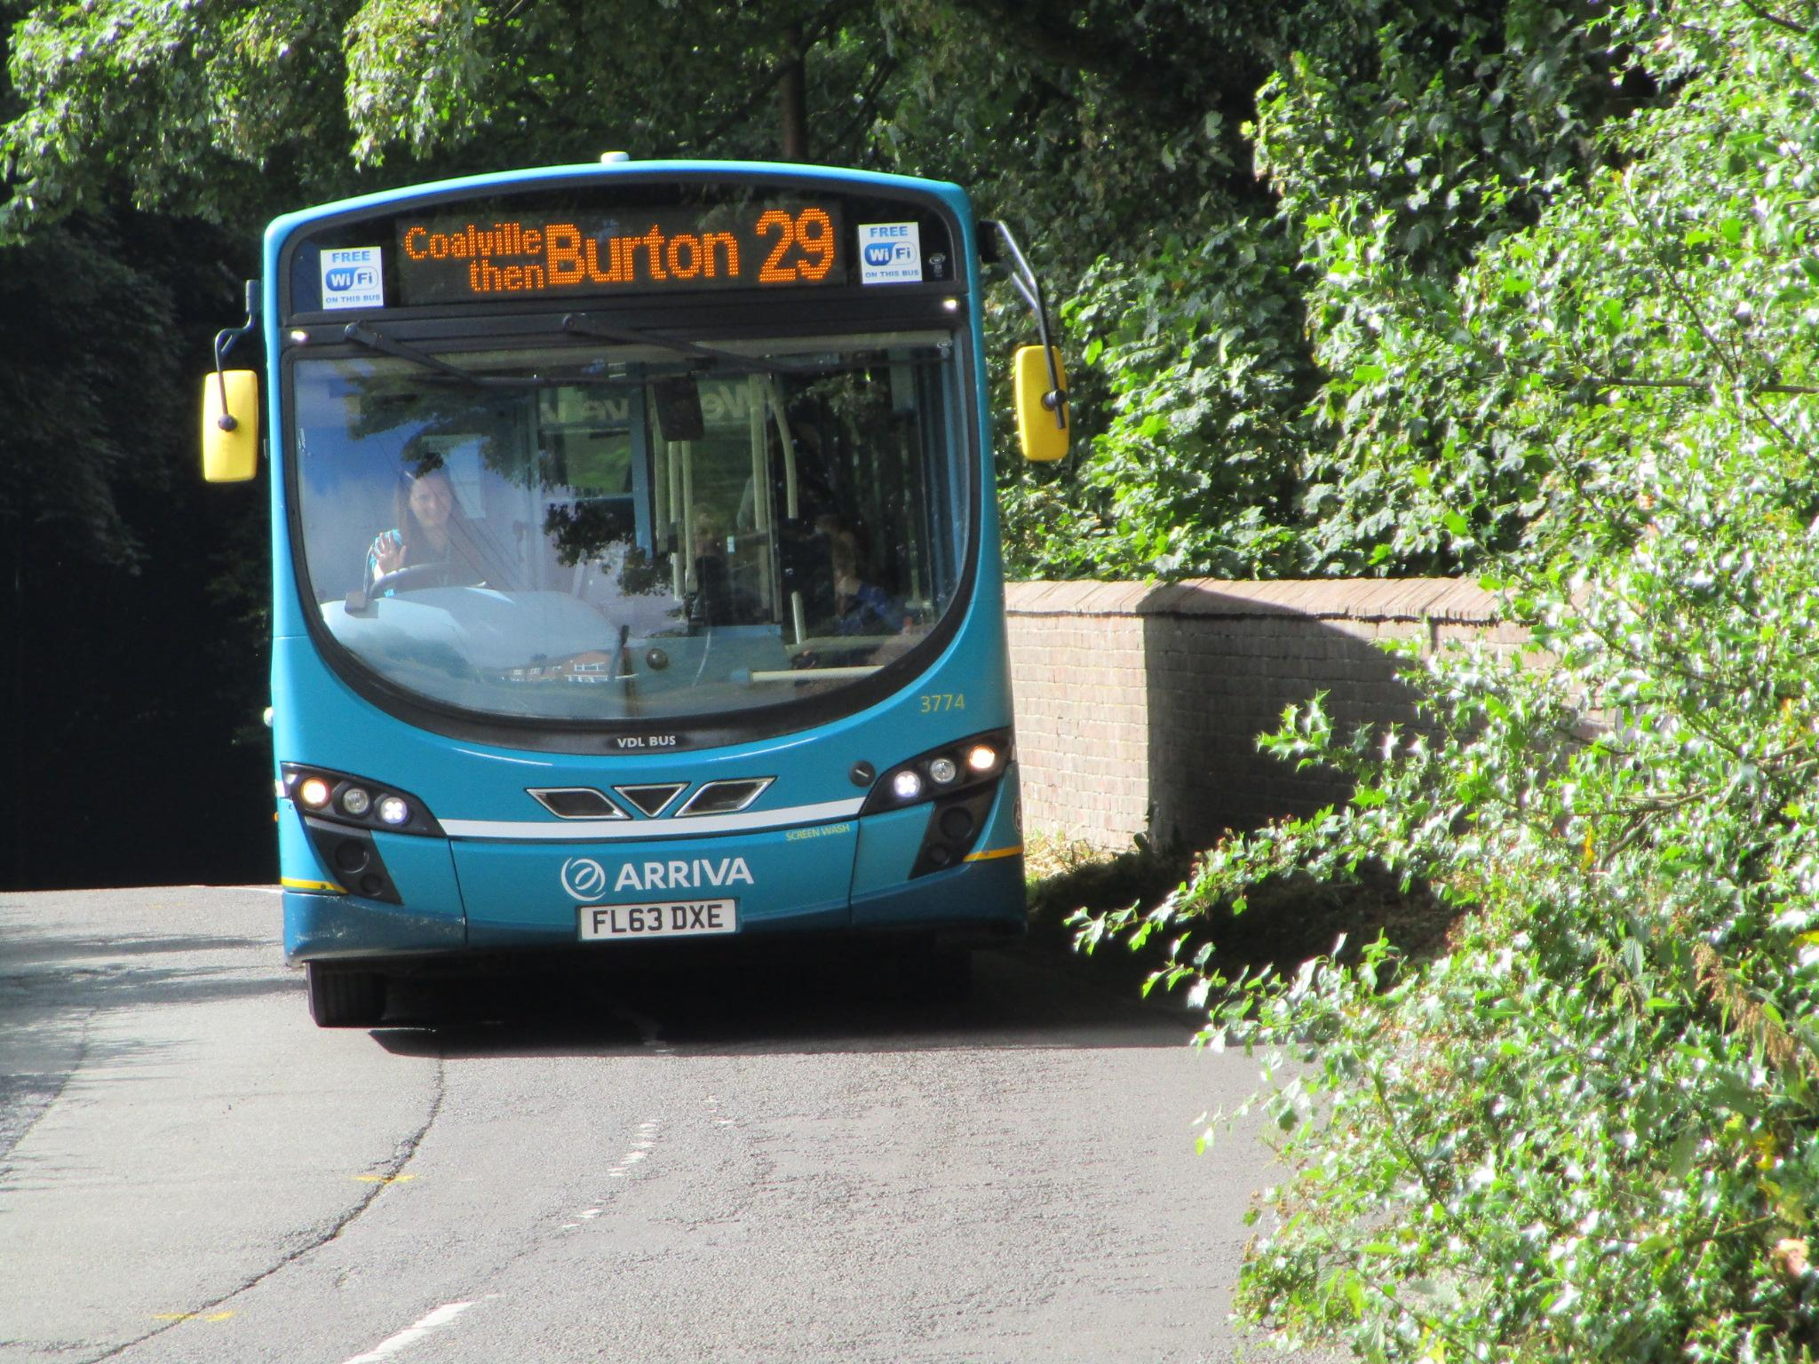
Heath Lane approaching Main Street. | Wide vehicles coming up from Main Street on to Heath Lane. (Deleted post Arriva 29 route change 19/11/19).

Main Street
This is the continuation of Heath Lane, leading downhill in to the village. Only for part of its length has pavements, but there is no pavement at all around the blind, very narrow and highly banked S-bend cutting. These narrow, banked and often blind S-bends continue from close to the meeting with Heath Lane down to the Church and graveyard entrance past The Black Lion to the narrow school entry lane.

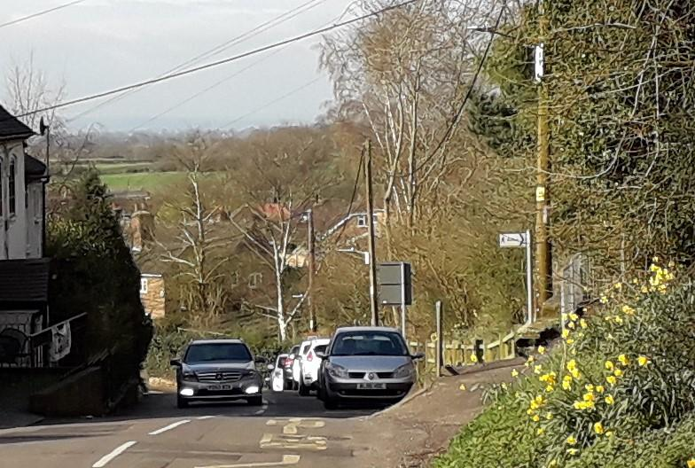 | 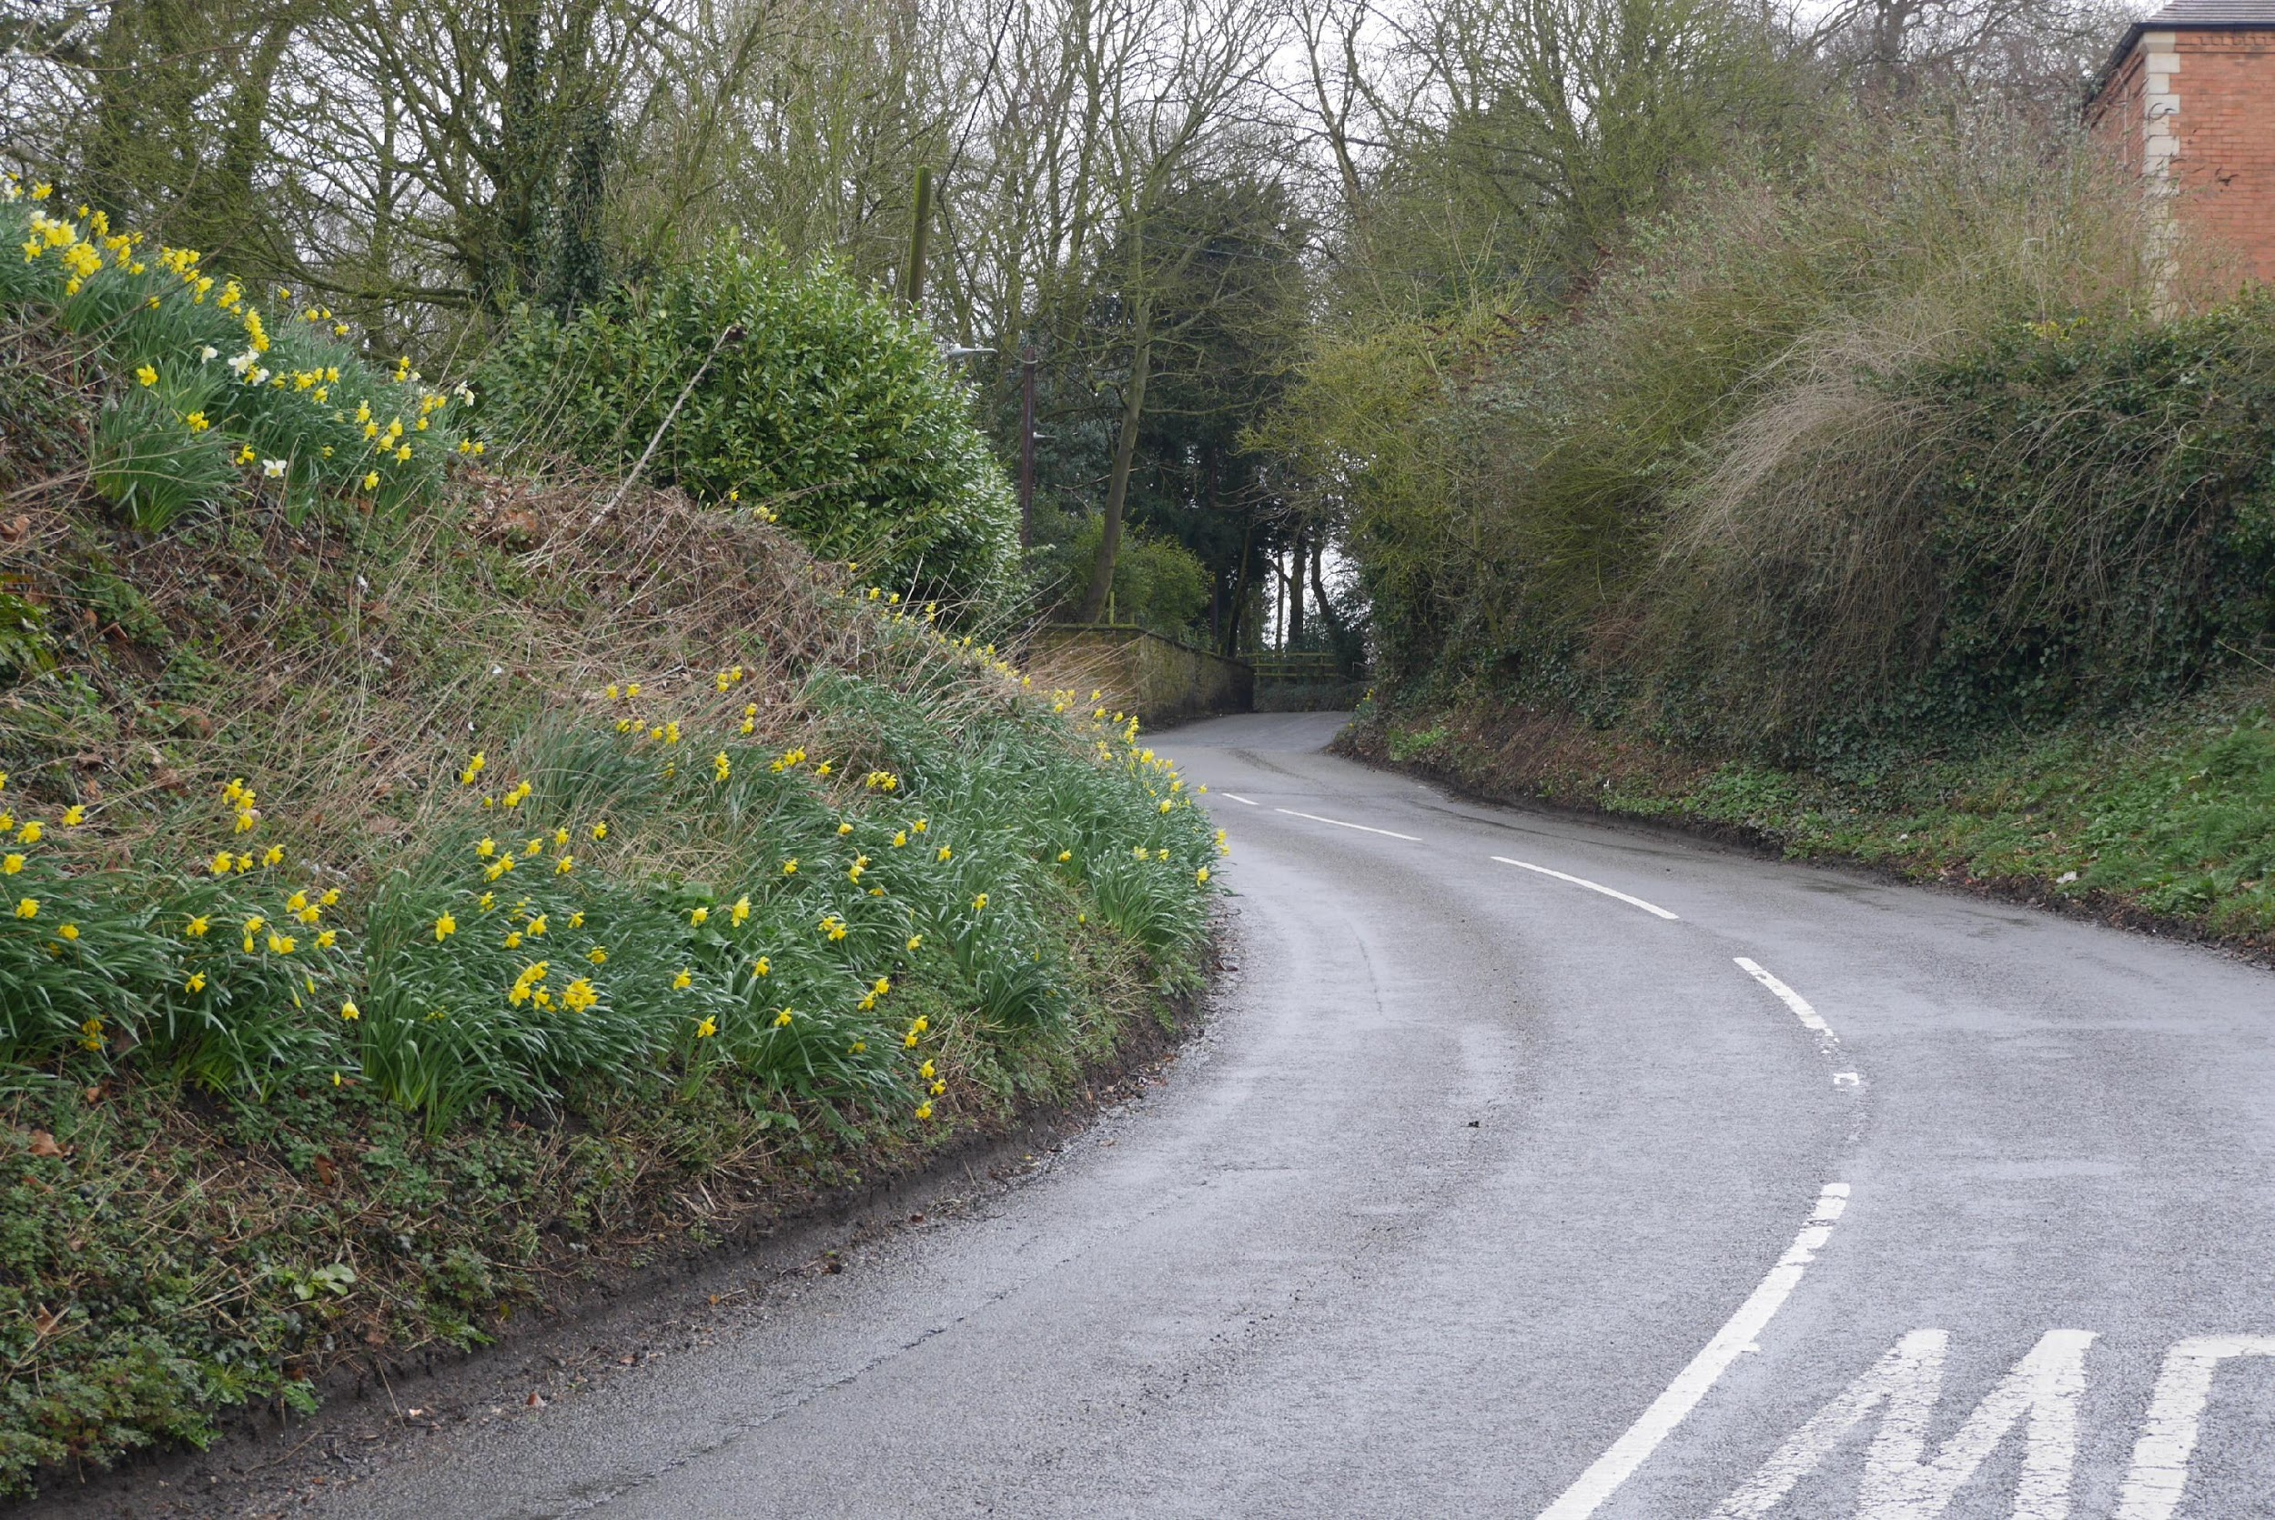
Coming up Main Street towards Black Lion School and Junior School entrance. | Further up Main Street passing hidden Church and grave yard entrance on left,
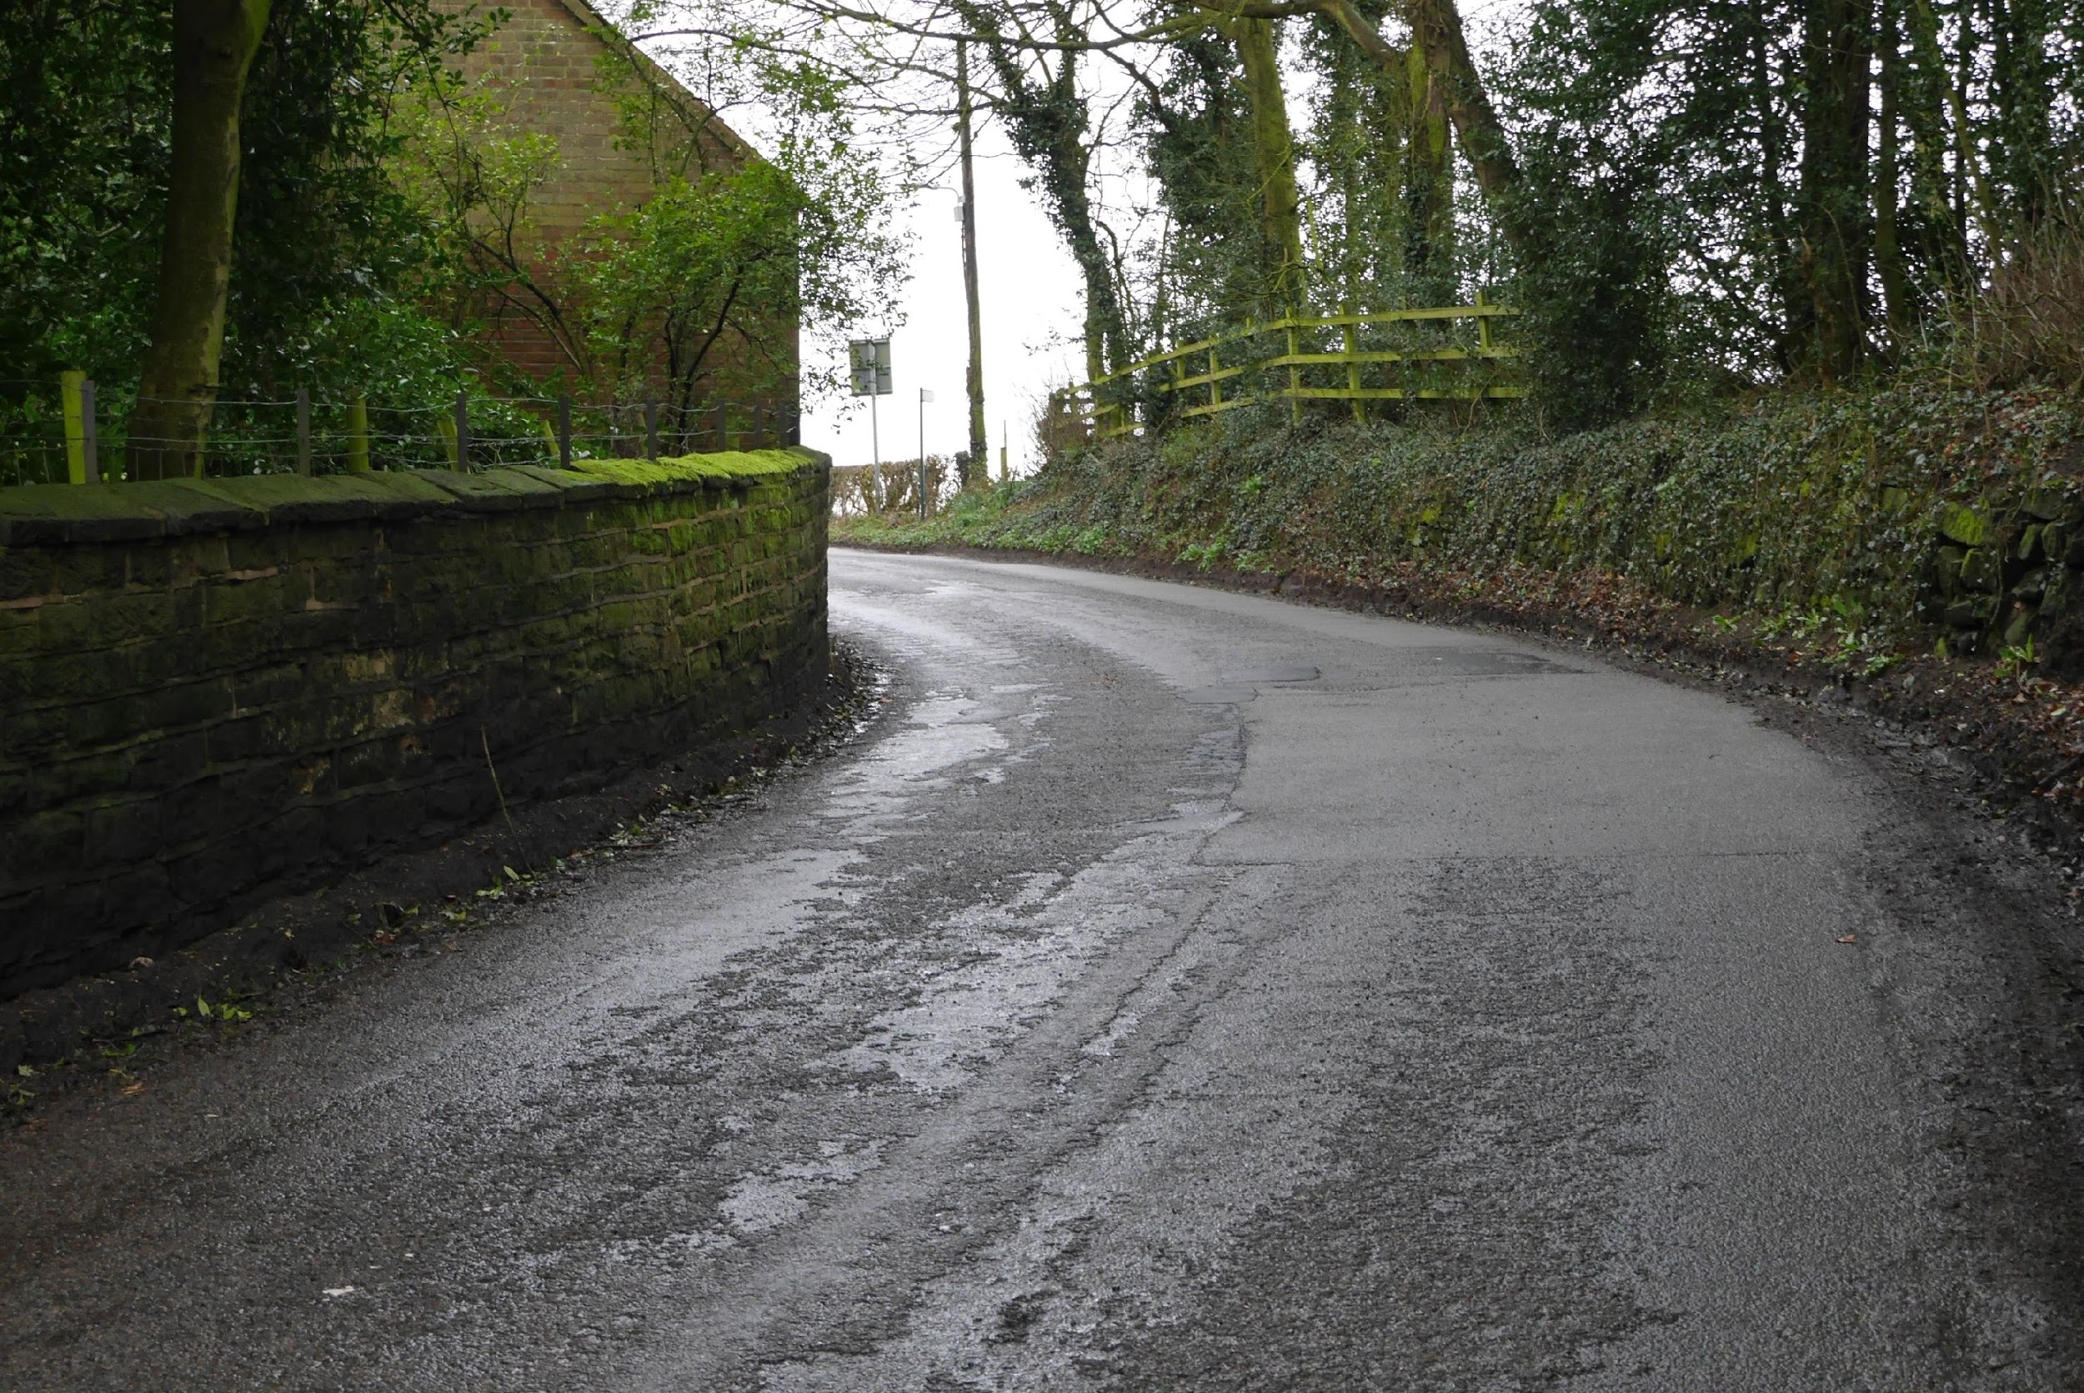 | 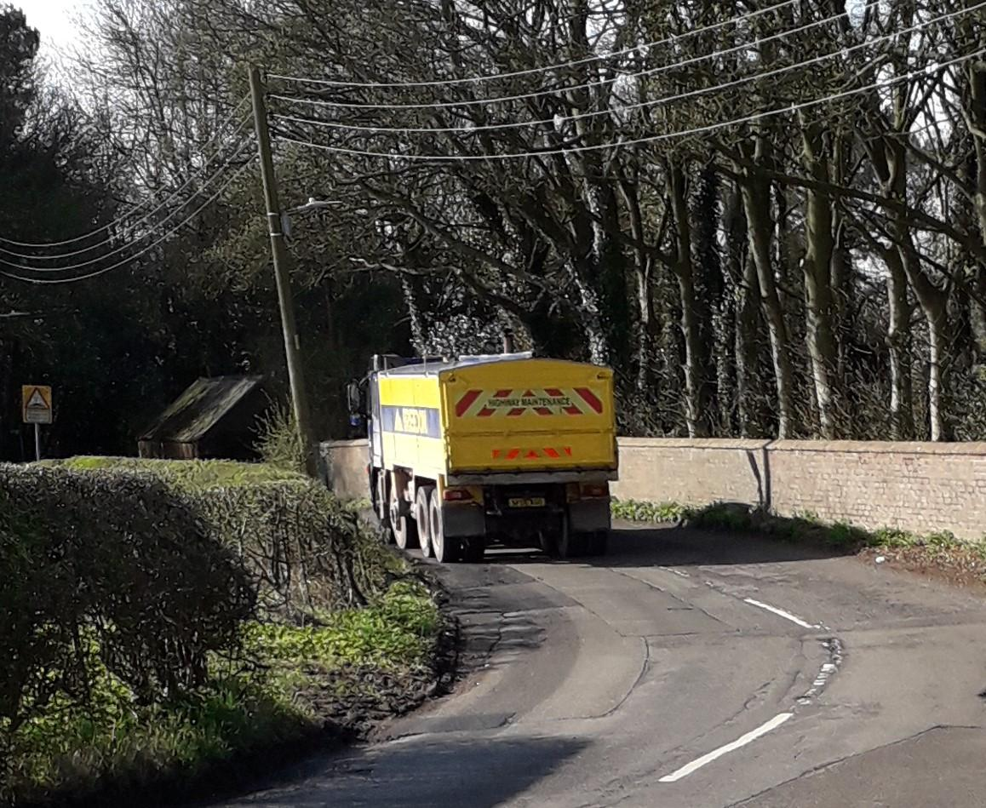
Towards top of Main Street, passing No.2 Old House. | What awaits drivers! Heading down Main Street from Heath Lane approaching Old House.

Larger vehicles, especially buses and lorries, cannot pass here, two often known to be stuck if they try to pass on the S-bend cutting.
Although there are 3 sets of speed bumps near the school and 20mph school speed signs, they do little to curb the traffic coming through the village. Several cars are also regularly parked outside of the school opposite to The Black Lion, especially during school hours. This results in reducing the road width at this point to a single lane, making passing very difficult especially for the buses that service the village. More off-road parking in the area of the school, if possible, would be useful in alleviating this bottleneck. There are other areas within Main Street where on road parking heavily restricts the road width. Again the 2015 traffic speed survey identified serious excesses over the 20/30 mph limits here.

Drift Side
This is the continuation of Main Street from its junction with Butt Lane and leads out of the village to Norris Hill. Though no speed bumps this is the start of the (illegal) acceleration and deceleration zone for the short stretch of de-restricted length joining the 30mph limits of Blackfordby and Norris Hill (the middle third of the overhead picture, and the main sections of the two adjoining road photographs below). It is unclear why this total road from to Norris Hill is not all 30mph.
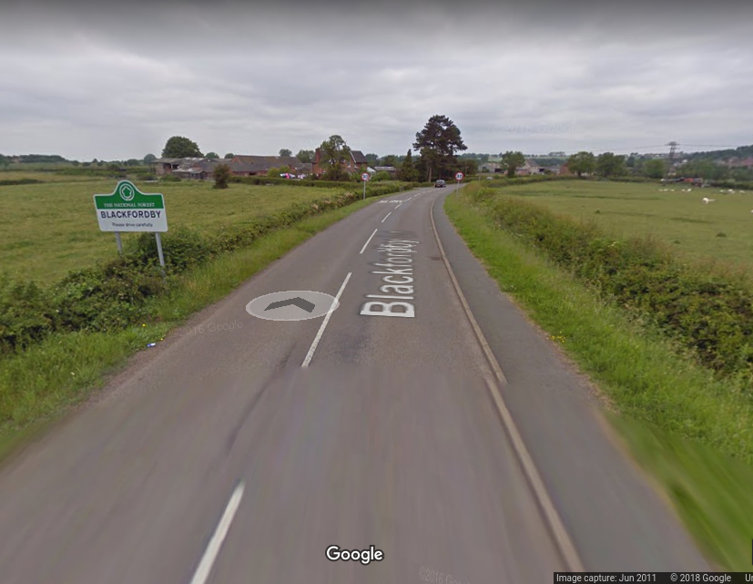
Drift Side between Blackfordby and Norris Hill. Open countryside with mix of 30mph and unrestricted.
It is noted that recently Moira Primary School, sited on this road just over the Parish border, has petitioned Leicestershire County Council to urgently analyse and audit the current risks here. Parents, residents and members of their community have backed the school’s appeal for a review into safety measures outside the school because of parents parking outside and a change in speed limits on the road approaching the school.

Butt Lane
The junction from the main A511 to Butt Lane is a fully traffic light-controlled system. The issues in Butt Lane are like those in Heath Lane although this road carries heavy goods traffic from Swadlincote south and Albert Village industrial and distribution companies, Wavin factory on Butt Lane and the building sites between Blackfordby and Woodville south. This road is also used as a short cut and rat-run from Ashby de la Zouch and the A/M42 to Swadlincote and Burton upon Trent avoiding traffic hold-ups and speed cameras on the A511. Traffic has been shown to speed well in excess of the 30/40mph limits on Butt Lane, with the average speed here in excess of 34 MPH and 1.4% exceeding 50 MPH. On-road parking in Butt Lane adds to the difficulties in this part of the village by reducing road width and making passing difficult.
As of 19th November 2018, the hourly Arriva route 29 bus route between Leicester and Burton upon Trent now goes through the village via Drift Side and Butt Lane, returning to the main road at the A511 traffic lights. Bus shelters and permanent bus stop positioning and signage still have to be finalised by LCC and NWLDC. The impact of this route change has yet to be assessed.

Boothorpe
Boothorpe is a small hamlet half a mile from Blackfordby. The only vehicular access is through Blackfordby via Boothorpe Lane, a single width track road off Butt Lane. It is a dead-end road. This lane is used regularly by dog-walkers from Blackfordby, cyclists and ramblers, it is an access point to many footpaths across the National Forest. Part of the road within Boothorpe is also a bridle path.
Boothorpe falls within the Blackfordby ecclesiastical parish, although part of Ashby Woulds, the community associates significantly with Blackfordby. From a community and logistics perspective, however, Boothorpe’s links are with Blackfordby, playing an active part in the NP, going to the local schools, the pub and other aspects of Blackfordby life.

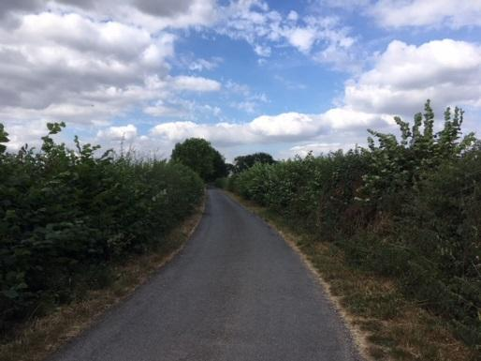 | 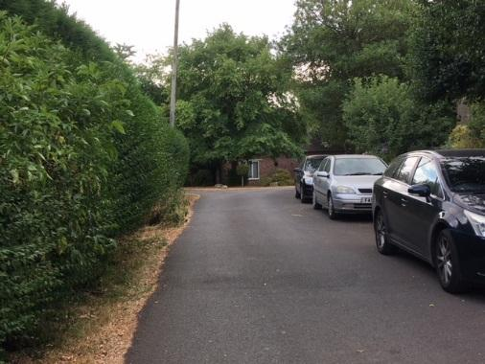
Lane from Blackfordby – only vehicular access to Boothorpe. 30 mph road. | No off-road car parks in Boothorpem even though a main cycling and walking hub.

General Traffic Management
Street lighting is considered adequate for most of the road network, though the very poor lighting on the s-bends down Main Street is a serious hazard for pedestrians.
Parking for tourists is minimal. The only public parking being at the Village Hall.
The main routes through Blackfordby are well used by cycle club group outings as well as local commuting and pleasure users, though there are few facilities to stop and rest here.

Results of 2019 speed survey

In January 2019 the police conducted a covert speed survey on Heath Lane, Blackfordy. Figures were in line with the previous 2015 survey.

Heath Lane – 94.8% were above the 30mph limit, with an overall mean speed of 38.2 mph.

