
B.E.E. part of our team…
Assistant Surveyor (Temporary for up to 18 months)

This booklet is designed to assist you in applying for the post. It is different to the more conventional recruitment processes because we feel that it’s important to welcome employees into the council who appreciate and are able to work within the council’s values and behaviours.

The following information will help you to understand our journey and encourage you to demonstrate how your skills, experience and achievements will be an asset to North West Leicestershire District Council.

If you need help with any aspect of this process please contact the Human Resources Team on 01530 454525

Our approach in developing effective relationships…

The council approaches new challenges, whether they are nationally or locally created, with enthusiasm and a belief that there is always a solution to any problem. These solutions can be found through effective and valued relationships, both internally and externally.

We are committed to listening carefully to the issues being raised by a broad range of people such as local communities, businesses, individual cases and council colleagues. In listening we support what is possible to be delivered and agree expectations which are fair to all. We deliver to the jointly agreed quality whilst using the council’s resources wisely.

Should we fall short of this in any way, we aim to learn and improve in those areas.

We believe in valuing our staff during the challenging events we need to deal with and with this in mind the Best Employee Experience programme has been developed. The objective is to bring together all our own best practice, plus learning from others in the public, health, educational and private sectors to provide a consistent approach to recruiting new staff who will own and deliver our commitment to creating valued and effective relationships.


Bev Smith
Chief Executive

Job description

Post title: Assistant Surveyor

Team: Housing Asset Management Team

Approved grade: D

Core responsibilities

To assist the Housing Assets and Repairs Teams plan and deliver improvement programs & cyclical maintenance of the Council’s housing stock.

- To assist with the undertaking and recording of surveys to the Council’s housing stock, offices and managed schemes. To update the relevant property databases, extract reports and help formulate programs of work.
- To assist in the efficient and effective delivery of the planned/cyclical maintenance and improvements programmes of works.
- To monitor (under supervision) on-site works undertaken by contractors and to advise and update project officers on progress, variations and deviations from agreed programs.
- To prepare and submit (under supervision) applications for Building Control and Planning approvals.

Additional responsibilities:

- To always see the service through the eyes of the customer and make suggestions for improvement where appropriate
- To constantly challenge self-performance and seek to find improvements
- To carry out duties efficiently and effectively
- To help build pride, passion and reputation for NWLDC
- To participate in the Council’s appraisal scheme and to undertake any necessary training and development as identified for the job role
- To promote the Council's Equality and Diversity Policy to ensure service provision and employment practices are non-discriminatory.
- To undertake any other reasonable tasks appropriate to the grading of the post and as required by the Team Manager
- To assist in the event of a civil emergency in any way as instructed

In all of our jobs, there are core duties and peripheral duties - the ones which the team undertakes and are the responsibility of all.

This diagram is designed to help you see what those duties are:

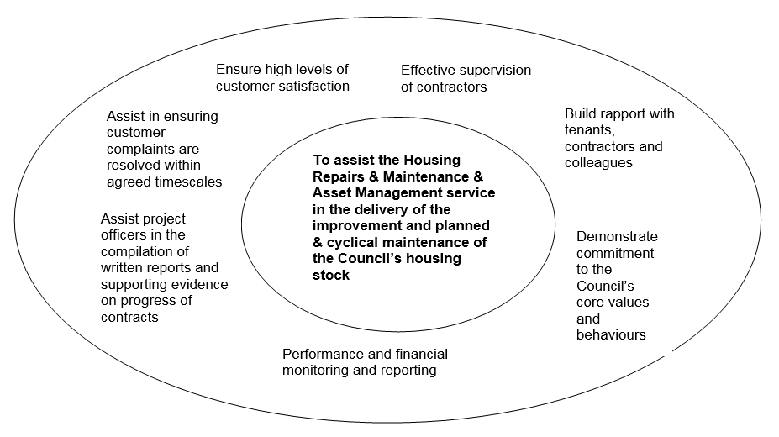

This job description describes the general duties of the job and does not preclude other duties which are necessary for the efficient service delivery of the council and team in serving its communities and meeting its objectives.

In consultation with you, it may be varied by the council to reflect actual, contemplated or proposed changes in or to your job.

Your team leader will commit to providing relevant, identified support and training in return for your commitment and dedication to the job role.
Employee specification

The employee specification is split into different sections to give you an indication of what we are looking for at all stages of the process.

Key questions or criteria are developed to set minimum criteria for this job.

In the role of Assistant Surveyor it is essential that you can answer yes to the following criteria:

- Are you are eligible to work in the UK?
- Do you have experience working within a dynamic, customer centric service with a high level of attention to detail and the ability to upload data accurately and via a wide variety of software systems?

Shortlisting questions

Please imagine yourself in the role of the Assistant Surveyor and show how your previous experience and achievements may contribute towards your success in the role.

To help you provide a quality summary of your experience and achievements to date, your answers must be limited to 300 words per criteria.

- Use our resources wisely - give examples of how your work has ensured value for money.

- Support what is possible - give examples of how you have identified, agreed and delivered outcomes using listening, negotiating and delivering skills.

- Be fair and proud - give examples of how you have shown pride in your work and taken individual responsibility for the work you do.

- Listen carefully - give examples of how you listen to the needs of customers and colleagues.

- Deliver agreed quality - give examples of how you set targets and monitor your work to ensure you deliver.
Interview criteria

If you are shortlisted and invited to interview, the panel will be looking for evidence that you meet the following criteria. Not only are we looking for evidence of work experience and knowledge but we are also looking at behaviours.

We will use a number of assessment techniques throughout the process, these may include:

- interview;
- group discussions;
- work-based exercises;
- psychological profiling;
- presentations; and
- references.

Behaviours
Methodical and accurate when carrying out work such as updating databases, extracting data and producing spreadsheets.

Able to use own initiative to prioritise own work tasks.

Able to work as part of a team and on own initiative.

Able to deal with difficult tenants and / or members of the public.

Must be prepared to work, occasionally, out of normal hours.

Technical
Good analytical and problem solving skills.

Able to follow and read instructions, plans and specifications.

Able to study for and achieve relevant industry qualifications.

Keyboard skills and a very good level of ICT literacy.

Test at interview
N/A

To help you see where this post fits into our organisation, we’ve added an organisation chart.
The Assistant Surveyor is part of the Housing Asset Management Team, which is within Housing & Customer Services.



Conditions of service

A full statement of the terms and conditions of employment will be given to you if you are the successful applicant. However, the following provides a summary of the main terms and conditions.

Temporary post

This post is temporary for a period of up to 18 months, or the return of the substantive post holder.

Salary scales

It is the council’s policy to appoint new starters at the bottom of the salary scale where employees have the opportunity to get an annual increment until they reach the top of the scale.

22 | £21,074
22 | £21,693
24 | £22,401
25 | £23,111
26 | £23,866

Salary is paid on the 25th day of each month, by bank transfer.

Hours of work

A 36 ¼ hours, 5 day week, is currently in operation. A flexible hour’s scheme is in operation.
The work may involve occasional evening and weekend working.

Holiday

Full-time annual leave entitlement is 24 days which increased to 28 days after five years continuous service in local government. In addition, there are nine bank holidays. For people who work part-time leave is calculated in hours, pro-rata to the contractual hours.

A scheme is in place whereby you can purchase limited additional annual leave on a salary sacrifice arrangement.

Notice

This post requires a notice period of four weeks.

Pension

You are automatically included in the Leicestershire Pension Fund. Pension rights are usually transferable if an officer moves from one public authority to another.

Probation

You will be subject to a probationary period of at least 6 months. Subject to satisfactory service the appointment will be confirmed for the remainder of the temporary post.

Smoking at work

The council has a Smoke Free Council Policy in place.

Use of vehicles

A casual car allowance is payable should the car be used for business use.

Immigration, Asylum and Nationality Act 2006

You must be eligible to work in the UK. Candidates will be required to provide original evidence of his/her eligibility to work in the UK. (Passport, national insurance number, or visa/work permit).

Medical assessment

Any offer of employment will be subject to a satisfactory medical assessment.

Where we are
North West Leicestershire District Council is both the council’s name and geographical location and is situated between Leicester, Burton upon Trent, Derby and Nottingham. The area of the district is 108 square kilometres.
Main roads through the district are the M42/A42 between Birmingham and Nottingham and the A50/A511 between Leicester and Burton upon Trent. The M1 motorway, which runs through the district, is accessible from junctions 22, 23, 23A and 24. The nearest railway stations are at Burton upon Trent, Loughborough and Leicester.
With a population of almost 93,500, North West Leicestershire is mainly a rural district, sitting at the heart of the National Forest, bringing in tourism from around the country. It is home to East Midlands Airport, which has replaced the mines as one of the region’s major employers. It is a key location for many large businesses, with the likes of Pall-Ex, United Biscuits and TNT having bases here, and large developments like Marks and Spencer distribution centre making North West Leicestershire their home.
Like many other shire districts, authority over North West Leicestershire is shared between the district council and the county council. Areas of responsibility of the district council include local planning, building control, council housing, refuse collection, recycling and some leisure services and parks.

The district council is currently controlled by 38 councillors representing 38 wards, who are elected every four years; the last election took place in May 2015 and saw the Conservatives hold on to control.

The council has an executive known as the Cabinet which is made up of 6 councillors who have special responsibilities and power. As the Conservatives have overall control of the council they hold all of the seats on the Cabinet.

Your application

References

Check that your referees are happy for us to contact them. If you do not wish a reference to be taken up at this stage, please mark this clearly on your form. It is our policy to approach referees before making an offer of employment. Please note that in entering the name(s) of referees in the section you will be deemed to have given your consent to us approaching these people for purposes of verification.

Do not use relatives as a referee, these will not be accepted.

Equalities

In accordance with current legislation and codes of practice we aim to ensure that no councillor, employee or prospective employee will be treated unfavourably on the grounds of marital status, gender, age, disability, sexual orientation, race, nationality, ethnic or national origins, trade union membership or activity, political or religious belief and unrelated criminal conviction.

Every possible step will be taken to ensure that individuals are treated equally and fairly and that decisions on recruitment, selection, training, promotion and redeployment are based solely on objective, non-discriminatory criteria.

The council will aim to employ a workforce that broadly reflects the community we serve. Appropriate steps will be taken to ensure that individuals from groups that are currently under-represented in the council’s workforce are encouraged to apply for posts within the authority.

The council will continue to develop and implement non-discriminatory practices to ensure that individuals are treated with dignity and respect. In attempting to ensure equality in all matters of employment a monitoring procedure has been established. In order to effectively monitor the policy, applicants are asked to complete the equal opportunities policy form at the end of the application form. The information contained on this form is strictly confidential and is treated separately from the application form.

Personal information

Your personal details at the end of the form are needed to enable us to contact you. Write your name, address and a contact telephone number clearly. You are also asked to complete other information, which will only be used for equal opportunities monitoring purposes. These details will not be included in the form when it is shortlisted.

Relationships to officers and councillors

You must declare if you are in any way related or the partner of a councillor or officer of the council. If you are related to such a person, you must state if you are their parent, grandparent, partner, child, stepchild, adopted child, grandchild, brother, sister, uncle, aunt, nephew or niece. This will not prevent you from being appointed. You must not seek the support of a councillor for any appointment in the council. If you seek the support of a councillor, you will be disqualified from that appointment.

Dates you are unable to attend

We will seek to accommodate a suitable date for candidates indicating their unavailability for interview, however we cannot guarantee being able to offer you an alternative date.

Disabilities

Disabled people will be offered an interview if they meet the essential requirements of the post.

An applicant with a disability should be able to carry out the duties and responsibilities of the post set out in the job description and meet the requirements of the post concerned ‘with reasonable adjustment’ within the meaning of the Equality Act 2010. This also requires the employer to make any ‘reasonable adjustments’ if an applicant is selected for interview.

The adjustments mean we have to provide practical assistance to disabled people for example, accessible venues, test materials in formats such as Braille and / or tape, rest periods during the interview process and a support worker for the interview. If you require any help in completing your application form, such as large print copies of information, or tape or Braille information, please contact the Human Resources Team.

Declaration

Your application should be signed and dated. Any information that may be false will disqualify you from appointment, or if appointed will render you liable to dismissal without notice.

What then?

After the closing date, your application will be considered and if your experience and achievements closely meet all the values of this council, within the context of the post you have applied for you will be invited to interview. The shortlisting officers will only use information from the application form and will not make assumptions.

Your application form is assessed to see how your skills, experience, knowledge and qualifications match the requirements for the job.

We do not shortlist applicants who do not appear to meet the essential requirements in the employee specification.

The interview

The interview panel will be made up of at least two members of staff. The panel will ask the same basic set of questions to each candidate and supplementary questions may be asked based on your answers. We will be looking for you to give examples of what you have done and give examples of experience you can demonstrate.

Not only will be we asking technical questions about your experience, skills and abilities but we will be looking at how you behave in work situations and what your preferred working style is. This is to assess your ‘fit’ within the organisation. If the ‘fit’ is right then you will be happier in the job and we’ll be happier with your performance.

Most of our interviews will be a two stage process so that quality time can be given to ensure we get to know you and that you get to know us. It is also your chance to ask questions about the job, terms and conditions of service, etc. You may notice members of the panel making notes. This will be done against an assessment sheet so that the reasons for their decision are consistent and justified. It will enable the panel to recall which candidate said what, which will determine the decision for the best candidate for the post.

Occasionally we will need you to undertake a personality profile and tests as part of the selection process. This enables us to assess your skills, experience and knowledge in a way that is more efficient than asking questions. The tests will always be job related and will be just one of the factors considered in the final outcome.

You will be notified in the invitation to interview if the selection process is to include personality profile or tests.

Often several people will be invited for interview and whilst we make every effort to remain on schedule, your interview may take place later than your appointment time. If this happens, we will not rush your interview.

After the interview the panel will notify you of when and how you will be informed of the outcome. The panel members will discuss their individual marks against the assessment sheet. If a test has been conducted the marks from this will also be incorporated at this stage. The panel will then determine who matches the employee specification most closely and select the successful applicant.

What can I expect if I’m successful?

If you’re successful at interview you will become part of an organisation that wants the best for its employees.

Our commitment to you is that you will ….

BEE part of our team– you’ve already become part of us through our recruitment processes

BEE welcomed – our welcome package for new employees includes a settling in period and probation

BEE valued – we will continually support and encourage you through regular appraisal and one to ones

BEE your best – we will support you and inspire you through our training and development processes

BEE in the know – our employee engagement package offers a range of schemes and programmes to ensure you feel informed and valued throughout your time with us

BEE prepared – when you leave our employment, we want you to have benefitted from your time with us and keep in touch.

