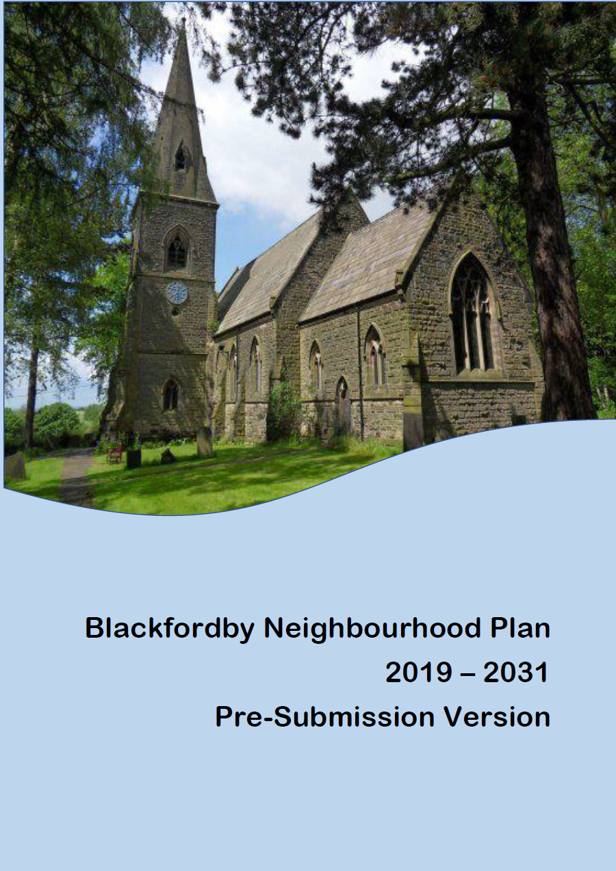
Examination Version

Kee

Contents

 |  | Page
 | Foreword | 4
1 | Background and Context | 5
 | Introduction | 5
 | How the Plan was prepared | 6
 | How the Plan fits into the Planning System | 7
 | The Neighbourhood Plan and what we want it to achieve | 8
 | How the Neighbourhood Plan supports sustainable development | 9
2 | Blackfordby | 11
 | A brief history of the settlement | 11
 | Blackfordby profile | 11
3 | A Vision for Blackfordby | 13
4 | Policies | 15
A: General
B: Housing and the built environment
C: Natural and historical environment

D. Community facilities and amenities
E. Employment
F. Transport
H. Developer contributions
5 Monitoring and Review | 58

Foreword
Within the Localism Act of 2011 there is provision for communities to shape their own future at a local level through the preparation of a Neighbourhood Plan. In September 2017, Ashby de la Zouch Town Council, following representations from residents of Blackfordby, made the decision to take up this opportunity and on 23rd January 2018 North West Leicestershire District Council Designated the Neighbourhood Area for the purposes of undertaking a Neighbourhood Plan.
As well as time spent gathering evidence through the examination of strategic documents, the Neighbourhood Plan Steering Group has carried out many hours of consultation with residents.
This work has resulted in a Plan which you are now invited to read and which sets out a vision for Blackfordby which will help to ensure that it continues to develop as a vibrant community whilst retaining its rural character for future generations.
This Plan has been produced by a Neighbourhood Plan Steering Group and members of three Focus Groups, including Town Councillors and community representatives. It is appropriate to record thanks to all of those who contributed many hours in the development of the Neighbourhood Plan, including consultants, Yourlocale, and Officers and Members of Ashby de la Zouch Town Council who provided support as the Neighbourhood Plan evolved.
Once the Plan has been ‘made’ following a favourable referendum, the Blackfordby Neighbourhood Plan will take its place alongside the North West Leicestershire Local Plan as the reference point for the determination of planning applications in the Neighbourhood Area. The Neighbourhood Plan covers the period up to 2031, in line with the adopted Local Plan.
The Plan considers the built environment, environmental issues, community facilities and services, transport and employment, all of which are important to the quality of life in Blackfordby during the years up to 2031 and beyond. The Neighbourhood Plan contains a number of policies and Community Actions. The policies will be used by North West Leicestershire District Council to help determine planning applications in the Neighbourhood Plan Area.
Community Actions are not planning policies and are not subject to Examination. They reflect future work activity that it is proposed be undertaken which will involve a wide range of third parties to help improve Blackfordby in line with the outcome of community consultation.

Robert Nettleton
Chair
Neighbourhood Plan Steering Group

Councillor John Coxon
Leader
Ashby de la Zouch Town Council

- Background and context
Introduction
1.1 A key part of the Government’s Localism agenda, a Neighbourhood Plan is a new type of planning document that gives local people greater control and say over how their community develops, now and in the future. This includes, for example, where new homes and businesses etc. should be built; what new buildings and extensions should look like and which areas of land should be protected from development.
1.2 As the Plain English Guide to the Localism Act 2011 states, “Instead of local people being told what to do, the Government thinks that local communities should have genuine opportunities to influence the future of the places where they live”.
1.3 The Plan covers the Neighbourhood Area indicated in Figure 1 below. This is the area within the civil Parish of Ashby de la Zouch that is not covered by the Neighbourhood Plan for the remainder of the Parish, which passed referendum on 22 November 2018.
1.4 The Plan sets out a long-term approach for the development of Blackfordby and describes clear development-related policies to realise this.
Fig. 1 Designated area

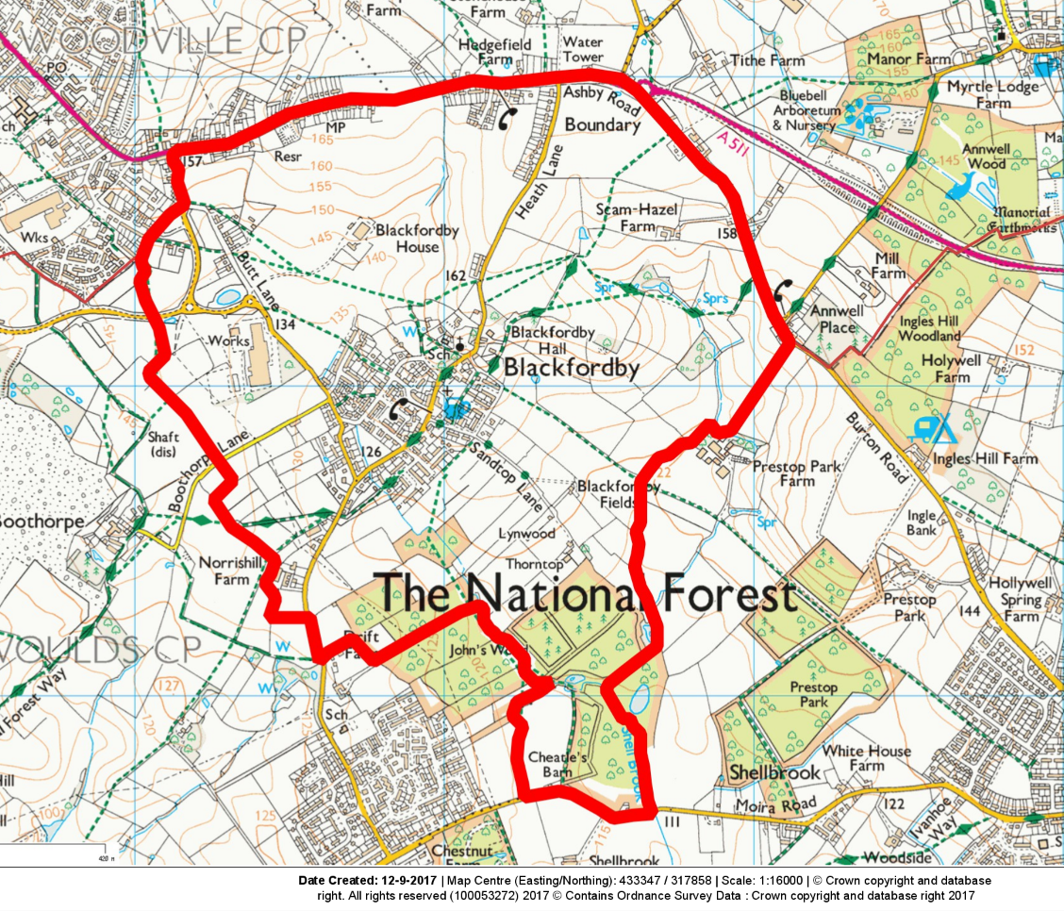

1.5 In preparing a Neighbourhood Plan a community is not working from ‘a blank piece of paper’. Legislation requires that the Plan, and the policies it contains, must be prepared in a prescribed manner; in particular, the policies must be in general conformity with relevant national and North West Leicestershire-wide approved strategic planning policies.

1.6 The Plan is now at the examination stage and will be formally submitted to North West Leicestershire District Council (NWLDC).
1.7 It will then go to an Independent Examiner, who will check to see that it is has been prepared in the prescribed manner. If the Plan successfully passes this stage, with any modifications, it will be put forward to referendum, where those on the electoral register within the Neighbourhood Plan Area will be invited to vote on whether or not they support it. Over 50% of those voting must approve it for the Blackfordby Neighbourhood Plan to become a ‘Made’ statutory planning document.
1.8 Whilst planning applications will still be determined by North West Leicestershire District Council, or for certain types of application Leicestershire County Council, the production of a Neighbourhood Plan will mean that they must have regard to the provisions of the Plan and the relevant locally formulated criteria when reaching planning decisions that affect Blackfordby. This means that residents will have a far greater control over where development takes place, and what it looks like.
How the Plan was prepared
1.9 The Plan has been prepared by the Blackfordby Neighbourhood Plan Steering Group.
1.10 This Steering Group comprises members of the local community and local Town Councillors, with the support of Neighbourhood Plan Consultants Yourlocale, and under the direction of Ashby de la Zouch Town Council (the Accountable Body for the Plan).
1.11 It is based on a range of evidence sources. This includes statistical information gathered through the Census as well as from community consultation and engagement. The preparation of the Plan has also had regard for the NWLDC Local Plan
1.12 Effective and extensive consultation has been at the heart of the preparation of the Plan. This is key to ensuring that the Plan fully reflects local need and priorities. There have been a variety of consultation exercises over the last 2 years, at which many local people have taken part. These include drop-in sessions, a questionnaire, and meetings with residents and stakeholders.
1.13 The Steering Group was chaired by Robert Nettleton. The Committee was supported by: Keith Thompson (Vice chair) – Resident, Cllr John Coxon, Cllr Jim Hoult, Cllr Rita Manning, Former Cllr Mrs Di Whetton & Former Cllr Allen Green of Ashby de la Zouch Town Council, plus Mike McCrea, Bill Chesterton, Jane Lloyd and Simon Best– Residents.
1.14 The Steering Group met on an approximately 6-weekly cycle and established a series of Focus Groups to help deliver the detail of the Neighbourhood Plan and the evidence base. The Focus Groups involved members of the community and people working locally and continued to meet until late 2018 developing the detail of the Neighbourhood Plan.
1.15 At the start of the process, the community were invited to an open event which took place on 1st April 2017. This event set out the context and stages of the Neighbourhood Plan and asked questions about people’s thoughts about Blackfordby – what was good and what could be improved. An analysis of the event is included in the evidence base.
1.16 The event was a great success with around 100 people in attendance. The views expressed by the residents were used to shape the strategy in preparing the Neighbourhood Plan.
1.17 In November 2017 there was a launch of the three ‘Focus Groups’ that were to be the vehicle through which the policies were to emerge. They were established to explore the details, to build the evidence base and to lay the foundation for the draft Neighbourhood Plan. Three Focus Groups were established: environmental, housing and the built environment and community facilities; transport and employment. The Focus Groups continued to meet until late 2018.
1.18 A Community Questionnaire was delivered to all households in the Neighbourhood Area in late 2018 with questions relating to housing, community facilities, transport and business.
1.19 With the emerging policies well advanced, a further open event was held on 9th March 2019. This event shared the draft policies with the local community and sought their support for the emerging Neighbourhood Plan.

How the Plan fits into the planning system
1.20 The right for communities to prepare Neighbourhood Plans was established through the Localism Act 2011, which set out the general rules governing their preparation.
1.21 A Neighbourhood Plan forms part of the Statutory Development Plan for the area in which it is prepared. This statutory status means that it must be taken into account when considering planning decisions affecting that area.
1.22 One of the main rules governing the preparation of a Neighbourhood Plan is that it must be in line with EU regulations on strategic environmental assessment and habitat regulations. The Government has confirmed that such regulations will continue to apply post Brexit. It must also be in general conformity with national, county and district wide (i.e. North West Leicestershire) planning policies. This means that it cannot be prepared in isolation. It will need to take into account, and generally work with, the grain of the district-wide and national policies unless there are good reasons for not doing so. These are known as ‘Basic Conditions’ which require Neighbourhood Plans to:
a) Have regard for national planning policy (primarily through the National Planning Policy Framework (NPPF) and Planning Practice Guidance).
b) Be in general conformity with strategic policies in the development plan for the local area (i.e. the North West Leicestershire Local Plan).
c) Be compatible with EU obligations and human rights requirements.
1.23 At the local level, the key planning document which a Neighbourhood Plan must have regard to is the District Wide Local Plan. In the case of Blackfordby, this is the North West Leicestershire District Local Plan, adopted in November 2017.
The Neighbourhood Plan and what we want it to achieve
1.24 The Plan Area encompasses the part of the Parish of Ashby de la Zouch in which Blackfordby sits and covers the period up to 2031, a timescale which deliberately mirrors that for the North West Leicestershire Local Plan.
1.25 The main purpose of the Neighbourhood Plan is not to duplicate national or district-wide (i.e. North West Leicestershire) planning policies, but to sit alongside these, to add additional or more detailed policies specific to Blackfordby. Where there are national and district-wide planning policies that meet the needs and requirements of Blackfordby they are not repeated here.
1.26 Instead, the Plan focuses on those planning issues which consultation shows matter most to the community, and to which the Plan can add the greatest additional value. These include policies that:
- Ensure that development takes place in the most sustainable locations;
- Encourage the right types of development that meet local needs;
- Protect important buildings and structures of historic and architectural interest;
- Protect important community facilities and shops;
- Promote high quality design in new development;
- Protect the countryside and special landscape; and
- Protect open spaces that are important to the community and/or wildlife.
1.27 Furthermore, these locally formulated policies will be specific to Blackfordby and reflect the needs and aspirations of the community.
It is important to note that when using the Plan to form a view on a development proposal or a policy issue the whole document and the policies contained in it must be considered together.
1.28 While every effort has been made to make the main parts of this Plan easy to read and understand, the wording of the actual policies is necessarily more formal, so that it complies with statutory requirements.
1.29 The Plan will be kept under review and may change over time in response to new and changing needs and requirements.
How the Neighbourhood Plan supports sustainable development
1.30 According to the key national planning document – the NPPF- the purpose of the planning system is to contribute to sustainable development.
1.31 The goal of sustainable development is to enable all people to satisfy their basic needs and to enjoy a better quality of life, without compromising the ability of future generations to meet their own social, economic and environmental needs.
1.3The NPPF carries a presumption in favour of sustainable development. It states that there are three dimensions to sustainable development: social, environmental and economic, all of which are important and interrelated. In accordance with this, the Plan’s aims and policies are centred on the achievement of sustainable development, including by, for example:
- Social
  - To safeguard existing open space for the enjoyment of residents;
  - To protect existing community facilities; and
  - To deliver a mix of housing types, so that it can meet the needs of present and future generations.
- Environmental
  - To ensure that housing development is of the right quantity and type in the right location, so that it does not harm but instead positively reflects the existing and historic character of the area;
  - To protect important open spaces from development,
  - To ensure that the design of development enhances the special character and identity of Blackfordby;
  - To protect and, where possible, improve biodiversity and important habitats; and
  - To make provision for improved pedestrian and cycling facilities, as appropriate.
- Economic
  - To protect existing employment uses;
  - To ensure effective broadband speeds in new development;
  - To support appropriate small-scale farm diversification and business development; and
  - To encourage appropriate start-up businesses and home working.

2. Blackfordby

A brief history of Blackfordby
2.1 The settlement of ‘Black Ford’ was established by the 9th century and largely developed with an agricultural based economy until the second half of the twentieth century. There was once a ford across the Main Street where clear spring water joined the brook running from Butt Lane. In the medieval period the La Zouch family of Ashby Castle owned lands at Blackfordby and the Abbott of Lilleshall (Staffordshire) held land around the settlement. After the dissolution of the monasteries in the late 1530’s lands at Blackfordby, as part of the manor of Ashby de la Zouch, were given to the Hastings family (the Earls of Huntingdon) of Ashby Castle. The Joyce family of Blackfordby Hall were also important landowners around the village from (at least) the eighteenth century.
2.2 In 1843 the National School opened on Main Street and in 1889, the primary school with its attached schoolmasters house was built next to the Parish Church of St Margaret of Antioch. The Parish Church itself had been newly built in 1858 and replaced a thirteenth century chapel. The church of St Margaret of Antioch occupies a commanding site on a hillside overlooking the village. A clock was added to the church in 1920 in memory of the men of Blackfordby who fell in the Great War. A new War Memorial was installed alongside the Old School Room in 2014. The Wesleyan Methodist Chapel was built in the 1930’s.
2.3 There was a thriving coal and clay extraction industry at Blackfordby during the 18th and 19th centuries and probably earlier. With both surface and underground workings, alongside associated brickmaking. The Blackfordby Colliery off Butt Lane closed in about 1900, although some extraction, predominantly by surface working continued until the late 1940’s. From the mid-nineteenth century the coal mining, brick, sanitary pipe and pottery industries increasingly became a source of local employment. This included industrial sites close to Blackfordby at The Shrubbery in Woodville, the Albion Works and Boothorpe Brickworks.
2.4 The post Second World War period also witnessed significant levels of new housing development in Blackfordby. Within the historic core a number of building demolitions occurred, the most significant being Blackfordby Hall in (1966).
2.5 The hamlet of Boothorpe is less than half a mile south west of the village of Blackfordby and only accessible via Blackfordby. It has always had a close association with the village but is located outside the Plan Area in the neighbouring parish of Ashby Woulds.

Blackfordby Profile

2.6 Blackfordby is a small vibrant village in North West Leicestershire, on the county border with Derbyshire and at the centre of the National Forest. At the heart of the village is St Margaret’s Church, the Methodist Chapel, St Margaret’s Primary School, the village hall, the Old School Room, the Black Lion Public House and the recently closed Blue Bell Public House. The nearest shop to the centre of the village is approximately 1 mile away in Norris Hill. The village hall is well used for community activities and private functions. The Old School Room has recently been refurbished and is now used for community activities.

2.7 There is a conservation area centred on Main Street around the junction with Well Lane. There are also 10 listed buildings.

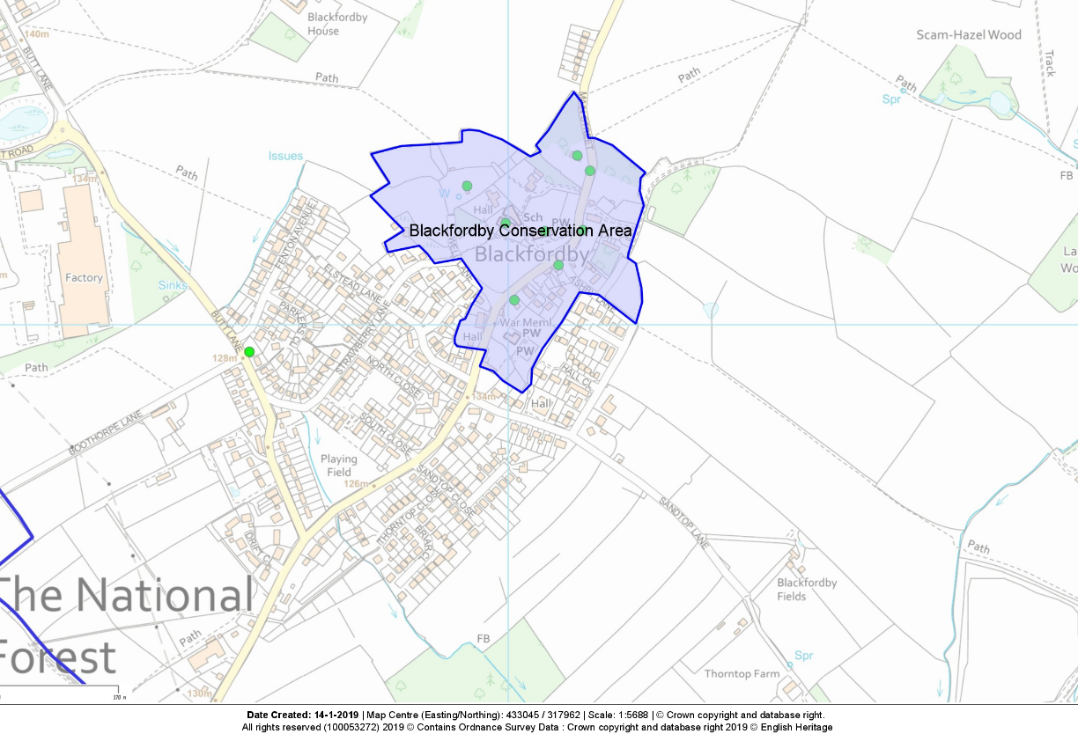

2.8 Housing in the village is split into three distinct areas, there is the main part of the village, with a separate area of housing extending along Heath Lane and along the Leicestershire side of the A511, as far as the traffic lights marking the start of Woodville, the area along the A511 is part of the hamlet of Boundary. There is a third smaller group of houses along the cul-de-sac on the upper part of Butt Lane. Recent planning approvals have been granted for 106 dwellings on Butt Lane, alongside Fenton Avenue and up to 91 dwellings at Hepworth Road, behind the houses on the upper part of Butt Lane. This means that only a field now separates the main village of Blackfordby from Woodville.

2.9 At the time of the 2011 Census Blackfordby had a population of 1159. The levels of good or very good health at 78% were below NWL district at 80.9%, the East Midlands at 80.4% and England at 81.4%, possibly in part due to the population age distribution.

2.10 Unemployment was lower than district, regional and national levels, 2.9% against 4.4% nationally. Levels of self-employment were 10% almost identical to district, regional and national figures. Economic activity, at 61.8%, was lower than District levels (73.5%) and also regional (69%) and England (70%) levels.

2.11 The proportion of households with no car was 12.1%, which is above the district (11.8%); but below the regional (22.1%) and national (25.8%) levels.

2.12 4.8% of working age residents stated that they work from home, slightly above the district, regional and national averages.

2.14 Blackfordby is a very popular place to live and demand for housing is strong, reflected in the high property prices. At the 2011 census there were 534 households, of which 58.8% of houses are detached, well in excess of district, regional and national levels. Whilst there is a low level of terraced houses, maisonettes and similar, 5.2% in total, compared with 26% in NWL and 47% nationally.

2.15 Other than a lack of one-bedroom properties: 2.1% in Blackfordby, 5.6% in NWL and 11.8% in England, the proportion with 2, 3, 4 and 5+ bedrooms are roughly in line with local, regional and national figures. Levels of affordable rented housing at 8.2% are below District (14.3%) and well below national (17.7%) figures. It should also be noted that the vast majority of Council owned properties are large, post war 3-bedroom semi-detached houses that do not often become vacant, and when they do so, are unlikely to be offered to young couples looking for a first home. In any case the under-occupancy would be likely to attract the “Bedroom Tax”.

2.16 There is an ageing population in Blackfordby. At the 2011 Census (the latest figures available for comparative purposes), 29.2% of the population was aged 65+ compared to 17.4% across the district and 16.3% in England.

2.17 The demography of Blackfordby has changed over the last 50 years or so. The economy of the surrounding area was dominated by coal mining, clay extraction and the associated manufacture of ceramics, pipes, tiles, pottery and similar products, plus extensive farming. As these industries declined there has been a significant move towards other manufacturing industries and distribution / storage warehousing, which provide the vast majority of the local unskilled and semi-skilled employment. However, most residents work outside of the village many with skilled/ professional roles.

2.18 Over the 5-year period from 2013 to 2017 the property market remained remarkably constant, with between 21 and 23 sales per annum. There was a slight upward trend in sale prices over this period. Only 3 properties sold for below £100,000, the average of all 112 sales being £191,142. Over that period only 45 terraced or semi-detached houses were sold, with an average price of £141,017. This means that a realistic entry price for a starter home would be in the region of £150,000. There is a desperate need for smaller and more affordable housing to be provided in the village. With the already aged population, low numbers of youngsters and the high price of housing it is inevitable that without major changes to policy, it will be impossible to set up a new home and raise a family.

3. A Vision for Blackfordby
3.1 Many local people believe that the planning system is too remote, heavily biased in favour of developers and are keen to establish local ideas and clear objectives for the future. The vision for this Neighbourhood Plan is to put in place a policy framework that ensures that land use, development and potential changes are consistent with the following key objectives:
- To reflect the wishes of residents.
- To ensure that development maintains the character of Blackfordby.
- To protect and enhance the rural setting, outstanding views and open countryside of the village.
- To ensure future residential development is in the correct places, maintains distinct separation between Blackfordby and other built-up areas, and is of types suitable for the needs of local people.
- To ensure that infrastructure is in place to meet the needs of the village. To be determined at planning application stage depending on the location and scale of development.
- To ensure that development is compliant with the strategic planning policies of NWL District Council.
The vision for Blackfordby is to maintain and enhance the good quality of life, community spirit and attractive natural and built environment in the village, now and for the future.
3.2 This will be realised by a small number of planning policies specific to the village grouped around the key policy issues identified by the community as being of special importance to them. These include policies that:
3.3 Ensure that development takes place in the most sustainable and least intrusive locations.
3.4 Encourage the types of development that meets local needs with a particular emphasis towards young families and the elderly and to ensure that requirements for affordable rented houses meet Local Plan requirements.
- Protect and wherever possible enhance important buildings and structures.
- Protect important community facilities.
- Promote good design.
- Ensure that the community continues to have good access to the surrounding countryside and green spaces, and to protect open spaces that are important to the community and or wildlife.
- Seek ways of addressing the problems of traffic speed and improve pedestrian and cycle connections within the Plan Area and into the surrounding countryside.
The Plan will be kept under review.

4. POLICIES

A. General
4.1 The Blackfordby Neighbourhood Plan is a key part of securing sustainable development as described in the NPPF, which states that all plans should be based on and reflect the presumption of sustainable development and that neighbourhoods should plan positively to support local development. Through the process of developing a Neighbourhood Plan, consideration has been given to the type and extent of new development, including the infrastructure required to meet the needs of the local community, where it should be located, and that it should be designed to blend in with the surroundings.
4.2 Through the Neighbourhood Plan, the opportunity has been taken to positively plan for development within Blackfordby that meets a local need and helps to support local services. The Limits to Development (see below) has been re-drawn to accommodate potential for small scale housing growth and to direct development to the most suitable locations.
4.3 This will enable Blackfordby to secure the growth that is recognised as being necessary through small-scale developments in locations that are favoured by the community, avoiding the disturbance that comes with speculative development proposals that threaten the character of the village into the future.
4.4 The Neighbourhood Plan is not intended to replace the policies contained in the NWLDC Development Plan or the requirements of the NPPF. It works in conjunction with these requirements to give additional, more detailed, Blackfordby-specific policies that help to clarify and achieve the community’s vision. Where suitable District-wide policies already exist in the NWL Development Plan or NPPF they are not duplicated in this Neighbourhood Plan.

Limits to Development (LTD)
4.5 In historical terms rural communities such as Blackfordby have often been protected by the designation of a village envelope (or settlement boundary) adopted in a statutory Local Plan.
4.6 The purpose of the new Neighbourhood Plan LTD policy is to ensure that sufficient land to meet residential and commercial need is available in the most suitable locations. The identified land should be supported by transport links and services infrastructure and avoid encroaching into the countryside unless covered by local and national planning policies.
4.7 LTDs were established by NWLDC in order to clarify where new development activity is best located. They are used to define the extent of a built-up part of a settlement and distinguish between areas where, in planning terms, development would be acceptable in principle, such as in the main settlements, and where it would not be acceptable, generally in the least sustainable locations such as in the open countryside. Such unfettered and/or unsustainable growth would risk ribbon or piecemeal development and the merging of distinct settlements to the detriment of the community and visual amenity of the built-up area.
4.8 The Neighbourhood Plan therefore designates the LTD policy for the built form of Blackfordby – as shown below in Figure 2. This updates and supersedes the existing LTD used by NWLDC as it takes into account recent housing allocations and site allocations proposed through the Neighbourhood Plan. Within the defined LTD an appropriate amount of suitably designed types of development in the right location is acceptable in principle, although some sites within the LTD boundary are protected, and all development will be required to take into account the policies within this Neighbourhood Plan.
Methodology:
4.9 In designating the actual LTD the Blackfordby Neighbourhood Plan will apply the following methodology: Existing physical features such as walls, fences, hedges, gardens, streams, leisure amenities, footpaths and roads will be used to delineate the boundary. Non - residential land which is associated with the countryside, agricultural land or woodland will be specifically excluded. The residential allocation within the Neighbourhood Plan is incorporated within the Limits to Development.
4.10 The community have expressed a strong desire to protect what is special about Blackfordby for future generations. The countryside setting, the high quality of life and the quiet environment are of particular importance.
4.11 In statutory planning terms, land outside a defined LTD boundary, including any individual or small groups of buildings and/or small settlements, is treated as countryside. It is national and local planning policy that development in the countryside should be carefully controlled. It should only be allowed where it is appropriate to a rural location, such as for the purposes of agriculture, including farm diversification, or if needed for sport and recreation uses or for affordable housing.
4.12 Blackfordby is surrounded by beautiful countryside and numerous scenic walking areas through open fields and woodland. The village features a diverse range of attractive houses and other buildings with strong historical traditions. It has great character that local people wish to see maintained and enhanced wherever possible.
4.13 This approach to development in the countryside is supported by the Neighbourhood Plan because it will ensure that any development is focused in the areas which are most needed and least intrusive, making best use of the limited range of services and facilities. The following policy will also help to maintain the special and unique landscape character and setting of Blackfordby and protect the open countryside for what it is, an attractive, accessible, distinct and non-renewable natural resource.
POLICY G1: LIMITS TO DEVELOPMENT - Development proposals within the Neighbourhood Plan area will be supported on the sites within the LTD boundary as shown in Figure 2 (below) where the proposal complies with the policies in this Neighbourhood Plan including the need to achieve positive design and amenity standards.
Land outside the defined Limits to Development will be treated as countryside, where development will be carefully controlled in line with local and national strategic planning policies.
Figure 2 – Limits to Development
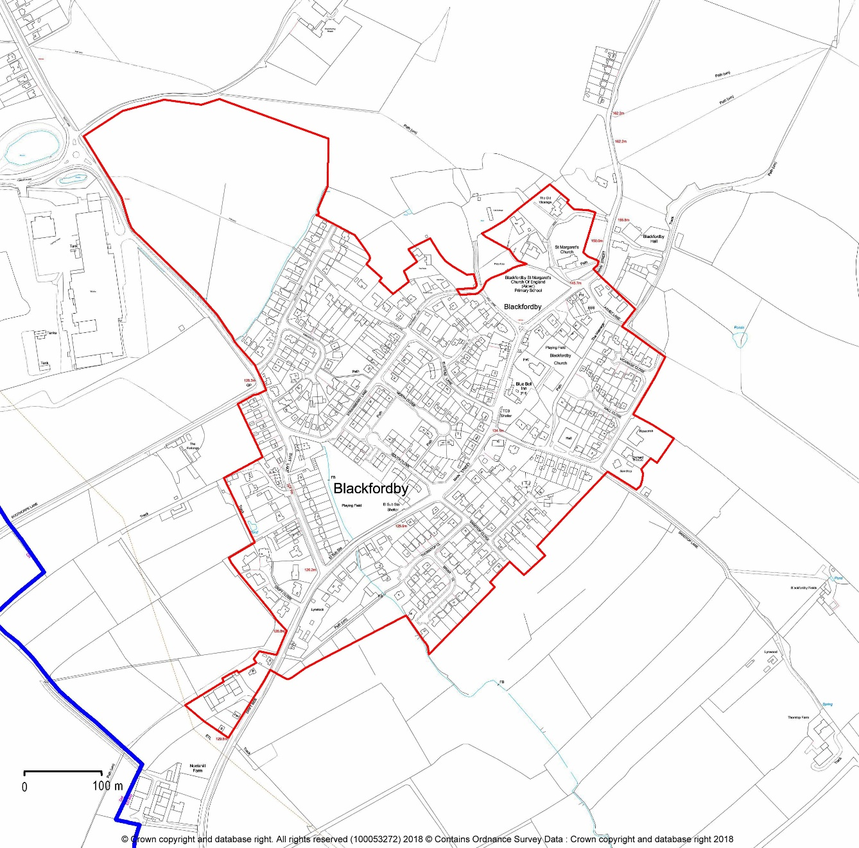

Design standards

4.14 Blackfordby residents require the Neighbourhood Plan to ensure that future development will reflect the architectural character of the village and fully integrate it into the environment or make a positive architectural contribution to the location. There is an expectation of high-quality materials and sustainability in any future house building in order to sympathetically integrate with the style and environment. The proposed location of any development should not adversely affect the Local Green Space or environmentally important areas within the village that play an important part in the overall character and physical form of the village.
4.15 Blackfordby has developed over a long period of time with certain times showing an increase in construction activity, for example during the 1970’s. The aim of the design policy is to keep what is special, particularly in the conservation area whilst encouraging modern building and design.
4.16 Mobility can be an issue effecting many people as age forms its restrictions, but it is just as important an issue, for anyone with a disability, at any age. Currently, grants are severely limited for home owners to cover the cost of any necessary alterations to make life easier in their homes. Any modifications must normally be self-funded or they must move house at great expense and upheaval to meet their mobility needs. In terms of the 2011 census 25.3% of Blackfordby residents had their day-to-day activities limited a lot or a little, this compared to 19.1% for NWLDC and only 17.6% nationally. Evidence from the community questionnaire strongly suggests that this position has worsened over the last eight years as people continue to age in Blackfordby, an ex-deep mining community. It would be logical that the properties built under the M3 standard would be single storey dwellings.
4.17 Residents in the Plan Area want their communities to play their part in the sustainable development of the district. As noted in the NPPF, Planning Authorities should, through their policies, contribute as fully as possible to the aims of Biodiversity 2020 DEFRA, 2011. New development in Blackfordby should be designed to incorporate the current (at time of Application) best practice standards and methods for biodiversity protection and enhancement. The NPPF, updated in 2019, promotes the enhancement of biodiversity as a key environmental objective of the planning system.
POLICY G2: Design - This policy will apply to all new commercial and residential developments, including one or more houses, replacement dwellings and extensions.
All development should continue to reflect the character and historic context of existing developments in Blackfordby. However, contemporary and innovative materials and design will be supported where positive improvement can be robustly demonstrated without detracting from this historic context. The following criteria should be met:
- Development shall be carried out sensitively and reflect the character of the area within which it is situated, particularly that of the National Forest and the area around the Conservation Area. Any proposals should clearly show how the general character, scale, density and layout of the site fits in with the character of the surrounding area and incorporate local materials where possible. Care should be taken to ensure that the development does not disrupt the visual impact of the street scene or adversely affect any wider landscape views identified in Policy ENV7.
- Owing to the limited public transport, sufficient off-road parking should be provided, a minimum of two car parking spaces per dwelling and electric vehicle charging points.
- Development should be enhanced by landscaping with existing trees, topography and hedges preserved whenever possible to promote biodiversity. Wherever possible, plots should be enclosed by native hedging, wooden fencing or walls in keeping with the local style.
- Development should incorporate sustainable design and construction techniques to meet high standards for energy and water efficiency, including the use of renewable and low carbon energy technology such as solar panels and rainwater harvesters. These features should not adversely detract from the visual amenity of the current street scene.
- The phasing of the development must take into account, where appropriate, the need to provide water quality improvements through developer contributions to ensure that there will be no adverse impact, directly or indirectly, on the integrity of the River Mease Special Area of Conservation. Development will not be allowed to take place until whichever is the sooner of the following:
  - Additional capacity being made available through a further Developer Contribution Scheme or;
  - Pumping out of catchment having taken place.
- Where appropriate, development shall incorporate sustainable drainage systems such as balancing ponds to retard surges and to minimise the vulnerability to flooding and climate change unless they are not financially viable and alternative mitigation methods are available, or the SuDS scheme will itself adversely affect the environment. Where appropriate, SuDS should be linked into wider initiatives to enhance green infrastructure, improve water quality and benefit wildlife or contribute to the provision of the ecosystem. All SuDS must be designed to treat surface water quality sufficiently to ensure that there is no adverse impact on the integrity of the River Mease SAC. Arrangements in accordance with national policy will need to be put in place for the management and maintenance of the SuDS over the whole period during which they are needed.
- All new development will have access to superfast broadband of at least 30Mbps.
- Housing that complies with Part M4(2) of the Building Regulations with 10% of housing built in accordance with Part M4(3) will be supported.
- Provision should be made in the design and construction of new development in the Plan Area to protect and enhance biodiversity, including:
- Roof and wall construction following technical best-practice recommendations for integral bird nest boxes and bat breeding and roosting sites
- Hedges (or fences with ground-level gaps) for property boundaries that maintain connectivity of habitat for hedgehogs
- Lighting that has appropriate regard to the guidance note Bats and Lighting, Leicestershire and Rutland Environmental Records Centre, November 2014.
Regard should also be had to the National Design Guide and the National Model Design Code.

B. Housing
Introduction
4.18 Blackfordby is a very popular place to live and demand for housing is strong, reflected in the high property prices. The village is accessed by un-numbered roads from the A511 and from Norris Hill and Boothorpe Lane is a cul-de-sac leading from the village to the hamlet of Boothorpe. Boothorpe is part of the parish of Ashby Woulds but intrinsically connected to Blackfordby as its only access road is from the village.
4.19 There is a bus service which connects with Burton upon Trent via Swadlincote in one direction and Coalville via Ashby de la Zouch in the other. The nearest doctor`s surgery is about 1.35 miles away in Woodville, there are banks, supermarkets and a range of retail and service offerings in both Ashby de la Zouch and Swadlincote.
4.20 The 2011 census revealed that the number of children under 16 is considerably lower than the average in the area, but conversely those aged 65 and above, at 29.2%, is nearly double the national average of 16.3% and considerably higher than the district average of 17.4%.
4.21 Further context from the 2011 census shows there were 534 households, of which 20 were empty, the accommodation was as follows: 1 temporary structure, 6 flats or maisonettes, 21 terraced, 192semi-detached and 314 detached. Occupancy is low: there were at least 1514 bedrooms for a 1159 population and only 153 of 514 households had 3 or more occupants whilst only 3 households had 6 occupants.
4.22 Ownership is as follows: Owned outright 279, owned by mortgage 164, social rented 42, privately rented 22, rent free 8. What is particularly noticeable from the evidence is the very low number of properties in council tax band A, approximately 5%, compared with a local and national estimate of 20%, East Midlands being around 30%.
4.23 The principal aim of the Housing Focus Group has therefore been to consider the current housing situation and deliver the future housing provision that is required to meet the needs of the neighbourhood area in a holistic fashion.
Housing Provision and allocation.
4.24 The NWLDC Local Plan was adopted in November 2017, using the Housing and Economic Development Needs Assessment (HEDNA) report as its base for calculating need. The Plan notes that the agreed housing need between 2011 and 2031 is for a district-wide provision of 9,620 dwellings. It is estimated that with completions since 2011, sites under construction and with extant planning consents a total of 10,592 dwellings will be delivered by 2031, an excess supply of 972 units. The positive delivery figures are such that with a 20% buffer of the base HEDNA target NWLDC has a supply for more than six years and with a 5% buffer NWLDC has a supply for more than seven years.
4.25 One of the key aims of the neighbourhood plan is to deliver the necessary housing required to meet the housing need in the Plan Area to 2031. Following a request from the Town Council NWLDC has indicated that 126 dwellings would represent an appropriate housing target for the Neighbourhood Plan, this is until the end of the current Plan period in 2031.
4.26 Against this target of 126 for Blackfordby up to 2031 and 147 up to 2036, there have been recent planning approvals totalling 217 (net) which significantly exceeds the requirement for Blackfordby over the Plan period. The Housing Need Survey indicated that 63% of respondents felt no further housing was required in the village. This view was echoed at the consultation event on emerging policies, where it was explained that development will happen locally with or without a Neighbourhood Plan. Having a Neighbourhood Plan helps to shape that development in line with local need. The Housing Needs Survey identified a need for homes for elderly people, small family homes, homes for people with disabilities and homes for young people.
4.27 Notwithstanding the above, the Neighbourhood Plan has undertaken a comprehensive assessment of potential residential development sites in a positive approach to securing sustainable development and to help meet a local need. The process undertaken is detailed in the supporting information (Appendix 3).
4.28 The outcome of this exercise is that the land to the rear of 31 Main Street is allocated for residential development.
POLICY H1: RESIDENTIAL SITE ALLOCATION - Land is allocated at the rear of 31 Main Street for up to 14 units of residential accommodation as shown on the plan below (Figure 3).
The phasing of the development must take into account, where appropriate, the need to provide water quality improvements through developer contributions to ensure that there will be no adverse impact, directly or indirectly, on the integrity of the River Mease Special Area of Conservation. The layout of the dwellings shall protect, through the use of residential gardens, the wildlife corridor 1 as described in Policy ENV6.
Proposals will be required to protect, buffer and where possible enhance existing boundary hedges, trees and habitats and maintain undisturbed ecological connectivity.
Proposals are to be supported by an ecological survey including a survey of protected species and to demonstrate how development would not cause harm or the loss of ecologically significant habitats, constrain ecological connectivity or displace without adequate mitigation any species present on site.
Proposals will be required to safeguard and, where possible, enhance the natural corridor along the Shell Brook and secure natural boundary screening along the southern boundary and undeveloped parts of the boundary along Drift Side.
Planning proposals are required to be accompanied by a Landscape and Visual Impact Assessment (LVIA) that demonstrates that the proposed scheme would not cause significant harm to landscape character and that any adverse effects on landscape have been adequately mitigated. The LVIA should further demonstrate how any associated planting accords with landscape character, uses native species and achieves net gain gains in biodiversity.
The National Forest Way, where it crosses the site, shall follow an alignment that is commodious for walkers.
Figure 3 – Residential allocations
Housing Mix
4.29 The Neighbourhood Plan recognises that providing a wide choice of high-quality homes is essential to developing a sustainable, mixed and inclusive community. A better housing mix in terms of tenure and size will help meet the needs of a well-balanced population vital to the on-going viability of local services and the prosperity of the community, particularly in light of its increasingly ageing population.
4.30 It is the need to provide for a mixed cross-section of ages in the village population, which will continue to enable the community to thrive and be the pleasant place to live and not be swallowed into one of the larger habitations. Businesses such as the much-needed local shop and Post Office would be sustained and though the local school is currently at 98% capacity, the greater proportion of children come from outside the village.
4.31 The Housing Focus Group has considered the evidence from the current mix of stock in terms of sizes, tenure and accessibility. The core documents used to justify the policy position are the HEDNA study 2017, a housing needs report (see Appendix 4), the census data from 2011 and the land registry data from 1995 to 2016.
4.32 The proportion and average age of elderly residents is increasing and this is contributing to under-occupancy which is particularly evident in larger properties with 52% of households with 4 or more bedrooms occupied by just one or two people, above District and Regional levels. It suggests a need for smaller homes with fewer bedrooms, which would enable downsizing and provide for small families and those trying to get on the ‘housing ladder’.
4.33 Similarly, younger residents who wish to remain living in the community as their needs change should be enabled to do so. Providing smaller homes would enable elderly and younger people to stay in the community and at the same time release under-occupied larger family homes onto the open market which would then be to the advantage of other growing families whilst sustaining a vibrant local housing market. This evidence is supported by comments in the December 2018 Blackfordby Housing Needs Survey.
4.34 In addition, the HEDNA report (2017) recommends the NWLDC housing mix for market housing as;
One bedroomed as 0 to 10% of future provision.
Two bedroomed as 30 to 40% of future provision.
Three bedroomed as 45 to 55% of future provision.
Four or more bedroomed as 10 to 20% of future provision.
POLICY H2: HOUSING MIX - New housing development proposals should provide a mixture of housing types specifically to meet identified local needs in Blackfordby. Unless the latest evidence indicates otherwise, development proposals should concentrate on providing 1- and 2-bedroom dwellings, including where feasible and viable bungalows for older people (built to the appropriate mobility standard), mixed with some 3 bed dwellings.
The inclusion of four-bedroom houses in housing developments will be supported where they are subservient in number to one, two and three-bedroom accommodation.

Windfall development

4.35 A windfall site is defined in the NPPF (2019) as one which has not been specifically identified as available in the Development Plan. These sites often comprise redundant or vacant buildings including barns, or a gap between existing properties in a built-up street scene.
4.36 Such sites have made a small but regular contribution towards the housing supply in Blackfordby for a considerable time. As there remain only limited opportunities for windfall development, there is evidence that windfalls will continue to make a small contribution to housing provision up to 2031.
4.37 To help protect the character of Blackfordby, development beyond the housing allocation described above will be restricted to windfall sites within the LTD boundary.
4.38 As there is a need for smaller properties, single unit developments would need to be appropriate to the size of the plot, but developments of two units or more should wherever possible be of one, two or a maximum of three bedrooms.
POLICY H3 Windfall Sites - Proposals for infill and redevelopment sites (individual dwellings or small groups of dwellings) will be supported where:
- The location is within the Limits to Development boundary for Blackfordby;
- The site retains existing important natural boundaries and features such as gardens, trees, hedges, footpaths and streams;
- There is a safe vehicular and pedestrian access to the site;
- The site does not reduce garden space to an extent where there is an adverse impact on the character of the area, or the amenity of neighbours or the occupiers of the host property.
Affordable housing

4.39 Over the five-year period from 2013 to 2017, the property market has remained remarkably constant, with between 21 and 23 sales per annum in Blackfordby. There was a slight upward trend in sale prices over this period. Only three properties sold for below £100,000, the average of all 112 sales being £191,142. This “village premium” means that for access to mortgage facilities for a first-time buyer they would need to have a family income in excess of £47,785 and in addition, a substantial deposit is often required.
4.40 Affordable housing is defined in the NPPF (2019) as “housing for sale or rent, for those whose needs are not met by the market”. The definition refers to affordable housing for rent; starter homes; discounted market sales housing and other affordable routes to home ownership, including shared ownership and equity loans.
4.41 The adopted NWLDC Local plan makes the following statement about affordable housing. “The Council’s preference is for on-site affordable housing provision which should include a mix of types and tenure that reflects the type and nature of any need at the time that the application is determined; and be integrated within the design and layout of a development such that they are externally indistinguishable from market housing on the same site”.
4.42 There is a requirement to provide a minimum of 30% affordable units on-site for all developments on relevant housing sites, these are defined as; a) of more than 11 dwellings; or b) with a combined gross floor-space of more than 1,000 square metres.
4.43 In addition the HEDNA report recommends the NWLDC affordable housing mix as: one bedroomed as 30 to 35% of future provision; two bedroomed as 35 to 40% of future provision; three bedroomed as 25 to 30% of future provision and four or more bedroomed as 5 to 10% of future provision.
4.45 Local consultation has demonstrated support for more affordable units to be provided across a range of tenures. Similarly, the local consultation activities support provision of starter homes so these will be supported to help achieve a balanced community. In line with the HEDNA report the Neighbourhood Plan seeks a tenure split for the affordable housing as 80% social and affordable rented and 20% intermediate housing to be delivered.
4.46 The Plan supports the provision of more affordable housing within Blackfordby, especially as recently approved applications for 11 or more dwellings have not delivered the 30% affordable housing target as defined in the Local Plan.
POLICY H4: AFFORDABLE HOUSING PROVISION – Affordable housing should be provided on sites in line with Local Plan requirements.
New affordable housing proposals should provide a tenure split of 80% social and affordable rented homes and 20% low-cost starter homes or other home-ownership products and provide a balance of accommodation, including bungalows, which meets the needs of people of all ages, including older people, subject to monitoring and review.
The affordable units should be integrated within the design and layout of a development such that they are externally indistinguishable from market housing on the same site.
C. Natural and Historic Environment

Introduction
The environment in sustainable development
4.47 This section of the Plan deals with the environmental component of sustainable development, as described in the National Planning Policy Framework. It balances the requirement for appropriate development in Blackfordby against the value of environmental features that are both special – appreciated, in their own right and as community assets, by local people - and significant for their wildlife and history. It also deals with broader environmental issues of concern to the community, including biodiversity in new development and renewable energy generation.
4.48 Care was taken during preparation of the Plan to ensure that the policies (and the sites and areas of environmental significance covered by them) were not unduly restrictive on development during the Plan’s lifetime. Just 16% by area of all the open and currently undeveloped land in the Plan Area has been earmarked in this Plan for environmental protection at any level in the planning system.

Total area of Blackfordby Plan Area = 300 ha
Area of open or currently undeveloped land = 260 ha
Area of sites designated or notified for environmental protection = 44 ha (16%)
(NB: of which 26 ha is in the National Forest)

Landscape, geology and setting
4.49 Blackfordby’s location is described by its name – itself a reminder of the village’s 8th-century origin – there are several theories about the origin of the name, one theory is that it is the ‘settlement at the black stream crossing-place’. It grew up on a steep valley-side, above a place where a brook tumbled from a bluff of hard sandstone over an outcrop of black coal seams (Figure 4). The sandstone provided spring water and dry places to build houses, while the high ground to the north and lower land to the south became the productive fields of the early medieval township.
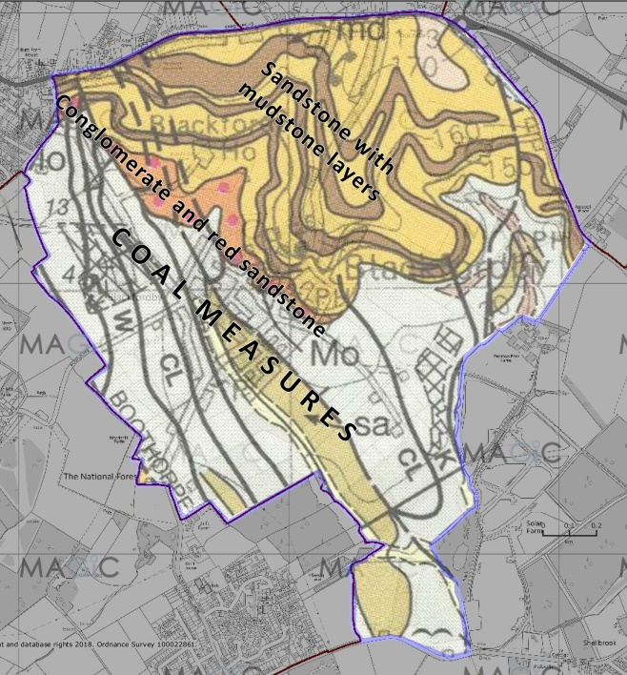
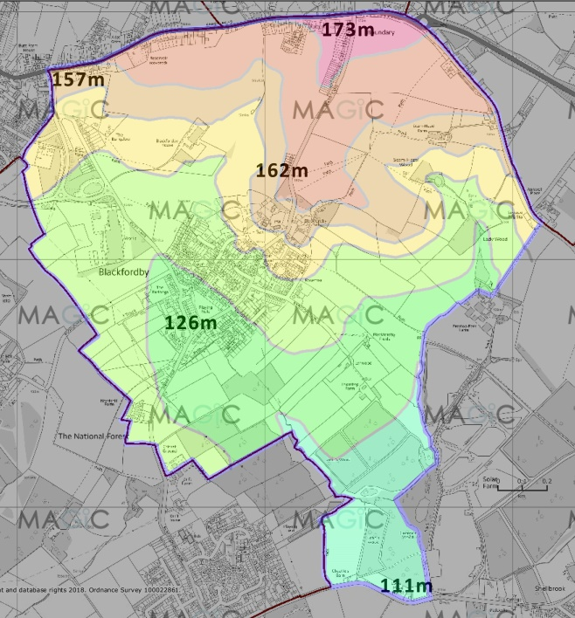
Figure 4: Geology (left) and topography of Blackfordby. Geological map adapted from British Geological Survey online mapping. Both © Crown copyright and database right. All rights reserved (100053272)
2018
Historic environment
4.50 Blackfordby’s developed, as a ‘dark ages’ nucleated settlement, Norman manorial and ecclesiastical property, medieval township, enclosed aristocratic estate, and an area of pre-industrial mining and 19th – 20th century industry.
Natural environment
4.51 Blackfordby’s development means that few and diminishing wildlife habitats exist. However, historical complexity combined with varied topography does mean that the Plan Area has a wide range of small-scale, semi-natural habitats, all of which make a significant contribution to local and national biodiversity. The southern section of the Plan Area has, since 1990, been planted as part of the National Forest; this adds further biodiversity potential to the already well-wooded surroundings of the village.
Existing environmental designations
4.56 The Plan Area is located in National Character Area (NCA) 71 Leicestershire and South Derbyshire Coalfield (defined by Natural England for Planning purposes) and across two landscape types (‘enclosed farmlands’ and ‘coalfield village farmlands’) as mapped by NWLDC. There are ten Listed Buildings, 12 further sites and features of historic significance (Leicestershire & Rutland Historic Environment Records and/or Historic England), 11 areas of Priority Habitat (as defined by Natural England), and some 14 validated and candidate Local Wildlife Sites identified in a Phase 1 Habitat Survey (Leicestershire & Rutland Environmental Records Centre / NWLDC, 2009). The historic core of the village is a Conservation Area (2001).
4.57 Special mention should be made to the river Mease. Though it is not located within the Plan Area the majority of the Plan Area lies within the catchment of the river. The river Mease is a designated Special Area of Conservation (SAC), a European level designation, as well as a Site of Special Scientific Interest (SSSI). These designations reflect the important species, such as the spined loach, and the habitats it supports. As a SAC and SSSI, the river Mease is a strictly protected site. Environment Agency monitoring has revealed high phosphorous levels in the river Mease. This has required restrictions on development in the catchment area, including the Plan Area.
4.58 The District Council is working with a range of partner organisations (The Environment Agency; Natural England; Severn Trent Water; South Derbyshire District Council; and Lichfield District Council) to address this problem, including plans and strategies which will allow development to take place within the river Mease catchment area whilst ensuring that the integrity of the river Mease is protected. Policy En2 in the Local Plan reflects this joint approach and is supported by this Plan.
Environmental inventory
4.59 An environmental inventory (Appendix 5) of Blackfordby was carried out between June and September 2018. The work comprised two elements:
- Review of all existing designations and available information, and
- Fieldwork to identify sites and features of natural and historical environment significance in the context of the Plan Area.
4.60 The data collected from the site surveys and from existing information was used to score each site and evaluated using the nine criteria for Local Green Space selection in the NPPF (2018) (See Appendix 6):

Sites qualifying for more than one designation:
Because of the assessment criteria and methodology employed in this Plan for identifying sites of environmental significance and protection, some sites qualify for two or more of the categories Local Green Space, Important Open Space and Site of Environmental Significance. The designations are not exclusive, as follows:
Local Green Space (LGS): score highest overall; the designation is ‘a matter for local discretion’ (NPPF Guidelines 2019). Criteria are a combination of community value and factual evidence, so can overlap with IOS/OSSR designation and/or wildlife and history evidence (SES)
Important Open Space (IOS): Score high under community value criteria and are designated or candidate OSSR sites. Can also be LGS (the statutory protection afforded does not affect OSSR status and amenity value) or SES (which is a fact-based designation unaffected by function as an important open space)
Site of Environmental Significance (SES): Score high for their historical or ecological (wildlife) features. They are either existing designations by statutory bodies (Natural England, Historic England, Leicestershire County Council) or potential/candidate sites for similar designation in the Plan. The evidence for these sites’ significance is a matter of fact (the habitats, species and features exist). Both LGS and IOS/OSSR can have historical and wildlife significance that should be taken into account in the Planning system irrespective of any higher-level status and level of protection.
Site-specific policies
Local Green Spaces
4.61 Of the approximately 152 parcels of open land in the Plan Area, 39 were identified as having notable environmental (natural, historical and/or cultural) features. These sites were scored, using the nine criteria for Local Green Space designation noted in the NPPF (2019).
4.62 Three sites score 75% (18/24) or more of the maximum possible and meet the essential requirements for designation as Local Green Space as outlined in the NPPF, paragraph 100. Their statutory protection will ensure that these most important places in Blackfordby’s natural and human environment are protected for future generations. Respondents to the Neighbourhood Plan survey strongly supported the protection of Local Green Spaces; especially the Recreation Ground and football pitch.
Figure 5: Local Green Spaces
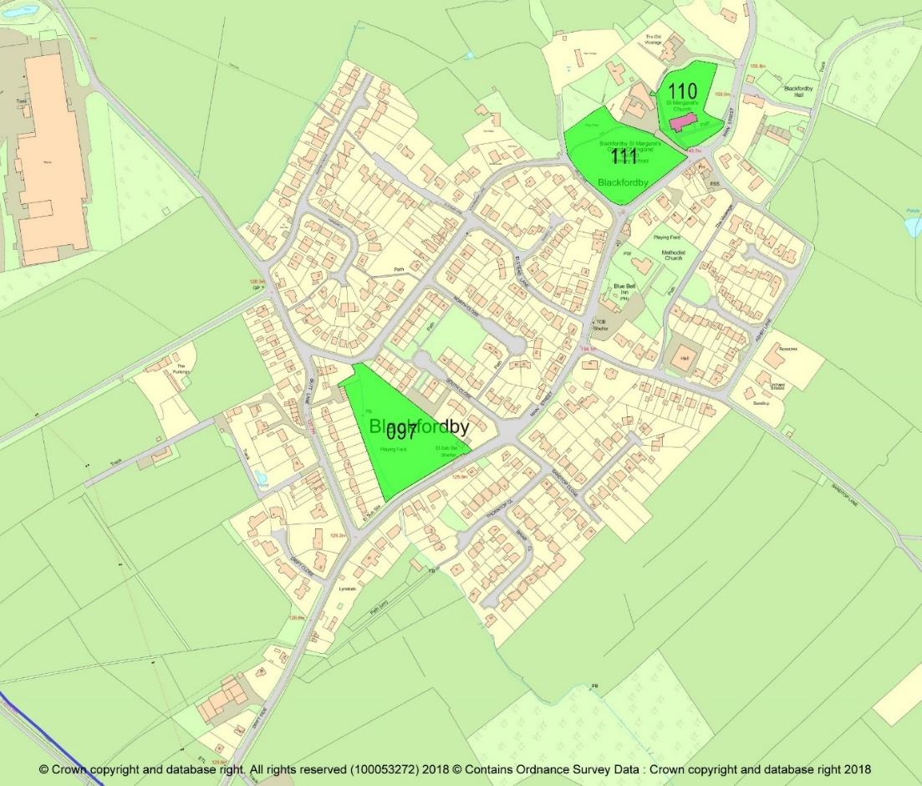
POLICY ENV 1: PROTECTION OF LOCAL GREEN SPACE – Development proposals that would result in the loss of, or have an adverse effect on, the following Local Green Spaces (details above; map fig. 5) will not be permitted unless the development is consistent with Green Belt policy as set out in the NPPF.
- St Margaret of Antioch Churchyard
- Blackfordby Recreation Ground
- Cow Close Recreation Ground/ Football pitch

Sites of environmental significance
4.63 A group of inventory sites scores highly for ‘history’ and ‘wildlife’ (scoring at least 3/4 in either criterion) but, because their community value scores are not high enough, they are not eligible for Local Green Space designation. The features for which the identified sites have been noted in the environmental inventory (Appendix 5). The map (Figure 6) shows their locations. This inventory will be reviewed as part of the regular monitoring of the Neighbourhood Plan.
4.64 Local benefit: in Policy ENV 2, the benefits of a development do not include those relating to a developer’s business plan or profitability, or to partisan political advantage. The intended reference is to demonstrable benefits to the Plan Area, e.g. housing need, infrastructural enhancement.
4.55 The historical environment sites comprise a) sites with extant and visible archaeological or historical features recorded in the Leicestershire and Rutland Historic Environment Records (L&RHER) and Historic England databases and b) other sites of archaeological, historical and social significance identified in local records and during the inventory process.
4.56 The natural environment sites comprise a) those where priority habitats occur (Natural England mapping) or where biodiversity action plan (BAP) species have been recorded as breeding or as regular visitors; b) sites identified as ecologically significant by Leicestershire Environmental Records Centre, including Local Wildlife Sites, potential Local Wildlife Sites and important habitats, and c) sites identified during the inventory process as being of high biodiversity significance in the context of the Plan Area.
Figure 6: Sites of historical and natural environment significance
Brown = historical environment sites and features (existing and new designations); Blue-green = Priority Habitat sites (Natural England); Bright green = Local Wildlife Sites (existing designations)
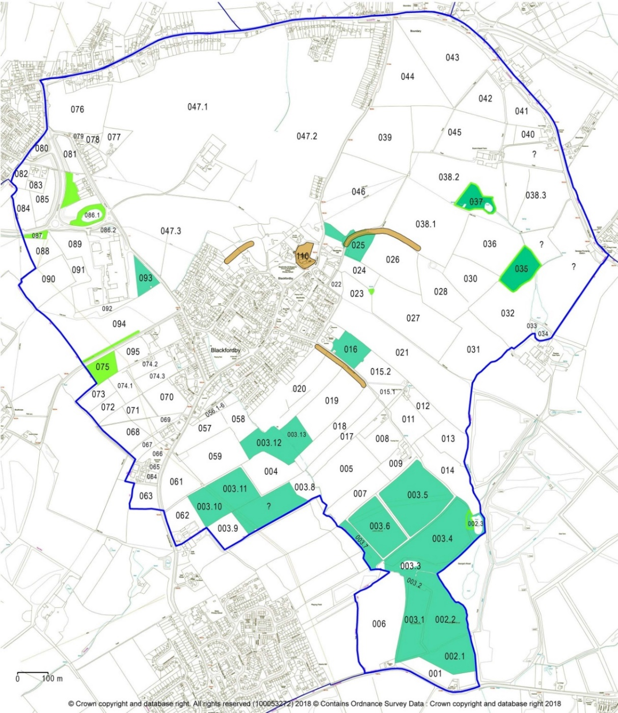

POLICY ENV 2: PROTECTION OF SITES OF ENVIRONMENTAL SIGNIFICANCE – The sites listed in Appendix 5 and mapped (Figure 6) have been identified as being of high significance for their environmental features. These can be natural and/or historical.
- Where there are natural features, these are ecologically important in their own right,
- Where there are historical features, these are extant and have visible expression (or there is proven buried archaeology on the site), and they are locally valued.
Development proposals shall demonstrate that the significance and value of the species, habitats or historical features present have been balanced against the local benefits of any development that would affect or destroy them.
Important Open Spaces
4.57 A group of sites scored highly in the inventory (scoring at least 75% of the possible total under the relevant criteria) for their outstanding community value. They have been identified in fieldwork, community consultations and from local information.
4.58 Open Space provision in Blackfordby appears (North West Leicestershire Open Space Audit, 2008) to be well below acceptable standards; the reality, however, is that there are nine functioning open spaces in several categories, some with long-standing formal or informal use and access. Some residents regret the recent (2018) conversion of a tenth amenity green space for development. Irrespective of their Open Space Audit status, the remaining sites’ value as open space within and close to the built-up areas and/or their current, or potential, value as community resources is recognised in this Policy.

POLICY ENV 3: IMPORTANT OPEN SPACES – The following sites (as defined in Figure 7)are of high value for sport, recreation, amenity, tranquillity or as green spaces within the built-up area. Development proposals that result in their loss, or have a significant adverse effect on them, will not be supported unless the open space is replaced by equivalent or better provision in an equally suitable location, or unless it can be demonstrated to the Local Planning Authority that the open space is no longer required by the community.
Blackfordby Playing Field (inventory reference 097) – NWLDC Open Space Audit (2008) site (Local Open Space)
North Close/South Close Open Space – remaining area (099) NWLDC (Amenity open space)
Methodist Chapel access greenspace (101) Owned by the Chapel (Amenity open space)
Methodist Chapel playing field (103) Owned by the Chapel (Amenity open space / playing field)
Hall Close open space (104) (Amenity open space)
Methodist Chapel ‘churchyard’ (105) Owned by the Chapel (disused burial ground / cemetery OR Amenity open space)
Thorntop Close open space (109)
Blackfordby recreation ground and children’s play area (‘The Rec’) (111) (Local Open Space – previously common land; also functions as the school playing field)
Churchyard of St Mary of Antioch (110) (Cemeteries)

Figure 7: Important Open Spaces
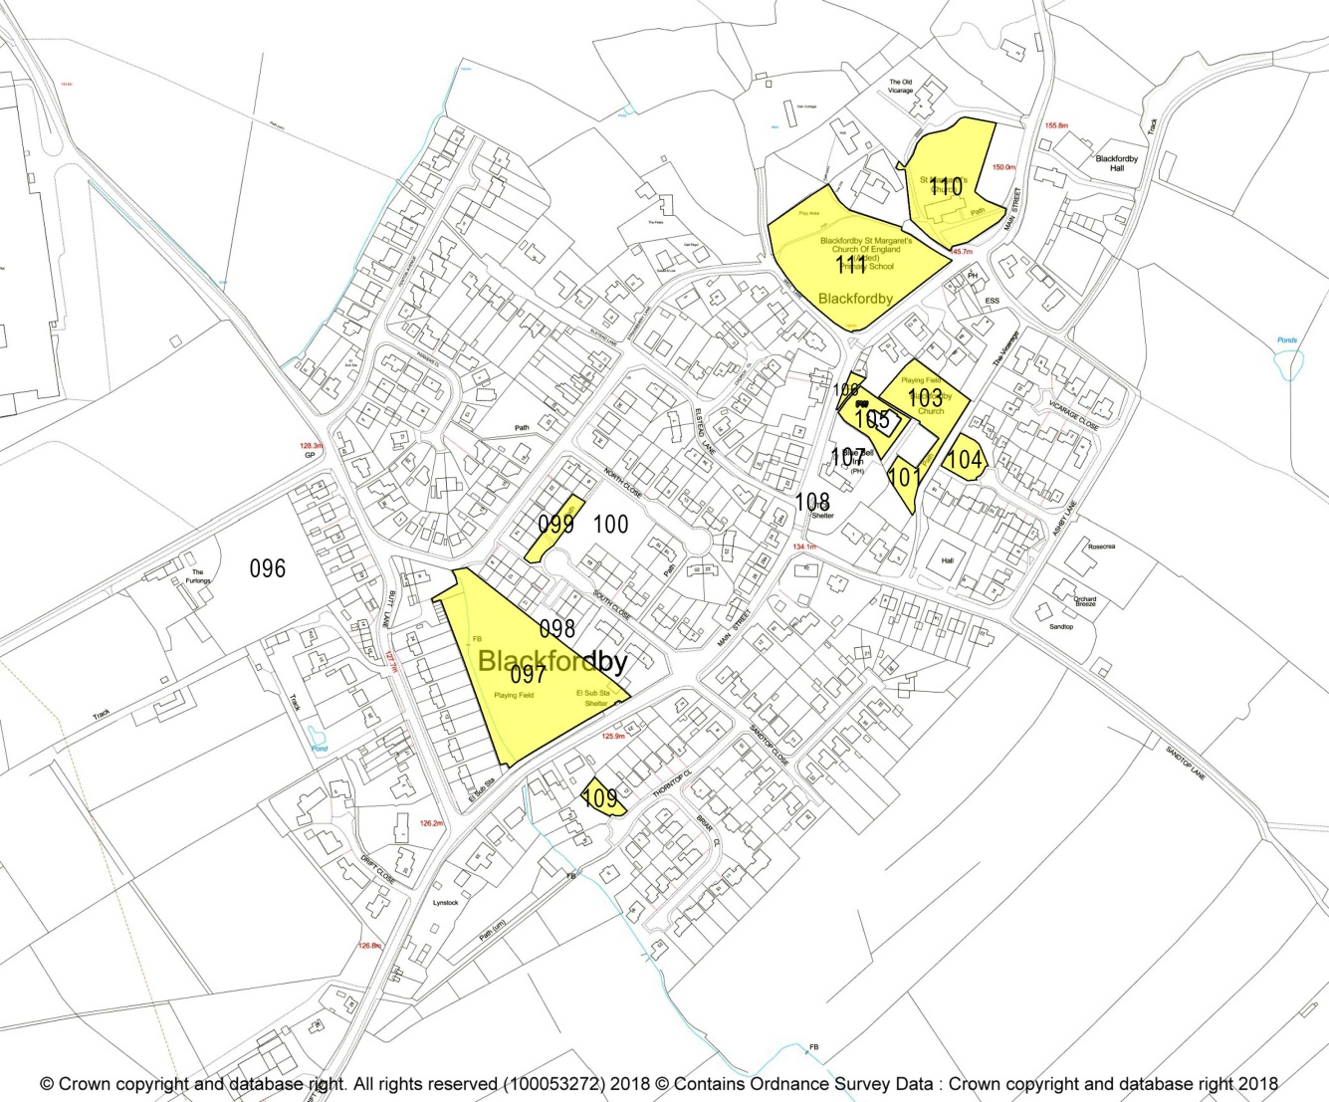

Buildings and structures of local significance
LISTED BUILDINGS
4.59 Ten buildings and structures in the Plan Area have statutory protection through Listing at Grade II (Appendix 7). New development will be required to take into account their settings as defined, on a case-by-case basis, by Historic England.

Figure 8: Listed Buildings in Blackfordby (for protection of their settings)
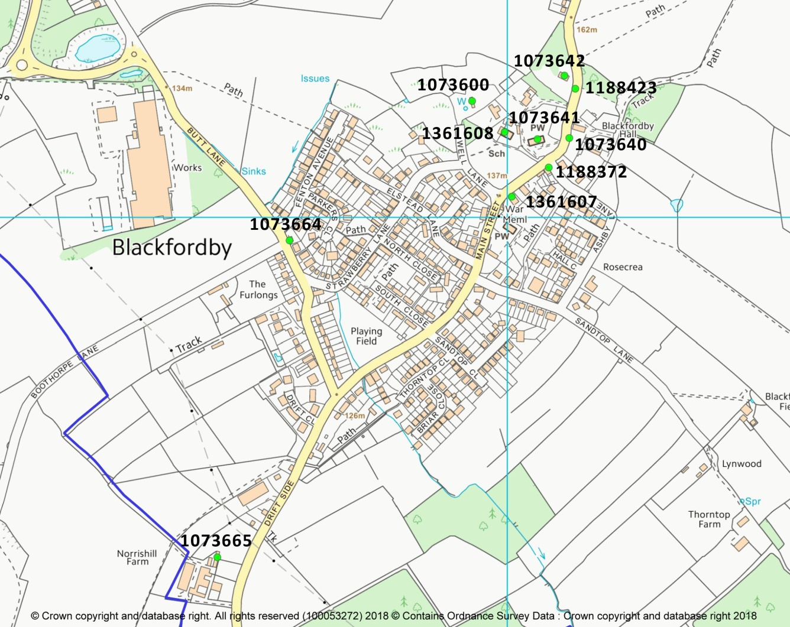

LOCAL HERITAGE ASSETS
4.60 The Conservation Area Appraisal for Blackfordby (NWLDC, 2001) identified a number of non-Listed buildings and structures in the built environment of the village that were considered to be of local significance for architectural, historical or social reasons. The environmental inventory for this Neighbourhood Plan updated this list adding 2 more.
4.61 Their inclusion in this Neighbourhood Plan records them in the Planning system as non-designated key buildings, following the recommendations of Historic England and in conformity with NPPF paragraphs 184 and 197 and NWLDC Local Plan policy He1, to which the Neighbourhood Plan Policy adds detail.
4.62 Planning Practice Guidance, updated in July 2019, confirms that the process through which non-designated assets may be identified, includes neighbourhood plans (paragraph 040 Reference ID: 18a-040-20190723.
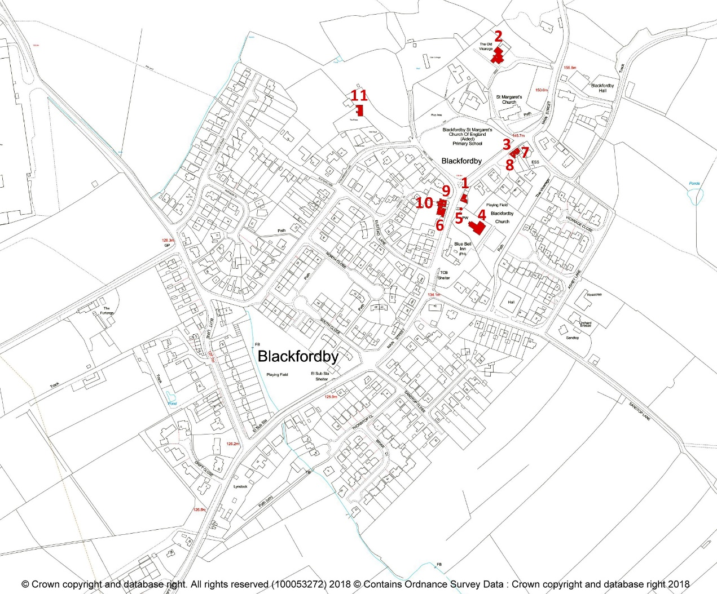
Figure 9: Local Heritage Assets for Blackfordby (non-designated key buildings)

POLICY ENV 4: BUILT ENVIRONMENT: NON DESIGNATED HERITAGE ASSETS – The structures and buildings listed here (map above) are non-designated buildings noted as significant and characteristic in the Blackfordby Conservation Area Appraisal 2001. They are important for their contribution to the layout and characteristic mix of architectural styles in the village, and their features and settings will be protected wherever possible.
There is a presumption against the loss or harm to the heritage asset unless if it can be demonstrated that the public benefit of the development proposal significantly outweighs the harm caused.
Development proposals are required where possible to enhance the historic features and significance of non- designated heritage assets and their settings and to demonstrate how proposals would result in a net enhancement to the historic significance of heritage assets and their setting
1. Former National School (1843)
2. Old vicarage, No.4 Main Street (1878)
3. 7 Main Street
4. Methodist (Wesleyan) Church, Main Street
5. Blackfordby spring, Main Street
6. 12 Main Street (Spring Cottage)
7. No. 5, Main Street
8. Blacksmith’s Cottage, No.9 Main Street
9. No.6 Main Street
10. No.8 Main Street
11. The Fields, Well Lane

Ridge and furrow
4.62 Like many other villages in Leicestershire, Blackfordby was established, probably in the 8th century, when a change in the way society was organised led to people who had previously lived in scattered farmsteads moving into what historians call ‘nucleated settlements’. Farming was centralised to match, with (usually) three huge open fields radiating from the village. The fields were managed using a system of crop, livestock and fallow rotation (woodland and meadows were separate), and were subdivided into many strips, whose ownership was allocated among the free and land-owning families. The strips were cultivated using the medieval plough, which – because it was not reversible – always turned the soil rightwards as the plough-team, pulled by oxen, went up and down the furlongs in clockwise fashion. The result, over many years, was to raise sets of ridges (up to 2m high) with deep furrows between them. This system prevailed in Blackfordby until the 16th century, when the arable open fields began to be enclosed and converted to permanent pasture. The modern reversible plough quickly obliterated most of the ridge and furrow, while in Blackfordby mining, quarrying and industry did the rest.
4.63 English Heritage (now Historic England) organised a survey of ridge and furrow sites in all Midland parishes in the late 1990s; the results were published in 2001. The two sets of maps show how much had been lost – 90% in most parishes – and more has been destroyed in the 21st century. Blackfordby’s agricultural and economic history puts it at the ‘worst’ end of the scale.
4.64 The maps of 1947, 1999 and 2018 (figure 10) show the decline: of the approximately 60 fields with ridge and furrow immediately after WW2, only two remain with clearly visible ridge and furrow, four more with faint traces (some of these had been missed in 1999).
Figure 10.1: Full extent of ridge and furrow c. 1947  (Reconstruction by R F Hartley, Leicestershire CC, 1985) | Figure 10.2: Ridge and furrow in 1999  Mapped for Turning the Plough 2001 (Historic England)
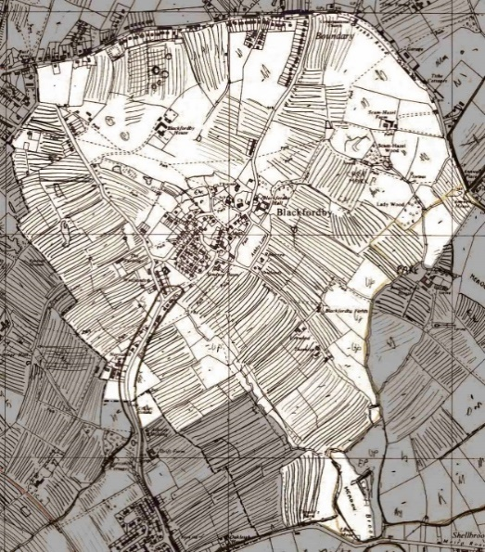 | 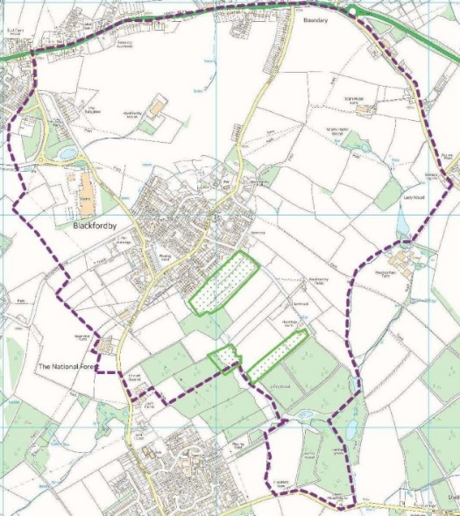

Figure 10.3 Surviving ridge and furrow in Blackfordby, 2018 Dark symbol = well-preserved; pale = trace
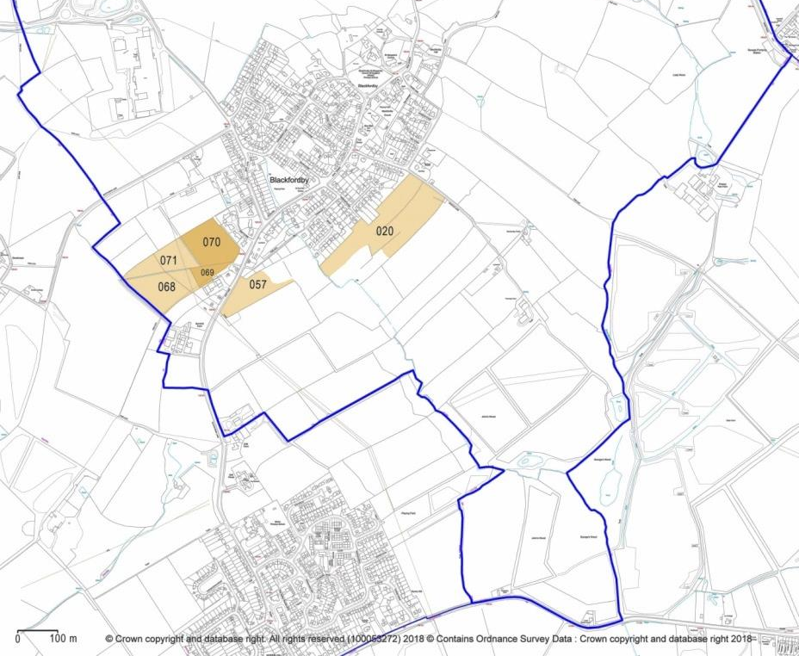
4.65 Following Historic England’s recommendation and practice, this Plan recognises all of these survivors as non-designated heritage assets. Every effort should be made to ensure that new development is located so that none of these few surviving areas is damaged or destroyed. The policy adds local detail to paragraph 135 of the NPPF and to NWLDC Local Plan policy He1(4).
POLICY ENV 5: RIDGE AND FURROW – The areas of ridge and furrow earthworks mapped above (Fig. 10.3) are non-designated heritage assets.
In weighing applications that directly or indirectly affect these assets, the provisions of the National Planning Policy Framework, July 2021, at Paragraph 3 shall apply.
General policies
Biodiversity and habitat connectivity
4.66 Blackfordby’s history and location means that, from an ecological point of view, it has a number of mainly small areas of significance for wildlife, together with the larger, developing area of deciduous and mixed woodland in the parts of the National Forest in the Plan Area. The community wishes to protect and enhance these biodiversity sites and to increase the area for wildlife whenever possible. This Plan recognises three strategies, in conformity with the letter and spirit of relevant sections of the Wildlife & Countryside Act 1981, the Conservation of Species and Habitats Regulations 2010 and European Council Directive 92/43/EEC of 21 May 1992 on the conservation of natural habitats and of wild fauna and flora, for improving the Blackfordby situation:
- Conserving the remaining areas of semi-natural habitat
- Encouraging and taking part in biodiversity enhancement through habitat creation.
- Recognising opportunities for species and habitat connectivity by designating two wildlife corridors
4.67 Connectivity is a recognised essential component of biodiversity protection and enhancement: actual and potential wildlife corridors should be taken into account by the Planning system, to allow isolated pockets of habitat to re-connect with their neighbours so that viable populations of currently threatened English species can be maintained. This connectivity can travel through built up areas through watercourses and residential gardens, as demonstrated in Wildlife Corridor 1.
POLICY ENV 6: BIODIVERSITY AND HABITAT CONNECTIVITY – Development proposals will be expected to safeguard locally significant habitats and species, especially those protected by relevant English and European legislation, and, where possible, to create new habitats for wildlife.
Development proposals should not damage or adversely affect the habitat connectivity provided by the wildlife corridors:
- From John’s Wood, (National Forest) along the brook northwest through the village and around its north-western edge to the areas of grassland and woodland on the crest of the village escarpment
- From George’s Wood, National Forest, north along the brook to Lady Wood and Scam-Hazel Wood.
Figure 11: Wildlife corridors
Corridors = turquoise; existing habitat sites = green
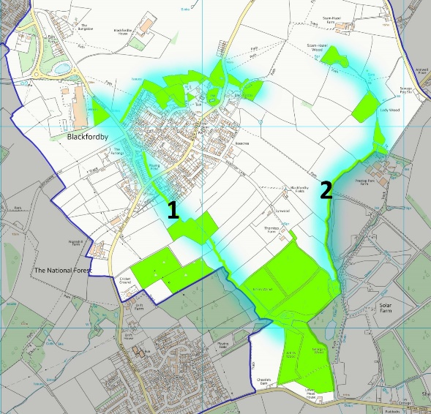
COMMUNITY ACTION ENV 1: BIODIVERSITY - Ashby de la Zouch Town council will work with community groups, landowners, funders and other organisations to enhance the biodiversity of the Plan Area by creating and/or managing habitat sites (e.g. wildflower meadows, woodland, wetland) on suitable parcels of land.
Important Views
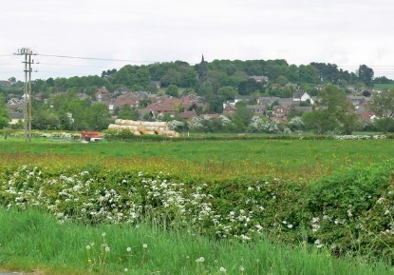
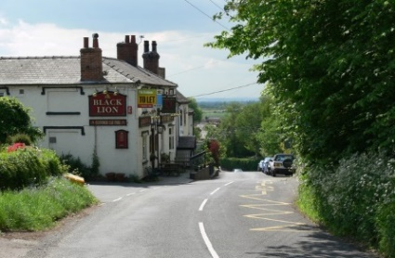
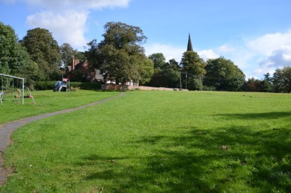
4.68 Consultation during the Neighbourhood Plan’s preparation identified a widely held wish to protect Blackfordby’s rural setting, and its relationship with the surrounding landscape. One of the main ways in which residents expressed this wish was by describing several highly-valued views within the village and toward it from the surrounding countryside. These consultation findings were supported by the environmental inventory, which although principally aimed at identifying sites of environmental significance also confirmed the sight-lines of the suggested views and mapped them (below, Figure 12). Arrow sizes represent the different length and scope of the views.
View 1 View 2 View 3

POLICY ENV 7: PROTECTION OF IMPORTANT VIEWS – The following views (Figure 12) are important to the setting and character of the village. To be supported, development proposals must not significantly harm them, and should include a statement of proposed mitigation and/or protection of views.

- View northeast over the Recreation Ground to the parish church and school
- View south along Main Street from the northern edge of the Conservation Area into open countryside beyond
- From Drift Side and the cricket ground north to the village in its hilltop setting

Figure 12: Important views.

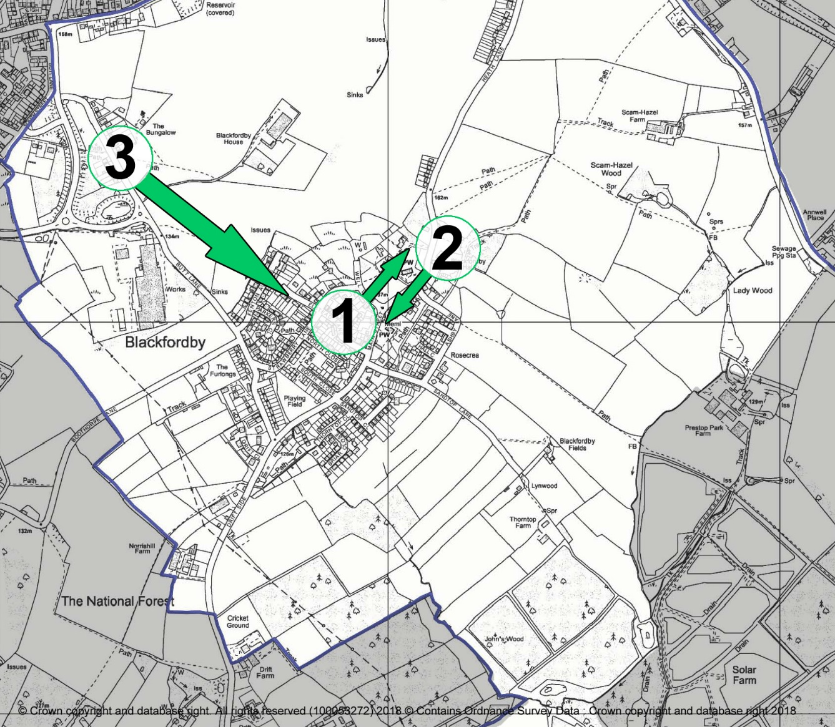
Renewable energy generation infrastructure
4.69 North West Leicestershire Local Plan Policy Cc1 (2a) states that ‘proposals for one or more wind turbines will be supported where (a) the site lies within the area identified as suitable [for large turbines] … on the policies map. However, the legend on the map to which the policy refers states that: It should be noted that those areas identified as potentially suitable have only been the subject of detailed assessments in respect of wind speed and proximity to residential properties. No detailed assessment has been undertaken in respect of other factors such as landscape character or potential impacts upon heritage assets or their settings. Any proposal will need to consider such as part of a detailed assessment. The Leicester and Leicestershire Landscape Sensitivity … Study 2017 which was used in preparation of the Local Plan lists the following ‘attributes and features of the landscape [which] would be particularly sensitive to development’ in the Coalfield Landscape Character Area, in which Blackfordby is located:
- Steep areas of landform associated with streams.
- Valued habitats, including the River Mease which is internationally designated as a Special Area of Conservation and areas of heathland and wetland.
- Well-wooded character, with numerous areas of new planting as part of the National Forest initiative e.g. the 186-hectare Queen Elizabeth Diamond Jubilee Wood west of Coalville.
- Respect the form and vernacular of existing settlements within the landscape, including the setting of Conservation Areas.
4.70 All these features are characteristic of the landscape of Blackfordby.
4.71 This Neighbourhood Plan adds detail to the Local Plan and provides the environmental evidence to which consideration should be given when assessing proposals for such developments.
4.72 Although there were mixed views about renewable energy infrastructure expressed at the open event which shared the draft policies on 9 March 2019, it was unclear whether this represented a dislike of the policy itself or an objection to planning applications for renewable energy. The Regulation 14 process did not result in any objections to this policy it is therefore retained.
POLICY ENV 8: RENEWABLE ENERGY GENERATION INFRASTRUCTURE – Small-scale renewable energy technologies, including solar and wind generation infrastructure will be supported, subject to their complying with the environmental protection conditions listed in North West Leicestershire Local Plan Policy Cc1 (1).
Large and medium scale turbine developments will only be supported, if in conformity with North West Leicestershire Local Plan Policy Cc1 (2a) and the detail and legend on the map of suitability for large and medium scale wind energy to which the policy refers, and Policy Cc1 (2b).
Proposals for wind turbines shall be supported with a Landscape and Visual Impact Assessment (LVIA) to provide an assessment of the landscape significance of the site and the likely impact of development.
Comprehensive restoration of the land is required following use including a net improvement in the landscape quality of the site where feasible and appropriate.
Area of Separation
4.73 One of the most important characteristics of Blackfordby is that, despite the pressures of industry, mining and new housing, it is still a rural, nucleated village set within its historic parish and surrounded by open countryside. This is very highly valued by residents.
4.74 The principle of maintaining the identity of individual settlements by designating Areas of Separation, as applied by NWLDC in Local Plan policy En5 for Coalville and Whitwick, is applied in this Neighbourhood Plan in order to prevent the coalescence of Woodville and the A511 corridor with Blackfordby.
POLICY ENV 9: LOCAL AREA OF SEPARATION – To retain the physical and visual separation between Blackfordby and Woodville and the A511 corridor, an area of open land will be designated as a Local Area of Separation as shown in Figure 13. Development proposals in the identified gap should be located and designed to maintain, and wherever possible, enhance the separation of the identified areas.
Figure 13: Local Area of Separation

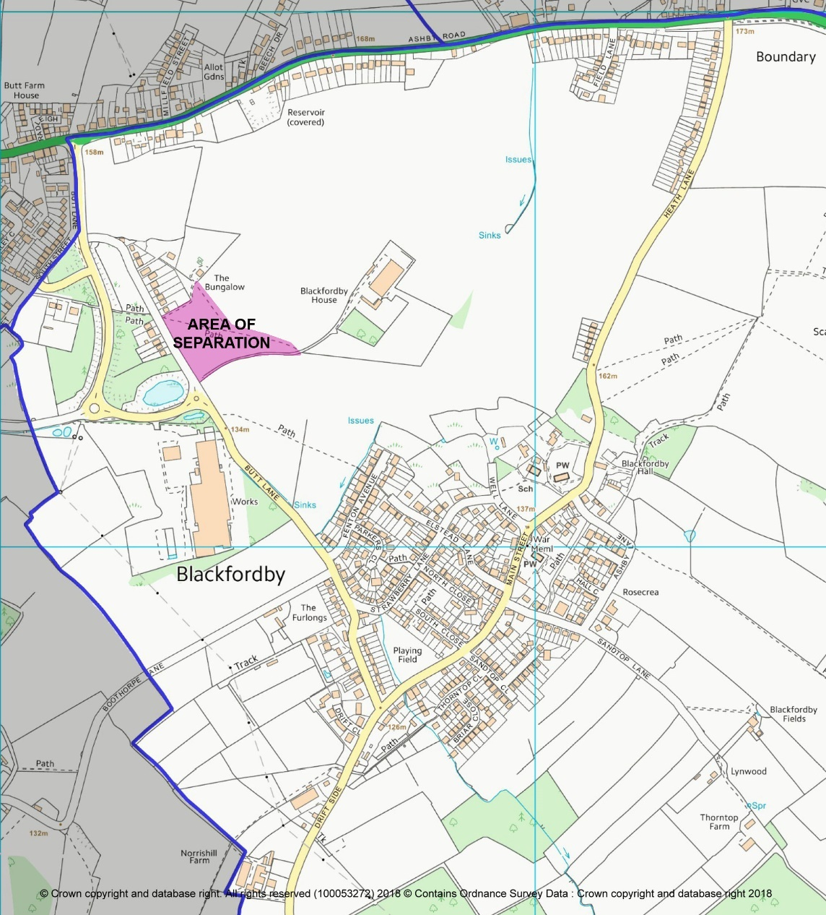

D. Community Facilities and Amenities
- 4.75 The community facilities and amenities that exist in Blackfordby make a significant contribution to its vitality and sense of community. They have a positive impact on its sustainability, enhancing the quality of life for residents and providing the potential for social interaction.
- 4.76 To promote the on-going prosperity of Blackfordby, it is essential that the village retains existing community facilities and amenities and continues to provide local services that will sustain the vitality of the community. Development leading the removal of a community facility can only happen where there is no longer a need or demand for the facility or it is not financially viable or able to be supported by the community, such viability and support includes fundraising and volunteering by parishioners and others.

St. Margaret’s Primary School
4.77 A classic Victorian school building situated on a hillside alongside other village assets that include the parish church and recreation ground. The school is currently at 98% of the 110 pupil capacity. The catchment of Blackfordby & Boothorpe accounts for 32% of pupil numbers. Of the 68% non-County/Blackfordby pupils a high proportion currently come from Derbyshire and Woodville, over the County boundary.
4.78 Apart from Sunday when the School playground is used as a car park there is no car parking at the school site, this has created problems with cars parking on Main Street. A walking bus from the Village Hall car park was introduced to help with these issues but residents report there are difficulties with school visitors/staff parking around the school.
4.79 There is suitable land abutting the north west of the school with potential for developing into a secure and purpose made activity space. This is understood to be owned by the Church and managed by the Parochial Church Council (PCC). At the time of writing this document the school has requested the PCC to grant permission to use this land; the decision is awaited. This land includes an old wooden Scout hut which is currently unusable. The playing field and/or the Scout hut grounds are essential for the school’s activities.
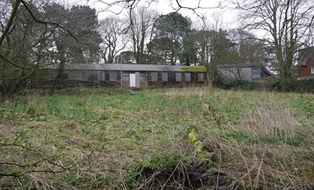
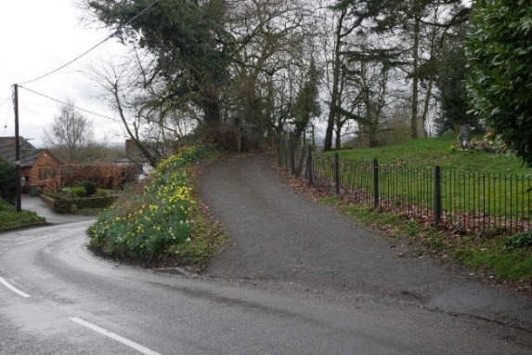
The only vehicle access to the church and grave yard, off a steep section of Main Street.
The disused Scout Hut abutting the Junior School

Parish Church of St Margaret of Antioch
4.78 Worship has taken place on this site for 1,000 years and the present church replaced an ancient Chapel of Ease and was built in 1858. The churchyard is still in use but only 8 burial plots remain, although there is sufficient room for ashes.
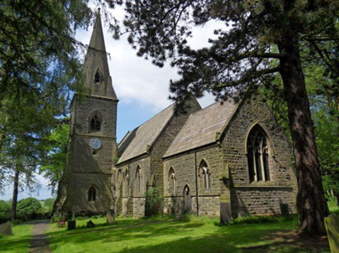

Blackfordby Methodist Church
4.79 The chapel was built in 1929 on a field of around 2 acres given to them by the Joyce family and is located on Main Street. The Chapel owns land to the rear of the Church that is leased out to a plant nursery and a seven-aside football pitch which is used by Blackfordby School.

Village Hall
4.80 The hall was opened in 1971 and is very much part of village life and is heavily used by the local community. It also has the only car park in the village.

The Old School Room
4.81 This was the original school room for the village. It is managed as a charitable trust and there has recently been a change of executors, along with re-branding and a change of name to the “Old School Room” to reflect the history of the building. The plan is to fund raise to update and potentially extend the building so that it can be used for all sectors of the community.
The Village Spring
4.82 Outside of the old school rooms is a paved area with a historic spring and a second war memorial

Village pubs
4.83 There were two public houses in the village:
- The Black Lion is a successful and popular pub at the heart of the village.
- The Bluebell – Until recently this was owned by Punch Taverns but has recently been sold. In 2019 a planning application was submitted to demolish the pub and to erect 6 new dwellings.

Defibrillator
4.84 There is a defibrillator located on the left-hand side wall of the Village Hall, fixed there early 2018.
Football field
4.85 Ashby de la Zouch Town Council own the village football field which is used by local clubs.
Recreation Ground
4.86 Adjacent to the village school, on a steeply sloping hill side, is a recreation ground with a small assortment of swings, slides and play equipment. This is well used by the village, with a village picnic held there in 2019. The grassed playfield area is utilised by the adjacent school for sports activities.
Post Office
4.87 A mobile post office visits the village once a week.
Other Community facilities
4.88 Consultation has highlighted strong support for the provision of a shop within the village and if deemed necessary by the Local Education Authority for an extension to the existing school to ensure the school can cope with children moving in to new dwellings being built in the village.
4.89 Appendix 8 provides further information on existing community facilities.
POLICY CFA1: COMMUNITY FACILITIES AND AMENITIES - Development leading to the loss of existing community facilities (as described in Section D above) will not be supported unless it can be demonstrated that:
- There is no longer any need or demand for the existing community facility; or
- The existing community facility is, demonstrably, no longer economically viable or able to be supported by the community; or
- The proposal makes alternative provision for the relocation of the existing community facility to an equally or more appropriate and accessible location within the Plan Area.
Proposals that improve the quality and/or range of community facilities, will be supported provided that the development:
- Will not result in unacceptable traffic movements or disturbance to residential properties or generate a need for parking that cannot be adequately catered for, and
- Is of a scale appropriate to the needs of the locality and conveniently accessible for residents of the village wishing to walk or cycle, and
- Takes into full account the needs of people with disabilities.

Community Action CFA1: The Town Council will work with Leicestershire County Council and Parochial Church Council to secure the retention and working of the War Memorial Clock as a community asset and as a War Memorial.
Community Action CFA2: The Town Council will work with the wider community to co-ordinate and develop events for the community.

E. EMPLOYMENT

Support for existing businesses and employment
4.90 For any community to flourish, good employment opportunities are essential. There are already several local employers and businesses within Blackfordby. Blackfordby is a rural community yet close to several significant employment centres, such as Ashby de la Zouch, Swadlincote, Burton and Derby. Existing local businesses and employment include a pub, garden nursery, design companies, car dealership, builders, pipe manufacturer, farms (including the alpaca farm) and the Primary School.
4.91 Most existing businesses in Blackfordby do not employ more than one or two people locally. A small number of businesses employ larger numbers of workers, mostly drawn from outside Blackfordby such as the Primary School and pipe manufacturer.
4.92 There is also a small range of local residences that have businesses in the village or work from home. These include landscaping, health and safety consultants, graphic designers and a signwriter. In addition, the village hall is used by local people for paid activities such as gymnastics, badminton, dancing and public meetings.
4.93 It is important that the Neighbourhood Plan protects and strengthens the economic base within Blackfordby, existing employment should be proactively encouraged and supported to develop where appropriate reflecting the growth of Blackfordby and its residents.
POLICY BE1: SUPPORT FOR EXISTING BUSINESSES & EMPLOYMENT OPPORTUNITIES - There will be a strong presumption against the loss of commercial premises or land that provides employment. Applications for a change of use to an activity that does not provide employment in offices, industry or storage/distribution will only be supported if it can be demonstrated that:
- The commercial premises or land in question has not been in active use for at least six months; and
- The commercial premises or land in question has no potential for either reoccupation or redevelopment for employment generating uses (offices, industry or storage/distribution) and as demonstrated through the results both of a full valuation report and a marketing campaign lasting for a continuous period of at least six months.

Support for new businesses and employment
4.94 New employment initiatives can help to boost and diversify the local economy, thus providing more local employment opportunities.
4.95 Any new employment initiatives should be sensitive to the character of the Plan Area. Employment proposals should only be seen as acceptable if they avoid harmful impacts such as increased traffic, parking.
POLICY BE2: SUPPORT FOR NEW BUSINESSES AND EMPLOYMENT- In supporting additional employment opportunities, new development will be required to:
- Fall within the limits of development for Blackfordby, unless it relates to small scale leisure or tourism activities, or other forms of commercial/employment related development appropriate to a countryside location or there are exceptional circumstances;
- Where possible, be sited in existing buildings or on areas of previously developed land;
- Avoid unacceptable traffic movements and ensure that appropriate parking provision is made;
- Be of a size and scale not adversely affecting the character, infrastructure and environment of the village itself and the Plan Area, including the countryside;
- Not involve the loss of dwellings;
- Contribute to the character of the local built environment and the vitality of the local area.

Home working
4.96 There is an increasing national trend to home working and therefore, as Blackfordby develops and grows, it too will need to support more residents who are working from home. This will include good broadband infrastructure and also opportunities within the village to allow businesses to develop and grow. The provision of business hubs, meeting spaces and workshops could create opportunities for residents.
4.97 The Neighbourhood Plan recognises and supports the increasing numbers of people who conduct their businesses from home. This is reflected through policies to encourage a diverse range of housing types and support for proposals to extend or convert suitable buildings to accommodate such businesses. It will be important that any future housing and developments within the village should consider accommodation that can promote home working and local employment, in many cases planning permission is not required for home working. This policy will apply where planning permission is required.

POLICY BE3: HOME WORKING – Where planning permission is required proposals for the use of part of a dwelling for office and/or light industrial uses, and for small-scale free-standing buildings within its curtilage, extensions to the dwelling or conversion of outbuildings for those uses, will be supported where:

Such development will not result in unacceptable traffic movements and that appropriate parking provision is made;

No significant and adverse impact arises to nearby residents or other sensitive land uses from noise, fumes, light pollution, or other nuisance associated with the work activity; and

Any extension or free-standing building shall be designed having regard to policies in this Plan and should not detract from the quality and character of the building to which they are subservient by reason of height, scale, massing, location or the facing materials used in their construction.

Tourism and Accommodation
4.98 Although geographically in the centre of the National Forest and at the junction of many local and long-distance footpaths, very little has been done to attract tourists to visit or stay in Blackfordby.
4.99 On the National Forest Way web site (https://www.nationalforestway.co.uk/) the section though Blackfordby is included in 7 of the 12 themed walk sections (ancient woodlands, attractive village, clay & coal, family fun, great views, open spaces and transformed land). There is, however, a lack of adequate car parking, no shops and one pub that serves snack food and is not open weekdays in the day time.
4.100 Except for Charnwood Alpacas, there is little to entice tourists to linger in Blackfordby or use it as a base, just a route through to busier towns, villages and tourist attractions (e.g. Conkers, Hicks Lodge, Moira Furnace). There are no known Bed & Breakfast nor “Airbnb” houses in Blackfordby.
4.101 Blackfordby is keen to extend a welcome to visitors whilst ensuring that their visit does not have a negative impact on residents - for example, in the context of traffic.
POLICY BE4: TOURISM- Support will be given to facilities to enhance and manage tourism where the development:
- Is of good quality design and contributes to the distinctive rural character of the Plan Area;
- Does not adversely affect the surrounding infrastructure, particularly local road networks, water supply and sewerage, and provides adequate parking facilities;
- Benefits the local community through, for instance, provision of local employment opportunities and improvements to local service provision, and is proportionate to the size of settlement in which it is located; and
- Where feasible, the development involves the re-use of existing buildings or is part of farm diversification.

Broadband and mobile phone infrastructure
4.102 The modern economy is changing and increasingly requires a good communications infrastructure to maximise technological advances. High-speed Internet connectivity is driving business innovation and growth, helping people access services, and opening new opportunities for learning. This is particularly important in a mixed business and rural setting, such as Blackfordby, where better broadband enables improved access to an increasing number of on-line applications and services, provided by the public and private sector. This can help to significantly reduce social exclusion and create business and employment opportunities.
4.103 According to SuperfastLeicestershire.org.uk, as of November 2017 Superfast Broadband is available to most of the Plan Area.
4.104 Mobile signals vary across Blackfordby.
POLICY BE5: BROADBAND INFRASTRUCTURE- Proposals to provide access to superfast broadband for businesses and households in Blackfordby will be supported.
Improvements to the mobile telecommunication network that will serve businesses and households within the Plan Area will be supported. Where new masts are installed, these should be shared, where possible, by more than one provider.
Any infrastructure improvements, possibly requiring above ground network installations, must be sympathetically located, designed to integrate into the landscape and not be in or near to open landscapes.
Development proposals should be supported with a Landscape and Visual Impact Assessment (LVIA) to provide an assessment of the landscape significance of the site and the likely impact of development.

F Transport, Connectivity and Traffic Management

Geographic and historical location
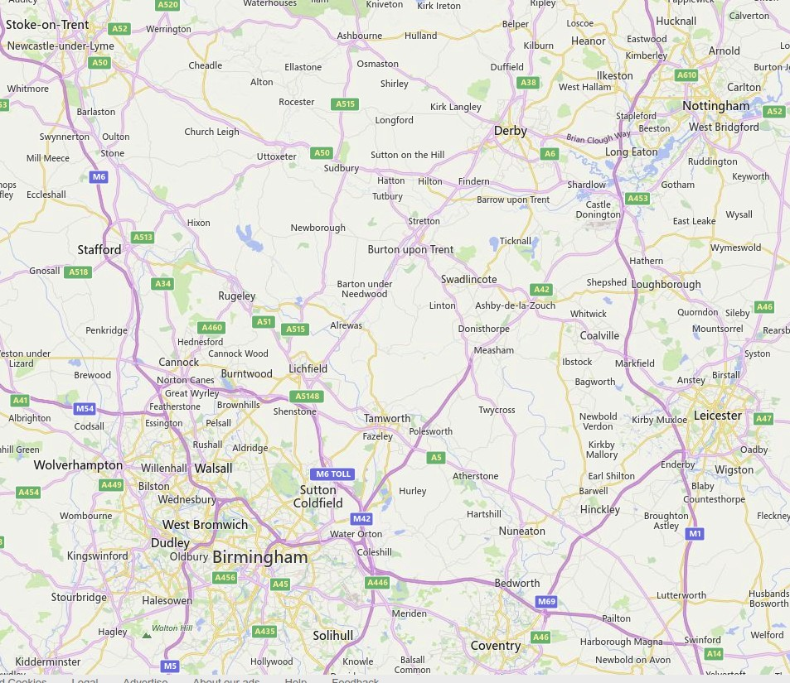
4.106 Blackfordby is sited on the ancient crossroads of footpaths, tracks and roads directly aligned between the cities of Leicester to Stoke on Trent West/East and Derby to Coventry North/South. More locally it carries the direct routes and pathways between the farming, mining and markets towns of North West Leicestershire and the East Staffordshire and South Derbyshire industrial centres of Swadlincote and Burton upon Trent.

4.107 Blackfordby is well served for road and public transport. It has excellent road connections and is close to the M1, M42 and A50. It is within half an hour (on a fair day) to main line train stations at Tamworth and Burton upon Trent, and equally to Birmingham and East Midlands airports.
4.108 There are three buses per hour passing through in each direction between Burton upon Trent and Ashby de la Zouch (two of these going on to Leicester). The Arriva company has two routes with one route actually passing through the village. The Arriva 29 route has recently been changed to use Butt Lane rather than Main Street and Heath Lane.

Roads and Pavements
  - 4.109 The A511 is the main Leicester to Burton route and passes along the northern edge of the Plan Area. Heath Lane connects the village to this route at Boundary, whilst Butt Lane/Hepworth Road connects the village with the A511 at Woodville. Driftside is the other route in to the village and comes from Norris Hill/Moira. The only access to the hamlet of Boothorpe is from Butt Lane in the village along Boothorpe Lane. Boothorpe does not form part of the Plan Area as it is within the neighbouring parish of Ashby Woulds.
  - 4.110 Residents have expressed concerns about speeding in the village and this has been looked at in detail by the Community Facilities, Transport and Employment Focus Group. Further details of their analysis of transport and speeding in the village can be found in Appendix 9.
  - 4.111 A Leicestershire Police Survey in 2015 highlighted serious and persistent excessive speeds on the following 30mph limit roads:
  - Drift Side – 57% above the speed limit, with 6% well over 40mph
  - Butt Lane – 81% above the speed limit, with 17% well over 40mph
  - Heath Lane – 94% above the speed limit, some were over twice the limit and the mean speed was 40mph.
  - 4.112 Leicestershire Police conducted a survey in January 2019 on Heath Lane which produced similar results with 94.8% being above the speed limit and the mean speed was 38mph.
  - 4.113 Both Heath Lane and Butt Lane are used when the A511 is busy as a short cut/ rat run.
  - 4.114 Heath Lane has a very narrow pavement on one side that terminates before the narrow high banked S bend section, which leads on to Main Street and the narrow school entry lane.
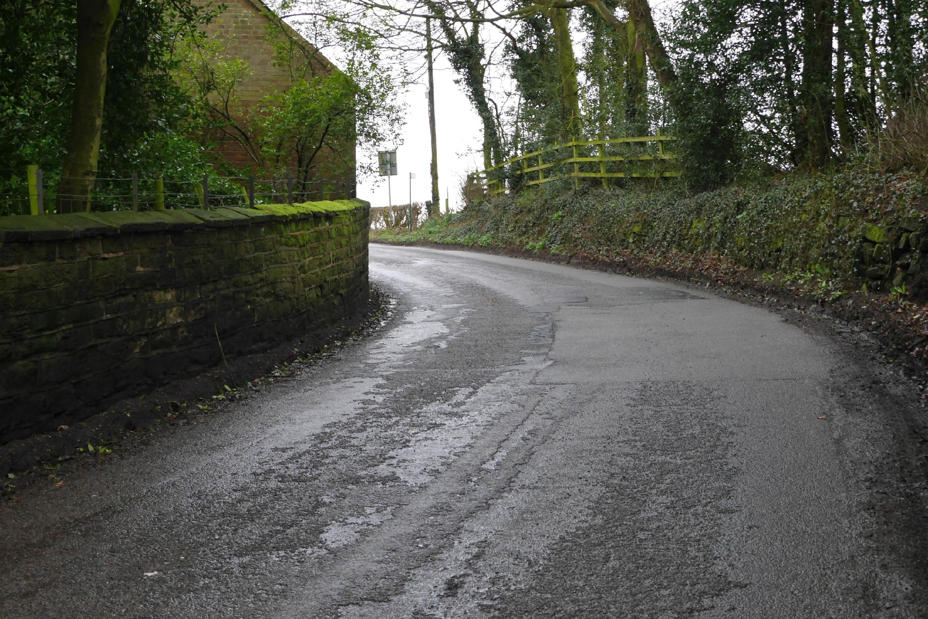
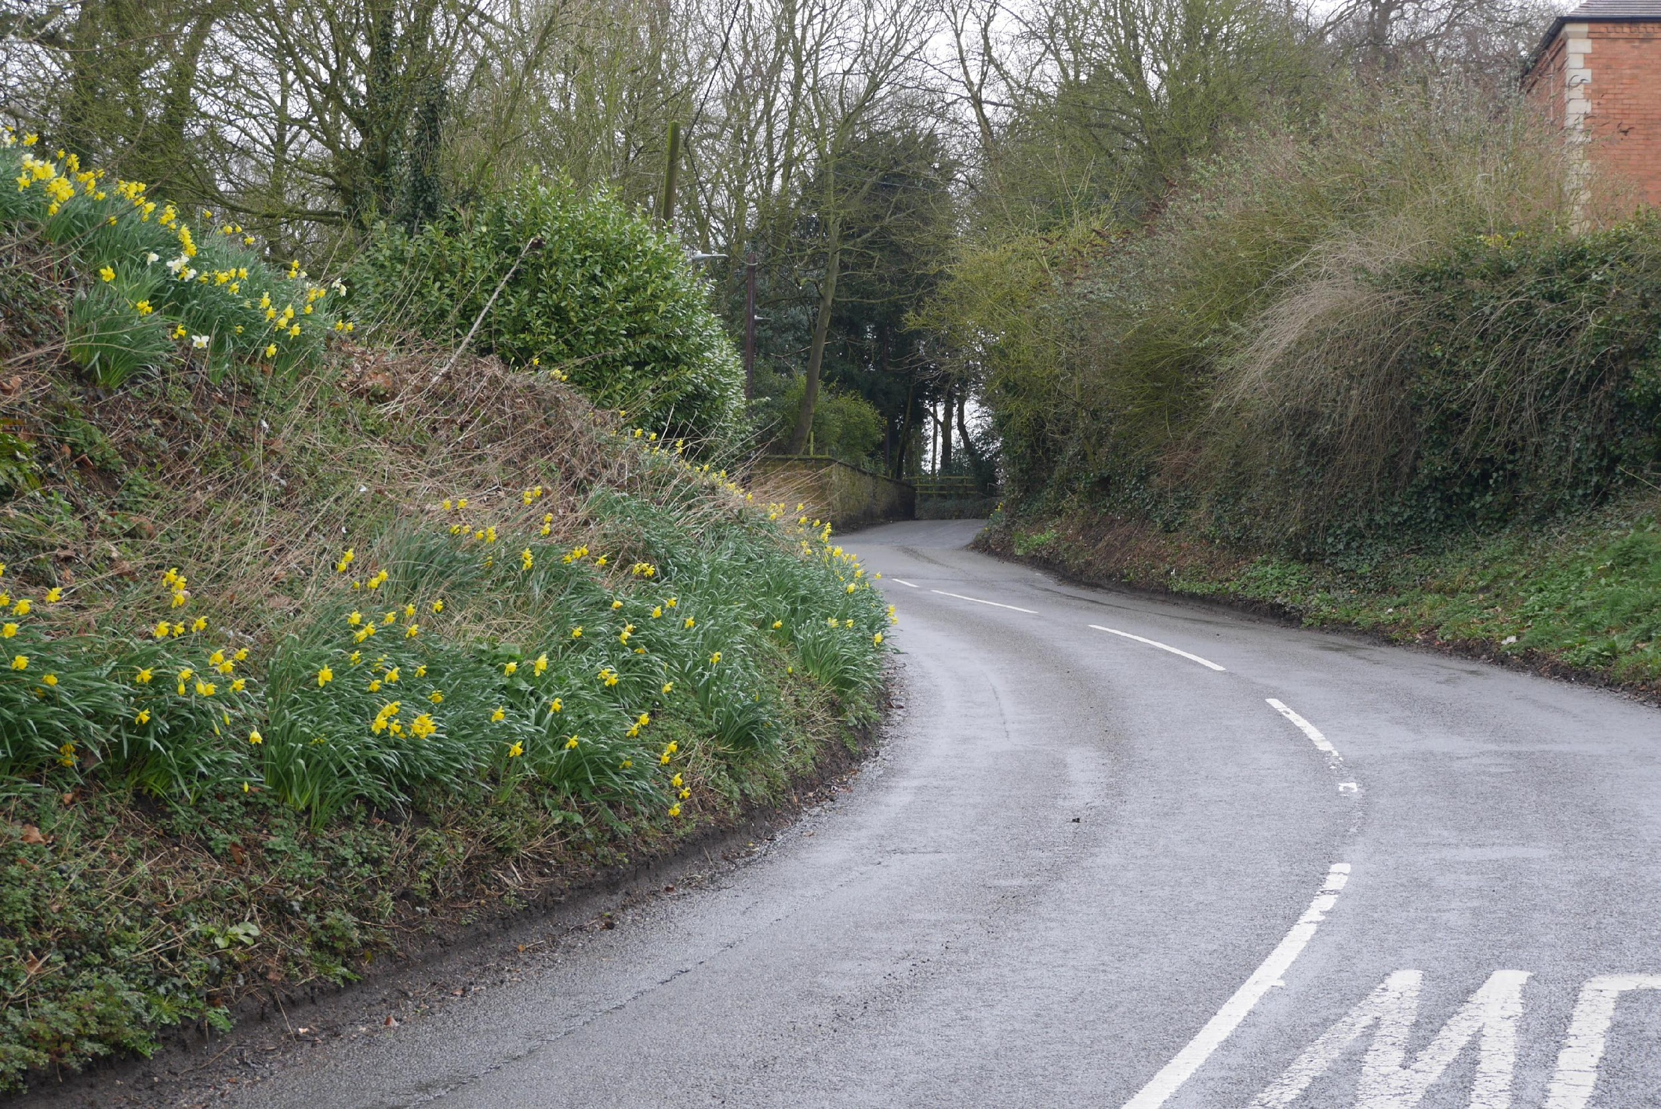

  - 4.115 The S bend on Main Street is a pinch point for buses and lorries as they cannot pass at this point when travelling in opposite directions.

- Community Action TR1: The community will work with Leicestershire County Council to join Community Speed Watch, with the objective of monitoring and managing traffic speeds issues within the Plan Area.

Car Parking
- 4.116 On street car parking causes difficulties on a number of roads in the Plan Area, during consultation a number of residents have highlighted the difficulties parked cars are causing when the bus is travelling along Butt Lane.

  - POLICY TR1: TRAFFIC MANAGEMENT - With particular regard to the rural highway network in Blackfordby and minimising the impact of any increase in vehicular traffic all development must:
- Be designed to minimise additional traffic generation and movement through the village;
- Incorporate sufficient off-road parking;
- Not remove or compromise the use of any existing off-road parking areas unless a suitable equivalent alternative is provided;
- Provide any necessary improvements to site access, communal parking and the highway network either directly or by financial contributions;
- Consider, where appropriate, the improvement and where possible the creation of footpaths and cycleways to existing community facilities (Policy CFA1); and
- Where a new development will create a significant increase in traffic in the surrounding area traffic calming measures will be supported.

Footpaths & Bridleways
4.117 There are 16 footpaths and 2 bridleways running to and through the Neighbourhood Plan Area some of which form most of the central section of the National Forest Way (http://www.nationalforestway.co.uk/), a long-distance path over 75 miles from the National Memorial Arboretum in Staffordshire to Bradgate Park in Leicestershire. Of these Rights of Way those in the north, west and east are most frequently used and in best condition, whilst others are less used but remain clear.
4.118 The Leicestershire County Council Rights of Way Improvement Plan (ROWIP) was required to consider: “the extent to which local rights of way meet the present and likely future needs of the public and the opportunities they provide for exercise and other forms of open-air recreation and the enjoyment of the authority’s area”.
4.119 The footpath network serves dog walkers well. However, there is a lack of dog waste deposit bins in the village.
POLICY TR2: FOOTPATHS - The upgrading and, where appropriate, extension of the pedestrian footpath network in the Plan Area will be supported as part of new developments in order to:
- Provide connections to the existing pedestrian footpath network;
- Encourage walking over car use for making journeys; and
- Provide an improved and more extensive footpath network to support exercise and leisure activities for Blackfordby residents and visitors.
Electric Vehicles
4.120 The UK government has recently announced its intention to ban sales of new petrol and diesel cars from 2030 to combat rising levels of air pollution and address climate change concerns. This raises the crucial question of battery recharging. Residential charging is probably the current norm and larger capacity chargers are emerging. However, residential charging is generally only possible where off-road parking is available. It would seem wise to include such requirements for new developments in locations such as Blackfordby if rural communities are not to be left behind.
4.121 Similarly, commercial/communal rapid charging facilities are growing across the country (making use of 3-phase supply not possible at the domestic level and reducing the 7KW re-charge time by a factor of 3). These could be utilised in Blackfordby for example by the installation in a permanent parking area, providing re-charging for residents with no off-road parking, and allowing fast re-charge for all residents.
POLICY TR3: ELECTRIC VEHICLES - 7KW cabling (or such other means of facilitating fast charging) is to be provided to the most practical point in all new homes to facilitate subsequent installation of a home electric vehicle charging point;
The provision of communal vehicular charging points within the Plan Area will be supported where there is universal access and they do not impact negatively on the availability of existing parking.

G Developer Contributions

Infrastructure requirements

4.121 All development has the potential to impact on the environment and place pressure on local infrastructure and services. It is recognised that the planning system should be used to ensure that new development contributes positively to the local environment and helps to mitigate against any adverse impacts on infrastructure.

4.122 Provision of the necessary physical and community infrastructure arising from proposed development is therefore a critical component of the Plan, which has identified a range of potential infrastructure requirements through its production.

4.123 The priority infrastructure requirements identified and detailed within the Plan are listed below, in the order in which they appear in the Plan:

Water quality improvements to avoid adverse impacts on the River Mease Special Area of Conservation (G2)

Superfast broadband of at least 30 Mbps (G2)

Enhanced requirements for affordable housing (H4)

Enhanced community facilities (CFA1)

Improvements to and where possible creation of footpaths and cycleways to key village facilities (TR1)

Traffic calming measures where new development will create a significant increase in traffic (TR1)

Provide an improved and more extensive footpath network (TR2)

Provision of communal vehicular charging points in Plan Area (TR3)

5. MONITORING AND REVIEW
5.1 The Neighbourhood Plan will last up to 2031. During this time, it is likely that the circumstances which the Plan seeks to address will change.
5.2 The Neighbourhood Plan will be regularly monitored. This will be led by Ashby de la Zouch Town Council on at least an annual basis. The policies and measures contained in the Neighbourhood Plan will form the core of the monitoring activity, but other data collected and reported at the Parish level relevant to the delivery of the Neighbourhood Plan will also be included.
5.3 The Town Council proposes to formally review the Neighbourhood Plan on a five- year cycle commencing in 2023 or to coincide with the review of the North West Leicestershire Local Plan if this cycle is different.

