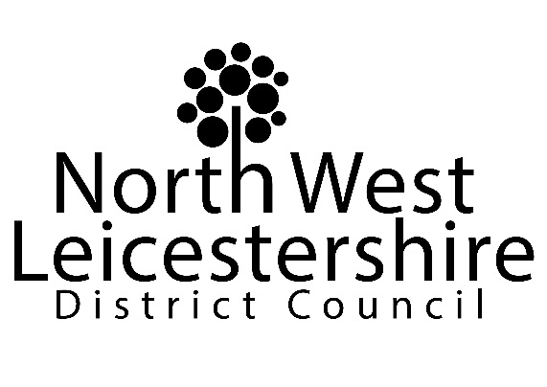
Licensing Act 2003
Variation of
Premises Licence / Club Premises Certificate

Notice is hereby given that [applicants name] have applied to North West Leicestershire District Council for [state type of application eg grant for premises licence] in respect of [name and address of premises].
The nature of the application [state details of the relevant licensable activities including times those activities are to take place or in the case of a variation a brief description of the variation].
Full details of the application can be viewed at the NWLDC, Customer Services Centre, Belvoir Rd, Coalville LE67 3PD
or at www.nwleics.gov.uk.
Any person who wishes to make any representations regarding this application should submit their comments in writing to the above address no later than [give date - 28 days after the day after the licensing authority received the application].
Please note it is an offence to knowingly or recklessly make a false statement in connection with an application. The maximum fine on summary conviction for this offence is unlimited.

COMPLETION NOTE: Please insert the information requested between the square brackets. The assisting information between the brackets can also be deleted, as can this completion note.

