North West Leicestershire District Council  Covid-19 Event Planning | 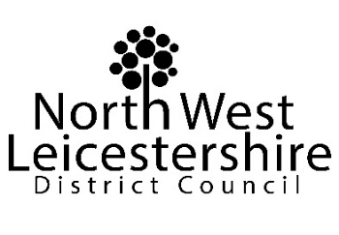
1. Event / Organiser details
Event name
Name of organisation
Day(s) / Date(s) of event | Start | Finish

2. Please describe the measures that will be in place in relation to risks relating to Covid-19
A. What steps will you be taking to regulate the numbers / mix of people attending to ensure that the operation of the event will adhere to the regulations / guidance in place when it takes place e.g. communication plan, ticket only, security etc?
B. What steps will you be taking to manage behaviour on site, and to ensure appropriate social distancing, in line with latest Government guidance e.g. segregated areas, signage, stewards / marshals etc.?
C. What steps will you be taking to ensure appropriate hygiene measures are in place?
D. What risk assessment(s) do you have in place for the event?
E. How will you address behaviour that does not fall in line with the restrictions and guidance for your event?
F. If appropriate, how will you capture contact details for those attending the event for track and trace purposes?
G. How will you ensure that you keep up to date with any local lockdown restrictions, and how will your event planning prepare for the effect of local lockdowns (e.g. the possible need to restrict attendance by people living in / working in an affected area)?
H. Any other comments relating to Covid-19 measures (if applicable)

Here are some links to websites relating to Covid–19 which you may find helpful:

The Government’s COVID-19 guidance for mass gatherings:
https://www.gov.uk/guidance/covid-19-guidance-for-mass-gatherings

The Event Industry Forum Registration page (once registered you will be able to access their latest Covid–19 event guidance):
https://www.eventsindustryforum.co.uk/index.php/register

Health and Safety Executive guidance relating to Covid-19:
https://www.hse.gov.uk/coronavirus/index.htm

