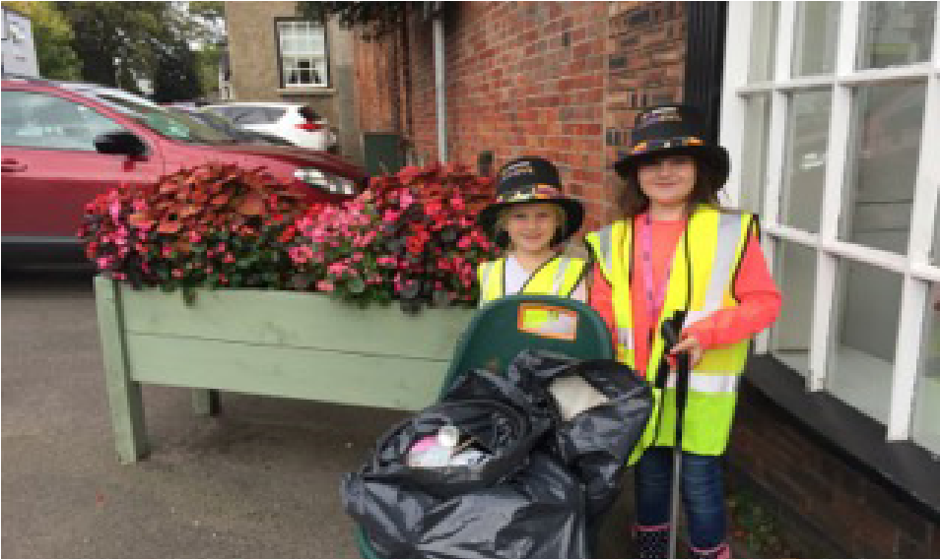
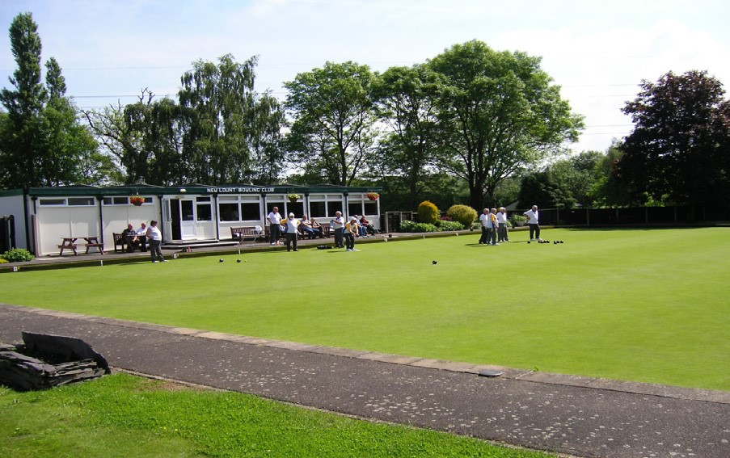
This grant scheme supports and encourages a range of community activities, initiatives
and events that meet the needs of residents.
Green Grants of £500 are available for environmentally-focused projects relating to
climate change, energy efficiency, community orchards, litter picking equipment or
general environmental improvements. Applications are welcome from groups and
organisations, including parish councils.
Green Grant Scheme
Application Form
For office use only

Date received
Date acknowledged
Name of applicant
Amount applied for
Date of commencement of project
Geographical area of project
Ward member
Grant approved/Refused (link to evaluation)
Does the application link to council priorities?
Applications from organisations which have been active in their community are eligible to apply for £500.
Match funding of £500 is required; this needs to be cash as opposed to in-kind funding and therefore your project should have a minimum total value of £1,000.
Circumstances where we WILL NOT provide financial support:
- Funding requests from organisations which have a large cash flow surplus
- Request for funding AFTER the activity or project has taken place
- Requests for funding for religious activities
- Requests for funding for political activities or by a political organisation
- Requests for funding for activities / projects which do not benefit individuals who live in the wards above within North West Leicestershire
- Requests for funding from private organisations or individuals
- Where there is potential reputational risk for North West Leicestershire District Council.

1. Your organisation name and type

Full name as it appears on your governing document and what type eg. community group, charity, social enterprise/ CIC, uniformed group, sports club, other.

2. Tell us about your organisation and its main objectives

Give a quick snapshot of your organisation and what it aims to achieve.

3. Project name

Give the full title of your project, keep it simple and snappy.

4. Tell us about your project (maximum of 300 words)
Give a brief summary of your proposed project.

5. Please provide an address or indicate on a map (ie Google) for the site(s) you are considering where your project will take place

Please insert street name and village or town names or attach a map representing site.

6. Please tell us how your project will benefit the local community

What issues or challenges exist for the community who will benefit from the project?
- How have you identified the need for your project?

eg. carried out a consultation, completion of a questionnaire?
- What outcomes will your project achieve?

Include how you intend to measure the impact of your project

9. Agreement for project and long-term maintenance
I confirm that:
• Our group is the long-term lease holder
• We have secured agreement with the land owner for developing the project
I confirm that:
• We will carry out any long-term maintenance required
• If not applicant, who will carry out any long-term maintenance?
Where your group/council is not the landowner, please demonstrate that you are the long-term lease holder or have secured agreement with the owner for developing the project and any long-term maintenance required. A copy of the meeting minutes is sufficient. Please tick appropriate boxes.
- When do you anticipate that your project will start and end?
Estimated start dateEstimated end date mm/yyyy:mm/yyyy:
We need to know that you have a definite timetable in place for your project.
- How do you propose to sustain your project in the future?

Tell us how you plan to continue funding this project beyond the life-time of the award.

12. What is the total value of your project
Item Amount
Green Grant |  | £500
Applicant contribution |  | £
Other sponsorship / funding |  | £
Total projects costs |  | £
Please insert total value of grants and cash contribution. We need to have sight as evidence of all contributions listed to support your application.
- What is the breakdown of intended project spend?

Please list items of expenditure relating to your project.
- Which part of your project do you want the scheme to fund?

With our grant of £500 which particular section of your project would this funding go towards?

15. Organisation’s main or registered address, including postcode
This is the address that we will use for correspondence.

16. Details of main contact for your organisation
*Name and title
*Position
*Address
*Postcode
*Email
Landline telephone
* Mobile telephone

- Charity number (if applicable)
- Company number (if applicable) Please input reference number.
- When was your group formed?
Input the year your group was formed.
- Are you VAT registered?
Please answer yes or no.
- VAT registration number (if applicable)

17. Any other information to support your application

Please include any additional information you think will help support your application.
18. Have you included the required documents?
A signed and dated copy of your organisation’s constitution
Copies of your most recent bank account statement
Evidence of match funding
Policies in place that are appropriate to your organisation’s work and the project you are asking us to fund
Safeguarding policies if your project directly involves children and young people under the age of 18
Formal quotes of expenditure which cross reference to your project costings
Letters of support for example from your local councillor, schools, community groups, businesses etc
It is your responsibility to have appropriate policies and procedures in place. Please tick appropriate boxes.
Please make sure that you have answered all of the questions in the form before sending it to us. If your application is incomplete and is without the required information, this may result in your application being delayed or even withdrawn from consideration.
Project Monitoring
NWLDC are required to ensure that all grant funding is spent as set out in your application. Successful applicants will be asked to provide project feedback to NWLDC within 8 weeks of the project completion date. This will include an end of project evaluation form, photographs and receipts relating to expenditure. Failure to provide this information may result in future grant applications being withdrawn from consideration and NWLDC reserve the right to reclaim any monies where this monitoring information is not provided. By ticking this box, you confirm that you understand this requirement and agree to provide project monitoring information when requested.

Appeals against decision
If you disagree with a grant application decision, you can appeal. You will need to appeal in writing to grants@nwleicestershire.gov.uk. This will be considered by our grant scheme assessor and you will receive a decision within 28 days.

Data Protection
We may share information with organisations and individuals with a legitimate interest in our grant funding programmes. We have a duty to protect public funds and for that reason we may also share information with other government departments, organisations providing matched funding or for the prevention and detection of crime. If you provide false or inaccurate information in your application or at any point in the life of any funding we award you and fraud is identified, we will provide details to the fraud prevention agencies to investigate. We might use the data you provide for research purposes. We recognise the need to maintain the confidentiality of vulnerable groups and their details will not be made public in any way, except as required by law.
On the success of your project, we retain the right to advertise your project in local and national media, including social media.

Freedom of Information Act
The Freedom of Information Act 2000 gives members of the public the right to request any information that the district council holds. This includes information received from third parties, such as, although not limited to grant applicants, grant holders, contractors and people making a complaint. If information is requested under the Freedom of Information Act we will release it, subject to exemptions; although we may choose to consult with you first.
By ticking this box you confirm that you understand North West Leicestershire District Council’s obligations under the Data Protection Act from 1998 to 2018 and the Freedom of Information Act 2000. You accept that as long as the Council’s actions conform to the relevant law it will not be liable for any loss or damage that your group might suffer as a result of the Council fulfilling its obligations.
Privacy statement – www.nwleics.gov.uk/grants
Email your completed application form and accompanying documents to grants@nwleicestershire.gov.uk

