NORTH WEST LEICESTERSHIRE
HEALTH AND WELLBEING STRATEGY

OCTOBER 2018

CONTENTS

PART 1: INTRODUCTION 1
PART 2: WHAT IS NORTH WEST LEICESTERSHIRE LIKE NOW? 4
PART 3: NATIONAL STRATEGY SUMMARIES 11
PART 4: REGIONAL AND LOCAL STRATEGIES 16
PART 5: THE STRATEGY 26
Strategy vision, outcomes and objectives 27

PART 1: INTRODUCTION

The life expectancy gap between rich and poor people in England has been widening for nearly two decades. The rich stay healthy longer. The poor die younger. That bleak assessment is based on national data.

Good health and wellbeing is fundamental to enable people to live active and fulfilled lives and play a full role in their communities. It is a core belief of North West Leicestershire Council (NWLDC) that all its residents have an equal right to enjoy good health and wellbeing. Its vision and the plans set out in this strategy illustrate how it intends to provide the direction, support and opportunities to enable this to happen.

Determinants of health

Many factors combine together to affect the health of individuals and communities. Whether people are healthy or not, is determined by their circumstances and environment. Factors such as where we live, the state of our environment, genetics, our income and education level, and our relationships with friends and family all have considerable impacts on health, whereas more commonly considered factors such as access and use of health care services tend to be secondary. The key determinants of health include:

- The social and economic environment.
- The physical environment.
- The person’s individual characteristics and behaviours.

The context of people’s lives determines their health, and so blaming individuals for having poor health or crediting them for good health is inappropriate. Individuals are unlikely to be in a position to directly control many of the determinants of health. The things that make people healthy - or not, include the above factors, and many others:

- Income and social status – these are closely linked to better health. The greater the gap between the richest and poorest people, the greater the differences in health.
- Education – low education levels are linked with poor health, more stress and lower self-confidence.
- Physical environment – safe water and clean air, healthy workplaces, safe houses, communities and roads all contribute to good health.
- Employment and working conditions – people in employment are healthier, particularly those who have more control over their working conditions
- Social support networks – greater support from families, friends and communities is linked to better health.
- Culture - customs and traditions, and the beliefs of the family and community all affect health.
- Genetics - inheritance plays a part in determining lifespan, healthiness and the likelihood of developing certain illnesses.
- Personal behaviour and coping skills – balanced eating, keeping active, smoking, drinking, and how we deal with life’s stresses and challenges all affect health.
- Health services - access and use of services that prevent and treat disease influences health
- Gender - Men and women suffer from different types of diseases at different ages.

Figure 1.1: Determinants of health and wellbeing

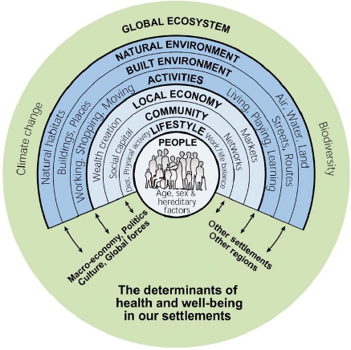

The Strategic (‘Marmot’) Review of Health Inequalities in England Post-2010 set out key policy objectives, based around the social determinants of health:

- Give every child the best start in life.
- Enable all children, young people and adults to maximise their capabilities and have control over their lives.
- Create fair employment and good work for all.
- Ensure a healthy standard of living for all.
- Create and develop healthy and sustainable places and communities.
- Strengthen the role and impact of ill-health prevention.

What can the District Council do?

The King’s Fund publication; The District Council Contribution to Public Health: A Time of Challenge and Opportunity provides a useful backdrop in respect of the challenges and opportunities that this Strategy should address. It makes the point that a range of factors, many of which district councils are in a good position to influence (directly or indirectly) affect health and wellbeing outcomes. One of the keys to both creating opportunity to make a greater contribution while concurrently achieving the savings needed by all partners is improved policy and practical integration.

The NHS five year Forward View argues that district councils need to:

- Ensure that their actions are cost-effective, have a positive effect on public health and, linked to this, offer a positive ‘social return on investment’
- Take on a more enabling role in respect of the health of citizens and communities
- Look to innovate in services, and in their delivery.

Until relatively recently, district councils were not part of mainstream public health policy despite the fact that they can, via their direct and influencing roles, have a positive sway on other bodies. Key to the extent of their influence is:

- Being better informed about the communities they serve and the roles of the partners with which they need to collaborate.
- Clarity about what they intend to do, its cost/cost-effectiveness and what they expect by way of positive return on investment.

In NWL, investment is based upon clear outcomes and accompanied by measurement devices which demonstrate their achievement, ultimately informed by metrics which put that achievement in context. In a health and wellbeing strategy context this is essential to underpin what are often tough decisions about priorities. Key areas of NWLDC influence on health and wellbeing are reflected in the structure of the Council and include, for example:

- Economic development
- Housing and property
- Regeneration and planning
- Community services.

PART 2: WHAT IS NORTH WEST LEICESTERSHIRE LIKE NOW?

North West Leicestershire (NWL) is a local government district in Leicestershire. It is mainly rural, covering 27,900 hectares (108 square miles) with the main towns being Ashby-de-la-Zouche and Coalville. Its total population is 97,247. The district contains the East Midlands Airport, which operates flights to the rest of Britain and to various destinations in Europe. It is also notable as the location of Castle Donington and Donington Park, a grand-prix circuit and a major venue for music festivals.

NWL is located within the National Forest, which is spans across parts of Derbyshire, Leicestershire and Staffordshire and aims to link the two ancient Forests of Charnwood and Needwood. The National Forest is an ongoing development which has 80% of its new woodlands publicly accessible.

Figure 2.1: Main towns and roads in NWL
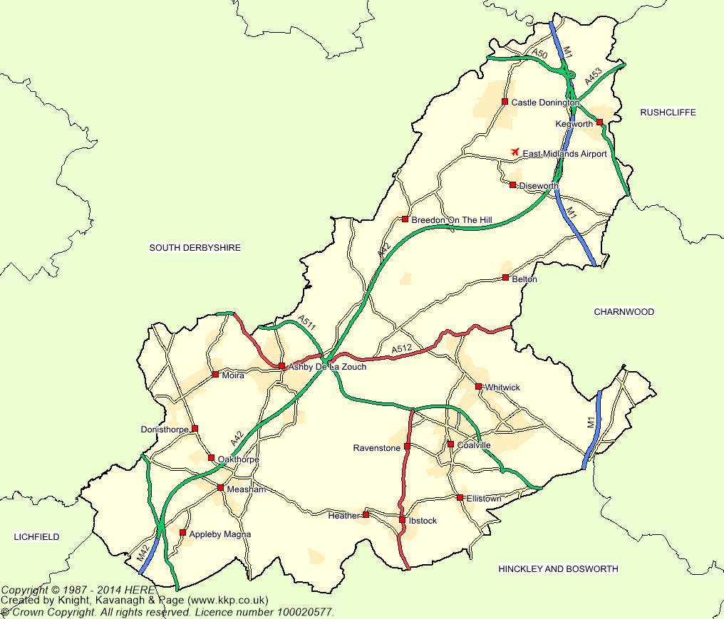
The Authority is dissected by the A42 which runs from north to south west, the A511 which cuts across the middle and the M1 which runs from north to south in the east of the District. The area has a long history of mineral extraction, with coal, brick clay, gravel and granite amongst the products. All the deep coal mines and open cast mining is now finished in the area.

Socio demographic context

There is relatively little difference in the age structure of NWL’s population from that of the region. Its ethnic composition varies considerably from that of England as a whole; it is 97.6% White, 1.1% Asian and 0.9% Mixed compared to 85.4%, 7.8% and 2.3% nationally.

It is anticipated that projected changes in population from 2016 to 2028 will see it rise by 9,505 (9.7%). This includes an increase of 870 (4.8%) in the number of 0-15 year olds; but a fall of 2,301 (14.8%) in 45-54 year olds. Changes up to 2041 are projected to increase by 17,176 (17.4%) including a 60.5% rise in the numbers of people aged 65+ meaning that they will, by then account for over one quarter of the population (26.9%).

Figure 2.2: Projected population change (2016 -2041)
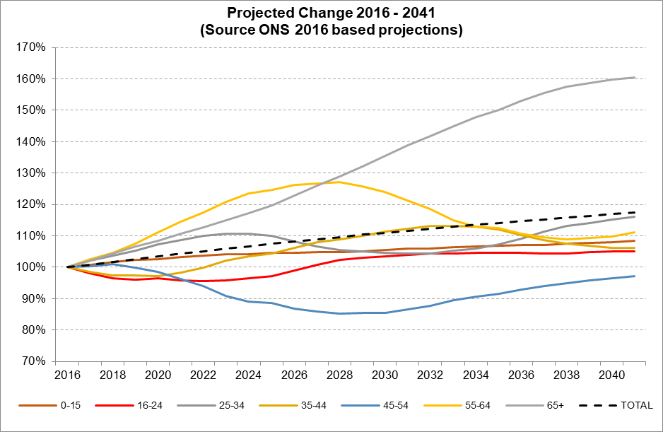

Deprivation and ill health

Only 8.8% of the population fall within the most deprived 30% nationally. Conversely, however, 40.9% are within the three least deprived groups (nationally - 30%). The IoD points towards similar levels of health deprivation with 8.7% falling in the most deprived (three worst) cohorts based on health measures when a national equivalent would be 30%. Similar to the overall measure of deprivation, 37.3% of the population is in the best three cohorts for health.

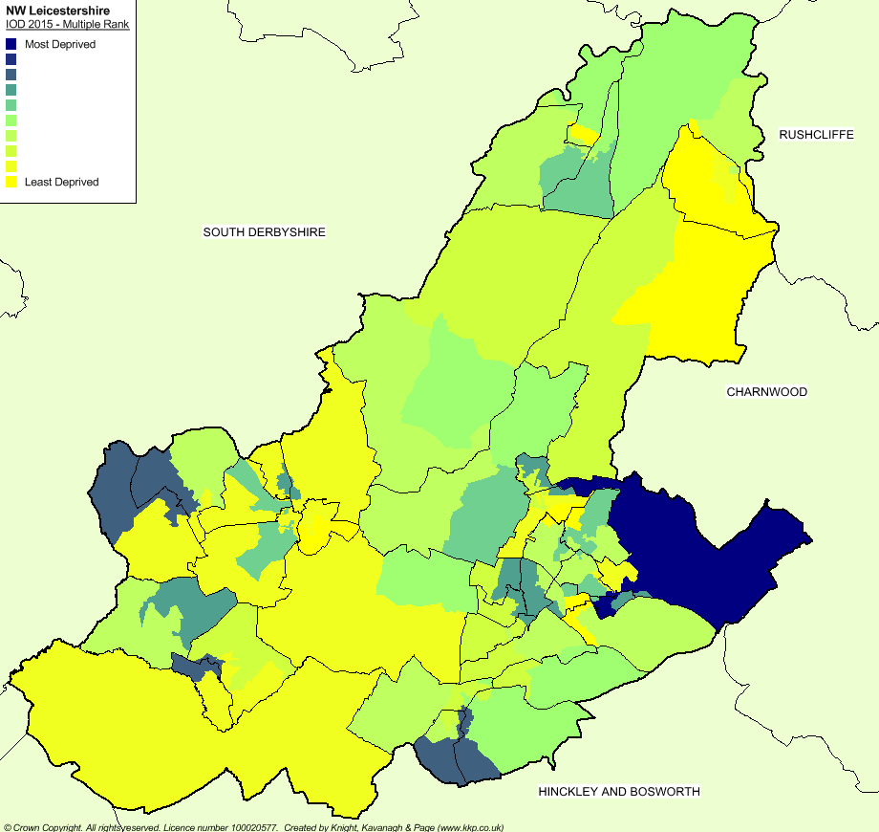
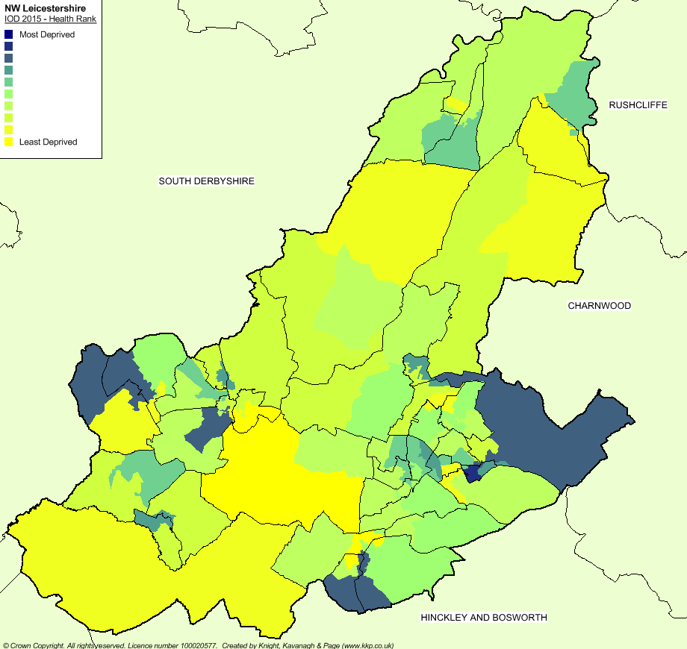
Figure 2.3: Index of multiple deprivation Figure 2.4: IMD Health domain

Figures 2.3 and 2.4 indicate the overlap of health and multiple deprivation in the wards of Castle Rock (East of the District), Ibstock West and Ibstock East (South of the District) and Ashby Woulds and Blackfordby (West of the District).

The highest levels of health deprivation (LSOA) are to be found in Greenhill ward. Here people have a life expectancy of 76.1; this compares to Ravenstone & Packington which has the lowest levels and life where expectancy is 80.1 years. Ashby Castle ward has the highest life expectancy (85.7 years) and Thringstone the lowest (75.1 years) suggesting that, dependent upon where you live, there is a potential 10-year difference in life expectancy in the Authority. Neither of these latter two LSOAs are in areas of higher deprivation so it may well be that other mitigating reasons influence the illustrated discrepancy.

Figure 2.5 indicates that adult obesity (29.1%) is above the national (24.0%) and regional (25.5%) average. Child obesity rates (16.7%) are however below the national (19.1%) and regional (18.5%) rates. Child rates increase significantly between reception and Year 6, by which time just fewer than one third of children (31.3%) are either overweight or obese.

Avoidable ill health cost to the NHS in NW Leicestershire (due to physical inactivity) is estimated in total to be £1.4m; this is 12.7% and 9.8% below the respective national and regional averages (per 100,000).
Figure 2.5: Adult and child obesity rates in NWL
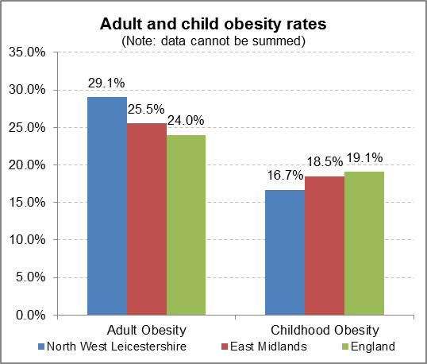

Unemployment is below both the national rate and the regional average. Earnings are 5.9% below national and 1.6% above regional averages.

Table 2.1: Unemployment and income
 | North West Leicestershire | East Midlands | England
Unemployment | 1.1% | 1.8% | 2.2%
Income (median) | £28,049 | £26,806 | £28,740

Health profiles 2018

Health profiles are published annually by Public Health England at county council and district/borough level. They provide a snapshot of the overall health of the local population and highlight potential problems via comparison with other areas and national averages. They are designed to help local government and health services identify problems in their areas and decide how to tackle them. Table 2.2 (overleaf) highlights where areas are performing well or issues of concern and areas of inequality within Leicestershire.

In many areas Leicestershire performs well; it has 20 indicators that are significantly better than the England average, however performance is uneven across the county and there is still considerable room to improve the overall health of the population. With regard to Leicestershire, overall:

- In three indicators, all districts perform significantly better than the England average
- Six districts have significantly worse levels of breastfeeding initiation compared to England.
- The excess weight indicator performs significantly worse than the England average in two Leicestershire districts (Charnwood and North West Leicestershire).
- Harborough performs significantly worse for diabetes diagnoses (17+)
Table 2.2: Health profiles of local authorities in Leicestershire 2018

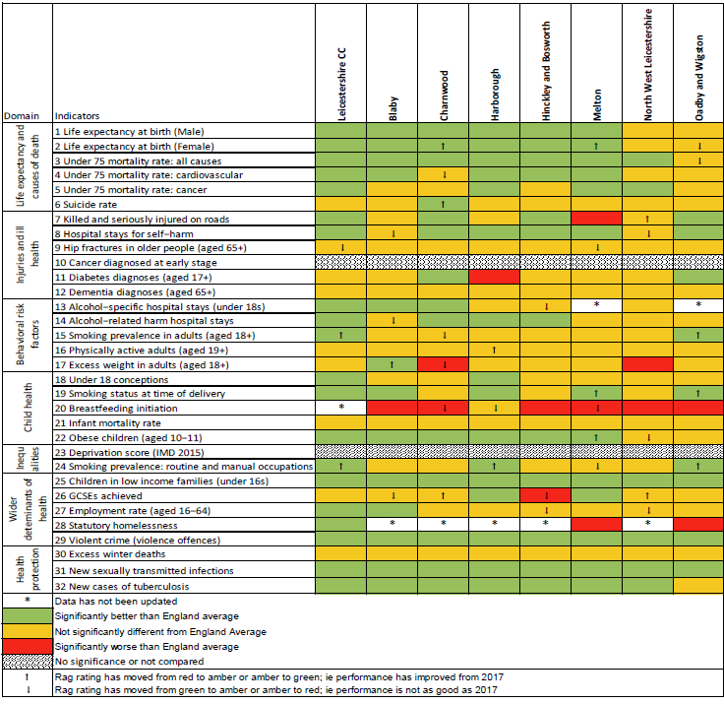

When considering NWL, in particular, two indicators perform significantly worse than England:

- Excess weight in adults (18+) has performed significantly worse than nationally in 2015/16 and 2016/17. The percentage has declined (improved) between these time periods from 69.9% to 66.4%. Nationally the percentage has remained constant at 61.3% i.e. NWL has significantly worse levels of excess weight in adults compared to England.
- Breastfeeding initiation in North West Leicestershire has remained significantly lower than the national average for the past four years. The latest prevalence in 2017 is 65.7% whereas nationally, the latest prevalence rests at 74.5%

Three indicators have declined, moving from green to amber. These are hospital stays for self-harm, obese children (aged 10-11) and the employment rate (aged 16-64). The two indicators which have improved, moving from red to amber, are being killed and seriously injured on the roads and GCSEs achieved.
Active Lives

Sport England’s Active Lives Survey (ALS) incorporates a broad definition of sport and physical activity including walking, cycling for travel and dance. Replacing the Active People Survey it is based on a national sample of 200,000 adults, which is then scaled up to provide an England wide picture. It has been operating for two years so trend information is not yet available.
Definitions used in the ALS for active, fairly active and inactive are as follows:

- Inactive- less than 30 minutes exercise per week.
- Fairly active – between 30-149 minutes per week.
- Active – 150+ minutes per week.

Figure 2.6: Sport England’s Active Lives survey 2016

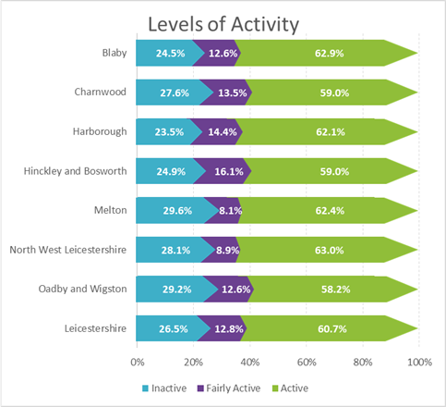

Sport England confirms that ALS data highlights significant disparities between different socio-economic groups across England. In particular:

- People who are long term unemployed or have never worked (NS-SEC 8) are the most likely to be inactive (38%) and the least likely to be active (49%)
- People who are in managerial, administrative and professional occupations (NS-SEC 1-2) are the least likely to be inactive (17%) and the most likely to be active (71%).

Figure 2.6 indicates a mixed picture for NWL. It has the third highest percentage of inactive adults; faring slightly better than Oadby & Wigston and Melton but does, however, have the most active population in comparison with the other six districts in the County. Thus, on the one hand it has higher levels of inactivity than the county and higher levels of activity than the county norms. The aim, therefore, should be to reduce the percentage of inactive people whilst moving more people from fairly active to active.

Summary

The overall picture for NWL is one of general good health compared with many other areas of the country. There is, however, a 10-year difference between the average age of people dying between the highest and lowest super output areas in the district. The ageing demographic will see the number and proportion of over 65’s rise (to account for over one quarter of the population by 2041). This is (statistically) likely to lead to a rise in, for example, levels of hip fractures and an increasing number of people living with dementia. It may also indicate increased levels of social isolation as partners are left on their own to cope.

The District has relatively high levels of employment (although average incomes are slightly below national figures) which indicates that work place health and wellbeing interventions may become increasingly important in the future. Adult obesity is higher than the national average (although this has shown improvement in the last year). The number of hospital stays from self-harm and the number of obese children (10-11years) has also seen an increase.

NWL appears to have the highest percentage of active adults compared to other districts in Leicestershire but this is offset by having the third highest number of inactive adults. The aim must be to reduce the percentage of inactive people whilst moving more people from fairly active to active. Further action is needed on reducing the social gradient in health.

PART 3: NATIONAL STRATEGY SUMMARIES

In order to embed the objectives and actions which will emanate from adopted Strategy it is essential that the emerging Health and Wellbeing Strategy reflects the aims and ambitions of key national, regional and local plans and strategies. The key links are outlined below.

Public Health England: Everybody Active, Everyday

In October 2014, Public Health England (PHE) produced its plan to tackle low activity levels across the country. Along with making the case for physical activity, this identifies four areas where measures need to be taken at a national and local level:

- Active society: creating a social movement, shifting social norms so that physical activity becomes a routine part of daily life.
- Moving professionals: activating networks of expertise. Making every contact with the health sector count to push the ‘active’ message and to deliver the message through other sectors including education, sports and leisure, transport and planning.
- Active environments: creating the right spaces. Making available and accessible appropriate environments that encourage people to be active every day.
- Moving at scale: scaling up interventions that make us active. Maximising existing assets that enable communities to be active.

PHE Strategic Plan (2016)

This sets out how PHE intends to protect and improve public health and reduce inequalities over the next four years. It specifically defines the role of local government and outlines actions that PHE will take over to achieve these aims and deliver its core functions.

Its stated ‘game changers’ include place-based approaches led by local authorities; evidence on return on investment (ROI) of public health interventions to support prioritisation and spending decisions; behaviour change, particularly the opportunity to exploit digital technology; employer contribution to improving staff health and wellbeing; measures of ‘wellness’ to give a broader, person-centred view of health; and developing evidence-based NHS preventive programmes in partnership with NHS England and NHS Improvement.

PHE states that it will support local authorities to deliver their statutory duty to improve the health of local people and deliver value for money, by sharing knowledge, data, evidence and expertise via a range of tools and examples of interventions that work. It will (e.g.):

- Strengthen work on health as a driver of economic prosperity, responding to local authority requests for practical support on return on investment - and continue to make the economic case for prevention, encouraging employers to invest in the health of their workforce and reduce the disability employment gap
- Refine and test its products and services with LAs to ensure they meet their priorities, including a greater focus on practical delivery support.
- Develop a comprehensive catalogue of products and services to help LAs to find the support they need
- Support increasing understanding of the importance of the environmental determinants of health, including climate change… providing scientific and technical advice on reducing the health impacts of air pollution at a local level, as well as on how to harness approaches such as the design of urban environments to support better health
- Work with the LGA to support the transformation of local authority services through sector-led improvement
- Support the political leadership role of local authorities in local places and their role to deliver place-based leadership through health and wellbeing boards

Figure 3.1 PHE model

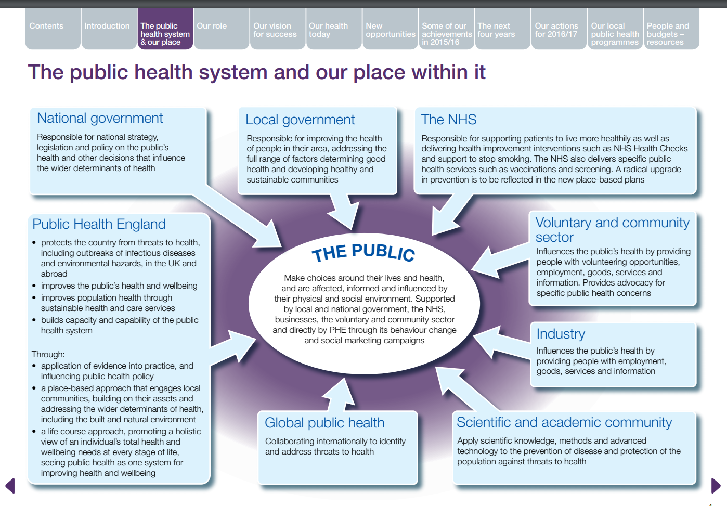

Making every contact count (MECC)

Making Every Contact Count (MECC) is an approach to behaviour change that utilises the millions of day-to-day interactions that organisations and individuals have with other people to support them in making positive changes to their physical and mental health and wellbeing. It targets the opportunistic delivery of consistent and concise healthy lifestyle information to enable individuals to engage in conversations about their health at scale across organisations and populations.

- For organisations, MECC means providing their staff with the leadership, environment, training and information they need to deliver the MECC approach.
- For staff, MECC means having the competence and confidence to deliver healthy lifestyle messages, to encourage people to change their behaviour, and to direct them to local services that can support them.
- For individuals, MECC means seeking support and taking action to improve their own lifestyle by eating well, maintaining a healthy weight, drinking alcohol sensibly, exercising regularly, not smoking and looking after their wellbeing and mental health.

It is recognised that partner organisations such as local authorities may adopt a broader definition of the MECC approach. This may include conversations to help people think about wider determinants such as debt management, housing and welfare rights advice and directing them to services that can provide support.

Social prescribing model

‘Social prescribing’ is a system whereby healthcare professionals are able to refer patients to local, non-clinical services to meet their wellbeing needs. What people can take part in will depend on what is available locally, and how local services work together. In some areas, a GP or nurse might refer someone to a ‘link worker’ – who meets with the individual to ascertain their needs, what they would like to do, and then puts them in in touch with a local organisation or group that can provide it. In other areas, the healthcare professional might put the individual in contact with a local group or organisation. In reality, many people experience social prescribing in action without necessarily knowing that is what it is.

A key reason for social prescribing getting more attention in the world of health and social care is the increasing recognition that people are attending healthcare services with non-medical needs, such as social isolation and loneliness. Recent studies have found that 20% of patients seen by GPs report a problem which is social rather than medical. In a time where healthcare services are under increasing pressure, there is a need for a new approach to support those in need of social connections.

Sporting Future: A New Strategy for an Active Nation’

This Government Strategy for Sport was released in December 2015. It confirms the recognition that sport makes a positive difference through broader means and that it helps deliver fundamental outcomes: physical wellbeing, mental wellbeing, individual, social, community and economic development. It has identified the following outputs.

- Maximising international and domestic sporting success and the impact of major events.
- More people from every background regularly and meaningfully taking part in sport and physical activity, volunteering and experiencing live sport.
- A more productive, sustainable and responsible sport sector.

It further identifies that action is needed to:

- Meet the needs of the elite and professional system and deliver successful major sporting events.
- Meet the needs of the customer and enable them to engage in sport and physical activity.
- Strengthen the sport sector and make it more effective and resilient.

Sport England: Towards an Active Nation

Sport England’s strategy (underpinned by seven investment programmes and a new Workforce Strategy and a new Coaching Plan) identifies that it will invest in:

- Tackling inactivity | - Children and young people
- Volunteering – a dual benefit | - Supporting sport’s core market
- Local delivery | - Facilities
- Taking sport/activity to the mass market

Figure 3.2: Sport England Strategy 2016-2021
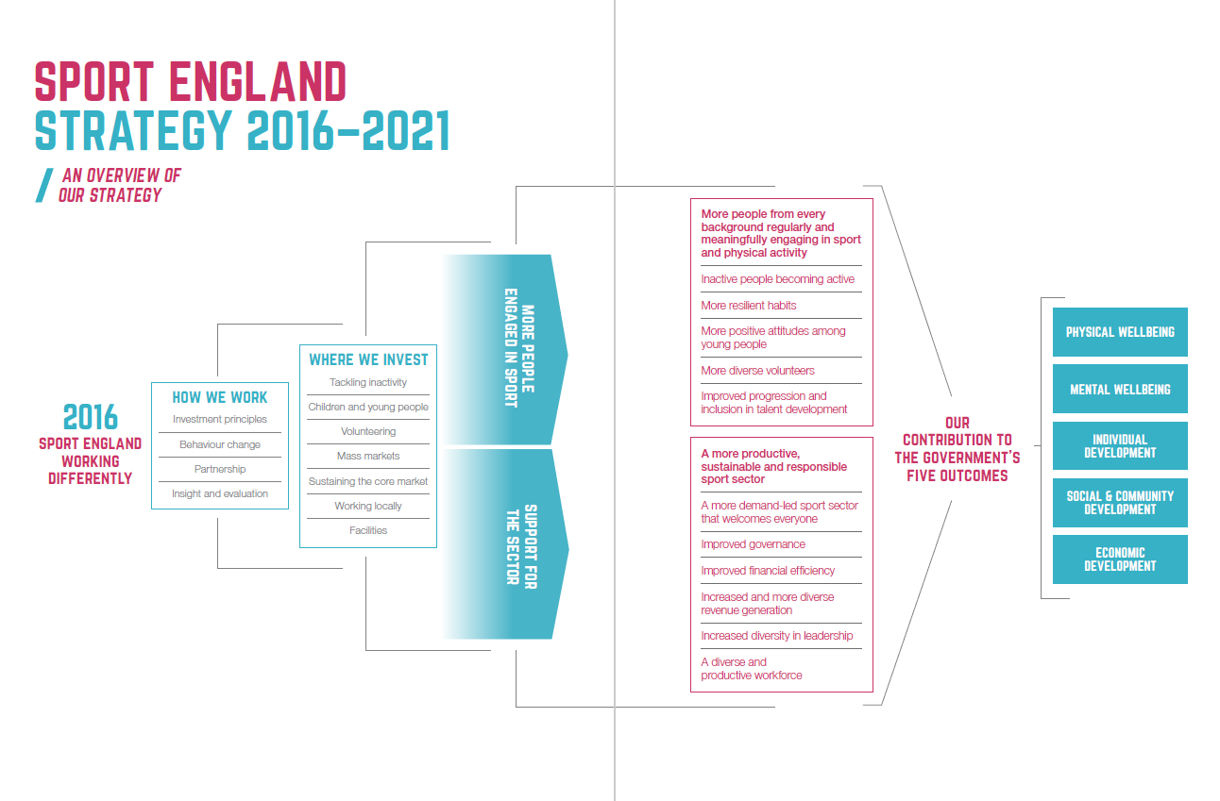

Investment in school sport

The Government 2013 Primary PE and Sport Premium fund of £150 million per annum provided two years of investment in school sport. Supported by the Government’s Education, Health and DCMS departments, funds went directly into the hands of primary school head teachers for them to spend on sport. Its four objectives were to:

- Improve the quality of existing PE teaching through continuing professional learning in PE for generalists, so that all primary pupils improve their health, skills and physical literacy and have a broader exposure to a range of sports.
- Increase participation levels in competitive sports and healthy activity of pupils and maintain these into adolescence
- Increase the quality of initial teacher training in PE and sport, and to promote PE specialisation in primary level workforce.
- Ensure that schools understand and value the benefits of high quality PE and sport, including its use as a tool for whole school improvement.

In 2015-16 schools with 17+ pupils received £8,000 plus a payment of £5 per head. Evaluation of this investment has highlighted the need for clearer guidance on how best to use this resource and the importance of good specialist knowledge for teachers of PE. Sport England is, in its Strategy, committed to further investment in young people and to improving the skills of secondary school teachers, particularly in respect of physical literacy. It also appears likely that funds generated via the proposed ‘Sugar Tax’ will be directed to fund school sport at some level.

Summary of national context

The national context is complex. A range of agencies is involved, leading and engaging on different elements of health and wellbeing. There is a clear understanding that they need to work collaboratively and that communication is key to success. Given the diverse range of interests and approaches an approach to policies which systematically and explicitly takes into account the health implications of the decisions taken is required. These need to target the key social determinants of health as well as looking for synergies between other core objectives with a view to improving the health of the population and reducing inequity.

MECC and the social prescribing model offer organisations and individuals the opportunity to engage in activities which have the potential to support individuals to make positive lifestyle choices land improve physical and mental health and wellbeing. Evidence suggests that interventions by health professionals and the wider community can contribute to improving the general health of the wider population whilst targeting specific populations, for example by geography, age or specific medical conditions.

Engaging all residents in physical activity is a high priority as is getting the inactive, active. It is acknowledged that regular sport and recreational activity plays a key role in facilitating improved health and wellbeing (both mental and physical). In addition, physical activity and sport provides a range of economic and health benefits and helps to provide jobs and opportunities to both spectate and participate. It is essential, therefore, that there is adequate opportunity for all residents to take part in physical activity within the Authority.

PART 4: REGIONAL AND LOCAL STRATEGIES

Public Health England – East Midlands

The stated ambition for PHE - East Midlands is to work with partners to deliver a system wide approach to prevention that will engage, enable and empower people to optimise their mental and physical health and wellbeing and enhance their quality of life. The East Midlands holistic approach to prevention targets both preventing the onset of disease through tackling risk factors and the wider determinants of health and enhancing quality of life for those with long term conditions through the prevention of the progression and impacts of disease through early intervention with high quality treatment and care.

To do this PHE East Midlands is committed to working with a wide range of stakeholders in the public, private and voluntary sectors to support the systematic adoption of evidence-based prevention approaches across the region.

A key concern is that prevention measures are not undertaken in isolation and are routinely embedded across the health, social and care system and applied systematically to ensure maximum benefit is achieved.

It is acknowledged that prevention also needs to be evident in local (authority) policies and approaches to business delivery across a range of functions including facilities management, employee health and wellbeing, the commissioning of services and the procurement of goods. The intention is to have an impact on the environments in which patients and the public live, influencing wider determinants of health such as employment, income, education, housing, air quality, social capital and connectedness and lifestyles (such as key risk factors; smoking, diet, physical activity and excess alcohol consumption).

Its prevention strategy will:

- Actively seek system wide engagement from partners across the public, private and voluntary sectors to develop a holistic approach to prevention in the East Midlands
- Prioritise primary prevention to address underlying causes of poor health and wellbeing, as well as having a continued focus on secondary and tertiary prevention
- Prioritise healthy life expectancy and quality of life, not just adding years to life
- Develop a person-centred prevention model to ‘engage, enable and empower’ individuals and communities, including those with health literacy needs
- Promote a non-silo approach to prevention that supports mental and physical health and wellbeing
- Utilise Making Every Contact Count (MECC) as a mechanism to embed the delivery of prevention

Good Food East Midlands (GFEM) Regional Food Strategy and Action Plan

GFEM is an independent cross-sector body set up to deliver a healthier, more sustainable and resilient food system for the region. Its aim is to develop a whole-system and consensual food strategy and action plan for the Region in pursuit of healthier, more sustainable and resilient food systems, cultures, communities and local economies. Its stated ambition is to address obesity, diet-related ill-health, food poverty, inequality and waste, climate change and biodiversity loss, declining prosperity and social dislocation, food quality and food waste.

In broad priority order, GFEM’s objectives are to.

Health
- Tackle health and hunger amongst the poor and vulnerable, particularly children and the elderly and reduce health inequalities
- Use all aspects of good food (see below) to promote mental health, substance abuse rehabilitation, physical activity, and other benefits to physical and mental health and wellbeing;
- Champion the specific role of food education and action in schools, particularly in relation to nutrition, breakfast clubs and meals in the school holidays.
- Develop food education for all citizens in the region.
- Work to support a healthy weight agenda across the region.

Environment
- Reduce food waste.
- Encourage, wherever appropriate, the adoption of short food miles.
- Be mindful of actions to reduce food insecurity.

Economy
- Support the importance of local food (and a vibrant food economy) within the wider food system.
- Encourage the use of food to stimulate local economic development and develop skills,
- Develop sustainable food procurement.

Culture
- Celebrate the food culture and distinctiveness of the East Midlands
- Sustainable Food Cities (SFC)
- Seek SFC status in 2017/18 (and to support local authorities to work towards the achievement of SFC accreditation).

Leicestershire Health and Wellbeing Strategy

The Joint Health and Wellbeing Strategy provides the vehicle for delivery of progress against the priorities identified in the Needs Assessment and leads to agreed commissioning priorities across the partner organisations and informs all policy making to support better health and wellbeing.

The refresh of the Joint Health and Wellbeing Strategy 2017 takes account of progress made against the priorities in the 2013 Strategy plus results of the 2015 Joint Strategic Needs assessment and the ongoing integration of health and social care services in Leicester, Leicestershire and Rutland. The new five-year strategy runs from 2017- 2022.

The stated vision for the strategy is: To improve health outcomes for the local population, manage future demand on services and create a strong and sustainable health and care system by making the best use of the available resources.

Better health and wellbeing outcomes for the next five years for Leicestershire are identified as follows:

Table 4.1: Leicestershire Health and Wellbeing priorities

Outcome | Priorities
The people of Leicestershire are enabled to take control of their own health and wellbeing. | - Use our influence to advocate the importance of all public policy making in improving the external factors that affect people’s health and wellbeing.  - Use our influence to advocate the importance of housing for good health with a focus on maximum independence for the ageing population and disabled people both now and in the future.  - Use our influence and control to advocate and offer good quality employment for all for health and wellbeing.  - Enable people to stay safe, well and healthy for longer with independence and connection to their community and provide targeted support for those most at risk of poor health and wellbeing.  - Provide care closer to home and enable local communities to help themselves through strong and vibrant community networks to reduce avoidable pressure on acute hospitals.  - Identify, recognise, value, involve and support carers of all ages.
The gap between health outcomes for different people and places has reduced. | - Improve our understanding of the people with the worst health and most at risk within the Leicestershire population; who they are and where they are.  - Use evidence to improve the targeting of activity to reduce health inequality between people and places based on local need.  - Work in partnership to improve outcomes for people with disabilities throughout their lives.
Children and young people in Leicestershire are safe and living in families where they can achieve their full potential and have good health and wellbeing. | - Ensure the best start in life for children and their families.  - Work proactively in partnership to keep children and young people safe and free from harm and sexual exploitation.  - Support those families identified as most troubled to become self-sufficient and resilient.  - Enable children with special educational needs, and/or disabilities and their families, to become increasingly independent through personalised, integrated care and support.  - Enable children in care to experience good physical and mental health throughout their lives.
People plan ahead to stay healthy and age well and older people feel they have a good quality of life. | - Improve the diagnosis and support for self-management of long term conditions.  - Improve the early detection and treatment of cancer.  - Plan for the ageing population and the needs of the increasing number of frail older people to minimise avoidable time they spend in hospital.  - Encourage people to plan for the end of their life in the place of choice and provide support to them and their carers.
People give equal priority to their mental health and wellbeing and can access the right support throughout their life course. | - Provide positive mental health promotion and improve awareness of risk factors for poor mental health to increase resilience.  - Improve access to mental health services for all ages to promote recovery and independence.  - Increase the early detection and treatment of mental health and wellbeing needs for children and young people.  - Increase the early detection and improve the management of dementia.

Healthwatch Leicestershire (Voluntary Action Leicestershire)

Healthwatch Leicestershire is the independent consumer champion created to gather and represent the views of patients and the public of Leicestershire. Its vision is higher quality and more accessible health and social care services in Leicestershire through public involvement. Its Mission and Objective is to be an independent, influential consumer champion of health and social care services in Leicestershire, ensuring that consumer rights and responsibilities in health and social care are understood and delivered. It achieves this by:

- Understanding what matters most to consumers, especially those most vulnerable, by always starting with their needs and rights.
- Developing evidence-based local insights to share with, local decision makers, partners, and Healthwatch England to inform a national picture.
- Influencing those who have the power to change design and delivery of services so they better meet the needs and rights of users.

Leicestershire Partnership NHS Trust

Leicestershire Partnership NHS Trust (LPT) was established in 2002 to provide services to a large and diverse population in terms of ethnic origin, affluence and deprivation and where people live, including the inner city, market towns and rural locations across Leicester, Leicestershire and Rutland. In April 2011, the Trust merged its existing services with local community services previously hosted by local Primary Care Trusts. The merger resulted in the full integration of physical, mental health, community health and learning disability services and an enhanced range of local services.

People are referred to its services by other providers for example GP’s. It delivers services from many different locations including: community hospitals; specialist mental health inpatient units; longer term recovery units; outpatient clinics; day services; GP surgeries; children’s centres; schools; health centres; prisons; in people's own homes. LPT is also a teaching trust It works in partnership with a range of educational establishments to deliver pre and post-registration education and learning opportunities.

LTP’s vision is ‘to improve the health and wellbeing of the people of Leicester, Leicestershire and Rutland by providing high quality, integrated physical and mental health care pathways’
The Trust’s key values as determined by staff vote in 2014 are respect, compassion, trust and integrity.

Leicestershire and Rutland Sport

Leicester-Shire & Rutland Sport (LRS) is the local network and support team for physical activity and sport across Leicestershire, Leicester and Rutland. It wants the area to be the most active place in England, building a healthy and vibrant future for its communities. It works in partnership with the local authorities of Leicestershire, Leicester and Rutland (LLR) together with a range of partners including schools, school sport & physical activity networks (SSPANs), local and national organisations, clubs, coaches and volunteers. It has a shared commitment to enrich the lives of the residents of LLR by:
- Getting more people to take part in physical activity and sport.
- Improving citizens’ physical and mental well-being.
- Developing the paid and unpaid workforce.
- Creating a strong voice for physical activity and sport.
- Building a physical activity and sport environment that is safe, fair and customer focused.

LRS organises and works with a range of agencies and organisations with a view to increasing physical activity across LRR. Examples include:

Programme | Rationale
Health kids | It is important to establish high levels of physical activity as early as possible to encourage children to stay active enough to benefit their health and to support continued interest and participation throughout adult life.
Programmes to get people active | LRS offers an A-Z of sport and physical activity opportunities to enable individuals to either get or stay active
Steady steps | A 24-week programme tailored to those who have previously fallen or worry about falling and is designed to help improve balance and stability. People are eligible for the Steady Steps programme if they are aged over 65, are at risk of falling (e.g. have a high fear or falling or poor balance) or have fallen less than three times in the past 12 months. Activities take place across NWL including; Ibstock, Coalville, Ashby- de-la- Zouche, Castle Donington and Measham.
Workplace health | The benefits of work place health programmes for individuals include:  - Improved morale  - Improved employee physical and mental health  - Improved communication and networking between colleagues and departments  - More opportunities to socialise with colleagues, fostering a community feeling  - Support the organisation to deliver social and corporate responsibilities  Benefits to the organisation:  - Increased productivity  - Reduction in absenteeism and presenteeism  - Reduction in staff turnover  - Cost saving of up to £1,950 per employee!  Led by fully qualified professionals, this flexible and affordable programme provides a unique opportunity to show employees how much employers value them whilst promoting a healthy and productive workforce.
Exercise referral and Heart Smart | This scheme is designed to aid individuals (adults aged 16+) identified by their GP or other health professional to start participating in enjoyable exercise. The two schemes cover Leicestershire and Rutland and Leicester City.

Additional activities and options to get people active coordinated/managed by LSR include:

Programme | Rationale
Daily Boost | The Daily Boost aims to encourage children and young people to do 15 minutes of organised activity at school every day.
Health for kids | Health for Kids is a website to help children to think about how they can stay healthy and look after their health.
Health for teens | Health for Teens introduces a new and different way for young people aged 11-16 to learn about their health.
Health for under 5s | For healthy happy early years. Support from trusted NHS professionals
Move it boom | A school based programme with prizes which being active.
Family Lifestyle Club | A programme of physical activity sessions and nutrition advice for families.
School games | Open to all young people aged 6-18 years, of all abilities and backgrounds, the LSR School Games provides quality school sport opportunities.
Change 4 Life | Eat Well, Move More, Live Longer. This includes activity ideas and recipes as well in order to lead healthy lifestyles.
Healthy schools Leicestershire | The aims of the programme are to:  - Support children and young people in developing healthy behaviour.  - Help to raise pupil achievement  - Help to reduce health inequalities  - Help promote social inclusion  Leicestershire has achieved a landmark figure of having 278 out of 282 eligible schools achieving national healthy school status (NHSS); this means that over 98% of schools have a foundation of health and wellbeing in place by having fulfilled the 41 criteria regarding the core themes of personal social health education, healthy eating, physical activity and emotional health and wellbeing.

School Sport Partnership

The NWL School Sports Partnership (NWLSSP) was formed in 2005 and is made up of 36 primary schools, six secondary schools and one special school committed to delivering high quality PE, school sport and physical activity opportunities for young people by working collaboratively to pool resource and expertise from across the district. Working closely as a partnership it provides the following for schools:

- An enhanced PE, school sport and physical activity offer demonstrating a high return on investment to key stakeholders such as DfE, Ofsted and parents.
- Greater economies of scale when it comes to purchasing or procuring services such as coaching or CPD.
- The opportunity to share and access examples of best practice in PE, school sport and physical activity at a local, regional and national level.
- Well-attended local inter-school sports competitions - that meet the needs of the schools and pupils involved.
- Support for the transition between schools within the partnership to ensure every pupil, particularly those who are committed or talented are able to access high quality PE, school sport and physical activity opportunities with information about pupils being shared when appropriate.
- A powerful network of advocates championing the benefits of PE, school sport and physical activity for young people and schools.
- The opportunity to successfully bid for additional external funding to enhance the PE and School Sport offer across all schools.
- Each primary school ‘buys into’ the NWLSSP at a rate of £5 per pupil on role each academic year.

Depending on the needs of each primary school they can also buy into one of three options of additional services provided by the NWLSSP to further enhance the PE, school sport and physical activity offer made to pupils. Figure 4.1 indicates the types of activities offered and how they fit into the wider health and wellbeing agenda. The SSP works to support the specific areas of development.

Figure 4.1: LSR’s whole school approach to PE, school sport and health and well being

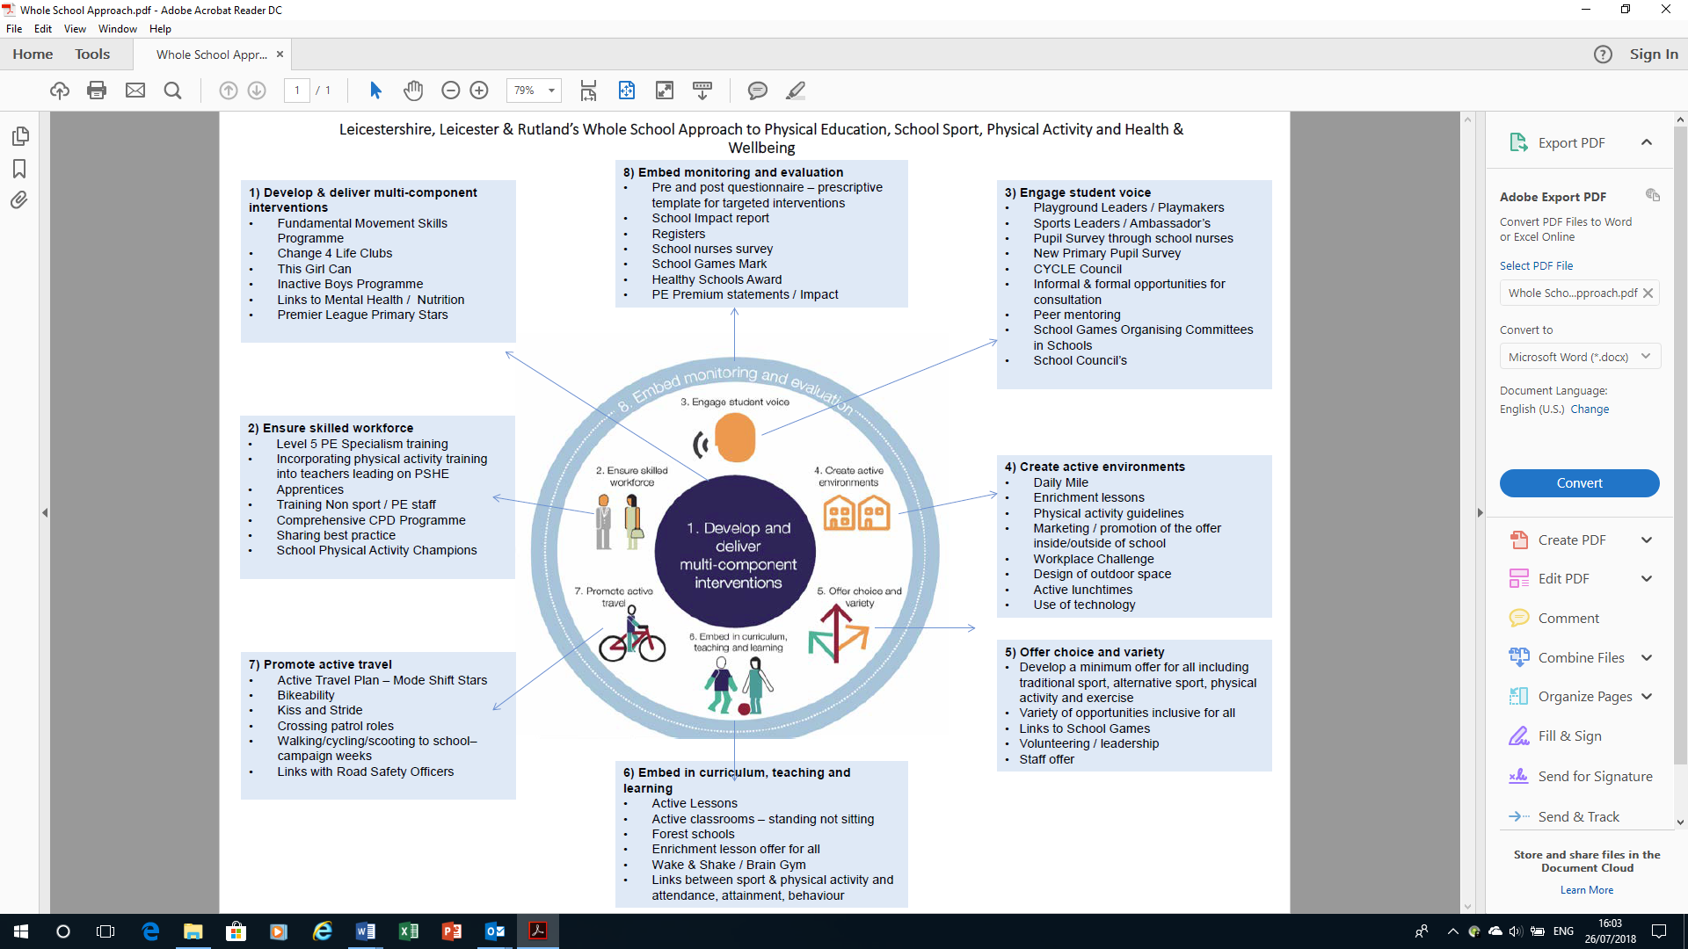

Active 8

The SSP in partnership with NWL council offers a programme (Active 8) which encourages pupils to take part in leisure activities at leisure centres across the District (this is an NWLDC/leisure centre initiative). Each school pays £1.50 per child per year (which ostensibly is paid for out of the PE premium). In return they get to access one activity per week at a leisure centre (up to the cost of a swim).
This is administered termly and children can save up their ‘weekly visit’ and use it for activity days during holiday periods. This appears to be a unique programme. All schools within the SSP participate and an annual report is produced identifying take up. Some schools indicate 35% - 40% take up of the programme.

In order to offer in wider variation of sessions external companies/providers were approached to offer discounts/offers to those of the Club Activ8 scheme. Those who wished to engage were:

Facility | Offer
The Golf Centre | Half price range balls
Simon Cooper Karate School | First month of training then 25% discount of monthly fees
Halfords | 10% cycles and accessories
Rebound | 50% discount on Tuesdays 4-5 and 5-6pm
Rollers Skating Sessions | £1 discount on skating
Conkers | Free child entry every full paying adult
Bouncy Days | 50p off wristbands at events
ME Sports | Free taster session, 50% off summer camps

Further information is required on the success of the scheme and it would be useful to improve understanding in respect of, for example, how many young people would use the facilities anyhow, whether it has increased take up from areas of higher deprivation the longer term impact on levels of childhood obesity experienced in the District. What is clear is that the administration capacity is in place should this scheme or something similar be rolled out to a wider (targeted) population.

Consultation with primary schools indicates that one key frustration with regard to health and wellbeing is travel routes to and from schools and related parking issues. It is not uncommon for up to two thirds of parents to use cars to drop their children off at primary school. Not only does this limit options for children’s physical activity at the start and finish of the school day but it also leads to increasing air pollution around schools themselves.

North West Leicestershire Corporate Strategy

NWLDC’s corporate vision for the district is that: North West Leicestershire is a place where people and businesses feel they belong and are proud to call home.

NWLDC has four priorities in order to ensure that it concentrates its resource to provide services that matter to local people and businesses. They are:

- Value for money – the aim is to provide council services that people feel give good value for money.
- Homes and communities - the aim is to improve the wellbeing of people in NWL.
- Business and jobs - the aim is to make the district a better place to invest, work and visit.
- Green footprints - the aim is to make people proud to be part of a cleaner greener district.

The health and wellbeing strategy will take account of all of the above.
Summary

A NWLDC specific approach aimed at primary, secondary and tertiary prevention is needed.

Whilst many health and wellbeing outcomes for the local population have improved gradually over the years, a number of communities and population groups are being left behind. The length and quality of life indicators demonstrate that deprived and disadvantaged groups have not experienced the same rate of progress as those from affluent wards. Closing the health inequalities gap across NWLDC should be a key priority.

The health and social care system is under significant pressure to cope with increasing demand. This is due to a combination of new technology and treatments, an ageing population, greater public expectations and an increase in lifestyle related illnesses. The health and social care sector is also under significant financial pressure following austerity and recently announced budget reductions. In order to improve outcomes for the local population, reduce health inequalities across the area and cope with the financial pressures there is need to strengthen effort applied to, and the impact made upon, prevention.

Strategic links and partners

This Strategy is the first step in a series of processes that will, in the longer term (10-20 years) fundamentally affect the quality of life of people in the district. It reflects the following stated overarching NWLDC ambitions that:

- People will live longer, and have healthier lives.
- Every child will have the best possible start in life
- People will ‘age well’ and have a healthy older life

To achieve this means NWLDC (and partners) focusing on creating and sustaining healthy and sustainable places and communities.

In the context of Strategy partners, it is important to note that some of these are crucial to the strategic shaping and management of programmes and services. Others have a role in policy development, programme delivery and accommodation of participation. A number, such as schools, have two, three or even four parts to play combining roles as, for example, good lifestyle advocates, information conduits, accommodators of sport, physical activity and community events and ‘routes to market’ for young people plus family members.

NWLDC will both lead strategy implementation and be responsible for gathering and coordinating the information and intelligence that will inform all about progress being made. It is a North West Leicestershire strategy so key strategy elements are set out in a format which reflects how NWLDC is structured and set up to support and deliver while, at all times, taking account of the responsibilities and ambitions of its key strategic partners. It is essential that the following organisations in particular work closely with NWL to deliver Strategy objectives and outcomes:

- Leicestershire County Council (LCC)
- Leicester-shire & Rutland Sport (LRS)
- Leicestershire Public Health (LPH)
- Schools.
Implementation of the policies as well as the provision of infrastructure will require co-operation and input from a wide range of organisations, including neighbouring authorities, as well as public, voluntary and private sector organisations

Overarching principles for the strategy

Based on the national, regional and local context, local demographics, increasing financial strain and increasing age demographic there are a number of clear principles on which the strategy should be based (not in any order)

- Promoting self-care – educating and empowering individuals to take more responsibility for changing their own behaviour (all ages).
- Targeting inequalities – ensure that key services are provided for all residents but resources and interventions target those most in need (Marmot principle)
- Prevention and early intervention – prevent and tackle the wider causes of ill health and poor lifestyle choices and health conditions.
- Improve mental health and wellbeing – ensure that mental health is regarded across all streams of work.
- Partnership working and cooperation – understand the roles of the various statutory bodies whilst enabling voluntary and community organisations to work alongside to improve health and wellbeing across the district.
- Interventions need to be where they can have the most impact

Figure 4.2: Health and Wellbeing Strategy linkages summary

Social determinants | Life cycle | Corporate social responsibility | Principles
Environmental  Social  Individual | Start well  Stay well  Age well | Housing | Targeting inequality
Environmental  Social  Individual | Start well  Stay well  Age well |  | Improved air quality
Environmental  Social  Individual | Start well  Stay well  Age well | Regeneration | Increasing physical activity
Environmental  Social  Individual | Start well  Stay well  Age well |  | Reducing obesity
Environmental  Social  Individual | Start well  Stay well  Age well | Planning | Promoting self-care
Environmental  Social  Individual | Start well  Stay well  Age well |  | Prevention & early intervention
Environmental  Social  Individual | Start well  Stay well  Age well | Community services | Partnership work
Environmental  Social  Individual | Start well  Stay well  Age well |  | Improved mental health/ wellbeing
MECC and social prescribing
Performance measurement
Communication

PART 5: THE STRATEGY

The Strategy outlines a new vision, strategy and action plan for health and wellbeing in NWL. It will determine and inform the future approach taken by the Authority, Public Health, its current (and any future chosen) leisure operator, other partners such as Leicestershire County Council, Leicester-Shire and Rutland Sport, community groups and residents associations. It will, at all times, retain an emphasis upon how best to utilise local assets, generate business growth and returns and achieve maximum impact (and value for money) in respect of driving agreed Strategy outcomes for district residents.

It will inform the positioning and delivery of key NWLDC services and those delivered by and for partners while capturing and reflecting the opinions and ambitions of other organisations. Liaison/engagement with key stakeholders ensures that their aspirations are encompassed within and influence the Council’s health and wellbeing role; addressing inactivity; encouraging people to become and stay active and increase activity levels. The focus will be on defining what is meant by, and then delivery of maximum return on, investment and value for money.

NWLDC will continue to make full use of existing data to consider the nature, scale, demands and needs of the area and the varied communities therein. In so doing, it shall identify and consider how the Area can best exploit its physical and staff resources, tap into positive future trends and, for example, most effectively ‘sweat’ existing (and new) leisure assets.

Fundamental to any contemporary strategy is effective communications platforms and processes. To be credible, the Strategy must evaluate how (and how effectively) the Council and partners promote health and wellbeing messages to target audiences. It is essential to consider whether and how digital communication can underpin monitoring and evaluation frameworks enabling both greater proactivity and much more sophisticated ‘real time’ review of performance against agreed target outcomes.

This links directly to mapping out a reporting framework best suited to demonstrating success, achievement and the value of the contribution that making health and wellbeing inroads will have on achievement of partner priorities both per se and in respect of, for example, the economy, social issues, skills, training and job opportunities.

The ambition is that the Strategy will set out a long-term (10 year) vision accompanied by more specific objectives that apply to the immediate five-year period up to 2023. As such, it will be one of the primary documents used to inform and shape health and wellbeing planning and activity in the Authority influencing and the work of a range of Council departments and partner agencies. It is, thus, essential that work continues on:

- Reviewing the health and wellbeing situation in NWL.
- Taking full account of the demographics of the district, the impact of housing growth and, for example, of the specific demands created by a less active population living longer.
- Working with and through partners ensuring buy in by key partners/stakeholders.
- Achieving a satisfactory level of all party consensus.
- Taking full account of the financial climate and austerity measures that affect public sector partners in the CCG/Health, Education, Regeneration and Sports/Leisure sector.
- Understanding the specific and changing needs and aspirations of national governing bodies of sport (NGBs), schools, colleges and sports clubs across the area.
- Reflecting new Government and Sport England strategies, Leicestershire and Rutland Sport perspectives and how Sport England gears funding programmes to drive delivery.

Strategy vision, outcomes and objectives

The core agreed strategic outcomes are set out under key headings which relate to the way in which they are managed/delivered/coordinated by NWL.

Overall Vision: To measurably improve the health and wellbeing of all people in NWL.

This will be achieved via the coordinated delivery of key services and interventions, improving the overall living environment, creating local opportunities, assisting those that need specific support and enabling people to help themselves.

The supplementary objectives relate primarily to how outcomes will be delivered.
North West Leicestershire Health & Wellbeing Strategy – Ambitions:

- Outcome A: Corporate leadership and coordination
To be in a position where health and wellbeing ambitions are stated, explicit, fully understood, embedded, championed and led by NWLDC.

- Outcome B: Economic development
To gear economic development to ensuring that all NWL people, including vulnerable residents, benefit from ‘good growth’ which brings health and wellbeing benefits to the district.

- Outcome C: Regeneration and planning
To gear regeneration and planning policy to ensuring that all NWL residents, including the most vulnerable, benefit from development which brings health and wellbeing benefits to the district.

- Outcome D: Housing and property
To utilise its investment, influence and communications capacity in respect of housing and property to enhance and support delivery of health and wellbeing outcomes.

- Outcome E: Community services
To deliver and coordinate facilities, opportunities, partnerships and proactive development work that drive both overall and physical activity based health and wellbeing outcomes.

- Outcome F: Performance measurement and evaluation
To effectively measure, analyse, evaluate, learn from and improve Strategy implementation including elements delivered by NWLDC, in tandem with partners and by other agencies independently.

The headline strategic outcomes translate into a series of key objectives. These are as follows:

Outcome A: To be in a position where health and wellbeing ambitions are stated, explicit, fully understood, embedded, championed and led by NWLDC.
Key objectives - to:

- Adopt this Strategy and confirm NWLDC as the lead strategic and primary coordinating agency in and among the range of organisations that drive strategy implementation in the district.
- Inform and organise NWLDC operational departments and structures and processes so as to wholly reflect these commitments and agreements.
- Inform and confirm the role of interest-based and contractual partners, grant-based and other support bodies and processes so as to wholly reflect these commitments and agreements - and clarify how they are to deliver against itemised objectives

It is acknowledged that the health and wellbeing arena is complex with various organisations leading on different areas. Activity crossover is not uncommon and can cause duplication of effort and resources. This is equally mirrored in areas of deficiency or gaps in service as organisations do not always understand what is being delivered and by whom. This Strategy for NWL will only be successful if agreement is reached with partners on health and wellbeing priorities accompanied by clear understanding of who is responsible for what. It necessitates collaboration with partner organisations in Leicestershire and should be subject to regular review to ensure that evidence-based, impactful, best practice is achieved.

To develop this collaborative approach both between NWLDC and other bodies and internally within the Council between departments, there is a need to establish an overarching Strategic Health and Wellbeing Group with the remit to drive the vision and ambition of this strategy. It will need to check, challenge and share good practice. Whilst ostensibly an internal council body, it will need to communicate with the wider health and wellbeing field across the individual remits encompassed.

Activity and interventions are all very well but there must be a clear plan and priorities. The role of the Strategic Group will, therefore, be to determine, plan, coordinate, communicate about and commission specific H&WB services and interventions for the local population so as both to limit and ultimately eradicate duplication of effort and to also ensure that gaps are plugged and that targeted interventions are successful. The established Staying Healthy Partnership would appear to be a group that can be used as a conduit for the delivery of the strategy actions as well as being able to monitor progress (rather than establishing new forums).

Making Every Contact Count (MECC) is an opportunity for NWLDC to utilise the day-to-day interactions that it and linked organisations have with other people to support them in to make positive changes to their physical and mental health and wellbeing. MECC enables the opportunistic delivery of consistent and concise healthy lifestyle information and enables individuals to engage in conversations about their health at scale across NWL and populations.

It is, therefore, incumbent on the Strategic Health and Wellbeing Group to identify MECC based opportunities to embed and drive H&WB opportunity in and across all areas of the Council and partner-driven service delivery. To achieve this it will need to consider how to embed MECC within the organisation, among staff and in individuals themselves.

Specific Strategy recommendations

Objective | Actions - to
Adopt this Strategy and confirm NWLDC as the lead strategic and primary coordination agency in and among the range of organisations that drive strategy implementation in the District, | - Ensure elected member and officer ‘buy-in’ to this strategy to ensure that the health and wellbeing strategy has a real and lasting impact on residents of NWL.  - Identify a senior officer champion who will take the Strategy forward ensuring that all departments within NWLDC are committed to driving its implementation.  - Establish a strategic group to support implementation of the Strategy by checking, challenging and sharing good practice.  - Adopt the MECC approach to behaviour change for staff, partner organisations and individuals.
Inform and organise NWLDC operational departments and structures and processes so as to wholly reflect these commitments and agreements. | - Identify a champion (with authority) in each department whose remit it is to keep health and wellbeing at the top of the agenda.  - Each department needs to commit to taking a full and active part in the health and wellbeing strategic group.
Inform and confirm the role of interest-based and contractual partners, grant-based and other support bodies and processes so as to wholly reflect these commitments and agreements - and clarify how they are to deliver against itemised objectives. | - Identify key partners with whom NWL can work with to best implement the principles and specific actions of this strategy.  - Ensure that contractual partners are fully committed to the health and wellbeing of NWL residents as well as their own employees.  - Set specific objectives for contractual partners which are specifically linked to the health and wellbeing agenda and monitor outcomes accordingly. (see Performance Measurement and Evaluation).
The Strategic Health and Wellbeing Group to drive the Strategy, check and challenge delivery and communicate effectively in respect of health and wellbeing activity. | - Develop a communications plan for the Health and Wellbeing Strategy which will inform partners and key stakeholders about Strategy vision, ambition and intentions.  - Work across departments to adopt the MECC approach to behaviour change for staff, partner organisations and individuals.  - NWLDC to commit appropriate resources to ensure that strategy principles are adhered to and championed.
Outcome B: To gear economic development to ensuring that all people in NWL, including vulnerable residents, benefit from ‘good growth’ which brings health and wellbeing benefits to the district.
Key objectives; economic development - to:

Overall
Incorporate strategic health and wellbeing outcomes as dictated by this Strategy in all relevant facets of economic development work.

Businesses:
Create/sustain resilient businesses ensuring good, fulfilling and long-term employment opportunity

Jobs and skills:
Develop skills that aid employability, career progression and life chances, thereby enhancing health and wellbeing and reducing inequalities.

Stable and fulfilling employment is a prerequisite for good health and, in turn helps improve the health of individuals, families and wider networks. This is particularly applicable to young people who if they do not source work early in life are less likely to be in employment as they grow older and then more likely to experience poor long-term health. In addition, communities with higher levels of income deprivation normally have lower life expectancy and poorer health.

NWL has an unemployment rate which is below both the national rate and the regional average. Earnings are 5.9% below national (and 1.6% above regional) averages. This would suggest that industry (whatever the size or scale) has an important role to play in the health and wellbeing of the wider population. This fits with both the stay well and age well ambitions set out in Figure 4.2 above.

Occupations in NWL include 47.4% as managers, directors and senior officials, professional and technical occupations. This is just above the average of 46.3%. Growth over the period 2011 to 2017 in this occupational group in the LLEP area has been above average (21.7% versus 15.1%). Managers, directors and senior officials however have seen a significant fall in their numbers. Given the relatively high number of people in managerial roles it is important to consider if and how they are accessing physical activity opportunity and how different businesses are supporting health and wellbeing in the workplace.

The NWLDC Economic Development Department facilitates the local conditions for sustainable economic growth, job creation and rising living standards by helping to develop a healthy workforce which will support economic development in a range of ways including, for example:

- Developing resilient people who will power business success.
- Enhancing the pool of confident, ambitious, healthy people able and willing to work.
- Better health for longer meaning more productive employees and volunteers able to work for longer.
- People being increasingly independent and resourceful thereby developing a supportive, positive, self-sufficient culture.
- Ensuring people have the best possible start in life and are therefore enabled to fulfil their potential and become productive members of society.
- Creating opportunities for community economic development that reduce the cost to the public sector.
- Improved perceptions of places/communities helping to support enterprise and investment.
- Ensuring the local health and social care sector considers the impact of the decisions it makes on the local economy.
- Growth in the health and social care sectors provides major opportunities for new business activity, innovation and employment.

Based on the school mantra that Attendance Matters, this could be developed into an all-encompassing workplace strategy suitable for all businesses to adopt regardless of size. A range of tools and organisations are available to support business to consider the health and wellbeing of their employees. In particular, Leicestershire and Rutland Sport (as a key partner) is currently helping NWLDC to develop its own programme.

Work place health initiative

This is where businesses can/will demonstrate a real commitment to improving the health and wellbeing of their workforce, while also making the organisation an employer for choice for prospective employees. Many areas can be considered; they include, for example:

- Physical activity in and linked to the workplace – how to build more activity into a working day by, for example, developing exercise guidelines for staff which consider types of exercise, how they can be undertaken over short durations and in ‘non-standard’ spaces and how to reduce sedentary behaviour.
- Healthy eating in the workplace – encouraging staff to enjoy a balanced, nutritious diet to feel better and improve their day at work; addressing common diet myths and the impact of nutrition on performance within the working day.
- Mental health awareness - there is increasing realisation of the importance of mental health and the impact that poor mental health can have on performance, attendance and other staff. Providing the information and resources needed to maintain good mental health is one option which could be accompanied by a process which encourages honest, open conversations about the effects of stress, anxiety and depression and outlines steps to proactively address such issues if and when they come up.
- Alcohol awareness - assessing the extent of need to educate employees on how alcohol can impact performance in work, as well as providing information on safe drinking habits, tools to assess personal intake, and resources to aid those who wish to make changes.

Work place interventions cannot sit in isolation and NWLDC has a major role to play in, for example, encouraging people to walk/cycle to work (and school), promoting workplace health promotion at/via its leisure facilities or publicising the value of installing workplace showers to facilitate such activity. In other contexts, new build businesses should automatically secure NWLDC support when seeking to minimise air pollution; this is something that will necessitate the Council supporting businesses in a policy as well as a practical context.

Working across departments

While Economic Development holds the remit to drive employment opportunity cross-department collaboration is vital with, for example, the environmental health team. The density of fast food outlets in specific locations (and, perhaps, the definition of a fast food outlet) may impact upon the obesity element of the strategy, whilst limiting gambling outlets on the high street is believed to affect the mental health and wellbeing of a small number of people. It is noted that many of the actions identified over leaf are currently being undertaken across the District, to a greater or lesser degree. Many of the actions could therefore be to continue to do specific actions.

Specific Strategy recommendations

Objective | Actions - to
Overall  Incorporate strategic health and wellbeing outcomes as dictated by this Strategy in all relevant facets of economic development work. | - Apply a health and wellbeing opportunity evaluation to all service plans developed and commit appropriate resources to ensure that H&WB strategy principles are adhered to and championed.  - Develop a communications plan related to the H&WB Strategy to inform partners and key stakeholders about the vision, ambition and desired outcomes.  - Working with other NWLDC departments, adopt the MECC approach to behaviour change for staff, partner organisations and individuals.
Businesses  Create/sustain resilient businesses ensuring good, fulfilling and long-term employment opportunity | - Encourage sustainable business practices, e.g. those which cut waste and enhance air and water quality  - Specifically support and promote healthy, safe, diverse workforces and workplaces.  - Actively support the introduction of workplace health initiatives, leading by example.  - Champion work life balance initiatives with a view to monitoring attendance (attendance matters). Identify good practice with a view to sharing with other business and colleagues.
Jobs and skills  Develop skills that aid employability, career progression and life chances, thereby enhancing health and wellbeing and reducing inequalities | - Encourage NWL based businesses to gain the Youth Friendly Employer Award kitemark to drive and embed a youth friendly employment culture and create a motivated future workforce.  - Assess the viability of NWL leading the implementation of a single shared apprenticeship account whereby employers pool funds to enable/support Apprentice Levy-paying employers to transfer funds to other employers, through the apprenticeship service.  - Work with and through the existing strong schools’ networks in NWL to look at how, working collectively, better advice, guidance and employer-linked/led support can be offered to assist young people likely to move directly into work, or work-related training in NWL to make informed choices.

Outcome C: To ensure that regeneration and planning policy leads to all NWL people, including vulnerable residents, benefitting from development which brings health and wellbeing benefits to the district.
Key objectives; regeneration and planning - to

Overall
- Ensure that health and wellbeing (and health infrastructure) are fully considered in local and neighbourhood plans and in all planning decision making (where relevant).

The Local Plan:
- Produce development proposals which take account of NWL health and wellbeing strategy objectives, other relevant health improvement strategies and consider the healthcare infrastructure implications of any relevant proposed local development.
- Consider the introduction of Health Improvement Assessments (HIAs) as part of the Local Plan review

Open spaces planning
- Produce an open spaces needs assessment and strategy to ensures that knowledge about the quality and value of open space, green infrastructure (including natural greenspace and woodlands) and play facilities in the district is detailed and up to date – and that its potential to contribute to H&WB is fully exploited

Active travel
- Use planning policy and actions to actively promote and drive active travel

Environmental health
- Use planning policy and Council influence to actively promote and drive positive environmental health outcomes at work in schools and in the home.

Overall

The purpose of regeneration is to improve the social, economic, physical and environmental wellbeing of local communities. Regeneration programmes tend to comprise multiple projects which combine to make this happen. Examples include processes designed to help new businesses get started across an authority area or to reduce crime in particular communities. Via its Local Plan, NWLDC assesses future need and looks to adopt and implement policies to sustain and improve the area ‘health economy’. The primary aim is to ensure that health and wellbeing considerations feature at the heart of all decisions taken by the Council.

Options to drive healthy lifestyles include, for example, planning for an environment that supports people of all ages to make healthy choices, helps to promote active travel and physical activity, and enables access to healthier food, high quality open spaces, green infrastructure and opportunities for play, sport and recreation.

Planning officers are well placed to see at first hand the health benefits of the delivery of quality housing, economic development and job creation. Effective and timely planning policy can deliver important infrastructure and a platform for private sector growth and job creation, optimising outcomes that apply to economic, environmental and social objectives. The ways in which local authorities do this include policies and related practice in respect of:

- Climate change and the natural environment
- Supporting communities to access healthier food production and consumption choices.
- Planning conditions such as S.106 obligations and the Community Infrastructure Levy are mechanisms to secure a healthy environment when granting planning permission.

Within NWLDC, a cross corporate working group model is being established. This should be the vehicle via which to check and challenge the coherence of the Council’s approach to check and challenge policy and monitor and evaluate accordingly.

The Local Plan

NWLDC is reviewing its Local Plan in 2018 to ensure that H&WB is incorporated at all levels across it. This Strategy will be used and applied to offer direction in respect of the Local Plan, planning applications and conditions, and securing local infrastructure and investment via the leveraging of S106 agreements and the Community Infrastructure Levy. To fully reflect health and wellbeing objectives and outcomes, the Local Plan should:

- Help create healthy living environments that, where possible, include making physical activity easy to do.
- Create places and spaces to meet to support community engagement and social capital.
- Promote health, social and cultural wellbeing and the reduction of health inequalities.
- Consider how to reduce traffic impact – i.e. proximity to locations where children and young people congregate such as schools, community centres and playgrounds.
- Ensure odours and noise impact are minimised.
- Support policies on refuse and litter (and recycling).

It is important to note that policies should only be put in place where there is evidence that they are needed and will improve a situation (without causing detrimental unintended consequences). A Health Improvement Assessment (HIA) could help this process. An HIA is intended to support the creation of healthy communities through health-promoting planning policies and development management. It is a process which ensures that the effect of development on both health and health inequalities are considered and responded to during the planning process. They are undertaken to predict the health implications on a population of implementing a plan, policy, programme or project, and in so doing aid decision-making.

Environmental health

A district council’s role in environmental health can encompass functions as varied as monitoring/managing local air quality, noise nuisance, food safety, smoking bans, occupational health and safety, pest control, and dealing with contaminated land.

Many of these have a direct bearing on health and wellbeing; part of the function of this strategy will be to explain and then point to areas where (so as to ensure that the evidence base to validate continued investment in such services is fully made) they have a crucial impact and where, why and how this should be measured and evaluated going forward.

Licensing

Under the Licensing Act 2003, district councils are the lead licensing authority responsible for licensing a range of activities associated with alcohol consumption, as well as preventing the underage sale of alcohol. Districts regulate the sale of alcohol in pubs, restaurants, hotels, off licences and supermarkets.

Effective partnership work between licensing authorities and NWLDC plus the Police, Fire, Ambulance and Healthcare services together with trade and local residents is vital to the delivery of positive health outcomes for people and places. It will, therefore be necessary for NWL to maintain the highest standards with regard to, for example, processing license applications, proactively enforcing licence conditions and consulting with responsible authorities regarding some licence applications

Open spaces planning

The challenge to get people physical active is substantial. One quarter of women and one fifth of men are physically inactive, as are many children. Access to green spaces has a recognised value in respect of mental and physical health. Key issues in NWL include:

- The need to deliver and lobby for improvements in local natural habitats…both in the context of its generic impact and with regard to the creation of options for active travel, walking and cycling to school or work, dog-walking and ‘leisure exercise’.
- Using the open spaces strategy (and associated intelligence such as the District Playing Pitch Strategy) to drive policy that respects and creates attractive places, thriving communities and supports health and wellbeing.
- Provision of allotments or allotment gardens, to ensure the provision of adequate spaces for food growing opportunity.

Active travel

Taking the opportunity to provide every incentive to encourage people to build walking and cycling into their everyday lives in the context of journeys to work, to school, to shop and on other occasions when it is feasible, is essential. This has a cross-cutting impact on, and can benefit from, work undertaken in respect of housing, green spaces, play provision, way-marking, schools liaison and the way that leisure centres and other potential active travel ‘access points’ function. The benefits of active travel include:

- Supporting local businesses and promoting vibrant town centres.
- Making for a high quality, appealing public realm.
- Reducing car travel, air pollution, carbon dioxide emissions and congestion, helping the environment.
- Reduces road danger and noise.
- Increasing the number of people of all ages out on the streets, making public spaces seem more welcoming and providing opportunities for social interaction and children's play.
- Providing an opportunity for everyone, including people with impairments, to experience and enjoy the outdoor experience.
- Health benefits (physical, emotional and mental).

When developing large sites, the Council needs to build active travel into site plans (which takes account of walking, cycling and public transport). Other considerations could be development of more formal routes (walking/cycling) to schools, routes (walking/cycling) to work, routes (walking/cycling) to town/village centres, Waymarking, off-road cycle/walking routes etc. Judicious use of CIL/S106 monies need to be considered within these developments.
Specific Strategy recommendations

Objective | Actions - to
Overall  Ensure that H&WB is fully considered in all planning decision making. | - Ensure that H&WB impact and outcomes is a key influence on, and at the forefront of, all planning policy development.  - Encourage neighbourhood plans to include H&WB elements within their development.
Local Plan  Produce development proposals which take account of NWL health and wellbeing strategy objectives, other relevant health improvement strategies and consider the healthcare infrastructure implications of any relevant proposed local development. | - Ensure health and wellbeing is at the forefront of strategy development when considering the Local Plan.  - Ensure staff are fully trained and cognisant of latest health and wellbeing practises and considerations such as:  - promoting active travel  - promoting physical activity and sport  - enabling access to healthier food  - enabling access to high quality open spaces, green infrastructure and opportunities for play, sport and recreation  - Consider developing a process for the application of HIAs where relevant within the Local Plan review
Open spaces provision  Produce an open spaces needs assessment and strategy to ensure that data about the quality and value of open space, green infrastructure and play facilities in the district is detailed and up to date and its potential contribution to H&WB in the district can be fully exploited | - Increase use of public open spaces (including natural greenspace and woodlands) by the resident population. This will entail developing understanding of current opportunities, identifying deficiencies and how best to access such facilities. (To include the full gamut of open spaces including, for example, allotments, green corridors, play spaces, cemeteries etc.).  - Utilise the recently completed Playing Pitch Strategy to drive improvement to the quality of pitch facilities, which should lead to increases in physical activity.  - Assess the feasibility of rolling out investment in ‘green gyms’ making them accessible to residents located in the District’s towns and villages.  - Optimise the use of open spaces when looking at how to develop active travel routes; use this to encourage greater use of open spaces both for travelling to and from work and for use in people’s leisure time.
Active travel  Use planning policy and actions to actively promote and drive active travel | - Develop a District active travel policy which takes account of existing infrastructure but seeks to influence new developments.  - Apply planning policy and actions to permissions to new businesses which actively promote and drive active travel.  - Link to the National Forest developments and consider how the Forest can be made more accessible to people in towns and villages. (This will entail working in partnership with highways, LCC and the National Forest plus other agencies).  - Encourage more schools to invest in Bike ability opportunities.

Objective | Actions - to
Environmental Health  Use planning policy and Council influence to actively promote and drive positive environmental health outcomes at work in schools and in the home. | - Ensure that licenses are up to date and valid in areas of national import.  - Develop a working group with Planners/Regeneration to look at and understand better where fast food outlets are or can be located – develop an internal policy which considers how many and how close, a specific number might be to other infrastructure (e.g. schools).  - Develop and publicise workplace, school and home environment guidance in respect of, for example:  - Air quality:  - Water sources, use and consumption.  - Food sources, quality and the eco-credentials attached to packaging, transport, use of pesticides etc..  - Electromagnetic fields and related devices  - Sound and visual pollution: from blaring music to lour cars to barking dogs.
Outcome D: To utilise investment, influence and communications capacity in respect of housing and property to enhance and support delivery of health and wellbeing outcomes.
Key objectives: housing and property – to provide:

Overall
- A service which enables people in NWL to live as independently as possible for as long as possible.

Housing:
- Good quality housing with high energy efficiency/standards supporting affordable warmth, good health and reduced living costs.
- Access to suitable, good quality homes and neighbourhoods offering a secure place for families to thrive and promote good health, wellbeing and independent living.
- A quality residential and neighbourhood offer impacting on quality of life and attracting people and businesses to locate there.

Good-quality housing is critical to good mental and physical health. Improving poor homes (and living environments) is cost effective and offers rapid ‘payback’. NWLDC is directly involved in its role as a provider of housing and ‘enforcer’ with regard to private rented housing.

The standard of housing is clearly linked to residents’ health and wellbeing, i.e. poor quality housing often leads to ill health (mental as well as physical), increased incidence of slips, trips and falls, excess winter deaths due to cold and a higher incidence of respiratory illnesses for those living in damp homes. In developing its housing Strategy, NWLDC has worked with LCC public health service to undertake a health impact assessment of the strategic priorities to establish where it might maximise positive impacts on the wider determinants of health and health inequalities whilst minimising any negative impacts. Its action plans will take account of these objectives.

In addition to directly tackling issues in respect of the condition and availability of accommodation, NWL is committed to targeting specific resource at clearly definable groups and areas and positively utilise its capacity to communicate with residents, families and associated providers to improve quality of life ‘across the board’. This links closely to other potential core Strategy areas described elsewhere.

The revised NWL Housing Strategy 2016 – 2021 builds on the work of the previous strategy, and taking into account national and local factors, focuses on how the district council and the NWL Strategic Housing Partnership (the partnership) can work together to provide the best homes and housing related support for its residents.

The partnership also recognises that sustainable, inclusive communities are vital to promote economic growth, improve health and well-being, and create a sense of pride and belonging for residents. A focus on strong communities underpins this strategy and the identified themes, priorities and outcomes for the next five years. Its themes are:

- Supply – making sure it has enough of the right type of homes
- Standards – that these homes are of a suitable quality and sustainable
- Support –making additional support available to all those who need it.

The Strategy has a number of strands including:

- Prevention of homelessness strategy
- HRA 30-year business plan
- Planning policies
- Affordable housing supplementary planning document
- Design supplementary planning document
- Registered providers business plans
- Empty homes strategy
- Developers business plans
- Allocations policy
- Affordable warmth strategy
- Asset management strategy
- Tenancy strategy
- Acquisition policy.

Increasing recognition is being given to the links between housing, health and well-being. The abovementioned health impact assessment was undertaken in conjunction with partners from public health, to identify where the strategic priorities have a direct impact on the health of residents. The implementation of this strategy will aim to maximise positive health impacts on our local communities.

First Contact is a partnership of services that work together to support individuals to live independently. It involves a wide range of public organisations, charities and voluntary groups. The aim is to offer assistance which includes:

Health and wellbeing
- Fitting simple adaptations to a home to stop people from having a fall
- Offering an emergency lifeline
- Informing Individuals about local groups and activities
- Advice and support for carers.

Money
- Advising about how to claim the benefits
- Helping to manage money and pay bills
- Helping to set up a bank account – and avoid pay day lenders and loan sharks.

Safety and security
- Having locks fixed on windows and doors.
- Making sure that the smoke alarms work
- Keeping homes warm.

The Lightbulb Project

LCC currently funds energy advice for vulnerable households, community awareness campaigns and training for front‐line staff through the Warm Homes Healthy Homes (WHHH) Project. The service, delivered by the Papworth Trust, helps people to reduce their energy bills and stay warm and healthy in their homes. The WFHH also funds works as part of a unique partnership called the Lightbulb Project to deliver heating and insulation measures to over 150 of the most vulnerable households across the county.
The Lightbulb Project brings together the housing services across seven district councils and the county council. Its aim is to integrate practical housing support into a single service that is available to all, easier to access, easier to use, and will provide support shaped around an individual’s need not an organisation’s processes.

Referrals are generated from a partnership with First Contact Plus, a single point of contact for referrals of vulnerable people from front‐line health workers, social workers, voluntary organisations the fire service and other council services such as housing and benefits. For some people, a free home visit will then take place and a qualified energy advisor and energy rating assessor.

The Lightbulb Project pilot is focusing on three areas which can then be evaluated before wider rollout. These are:

- A GP referral system in Hinckley and Bosworth using risk stratification analysis undertaken by integrated care coordinators
- An EHO‐led system for identifying houses with Category 1 hazards using HHSRS data linked to data on health, social care, income and tenure
- A hospital discharge referral process from Loughborough General Hospital’s older person’s unit linked to housing officer assessments triangulating data with data on income and tenure.

For those that take up the offer, a Papworth Trust officer will visit the household offering
energy advice and conduct a SAP assessment to determine the appropriate mix of measures in agreement with the householder. Following the installation of measures there will then be a follow up visit to inspect the work, offer further energy advice and conduct a post SAP analysis.

LCC public health will also be utilising a system for tracking health and social care usage so
that a robust before and after evaluation can be conducted to analyse changes compared to a matched cohort. It is hoped that this will demonstrate how providing affordable warmth can
have a significant return on investment as well as improvements in health and well‐being.

The troubled families programme (TFP)

The TFP aims to transform the lives of 400,000 families with multiple, persistent and often severe problems. It requires local authorities to change the way families experience support interventions via consistent application of the Troubled Families model. This ‘whole family working’ approach encompasses a key/lead worker model where a dedicated frontline professional organises services to address all the family’s problems accompanied by a persistent and assertive approach from frontline workers to help families progress towards an agreed improvement plan.
As of 2014, the TFP placed greater focus on families with younger children in need of early help and on the delivery of early support when families faced problems associated with child safeguarding (e.g. domestic violence and abuse). The programme is mainstreaming a whole family approach within early help services.

- LCC has been awarded £442,800 of funding from the Sport England (£40 million) National Lottery funding stream to help low-income families get active with their children.
- Working in partnership with Leicestershire Home-Start charities, district councils and LSR, the County is one of the first to receive investment from this funding stream.
- The National Child Measurement Programme (2016/17) show that around 20.3 per cent of Leicestershire schoolchildren in reception, and 29.6 per cent in year 6, were classed as overweight. Although this is better than the national average of 22.6 per cent and 34.2 per cent respectively, LCC is aiming to support the development of a lifelong commitment to physical activity to further improve (reduce) the rate of overweight children and the funds will be used to target inactive families with at least one child aged 5-10 years.
- The scheme is to be piloted, in its first year, in Harborough and NWL and will include:
- Work directly with families to assess physical activity needs and co-produce a bespoke activity plan with achievable, time-related goals.
- Weekly visits from volunteers to review physical activity plans and help with difficulties faced and attend activity sessions with families to boost their confidence and help them develop a manageable routine.
- Tailored, affordable family activities run by NWLDC physical activity development staff.
- Free or low cost physical activity opportunity featuring outdoor gyms, parks, bike routes and use of council leisure centres.

It will need to be closely monitored but has potential to have a significant impact on individuals and families which have been hard to reach and influence in the past.

Consultation with housing colleagues indicates the following:

Approximately one quarter of council housing stock is sheltered/supported living. NWLDC offers a range of services. In particular, the Council has increased the range and number of activities it offers at sheltered accommodation (and other places) over the past two years. In 2017 there were 1,870 different activities at 10 locations. Approximately one third of these were organised by the Council. NWLDC input has reduced slightly due to volunteers taking over the organisation and sustaining the activities on offer.

From a position of vacancies in 2015, NWL is now in a position where sheltered accommodation in demand and there is limited capacity.

The key aim for the housing is to provide a service which enables people to live as independently as possible and the department clearly understands the role that housing can play in contributing to the H&WB agenda.

Specific Strategy recommendations

Objective | Actions - to
Overall  To play the part of a ‘good neighbour’ and ensure that residents can live as independently as possible for as long as possible. | - Fully adopt the principles and practice espoused in MECC to ensure that the Council’s services and influence is as proactive as possible and has the optimum impact on quality of life, health and wellbeing and the tackling of factors such as loneliness and social isolation.  - Ensure that NWL has a quality residential and neighbourhood offer impacting on overall quality of life and attracting people and businesses to locate in the district.
Housing  A good quality housing and high energy/efficiency standards supporting affordable warmth, good health and reduce living cost | - Ensure that residents (of housing association stock and the wider home owning public) are aware of potential adaptations which can be made to properties and eligibility criteria for them to access.  - Via all the mechanisms at its disposal and the adoption of MECC, provide appropriate guidance and support in respect of housing and neighbourhood improvement related issues - to all residents of NWL.  - Maximise partnership work and options (with existing partner agencies, third and voluntary sector agencies) to ensure investment and support where it is most need in the housing market.
Housing  Access to suitable, good quality homes and neighbourhoods providing a secure place for families to thrive and promote good health, wellbeing and independent living | - Support and monitor the TFP pilot with a view to embedding it within mainstream activity. Ensure leisure centres and other facilities are primed and ready to accept families from this programme.  - Continue to identify and deliver activities (physical and cultural) which encourage social interaction, reduce loneliness and social isolation and support independent living.  - Agree in principle the roles and outcomes for which other agencies such as sports clubs and third sector organisation are able to have full or partial responsibility – in this context.  - Continue to encourage the voluntary sector to undertake this role encouraging more self-determinism within the sheltered housing community  - Work with colleagues in District and County Council departments to improve active cycle and active walk routes to and from parks, open spaces, the National Forest, town centres and businesses.  - Directly and effectively market resource at increasing young people’s participation among/in NWL’s key underrepresented groups and localities.  - Consider how Active Design principles can be applied to new build and new housing estates, with a view to embedding good behaviour with regard to physical activity.  - Assess the feasibility of extending the Active 8 scheme (which encourages school children to access Council-owned leisure facilities) to people in sheltered and other NWLDC owned/influenced accommodation.
Outcome E: To deliver and coordinate facilities, opportunities. partnerships and proactive development work that drive both overall and physical activity-based health and wellbeing outcomes.

Key objectives – community services – to:

Overall
- Continue to support and promote health and wellbeing through the policies and actions of NWLDC Community Services.

Development and engaging with communities
- Increase levels of participation in sport/physical activity via engagement with communities, strengthening social networks and delivery of NWLDC and partner-driven proactive community-centred approaches to H&WB

Facilities provision
- Improve the quality, accessibility and levels of community access to indoor and built sports facilities

Partnership work
- Work across NWLDC departments and with external partners in the public, private, health and 3rd sector to increase levels of participation in sport, physical activity and culture with a specific focus on harder to reach groups.

Overall

The NWLDC community team works with parish and town council, community groups and organisations and other District Council services to enhance the lives, H&WB of communities in NWL. It offers support and advice to solve local problems, working with other district council teams and services in partnership with residents, groups and other service providers, such as LCC, Voluntary Action Leicestershire, RCC (Leicestershire and Rutland), schools and the National Forest Company to name a few.

NWL Facilities Framework Audit (2017-2021)

This audit was supported by the LSR (county sports Partnership, Leicester-Shire and Rutland Sport) and was developed in liaison with Sport England, local sports clubs, schools, and parish and town councils.

The report presents a supply and demand assessment of indoor and built sport and recreation facilities in accordance with Sport England’s Strategy ‘Towards an Active Nation’.
The audit assessed the level and quality of provision of indoor sport and recreation facilities across the district, assessing and evaluating existing supply of facilities measured against both current and future demand for facilities. Whilst the report covers the period 2017-2031, the recommendation is that it be refreshed entirely every 3 to 4 years.

The scope of the audit covers sports halls, swimming pools, health and fitness facilities, indoor bowls, indoor tennis, squash and artificial grass pitches.
Development and engaging with communities

NWL can play a key role in strengthening social networks and community-centred approaches to health (plus other activity and engagement) via enhanced volunteering, neighbourhood based caring programmes and, for example, innovative use of mechanisms such as neighbourhood watch. Such interventions can be significant to health and the resulting programmes have been shown to mitigate common lifestyle risks, such as smoking, obesity, high cholesterol and blood pressure.

While the direct ‘social return on investment’ related to community-centred approaches to health is largely unmeasured there is potential to consider specific options in identified communities in the Authority, possibly linked to more specific outcome measurement.

Crime and disorder.

Reducing the impact of harm associated crime, disorder and anti-social behaviour within communities requires reliable and accurate insight into the communities affected – something which districts are considered to be uniquely placed to provide. As the responsible authority and leaders of local CSPs, districts have a pivotal role in shaping, leading and collaborating with not only local communities but the wider range of external partners to develop and deliver solutions that are sustainable and offer real respite. In NWLDC a range of programmes designed to increase engagement and physical activity across the District is available. These include:

Exercise on referral

The Active Lifestyle Exercise Scheme is a partnership between the Health Authority, local councils, G.P Practices and other Health Care Professionals. It offers people who are inactive or who have a condition that could benefit from physical activity. The individual is engaged in the scheme for 12 weeks giving them the opportunity to participate in exercise: at a special reduced rate, at a convenient venue in the local community, under the guidance of qualified exercise professionals. People need encouragement and support to help them to make the first step to becoming more active on a regular basis; this is what the Active Lifestyle Exercise Referral Scheme is intended to provide.

Exercise referral swim lessons – It is important to understand that people who have not learnt to swim cannot utilise the NWLDC offer fully. NWL acknowledges that it is never too late to learn to swim and, as a consequence, ‘latecomers’ to this activity are supported by this programme.

Active Hearts

This cardiac rehabilitation scheme is run by NWLDC in partnership with LRS, University Hospitals and local GP surgeries. It targets people who are either recovering from heart problems or heart surgery. It enables individuals to achieve and maintain better health and lifestyle by promoting and supporting individuals to engage in an exercise programme which will assist them in their daily lives. Referrals come from hospitals, GPs and the cardiac rehabilitation team at Leicester City hospitals and Queens Hospital in Burton Upon Trent.

Activ8

The SSP, in partnership with NWLDC, offers a programme (Activ8) to encourage pupils to take part in leisure activities at leisure centres across the district. Each school pays £1.50 per child per year (ostensibly paid for out of the PE premium). In return they get to access one activity per week at a leisure centre (up to the cost of a swim). This is administered termly and children can save up their ‘weekly visit allowance’ and use it for activity days during holiday periods. This is a unique (and very good) programme. All schools within the SSP participate and an annual report is produced identifying take up. Some schools indicate 35% - 40% take up of the programme.

In depth analysis is required to understand its impact on behavioural change, however, this scheme has the potential to be adjusted to create more of a focus on hard to reach groups, if funding can be identified to at least, cover the costs of administering the scheme. Links could, for example be made with the emerging Trouble Families Programme.
Sport and physical activity for people with disabilities

This is an area in which the proposed adoption of MECC could make a significant difference. Some form of additional intervention to enhance the extent to which schools, health and related bodies are sufficiently informed, confident about and prepared to transmit messages and broker contact in respect of the options for disabled people would be of value. Ensuring that good levels of appropriately timed, supervised and staffed opportunity within NWLDC sport/leisure centres could be accompanied by a system of referral to willing, safe, accredited clubs and groups with appropriate skills and interest. This would make a considerable difference to the effectiveness, capacity, breadth of options delivered and, arguably, in the medium term, the ability of such groups to attract and retain voluntary input and support.

Provision of and community access to indoor and built sports facilities

The Government Strategy, Sporting Futures, places a clear emphasis on the need to harness sport and physical activity for social good and how it can have a meaningful and measurable impact on improving people’s lives. There is a need to be clear on the social outcomes required and not just what is invested in but why. The opportunity exists for the new facility, in particular, to link much more closely to the emerging health and wellbeing strategy and other council strategies in respect of:

- Physical wellbeing.
- Mental wellbeing.
- Individual development.
- Social and community development.
- Economic development

The facilities and programmes therein will be required to contribute towards the achievement of the following outcomes:

- Improving health and wellbeing and targeting those with health inequalities
- Providing local economic benefit
- Ensuring local people have the skills to prosper
- Supporting safe and inclusive neighbourhoods
- Promoting community cohesion
- Educating, protecting and providing opportunities for young people
- Supporting and caring for vulnerable adults and older people
- Providing high quality services
- Sustainability/ environmental improvements.

Interdepartmental cooperation is required to ensure that the facilities and programmes therein reflect the requirements of the local population. It will much easier to build processes into a new facility which specifically monitor and evaluate usage from different target groups.

Provision of, and improving community access to, indoor and built facilities are also a key aspect of district council influence. Getting this right underpins increased physical activity from all sections of the community. Some reduced cost leisure centre access schemes are out there but the extent of their use, impact and the motivation provided to operators to fully apply them is a moot point. Given the present position of NWLDC in respect of its leisure management contract, this would be an area to which both a broader vision and short term strategic actions might be applied.

Driving increases in sport and physical activity is not the sole preserve of NWLDC and consideration needs to be given to how, in particular access schools-based facilities feature are taken forward under the auspices of this Strategy. It will, therefore, be incumbent on the strategic health and wellbeing group to:

- Ensure that the operational specification and KPIs set out for the operation of the new Coalville Leisure Centre fully match Strategy aspirations and ensure that the chosen operator delivers, and is held to account in the context of, a service that genuinely extends reach and opportunity to the whole district population giving the necessary emphasis to providing for the inactive, hard to reach and ill and unwell.
- Drive better coordination of the development, operation, programming and management of facilities in conjunction with key partners. To, in particular, establish a more coherent, structured relationship with schools to maximise community use of educational facilities.
- Develop a robust approach to planning, maintaining and developing sporting facility assets within the district, set out an initial investment programme and optimise internal and external opportunities for partnership and capital investment in addition to the new facility build in Coalville.
- Work specifically to improve the quality, affordability and accessibility of indoor and outdoor sports facilities for sports clubs – while concurrently ensuring that such clubs cater for young people and a broad(er) range of adult members.

Local Football Facility Plan (LFFP) - Future potential investment will follow the development of the Local Football Facility Plan. NWLDC will shortly, be asked to produce a local football facilities plan – something that will dictate where and why capital investment in football in the Authority is allocated. This Strategy provides an excellent opportunity to ‘pre-frame’ this process and determine areas, for example, in which it would like to see informal recreational provision offered, as well as considering its affiliated football provision.

Partnership work

The Community Safety Partnership (CSP)

This encompasses a number of bodies including NWL, LCC, Leicestershire Police, Leicestershire Fire and Rescue Service, the National Probation Service, local housing associations and others. The purpose is to work together to protect NWL’s residents, communities, businesses and visitors from crime and disorder which may cause them harm. Every three years each community safety partnership is required by law to produce a strategy. The key elements of the NWL strategy are to:

- Make the community safer for residents, communities, businesses and visitors
- Support and protect all those who are vulnerable within the community
- Work in partnership to achieve better value in what it delivers to residents, communities, businesses and visitors.
It is also required to tackle Government designated mandatory issues which include reducing reoffending and substance misuse (such as drugs and alcohol). The stated priorities for 2018/19 are

- Increasing community confidence by effectively addressing anti-social behaviour and its causes.
- Protecting those that live, work and visit the district from the effects of violence.
- Support the community by addressing rural crime.

Events

Working closely with Community Services the Cultural Services team facilitates/delivers events in the district. Although there is strong advocacy for uptake of both the arts and creative activities as determinants of individual health conditions, studies evaluating causal influence of attendance at cultural events on population health using individual population data on health are scarce. That is not to suggest that NWLDC should not be involved in the delivery of arts events simply to state that impacts on H&WB are considered associative by nature. Combined arts and leisure events may, however, help to draw in people from a wider socio demographic background.

NWLDC’s priority is Coalville centric due to the Coalville Project and special expense arrangements. The Coalville Special Expenses Community grant supports and encourages a range of community activities, initiatives and events that meet the needs of residents in the wards of Coalville, Bardon, Snibston, Thringstone and Greenhill. The Coalville Project is wide ranging; it aims to regenerate and build confidence in Coalville from 2016-2019. The intention is that projects and changes in the town that have a positive impact will carry the ‘Coalville Project’ stamp. Consultation suggests an ingrained dependency among some Coalville area residents on NWLDC – a shift away from the coal authorities over time. This is linked with the perceived low aspiration of certain communities.

It would appear that there is a need to develop an events strategy which complements the H&WB Strategy and links the events currently being managed in the District. There is a need for a clearer role and rationale for the organisation of events if reducing social isolation, increasing physical activity or impacting positively on the mental health of people who take part is to be a factor.

The National Forest

The National Forest is in the heart of the country, embracing 200 square miles of the Midlands. It spans parts of Derbyshire, Leicestershire and Staffordshire and links the two ancient Forests of Charnwood and Needwood. The ambition is to reach a third Forest cover so there is still more to do. With a history of coal mining and heavy industry, the landscape is now that of rolling farmland, ancient forests and new planted woodlands. Its main towns include Burton upon Trent, Coalville, Swadlincote and Ashby-de-la-Zouch.

The National Forest was set up in 1992, and its creation is overseen by the National Forest Company (NFC). Since the mid-1990’s this part of the country has been transformed through the planting of 8.7 million trees, increasing Forest cover from 6% to more than 20%. In the Heart of the Forest (which includes Measham, the Ashby Woulds villages and the edge of Ashby) the increase in tree coverage has been the most dramatic, with woodland cover increasing from 1% to 27% over the last 25 years.

There are over 300km of new trails which have been created, and over 80% of the woodlands are publicly accessible. The network of natural greenspace and accessible woodlands provide a perfect environment for promoting health and wellbeing. The Forest also acts as a therapeutic landscape, helping recovery from physical and mental ill health through “green prescribing” activities such as green gyms, forest bathing, mindfulness and meditation.

Creating an accessible Forest - Woodlands with public access and new trails connecting to where people live and work are being created. Communities are given the opportunity to understand and engage with the Forest, to promote healthier lifestyles, outdoor learning and hands-on activities. An Accessible Forest Standard will ensure that every community in the Forest is within 500 metres of woodland, and every school has access to an outdoor learning space.

Access and recreation- Woodlands are being created with people in mind which is why 80% of the new woodlands created in the National Forest are publicly accessible. NFC is working together with landowners, charities, businesses and local authorities to create new cycleways and bridleways, as well as connecting footpaths, so the Forest can be enjoyed off-road. A wide range of waymarked circular walks, the 75-mile National Forest Way (looked after by volunteer Rangers) and the National Forest Walking Festival (now into its 12th year) make it easy for people to get out and about in this part of the country.

Outdoor activity - Research supports the benefits of being outdoors. So far, over half a million children have taken part in outdoor education and over 45 community groups have been supported to manage woodlands. The ambition is for every child in the Forest to be given access to outdoor education; volunteering to continue to grow; and the wellbeing of Forest residents and visitors to be improved by developing and promoting outdoor activities and events.

The aim is to not only increase the tree cover within the Forest, but to ensure that it is used and appreciated by an increasing number of people, particularly those who do not currently use or access it. NFC is working with partners to address the challenges around bringing the benefits of the Forest into the towns and villages; and to ensure that local residents are aware of the health and wellbeing opportunities that the Forest can offer, and are able to access them.
Specific Strategy recommendations

Objective | Actions - to
Overall  Continue to support and promote health and wellbeing through the policies and actions of NWLDC Community Services. | - Utilise MECC and related initiatives work across departments to ensure greater levels of access among harder to reach groups to physical activity/sport/cultural involvement and participation.
Development and engaging with communities  Increase levels of participation in sport/physical activity via engagement with communities, strengthening social networks and delivery of NWLDC and partner-driven proactive community-centred approaches to H&WB | - Engage with communities to strengthen social networks and community-centred approaches to H&WB.  - Utilise MECC, work across departments to ensure greater levels of access among harder to reach groups to physical activity/sport/cultural involvement and participation via social prescribing  - Utilise MECC, work across departments to ensure greater levels of access among harder to reach groups to physical activity/sport/cultural involvement at district indoor and built sports facilities.  - Assess whether/how it will be feasible to enhance existing levels of volunteer-driven neighbourhood based caring programmes.  - Assess the feasibility of extending the Activ8 scheme to cater for a wider user base (e.g. those living in housing association premises) whilst concurrently maintaining a focus on the financial viability of all sport and leisure facilities.
Facilities  Improve the quality, accessibility and levels of community access to indoor and built sports facilities. | - Ensure that the specification for the new Coalville Leisure Centre (and other managed/available facilities) reflect NWLDC’s health and wellbeing ambitions and desired outcomes.  - Ensure that the leisure operator contract for Coalville and the work of NWLDC’s in-house team truly reflects the aims and objectives of the H&WB Strategy by driving up physical activity from harder to reach groups whilst ensuring financial sustainability and asset viability.  - Evaluate the significance of the factors which affect club access to appropriate facilities in NWL considering, for example, cost, times available, usage interruptions, facility location, facility condition, adjacence of other users etc. Pending findings, initiate a mechanism to coordinate access to the key facilities on school sites for which demand is evidenced.  - With this in mind, where possible, consider whether and how developing new community use arrangements with schools can lead to improved facility access.  - Work specifically to improve the quality, affordability and accessibility of outdoor sports facilities and associated ancillary accommodation for sports clubs  - Continue to provide club and community access to playing pitches and outdoor sports facilities by implementing the recommendations of the 2017 Playing Pitch Strategy.  - Optimise the usage and value of schools-based facilities, community and village halls.
Partnership work  Work across NWLDC departments and with external partners in the public, private, health and 3rd sector to increase levels of participation in sport, physical activity and culture with a specific focus on harder to reach groups. | - Work with partners including the National Forest, LSR and public health agencies to drive up participation in sport, physical activity and cultural activities.  - Assess the specific role, funding mechanism and modus operandi of the events portfolio in NWL.  - Review what elements of sports and active recreation development work or which areas of the District might be better catered for via the third sector.  - In these contexts, review and amend (if necessary) the areas of work and, potentially in the context of some aspects of the areas covered by the health improvement team in the District.  - Develop and incorporate a range of measures of outcomes which have a direct link to the objectives of this Strategy, which will be adhered to by partner organisations.  - Better understand all the resources available in the District with a view to raise awareness and driving up participation.  - Support the National Forest to increase public awareness of the availability of its facilities and how to access them and in the installation of green gym provision  - Support cultural/heritage/sports events in the National Forest with a view to engaging different groups (health by stealth!).  - Coordinate the development, operation, programming and management of facilities in conjunction with key partners.
Other | - Use the Activ8 programme as an option for targeting and increasing the use by those deemed overweight or obese. Make a specific programme offer to (the parents of and the) young people identified as overweight and/or obese at Year 6/7 (or earlier, if particularly relevant).  - Consider how the TFP programme can be extended to use the National Forest to help drive increases in physical activity. provide additional guidance for young people and their families with regard to parental inputs, diet and supplementary support for this form of programme via resources available and agencies operating in the local community.
Outcome F: To effectively and consistently measure, analyse, evaluate, learn from and improve Strategy implementation and delivery.
Key objectives:

- To invest in performance measurement to improve cost effectiveness and demonstrate the return the District (and partners) get from investment in sport and active recreation.
- To establish a benchmark for current provision and participation levels.
- To put in place systems to share data and generate intelligence to enable all partners to measure individual and collective impact based upon measurable outcomes achieved.
- To require Council, contractual, grant-based and other agencies to, as a core part of their work, supply the requisite performance information in specified, agreed formats.
- To develop more sophisticated performance mechanisms to gauge the economic, participation and social return on investment gained from events.

The planned outcome is coordinated processes, structures and systems operating in the district that enhance the attractiveness of participation, make it easier to start participating or to transfer from a school-based environment to one in the community and enable the interested, committed individual to progress as far as the talent or interest allows. NWLDC should work towards developing a system which captures some or all of the following:

- Annual increase in the number and proportion of NWL residents who are ‘members’ (i.e. ‘on the NWL H&WB Network system) with specific measures in relation to target populations and catchment area.
- Full range of memberships from zero cost to full monthly DD in place and actively promoted – specific measures in relation to target populations.
- Introduction of smart monitoring and communication systems (for both management of the facilities e.g. communications, monitoring) and users (e.g. smart health principles).
- Inter-agency system to enable residents to join H&WB Network (linked to social prescribing) incorporating specific measures in relation to target populations and the effectiveness of referral/ recommendation/’prescription’ processes and agencies
- The clarity of signposting between services and activities – linked to MECC.
- A universal, targeted resident communication offer with measured achievement extent.
- Increases in physical activity from baseline; H&WB Network led regular measurement.
- Increase in participation from baseline for target groups; H&WB Network led regular measurement of (e.g.) young people, male /female, 60+, BAME groups and disabled people encompassing mental health and wellbeing and dementia
- Clientele for key public health driven programmes; e.g., GP referral, clinical and high-risk referrals, weight management, falls prevention, rehab management & the inactive.
- Reduction in excess weight, particularly in children and adults of working age factored by those living in areas of higher deprivation and vulnerable groups
- Reduction in level and lifestyle impacts of cardiovascular disease, stroke and diabetes in the district/by neighbourhood.
- Volume of H&WB centre programming content: designed specifically to help improve the H&WB of residents and reduce social isolation in the district/key neighbourhoods.

As identified above social prescribing and MECC are emerging options/systems of which NWLDC can begin to take advantage. They present an opportunity to extend communications to ensure that housing associations and tenants and the District’s seven tenants and residents associations (TARAs) understand what is available and how residents can access provision.

APPENDIX 1: ADDITIONAL MAPPING

North West Leicestershire: IMD 2015 – Health rank
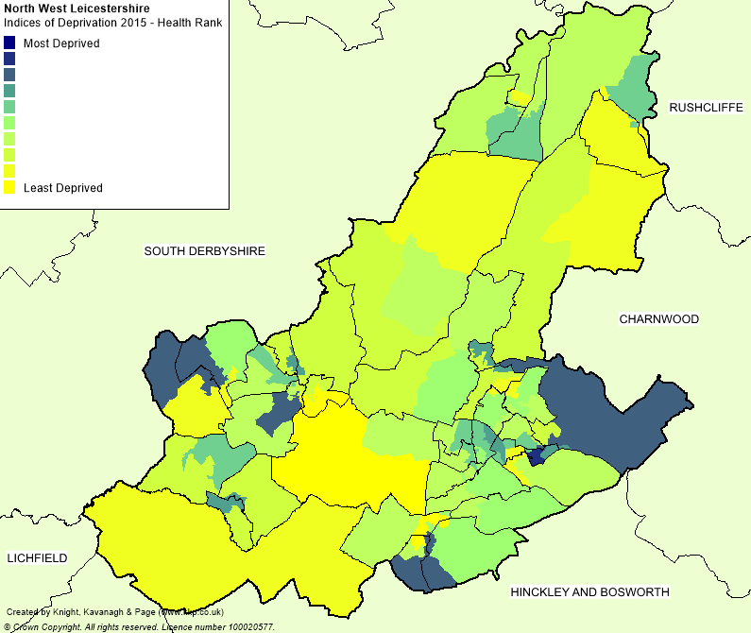
Measures risk of premature death and impairment of quality of life through poor physical or mental health. The domain measures morbidity, disability and premature mortality but not aspects of behaviour or environment that may be predictive of future health deprivation.

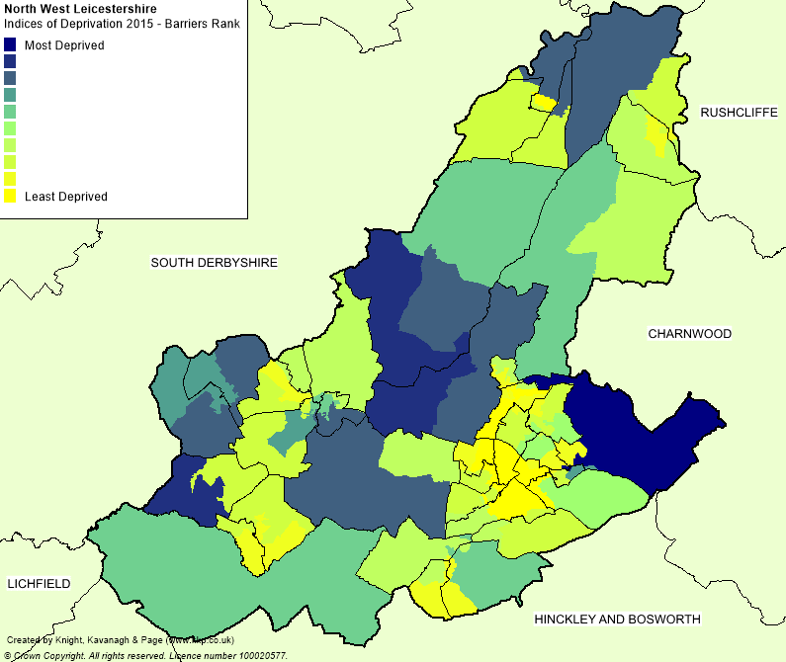
North West Leicestershire: IMD 2015 – Overall barriers rank

This measures the physical and financial accessibility of housing and local services. The indicators fall into two sub-domains:

- ‘geographical barriers’, which relate to the physical proximity of local services,
- ‘wider barriers’ - issues relating to access to housing such as affordability.

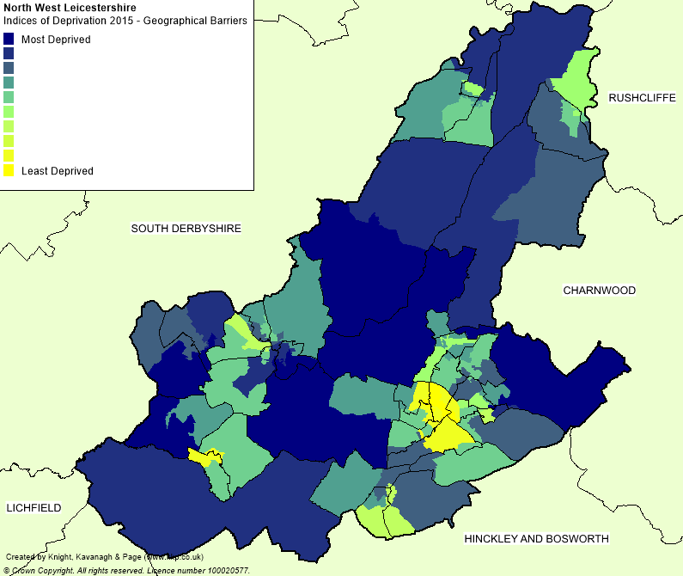
North West Leicestershire: IMD 2015 – geographical/wider barriers rank
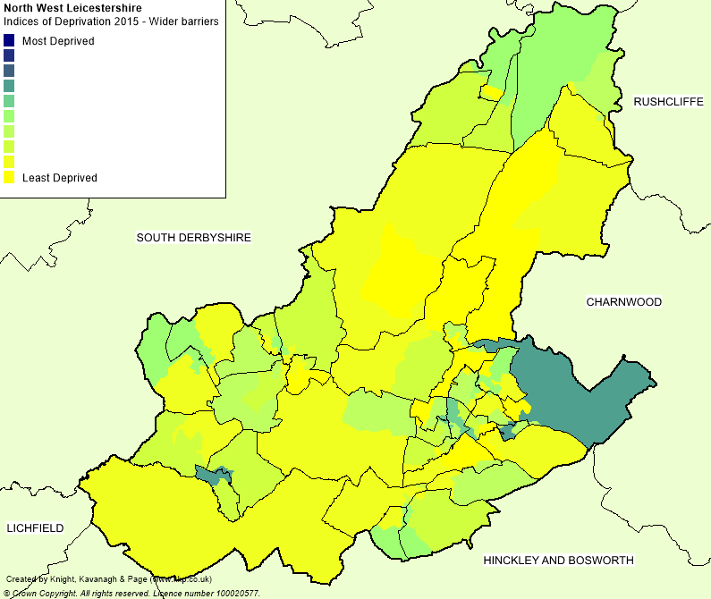

North West Leicestershire: IMD 2015 – Living rank
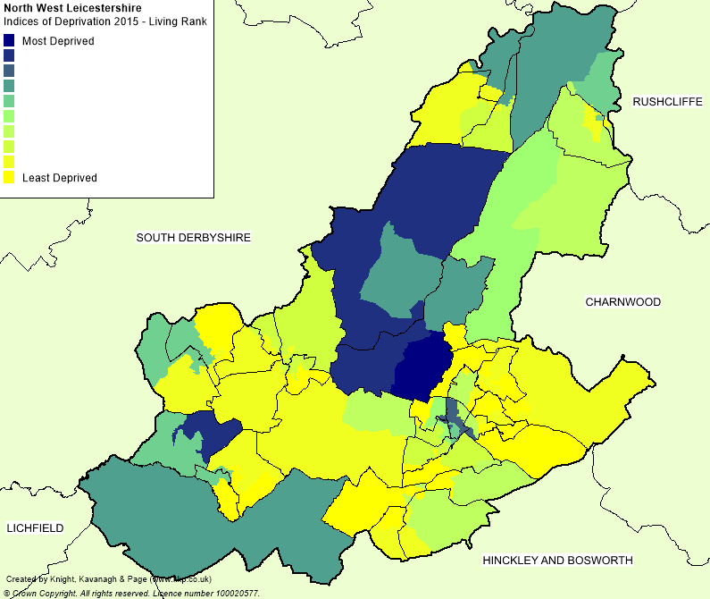
This measures the quality of the local environment in two sub-domains:

- ‘indoors’ living environment - quality of housing
- ‘outdoors’ living environment - measures of air quality and road traffic accidents.

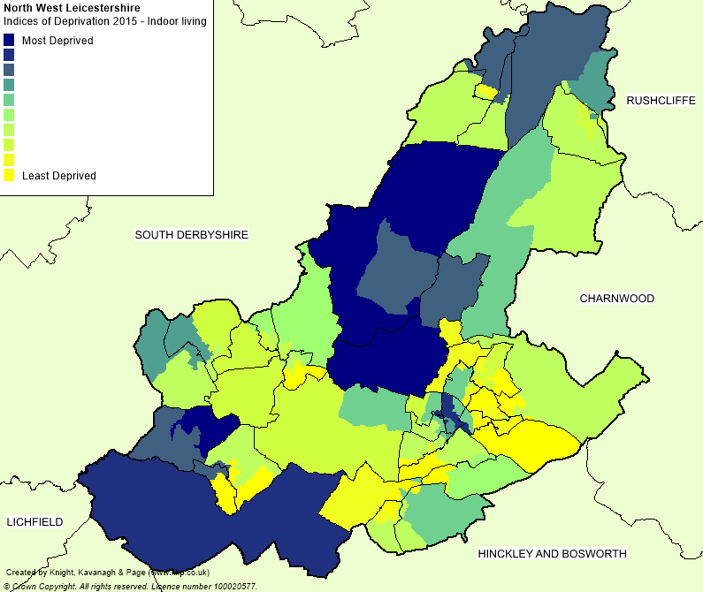
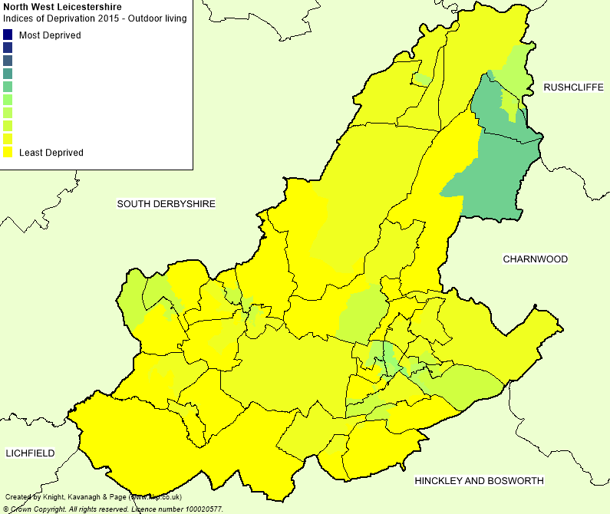
North West Leicestershire: IMD 2015 – indoors/outdoors

North West Leicestershire - % Households without access to a vehicle (2011 Census)
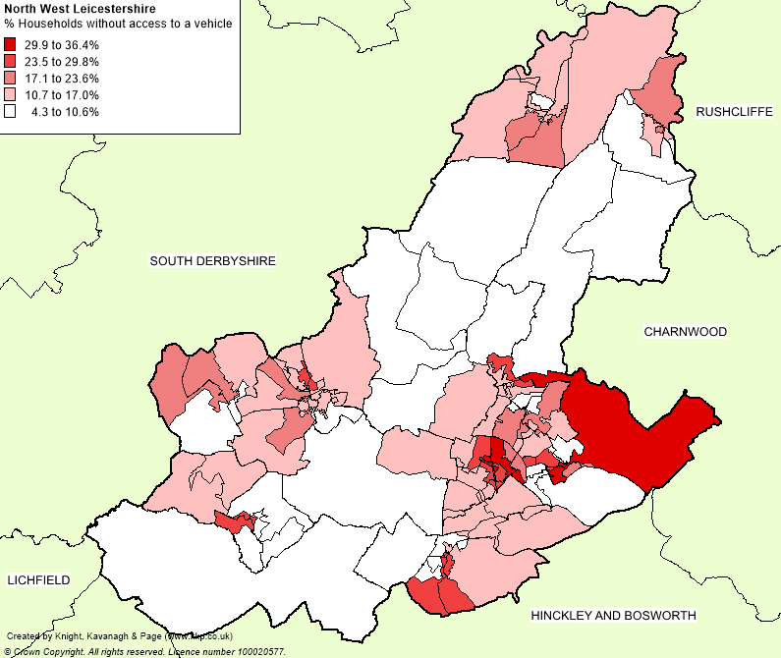
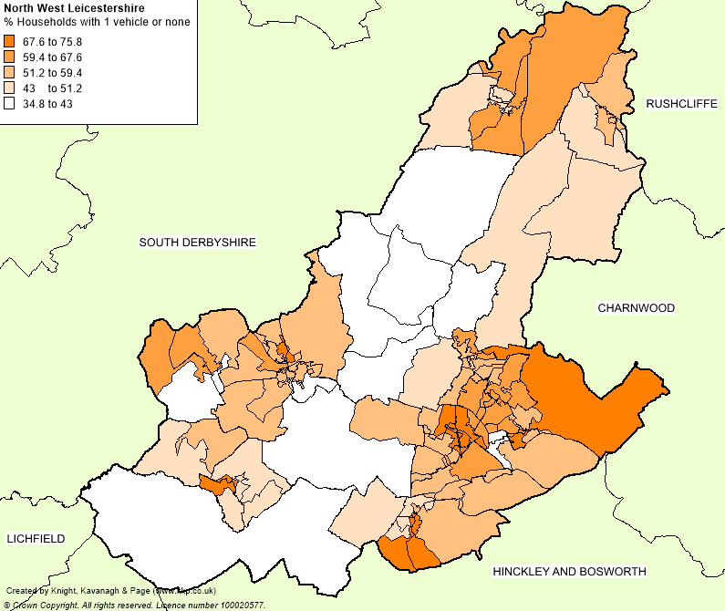
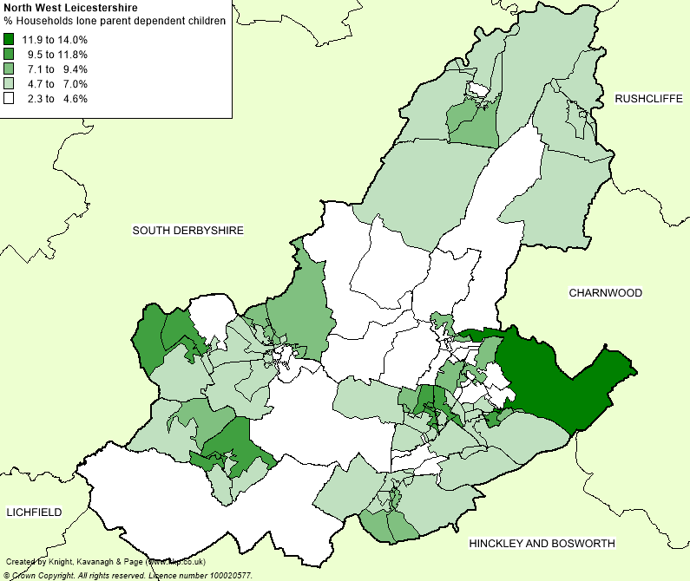
North West Leicestershire - % Households lone parent with dependent children

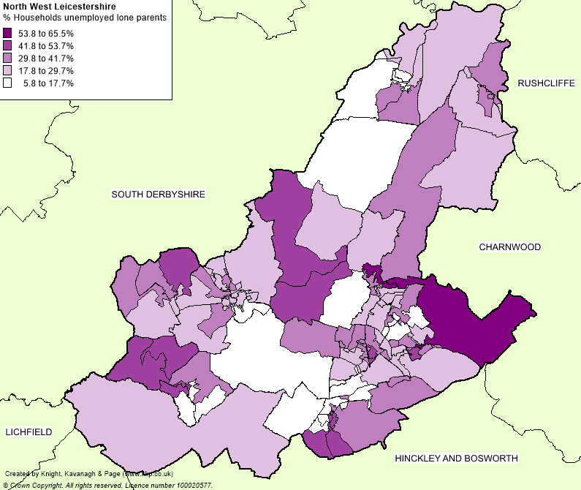
North West Leicestershire - % Lone parent households with unemployed lone parents

The percentage of unemployed lone parent (male or female) households with dependent children as a proportion of all lone parent households with dependent children.

Claimant count

This experimental series counts the number of people claiming Jobseeker's Allowance plus those who claim Universal Credit and are required to seek work and be available for work and replaces the number of people claiming Jobseeker's Allowance as the headline indicator of the number of people claiming benefits principally for the reason of being unemployed. The JSA datasets have all been moved to a new Jobseeker's Allowance theme.

Under Universal Credit a broader span of claimants are required to look for work than under Jobseeker's Allowance. As Universal Credit Full Service is rolled out in particular areas, the number of people recorded as being on the Claimant Count is therefore likely to rise.

All data are rounded to the nearest 5 and may not precisely add to the sum of the number of people claiming JSA, published on Nomis, and the number of people claiming Universal Credit required to seek work, published by DWP, due to independent rounding.

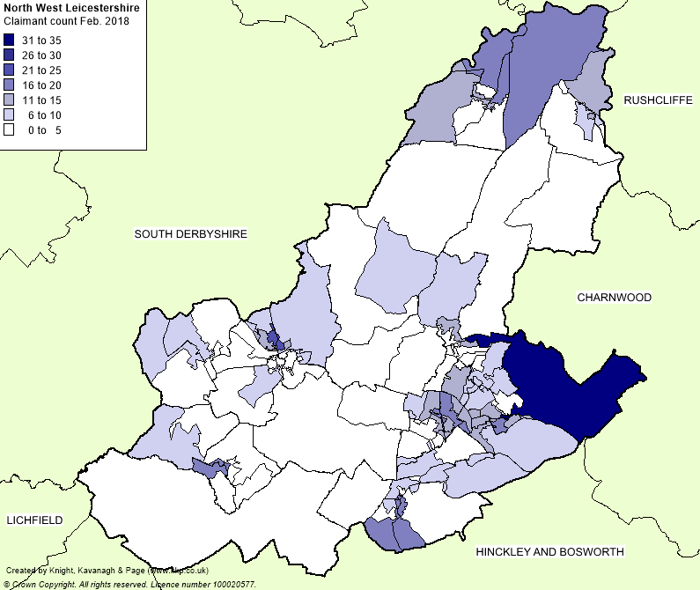
Health and provision of unpaid care

This map provides information about the health of usual residents, for England and Wales as at census day, 27 March 2011. It also provides information about the number of providers of unpaid care and the number of hours of care that they provide.

North West Leicestershire - % Limited a lot by long-term health problem or disability

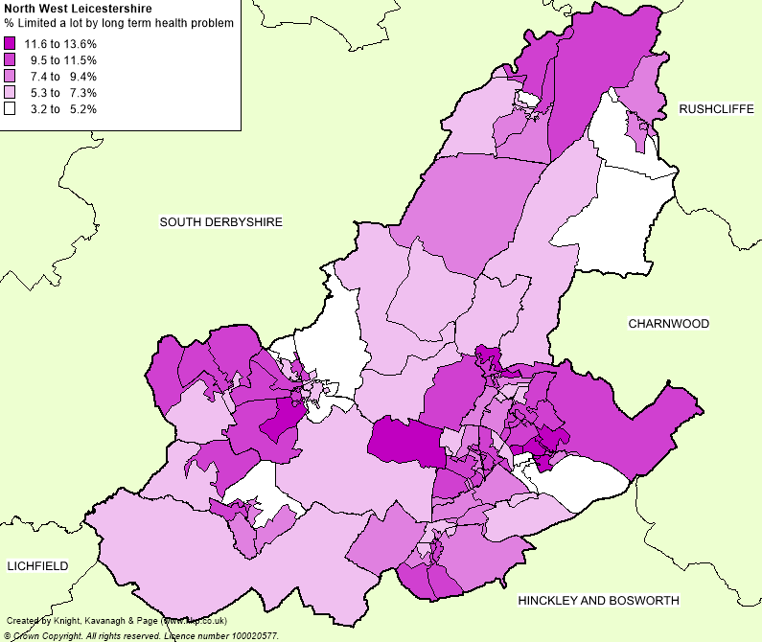
A long-term health problem or disability that limits a person's day-to-day activities, and has lasted, or is expected to last, at least 12 months. This includes problems related to old age. People were asked to assess whether their daily activities were limited a lot or a little by such a health problem, or whether their daily activities were not limited at all.
North West Leicestershire - % Bad or very bad health
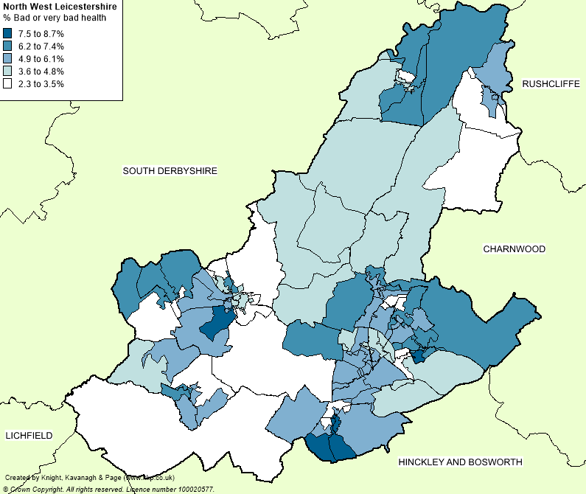
General health is a self-assessment of a person's general state of health. People were asked to assess whether their health was very good, good, fair, bad or very bad. This assessment is not based on a person's health over any specified period of time.

North West Leicestershire - % Providing 20+ hours per week of unpaid care
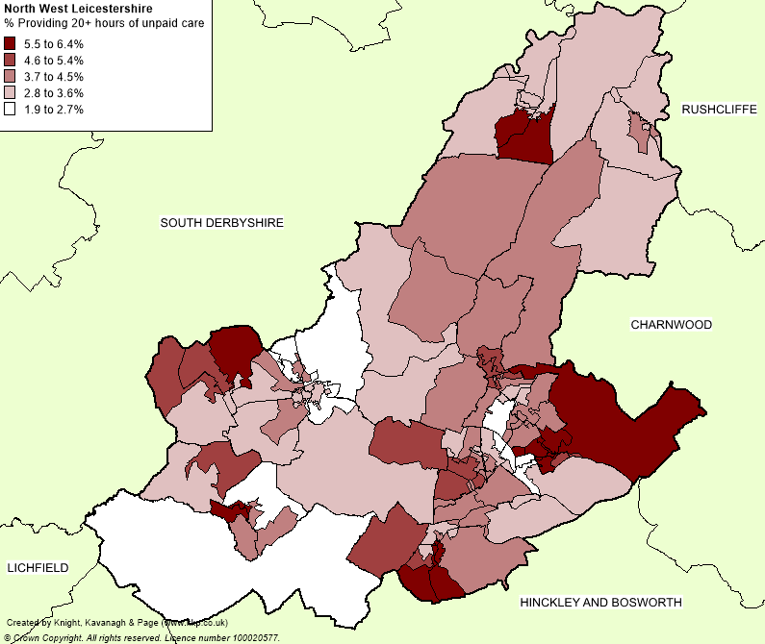
A person is a provider of unpaid care if they look after or give help or support to family members, friends, neighbours or others because of long-term physical or mental ill health or disability, or problems related to old age. This does not include any activities as part of paid employment. No distinction is made about whether any care that a person provides is within their own household or outside of the household, so no explicit link can be made about whether the care provided is for a person within the household who has poor general health or a long-term health problem or disability.

Source: ONS 2015 Mid Year Estimate
Index of Deprivation 2015 (Department for Communities & Local Government)

