Home Energy Conservation Act (HECA) Report - March 2017
Introduction
The Secretary of State for Energy and Climate Change requires North West Leicestershire District Council to provide an update report every two years, under the Home Energy Conservation Act 1995 (HECA). The report sets out the energy saving measures that the District consider possible, practicable and cost effective in improving the energy efficiency of residential property in the District area.
This report is the 2017 update on home energy conservation within residential properties in the North West Leicestershire district. It outlines the progress made since March 2015 and sets targets for the next period (2017-2019.)
The next report will be published in March 2019 and every two years thereafter. The data in this report and in future reports is obtained from a range of local and national sources. There are delays to the publication of large datasets and therefore the majority of the data covers up to and including 2014.
The District Council’s Green Footprints initiative, which is a key corporate priority, sets out the actions supported by all departments within the Council to ensure we continue to be even greener and a more energy efficient place to visit, live and work in.
This report shows how North West Leicestershire District compares to local and national statistics regarding domestic energy use such as CO2 emissions, gas and electricity consumption and fuel poverty. It shows that gas and electricity consumption, carbon emissions from domestic sources and fuel poverty across the District continue to show a slow steady decline.
We aim to reduce fuel poverty in the District through the use of education and any new measures available to residents such as the national Smart Meter initiative.
Context
The Climate Change Act 2008 sets a legally binding commitment of an 80% reduction in greenhouse gases for the year 2050, from a 1990 baseline, with an interim milestone of 34% by 2020.
In 2016, the Government ratified the Paris Agreement; part of the United Nations Framework Convention on Climate Change. The Agreement commits countries to taking action to hold the increase in the global average temperature to well below 2°C above pre-industrial levels.
Data Used
All data used in this report has been obtained from government sources and is referenced. There are delays in the production of large datasets; therefore the information may not cover the same time periods. Care should be taken if comparisons are made between data charts in the report.

Local Energy Efficiency
Table 1: CO2 Emissions from total domestic use (including electricity, gas and other fuels)
CO2 emissions (KT CO2) from total domestic use emissions | 2009 | 2010 | 2011 | 2012 | 2013 | 2014 | % reduction on 2009 data
North West Leics | 223 | 240 | 212 | 227 | 224 | 190 | 14.8%
Leicestershire | 1424 | 1537 | 1343 | 1449 | 1415 | 1188 | 16.6%
England | 111,285 | 119,575 | 104,259 | 112,171 | 109,260 | 91,411 | 17.9%
National | 135,913 | 146,011 | 127,142 | 136,485 | 133,045 | 111,987 | 17.6%

Data from:
https://www.gov.uk/government/statistics/uk-local-authority-and-regional-carbon-dioxide-emissions-national-statistics-2005-2014
“2005-2014_UK_local_authority_and_regional_CO2_emissions_data_tables (1)” (Excel Spread sheet)
Tab - “Subset Data Set”
Source Date: 28/03/2017
This table indicates the carbon emissions from domestic use in North West Leicestershire have fallen by 14.8% from 2009 to 2014. This figure is not representative of Leicestershire or the country as a whole.

Table 2: Per Capita Emissions
This is the population in ‘000s (mid-year estimate) / Total CO2 emissions for transport, domestic and industry & commercial.

Per capita emissions (t) | 2009 | 2010 | 2011 | 2012 | 2013 | 2014 | % reduction on 2009 data
North West Leics | 9.2 | 9.5 | 8.8 | 9.1 | 9.2 | 8.3 | 9.8%
Leicestershire | 6.5 | 6.8 | 6.0 | 6.3 | 6.2 | 5.7 | 12.3%
England | 6.1 | 6.3 | 5.7 | 5.9 | 5.7 | 5.1 | 16.4%
National | 6.3 | 6.6 | 5.9 | 6.2 | 6.0 | 5.3 | 15.9%

Data from:
https://www.gov.uk/government/statistics/uk-local-authority-and-regional-carbon-dioxide-emissions-national-statistics-2005-2014
“2005-2014_UK_local_authority_and_regional_CO2_emissions_data_tables (1)” (Excel Spread sheet)
Tab - “Subset Data Set”
Source Date: 28/03/2017
Per capita emissions have declined in North West Leicestershire by 9.8% for the period 2009 to 2014. These emissions figures take into account those within the District’s influence and disregard those that are not, including the EU Emissions Trading System and motorways or similar.

Table 3: Domestic Consumers’ sales of electricity (GWh)

Domestic Electricity Use | 2005 | 2006 | 2007 | 2008 | 2009 | 2010 | 2011 | 2012 | 2013 | 2014 | 2015 | % reduction since 2005
North West Leics | 186 | 183 | 185 | 176 | 174 | 175 | 173 | 173 | 171 | 171 | 173 | 7.0%
East Midlands | 8644 | 8510 | 8518 | 8095 | 8027 | 8109 | 7985 | 7878 | 7770 | 7749 | 7756 | 10.3%
England | 101,267 | 100,012 | 99,598 | 95,417 | 95,267 | 95,863 | 94,648 | 93,687 | 92,408 | 92,645 | 91,608 | 9.5%
National | 119,425 | 117,817 | 117,126 | 112,530 | 112,289 | 112,856 | 111,321 | 110,066 | 108,420 | 109,170 | 107,567 | 9.9%
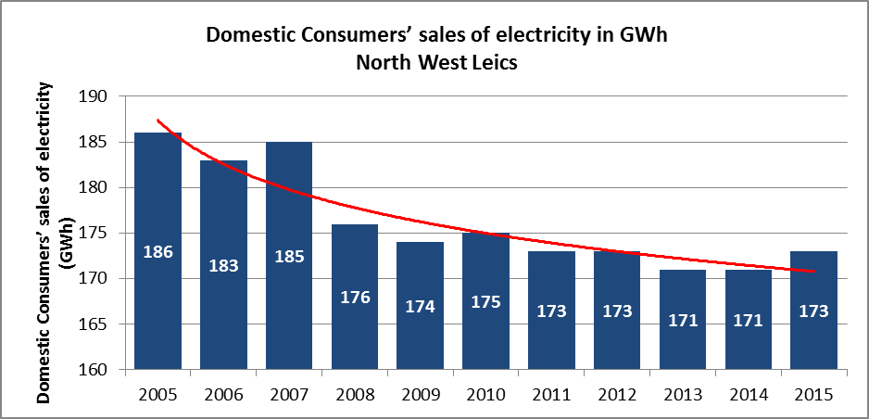

Table 4: Average domestic electricity consumption per consumer (KWh)
Average Domestic Electricity Use | 2005 | 2006 | 2007 | 2008 | 2009 | 2010 | 2011 | 2012 | 2013 | 2014 | 2015 | % reduction since 2005
North West Leics | 4756 | 4658 | 4631 | 4392 | 4342 | 4351 | 4269 | 4221 | 4139 | 4129 | 4098 | 13.8%
East Midlands | 4522 | 4415 | 4352 | 4135 | 4086 | 4103 | 4023 | 3954 | 3880 | 3881 | 3852 | 14.8%
England | 4618 | 4467 | 4404 | 4209 | 4163 | 4163 | 4095 | 4035 | 3963 | 3972 | 3914 | 15.2%
National | 4602 | 4457 | 4392 | 4198 | 4152 | 4148 | 4078 | 4015 | 3940 | 3954 | 3894 | 15.4%
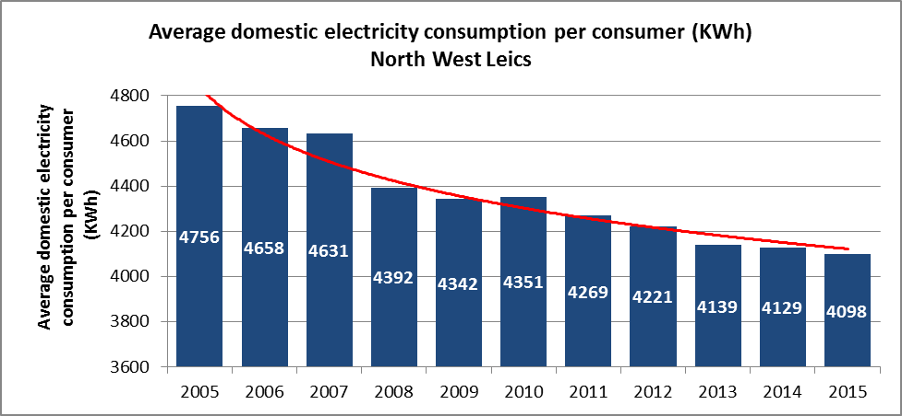

Data from:
https://www.gov.uk/government/statistical-data-sets/regional-and-local-authority-electricity-consumption-statistics-2005-to-2011
“Sub-national_electricity_consumption_statistics_2005-2015 (1)” (Excel Spread sheet)
Source Date: 28/03/2017
The average electricity consumption has been on a very slow decline in North West Leicestershire during the period 2005 to 2015. It can be seen that in various years there has been a slight increase, however the trend within the county and the country remain broadly the same. It is likely that the rural nature of the district and lack of gas contributes to and explains the steady decline. More information needs to be gathered to ascertain the exact reason for the slow decline.

Table 5: Average domestic electricity consumption per household (kWh) - 2015

Average Domestic Electricity Use per Household | 2015 Data  (KWh)
North West Leics | 4273
Oadby and Wigston | 3951
Blaby | 3950
Charnwood | 3777
Harborough | 4518
Hinckley and Bosworth | 4089
Melton | 4330
East Midlands | 3947
England | 3986
National | 4021
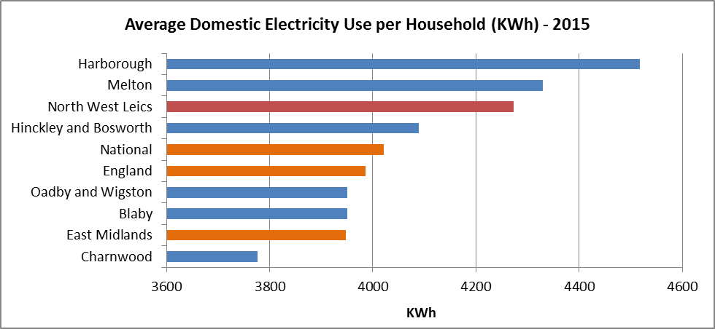

Data from:
https://www.gov.uk/government/statistical-data-sets/regional-and-local-authority-electricity-consumption-statistics-2005-to-2011
“Sub-national_electricity_consumption_statistics_2005-2015 (1)” (Excel Spreadsheet)
Source Date: 28/03/2017

Table 6: Domestic Consumers’ sales of gas (GWh)

Please note: This data covers the gas year – the period covering 1 October through to the following 30 September. Also please note that the gas data is weather normalised.

Domestic Gas Use | 2005 | 2006 | 2007 | 2008 | 2009 | 2010 | 2011 | 2012 | 2013 | 2014 | 2015 | % reduction since 2005
North West Leics | 662 | 651 | 627 | 608 | 559 | 559 | 530 | 530 | 521 | 510 | 514 | 22.4%
East Midlands | 31,469 | 30,484 | 29,878 | 28,750 | 26,490 | 26,449 | 25,007 | 24,870 | 24,292 | 23,722 | 23,771 | 24.5%
England | 355,379 | 345,227 | 337,775 | 325,847 | 299,804 | 297,407 | 280,025 | 278,715 | 272,429 | 264,551 | 265,941 | 25.2%
National | 410,737 | 399,179 | 391,441 | 377,473 | 347,410 | 344,321 | 324,430 | 323,186 | 315,656 | 307,832 | 308,851 | 24.8%
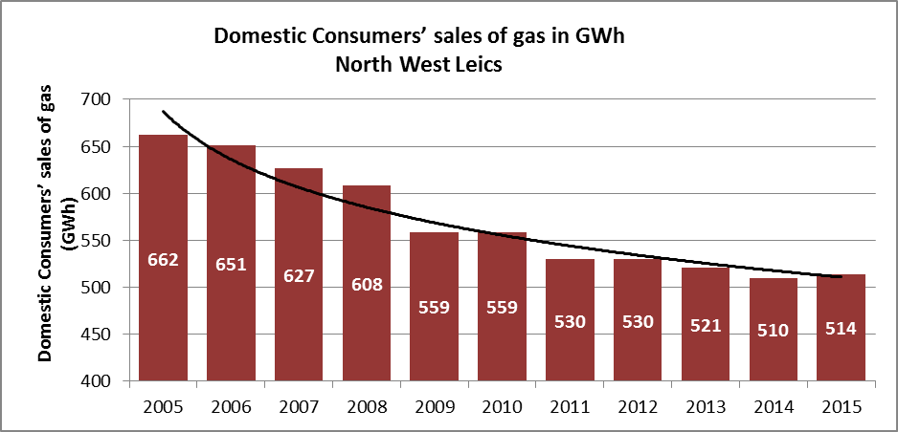

Table 7: Average domestic gas consumption per meter (KWh)

Average Domestic Gas Use | 2005 | 2006 | 2007 | 2008 | 2009 | 2010 | 2011 | 2012 | 2013 | 2014 | 2015 | % reduction since 2005
North West Leics | 20,734 | 19,593 | 18,880 | 18,131 | 16,462 | 16,358 | 15,413 | 15,363 | 14,944 | 14,384 | 14,215 | 31.4%
East Midlands | 19,416 | 18,492 | 17,823 | 17,075 | 15,532 | 15,423 | 14,489 | 14,343 | 13,919 | 13,505 | 13,401 | 31.0%
England | 18,921 | 18,132 | 17,508 | 16,799 | 15,307 | 15,110 | 14,157 | 14,043 | 13,660 | 13,226 | 13,210 | 30.2%
National | 19,020 | 18,241 | 17,614 | 16,906 | 15,383 | 15,156 | 14,205 | 14,076 | 13,680 | 13,246 | 13,202 | 30.6%
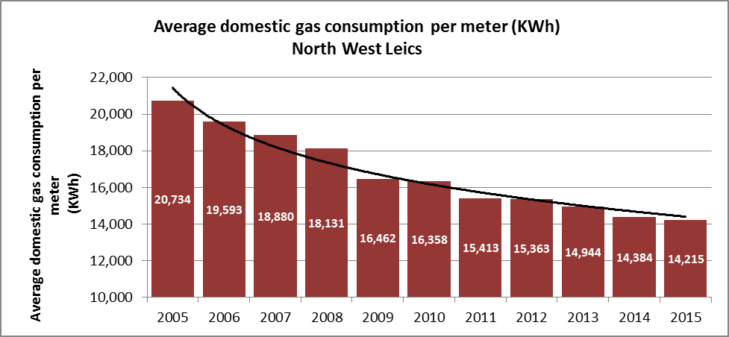

Data from:
https://www.gov.uk/government/statistical-data-sets/gas-sales-and-numbers-of-customers-by-region-and-local-authority
“Sub-national_gas_consumption_statistics_2005-2015 (1)” (Excel Spread sheet) Source Date: 28/03/2017

The average gas consumption per meter for properties in the North West Leicestershire has decreased from 20,734 in 2005 to 14,215 in 2015.

Table 8: Average domestic gas consumption (kWh) - 2015

Average Domestic Gas Use | 2015  (KWh)
North West Leics | 14,215
Oadby and Wigston | 14,828
Blaby | 14,115
Charnwood | 13,706
Harborough | 15,379
Hinckley and Bosworth | 13,532
Melton | 13,864
East Midlands | 13,401
England | 13,210
National | 13,202

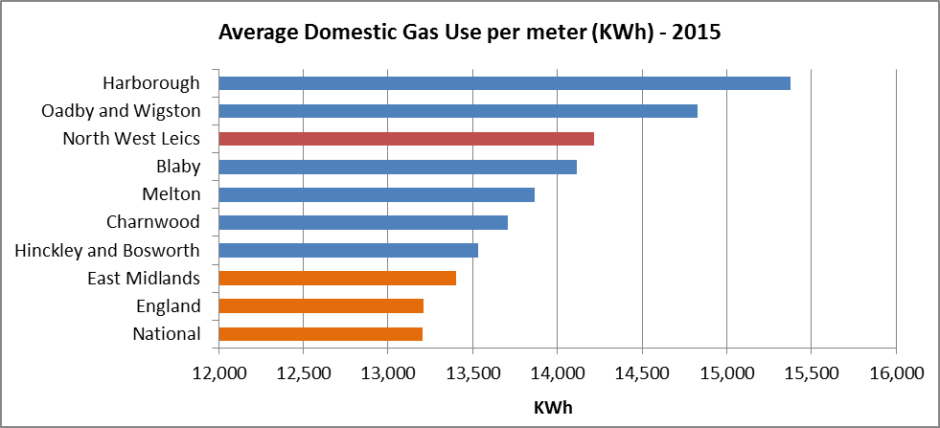

Data from:
https://www.gov.uk/government/statistical-data-sets/gas-sales-and-numbers-of-customers-by-region-and-local-authority
“Sub-national_gas_consumption_statistics_2005-2015 (1)” (Excel Spread sheet)
Source Date: 28/03/2017

Fuel Poverty
Table 9: The Percentage Proportion of Households that are Fuel Poor

Under the Low Income High Cost (LIHC) definition, a household is considered to be fuel poor where they have required fuel costs that are above average (the national median level), and were they to spend that amount, they would be left with a residual income below the official poverty line.

% of Households that are fuel poor | 2010 | 2011 | 2012 | 2013 | 2014
North West Leics | 16.8 | 12.5 | 11.5 | 9.0 | 10.0
Leicestershire | 17.3 | 13.6 | 11.3 | 8.9 | 8.8
East Midlands | 18.2 | 13.3 | 13.2 | 10.4 | 10.1
England | 16.4 | 10.9 | 10.4 | 10.4 | 10.6

Data from:
(2014) https://www.gov.uk/government/statistics/2014-sub-regional-fuel-poverty-data-low-income-high-costs-indicator
“Sub-regional_fuel_poverty__2014_data (1)” (Excel Spread sheet) Source Date: 28/03/2017
(2013) https://www.gov.uk/government/statistics/2013-sub-regional-fuel-poverty-data-low-income-high-costs-indicator
“2013_Sub-regional_tables” (Excel Spread sheet) Source Date: 28/03/2017
(2012) https://www.gov.uk/government/statistics/2012-sub-regional-fuel-poverty-data-low-income-high-costs-indicator
“2012_Sub-regional_LIHC_Final” (Excel Spread sheet) Source Date: 28/03/2017
(2011) https://www.gov.uk/government/statistics/2011-sub-regional-fuel-poverty-data-low-income-high-costs-indicator
“2011_sub_regional_data” (Excel Spread sheet) Source Date: 28/03/2017
(2010) https://www.gov.uk/government/statistical-data-sets/fuel-poverty-2010-sub-regional-data
“5267-fuel-poverty-2010-subregional-data” (Excel Spread sheet) Source Date: 28/03/2017
The data indicates that whilst the number of households that are experiencing fuel poverty has reduced since 2010, the figure remains at or near the national average of approximately 10%.
Report on North West Leicestershire Outcomes
Table 10 is a consolidated report on the work completed by North West Leicestershire District Council between 2013 and 2016. The information contained in the report has been collected at different time periods and amalgamated.
The raw information is available if required.
Renewable Heat Incentives
Between April 2014 and October 2016, there were 160 accredited domestic RHI installations in the North West Leicestershire District.
Source: https://www.gov.uk/government/statistics/rhi-deployment-data-february-2017
Zero-Carbon Homes
Since the withdrawing of the Government’s Code for Sustainable Homes, the Council have not perused the 2016 standards. The green standards are important to North West Leicestershire District Council and we will therefore continue to keep efficiency standards under review, new development should have regard to sustainable design and construction methods (Local Plan 2016).

Cost-Effective Measures to Deliver Energy Efficiency
We will:
- Work with National and Local partner authorities to promote the Green Footprint’s principles of keeping the District green, clean and energy efficient.
This includes utilising campaigns such as hitting the cold spots wherever possible and supporting the roll out of Smart Meters.
- Reduce fuel poverty by identifying and targeting areas most at risk, giving support and advice at all opportunities.
Delivery of National and Local Targets
- Reduce carbon emissions in the domestic sector by 10% on 2009 levels by 2020

- To assist in bringing homes out of fuel poverty in order to achieve the fuel poverty target and interim milestones for 2020, 2025 and 2030 which are to improve as many fuel poor homes as is reasonably practicable to an energy efficiency rating of a Band E, Band D and Band C respectively

Table 10: HECA Action Plan 2013-2016 - Outcomes

No | Action | Responsible Team | Completion Date | Achieved in 2013-2016
H1 | Home and Communities Agency grant funded or NWLDC funded affordable homes will meet the current code for sustainable homes level and meet the HCA space and energy standards as a minimum | Strategic Housing | March 2016 | A total of 151 grant funded affordable homes were built which meet the current standards
H2 | All non-grant funded affordable homes (s106 agreement sites) will be built to the same standards as market houses. Where these properties are provided as affordable rented properties they will be fully compliant with current HCA space and energy standards. | Strategic Housing | March 2016 | A further 216 affordable homes have been built through s106 agreements, all meeting these standards
H3 | Compliance with building regulations will be ensured through plan checks, site inspections and where necessary, enforcement. | Building Control | March 2016 | Compliance with building regulations is routinely carried out and enforcement carried out when necessary. Three enforcement cases were prepared and went to court, one was successful.
H4 | Advice on the standards that need to be achieved and how to meet them will be given. | Building Control | March 2016 | Free pre-planning application advice was always encouraged and provided
H5 | All new homes will have an Energy Performance Certificate on completion. | Building Control | March 2016 | All new properties had an Energy Performance Certificate on completion.
H6 | We will promote any changes in standards to relevant professions through CPD type training sessions. | Building Control | March 2016 | Changes in thermal standards were made in 2013 and the council ensured that CPD sessions were held for architects, designers and develops, 22 people attended. Another course ran in September 2015 via LABC East Midlands, all regular clients invited. A CPD course marketed to agents and paid for by LABC East Midlands ran in 2015.
H7 | We will define and publicise on the website the council's role in delivering the Green Deal and Energy Company obligation. | Building Control | March 2016 | Information about the Green Deal is available on the council's website at www.nwleics.gov.uk/the_green_deal
H8 | We are committed to Climate Local and will develop our delivery plan and targets | Community Focus/Sustainability | March 2014 | In October 2013 the council signed up to Climate Local. Information is available at www.nwleics.gov.uk/climate_change. The council's Climate Local action plan was developed and submitted to the Local Government Associations during 2014.
H9 | Energy efficiency, Green Deal and measures to tackle fuel poverty will be promoted through our Green Community network and planned events across the district. | Community Focus / Sustainability | March 2014 | Energy efficiency, Green Deal and fuel poverty initiatives have been promoted at community events in the district including Meashams’ Heart of the Forest Festival in June, Castle Doningtons’ Music in the Park in July. Four Ways to Warmth information was publicised through Clockwise Credit Union and the Council’s newsletters.
H10 | Smart meters will be provided to schools in priority areas and support them to develop a loan scheme. | Community Focus / Sustainability | March 2014 | Six schools received smart meters and guidance to enable them to loan them out to households, enabling households to monitor and manage their electricity consumption.
H11 | Support 4 Ways to Warmth through the Warm Homes Officer | Environmental Protection Team | March 2014 | The council's Warm Homes Officer made 462 referrals to the 4 Ways to Warmth scheme in 2014. These referrals have allowed local residents to access a number of energy efficient measures and receive advice on how to be more energy efficient in their homes. Funding for the Warm Homes Officer post concluded in March 2014 however there are now 3 Warm Homes officers working countywide receiving referral through the First Contact scheme.
H12 | Support delivery of a countywide department of Energy and Climate Change bid | Environmental Protection Team | March 2014 | Delivery of the DECC funded projects resulted in 18 boilers, 72 Jam Jar account appointments at the Citizen's Advice Bureau, £4,655 distributed in fuel debt vouchers, 16 emergency fuel deliveries and 115 Green Deal assessments during 2013-2014
H13 | Countywide crisis funding for energy measures will be distributed to those in fuel poverty | Environmental Protection Team | March 2014 | There were 11 food hampers delivered, 5 emergency heaters provided, 41 loft insulation and draught proofing measures, 9 boiler services and repairs during 2014. The crisis fund can now be accessed by residents through First Contact referrals to the 3 countywide Warm Homes Officers.
H14 | Work alongside Home Improvement Agency Papworth when bringing homes back into use. | Street Protection Team | March 2016 | No cases have required this intervention as crisis funds can now be accessed by residents through First Contact referrals to the countywide Warm Homes Officers.
H15 | Undertake a review of the council's approach to tackling fuel poverty. | Environmental Protection Team | March 2014 | A revised Affordable Warmth Strategy and action plan for NWL was launched in Autumn 2014. This assists the council in targeting our private sector residents that are most likely to be at risk of fuel poverty and associated health problems so that these residents have a better understanding of how they can access ECO and Green Deal.
H16 | Residents will be signposted to grants and loans available to improve energy efficiency and to reduce fuel poverty. | Street Protection Team | March 2016 | Delivery of the DECC funded projects resulted in 18 boilers, 72 Jam Jar account appointments at the Citizen's Advice Bureau, £4,655 distributed in fuel debt vouchers, 16 emergency fuel deliveries and 115 Green Deal assessments during 2013-2014. The Papworth Trust and National Energy Action delivered 5 events in the district to promote the Leicestershire Warm Homes, Healthy Homes Scheme which provides advice and support to those struggling to afford to heat their homes (Zoe Davies)
H17 | 534 A -rated boilers will be installed in council owned homes. | Housing Services | March 2016 | 1095 A-rated boilers were installed
H18 | 549 central heating systems with A-rated boilers will be installed in council homes by March 2015. | Housing Services | March 2016 | 435 central heating systems with A-rated boilers have been installed in council owned homes during 2013. A further 233 systems were installed in council homes during 2014 with a further 83 installed during 2015-2016.
H19 | 996 new doors will be installed in council owned homes by March 2015. A further 50 replacement doors and 300 windows will be installed in council owned homes before March 2016. | Housing Services | March 2016 | 1,252 new doors were installed during 2013 with a further 996 installed during 2014. A further 582 windows and 390 doors replaced during 2015-2016 which includes 118 doors and 15 windows fitted via the DHIP programme that started in June 2016.
H20 | 267 new roofs will be installed in council owned homes by March 2015 | Housing Services | March 2015 | 202 new roofs were installed during 2013 with a further 147 during 2014.
H21 | £125,000 pilot study retrofitting green technologies will be completed by March 2015 to inform a retrofit program in council homes for 2015/16 onwards | Housing Services | March 2015 | Tenants were invited to volunteer to pilot green technologies in an article in a special edition of the 'In Touch' newsletter alongside an engagement event providing further information to interested householders. Qualifying tenants and properties were identified and attended welcome events. By the end of December 2014 7 out of 13 properties used in the pilot had their installations completed. The remainder were completed by the end of March 2015.
H22 | The Green and Decent pilot will be reviewed at the end of 2015 and inform a retrofit programme in 2016/17 based upon the most suitable technologies | Housing Services | March 2016 | Completion of the Green and Decent Pilot has allowed the council to agree the use of renewable heating as a solution for off gas areas. Solid fuel heating will be replaced by air source heating in off gas areas. A renewable programme will be developed to allow a minimum of 50 properties to receive renewable heating by end 2017/2018. The renewable programme is under development and will be delivered in 2017/2018
H23 | An Energy Strategy for the Housing Service will be agreed with the aim of improving the energy efficiency of the Council's Housing stock and addressing fuel poverty amongst Council tenants. | Housing Services | March 2016 | The Housing Service has implemented an energy strategy and associated action plan in order to improve the energy efficiency or the council's housing stock and address fuel poverty amongst council tenants. The strategy will run until 2025 and contains targets for increasing SAP ratings and replacing solid fuel heating as well as actions to support those struggling to afford to heat their homes. Average savings of £279 were realised in the May 2015 Collective Switching round, 60 people registered and 18 switched. A Fuel Poverty awareness talk was given at the September CVS forum in 2015 which included information on Collective Switching, Warm Homes and Healthy Homes schemes. Average savings of £197 were realised in the October 2015 Collective switching round. 68 people registered and 14 switched. Eight pre registered people also switched with average savings of £279.

Table 11: HECA Action Plan 2017-2020 - Aspirations

No | Action | Responsible Team | Completion Date | Achieved in 2017-2020
1 | Mapping and Master planning exercise of heat network opportunities in Coalville and two rural off-gas Council estates. | Housing – Strategic Housing | 2017 | Report produced which will be shared with senior management in order to determine whether the Council will further explore potentially viable schemes.
2 | Council launched a collective switching scheme in October 2016 which is promoted to local residents | Housing – Strategic Housing | 2017 | Since Oct 15 137 people have switched supplier using the scheme with average annual savings per auction of £197 - £433 (£288 average over all auctions).
3 | Council will continue to install new energy efficient gas boilers as part of the Council’s Decent Homes Improvement Programme. | Housing – Strategic Housing | 2017 to 2020 ongoing | - Reduced CO2 emissions (not calculated)  - Increase in SAP rating of properties  - Reduced fuel bills for Council Tenants
4 | 300 council owned properties to receive air source heat pumps as part of a 7 year programme replacing solid fuel heating in off-gas areas (dependant on RHI income contribution) | Housing – Strategic Housing | 2018-2025 | - Reduced CO2 emissions (not calculated)  - Increase in SAP rating of properties  - Reduced fuel bills for Council Tenants  - Reduction in fuel poverty
5 | 400 properties to receive cavity wall insulation (subject to ECO funding support) | Housing – Strategic Housing | 2018-2020 | - Reduced CO2 emissions (not calculated)  - Increase in SAP rating of properties  - Reduced fuel bills for Council Tenants  - Reduction in fuel poverty
6 | 68 properties to receive solid wall insulation (subject to ECO funding support) | Housing – Strategic Housing | 2018-2025 | - Reduced CO2 emissions (not calculated)  - Increase in SAP rating of properties  - Reduced fuel bills for Council Tenants  - Reduction in fuel poverty
7 | Council continue to run a collective switching scheme promoted to local residents | Housing – Strategic Housing | 2017 and ongoing subject to contract review / success of scheme | - Reduced fuel bills  - Reduction in fuel poverty
8 | Council will continue to support the countywide advice and support service: Warm Homes, Healthy Homes, through referrals and promotion to staff and customers. | Housing – Strategic Housing | Ongoing | - Increase in SAP rating of properties  - Reduction in fuel poverty  - Reduction in excess winter deaths
9 | An online survey will be undertaken to identify energy efficiency needs and barriers within the District’s private sector housing. | Housing – Strategic Housing | 2017 | The Council is undertaking an online private stock condition survey in order to gather information about the condition of properties in private ownership in the District. The survey will collect information about the energy efficiency of properties and the uptake and desire for renewable energy. The results of the survey will help inform strategic decision making including the need to establish local energy efficiency schemes, for example through flexible ECO eligibility.
10 | Renewed Fuel Poverty Strategy for North West Leicestershire | Housing – Strategic Housing | 2017-2020 | The Council’s existing corporate affordable warmth strategy will be renewed in 2017. Key stakeholders will be approached to feed into the new strategy in order to develop actions to reduce fuel poverty and the effects of fuel poverty in the District.
11 | Continue to explore opportunities for heat networks and mine water heating schemes in Coalville subject to funding and viable opportunities. | Housing – Strategic Housing | Ongoing | Report produced from mapping and master planning exercise which will be shared with senior management in order to determine whether the Council will further explore potentially viable schemes.
12 | Increase the uptake of Smart Meters | Green Footprints | 2017-2018 | - Reduce fuel Poverty  - Reduce CO2 (not measured)  - Reduce fuel bills
13 | Investigate new initiatives and grants and engage when possible for example grants for insulation. | Green Footprints | 2017 - 2018 | - Reduce CO2  - Increased sustainability  - Reduce fuel bills  - Reduce fuel poverty

