

**B.E.E. part of our team…**

**Housing Assets and Property Team Manager**

This booklet is designed to assist you in applying for the post. It is different to the more conventional recruitment processes because we feel that it’s important to welcome employees into the council who appreciate and are able to work within the council’s values and behaviours.

The following information will help you to understand our journey and encourage you to demonstrate how your skills, experience and achievements will be an asset to North West Leicestershire District Council.

**If you need help with any aspect of this process please contact the Human Resources Team on 01530 454525**

**Our approach in developing effective relationships…**

The council approaches new challenges, whether they are nationally or locally created, with enthusiasm and a belief that there is always a solution to any problem. These solutions can be found through effective and valued relationships, both internally and externally.

We are committed to **listening carefully** to the issues being raised by a broad range of people such as local communities, businesses, individual cases and council colleagues. In listening we **support what is possible** to be deliveredand agree expectations which are **fair** to all. We **deliver to the** **jointly agreed quality** whilst **using the council’s resources wisely.**

Should we fall short of this in any way, we aim to learn and improve in those areas.

We believe in valuing our staff during the challenging events we need to deal with and with this in mind the Best Employee Experience programme has been developed. The objective is to bring together all our own best practice, plus learning from others in the public, health, educational and private sectors to provide a consistent approach to recruiting new staff who will own and deliver our commitment to creating valued and effective relationships.



Bev Smith

Chief Executive

**More information…**

Our new Housing Asset and Property Team is currently moving through a transitional period following a corporate restructure, and we are seeking an experienced and highly skilled professional to provide leadership and direction to the new team. By bringing together the former housing asset management team and the council’s corporate property service team into one business unit there are many opportunities for economies of scale, more efficient working and greater resilience that we are anxious to maximise the benefits of.

**Housing Asset Management**

After the successful completion of a £35 million decent homes backlog funded improvement programme through external contractor partners, we reviewed our approach to delivering our council house improvement programme going forward. We now have ambitious plans to deliver at least 5 years of works through our in house team of operatives, and are currently delivering the first year of this programme through our In-house Repairs Team (IRT) which is managed by the Housing Commercial Services Team Manager.

To support the work being completed by the in-house team a number of specialist contractors will be required, and their procurement and contract management will be critical to our wider programmes success. In addition, ensuring that our stock condition information and future improvement programme priorities and details are accurate is also essential , as is the managing the delivery of the planned and cyclical programmes of works.

We have a comprehensive Asset Management Strategy which includes active asset management through acquisitions and disposals, and we have a developing track record for both where there is a clear business case. Within our strategy there are a number of actions that will require progressing, which include developing and implementing a programme of garage site decommissioning and disposal, further work to strengthen our position regarding compliance, and development site appraisal and acquisition.

We are particularly proud of our new build programme, with the first phase having delivered the first new council housing in the district for over 30 years during 2018. Phase 2 of this programme is now underway, with exciting plans for partnership working with developers, and our own directly contracted development schemes forming part of our pipeline of future opportunities.

**Corporate Property Services**

Following our recent restructure the corporate property services function has been merged with the asset management team, and the Team Manager will have a key role to play in shaping this new combined team going forwards.

We have a portfolio of commercial and heritage assets, with the commercial assets currently under review, and ambitious plans to be developed for acquiring additional income generating property to support our wider organisational commercial agenda. The broad range of heritage assets includes a scheduled monument (Moira Furnace) as well as a range of other buildings including a memorial clock tower and various statues and other pieces of street art, each with their own challenges.

Having already agreed to adopt a corporate landlord model, the new property team will be responsible for consolidating our property assets and associated budgets to ensure that we maximise the efficiencies that this approach can offer, and our future planned preventative maintenance programme will be further refined as our stock condition information is updated.

Over the next 2 years we will need to make a significant investment in our office building, and as part of a wider review the successful applicant for this post will have a leading role to play in making our building fit to meet the organisations future accommodation needs.

If you have any questions please contact Chris Lambert, the Head of Housing and Property on 01530 4548780 or email [chris.lambert@nwleicestershire.gov.uk](mailto:chris.lambert@nwleicestershire.gov.uk)

**Job description**

**Post title: Housing Assets and Property Team Manager**

**Team: Housing Asset and Property Team**

**Approved grade: Band I**

**Core responsibilities:**

* Line management and lead officer for to the development and implement of a modern, effective, customer focused and high performing asset and property management service with key areas of work including:
* To develop and implement relevant strategies to maximise the value and potential value of current and future assets taking account of a range of factors including supply and demand;
* To oversee and develop investment options appraisals and ensure these are considered as part of the overall strategic direction;
* To develop and implement the strategic direction of the services to exploit markets and develop new business opportunities to expand income and the local footprint;
* To drive innovation and the consideration of non-traditional solutions that increase quality and value;
* To oversee the maintenance of accurate and up to date asset registers and stock condition profiles and use these to inform the strategic direction;
* To play a key role in supporting the development and maintenance of the HRA Business Plan and to ensure the effective management of service budgets, ensuring value for money is delivered across all services and contracts;
* To establish and lead a culture of customer service and continuous improvement by ensuring the implementation of high performance standards and high levels of productivity;
* To ensure that strategic risk mitigations are managed and delivered;
* To ensure compliance with all legal, regulatory and statutory requirements governing areas of responsibility;

**Additional responsibilities:**

* To create a team where a culture of excellent customer service is a key focus for all job activities;
* To grow talent and capability in the team by ensuring all employee appraisals undertaken both effectively and timely, addressing any issues as appropriate;
* To build pride, passion and reputation by creating a council of excellence through strong motivational leadership;
* To continually challenge and drive performance;
* To give presentations to a variety of audiences as required;
* To ensure that financial and corporate governance controls and are implemented whilst seeking areas for ongoing improvement;
* To work effectively with elected members as appropriate;
* To serve on the ‘emergency response on call rotas’ as required;
* To promote the council's Equality and Diversity Policy to ensure service provision and employment practices are non-discriminatory;
* To participate in the council’s appraisal scheme and to undertake any necessary training and development as identified for the job role.

In all of our jobs, there are core duties and peripheral duties - the ones which the team undertakes and are the responsibility of all.

This diagram is designed to help you see what those duties are:

To be a key member of the Housing Department’s Senior Management Team and to undertake any other reasonable tasks appropriate to the grading of the post as required

Developing the corporate approach through Team Managers forums and engagement with members and senior managers

**Lead officer for to the development and implement of a modern, effective, customer focused and high performing asset and property service**

Line management, coaching and development of direct reports and the wider team

Communications, embracing e-comms i.e. social media, website

Financial management

This job description describes the general duties of the job and does not preclude other duties which are necessary for the efficient service delivery of the council and team in serving its communities and meeting its objectives.

Employee specification

The employee specification is split into different sections to give you an indication of what we are looking for at all stages of the process.

Key questions or criteria are developed to set minimum criteria for this job.

In the role of Housing Assets and Property Team Manager it is essential that you can answer yes to the following criteria:

1. Are you are eligible to work in the UK?
2. Do you hold a full valid UK driving licence?
3. Do you have a degree in a property or asset management related discipline or relevant demonstrable experience?
4. Do you have significant experience and a proven track record of successfully operating at senior level, leading the delivery of high quality, customer-focused property and/or asset management services that deliver quality outcomes for customers, tenants, and communities?

**Shortlisting questions**

At North West Leicestershire District Council we have developed a set of values that run through the work we do. We think these values are so important that we use then to shortlist people who apply to work for us. ON the application form you will be asked to answer the following questions based on our values, giving examples of how you will follow them in your work. Please write something in answer to each of the values, but no more than 300 words. If you don’t write something in response to all the values we won’t be able to invite you to an interview.

**Trust** -As an organisation we want to be open, fair and transparent, and to be trusted that we will deliver our promises. Please give examples of how you have delivered what has been requested.

**Respect** - Our community is made up of many different people with different needs, all of them important. Please give examples of how you will respect and value customers and colleagues, taking into account their individual needs.

**Excellence** - North West Leicestershire District Council wants to lead the way and be the best we can for our community. Please give examples of how you make sure your work is of high quality.

**Pride** - The council is working to make North West Leicestershire a happy, healthy and vibrant place to work and live. Please give examples of what you do in your work to show pride in your workplace and community.

**Growth** - Life in North West Leicestershire District Council is not about standing still. We aim to work together to grow and to continually improve. Tell us about what you have done to help you do your job better and bring more quality to your work.

**Interview criteria**

If you are shortlisted and invited to interview, the panel will be looking for evidence that you meet the following criteria. Not only are we looking for evidence of work experience and knowledge but we are also looking at behaviours.

We will use a number of assessment techniques throughout the process, these may include:

* interview
* group discussions
* work-based exercises
* psychological profiling
* presentations
* references

|  |
| --- |
| **Behaviours** |
| Exceptional people and communication skills.  Exceptional mediation and networking skills.  Ability to lead, motivate and inspire a large and varied team of staff and trades operatives whilst positively embracing the values of the Council and embracing change.  Confidence and resilience to deal with changing demands.  Ability to resolve difficult and complex situations, professionally, tactfully and diplomatically.  Ability to represent the Council at internal and external meetings and to provide advice and make recommendations as appropriate. |
| **Technical** |
| Significant experience and a proven track record of successfully operating at senior level, leading the delivery of high quality, customer-focused asset management and property maintenance services that deliver quality outcomes for customers, tenants, and communities.  Experience of successfully leading, managing and motivating staff.  Proven ability to successfully develop and implement complex policies and strategies.  Strong commercial property management skills and an understanding of external markets and potential business opportunities, including all elements of procurement and contract management.  Detailed knowledge and understanding of the impact of the regulatory framework and government policy on asset management and compliance programmes.  Proven ability to successfully lead, motivate and manage teams to produce effective outcomes, including technical aspects and human resource issues.  Proven ability to successfully manage, interrogate and interpret complex financial and statistical data and information for use in the business and to manage financial performance.  Proven ability to manage projects and budgets successfully including the preparation and submission of project briefs and external funding bids. |
| **Test at interview** |
| * Presentation skills * Personality Profile Analysis |

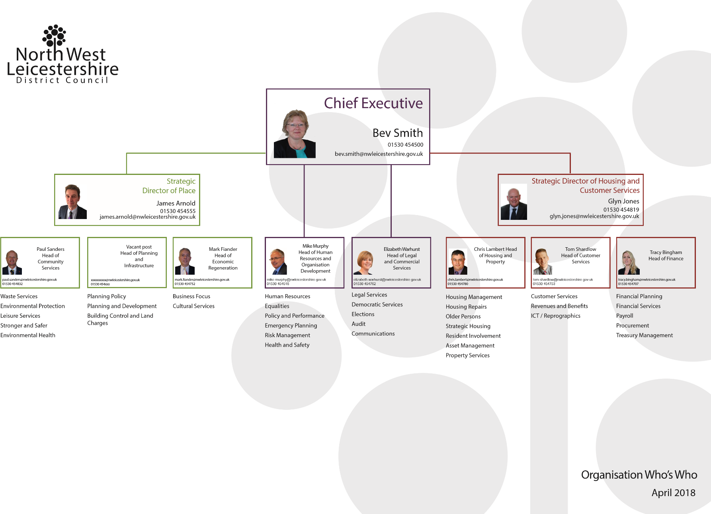To help you see where this post fits into our organisation, we’ve added an organisation chart.

The Housing Assets and Property Team Manager is part of the Housing Asset Management Team, which is within Housing and Customer Services

**Housing and Property Service Management Team**

**Housing Assets and Property team structure**

**Conditions of service**

A full statement of the terms and conditions of employment will be given to you if you are the successful applicant. However, the following provides a summary of the main terms and conditions.

**Salary scales and conditions of service**

This post attracts a £3,000 lump sum per annum for 3 years “Golden Hello” (subject to performance) and the option of a subsidised lease car, in accordance with our policy.

It is the council’s policy to appoint new starters at the bottom of the salary scale where employees have the opportunity to get an annual increment until they reach the top of the scale.

|  |  |
| --- | --- |
| 47 | £42,806 |
| 48 | £43,757 |
| 49 | £44,697 |
| 50 | £45,621 |
| 51 | £46,571 |

Salary is paid on the 25th day of each month, by bank transfer.

**Hours of work**

A 36 ¼ hours, 5 day week, is currently in operation. A flexible hours scheme is in operation.

The work may involve evening and weekend working.

It is a requirement of the role that you are a member of the Emergency Planning Forward Liaison Officer and out of hours service. This is undertaken on a rota basis with other members of the Senior Management Team.

**Holiday**

Annual leave entitlement is 24 days which increased to 28 days after five years continuous service in local government. In addition, there are nine bank holidays. For people who work part-time leave is calculated in hours, pro-rata to the contractual hours.

A scheme is in place whereby you can purchase limited additional annual leave on a salary sacrifice arrangement.

**Notice**

This post requires a notice period of 8 weeks

**Pension**

You are automatically included in the Leicestershire Pension Fund. Pension rights are usually transferable if an officer moves from one public authority to another.

**Smoking at work**

The council has a Smoke Free Council Policy in place.

**Use of vehicles**

An essential car allowance is payable should your own car be used for business use.

**Immigration, Asylum and Nationality Act 2006**

You must be eligible to work in the UK. Candidates will be required to provide original evidence of his/her eligibility to work in the UK. (Passport, national insurance number, or visa/work permit).

**Medical assessment**

Any offer of employment will be subject to a satisfactory medical assessment.

**Where we are**

North West Leicestershire District Council is both the Council’s name and geographical location and i**s** situated between Leicester, Burton upon Trent, Derby and Nottingham. The area of the district is 108 square kilometres.

Main roads through the district are the M42/A42 between Birmingham and Nottingham and the A50/A511 between Leicester and Burton upon Trent. The M1 motorway, which runs through the district, is accessible from junctions 22, 23, 23A and 24. The nearest railway stations are at Burton upon Trent, Loughborough and Leicester.

With a population of almost 93,500, North West Leicestershire is mainly a rural district, sitting at the heart of the National Forest, bringing in tourism from around the country. It is home to East Midlands Airport, which has replaced the mines as one of the region’s major employers. It is a key location for many large businesses, with the likes of Pall-Ex, United Biscuits and TNT having bases here, and large developments like Marks and Spencer distribution centre making North West Leicestershire their home.

Like many other [shire districts](https://en.wikipedia.org/wiki/Non-metropolitan_district), authority over North West Leicestershire is shared between the [district council and the county council](https://en.wikipedia.org/wiki/Non-metropolitan_district#Shire_districts). Areas of responsibility of the district council include [local planning](https://en.wikipedia.org/wiki/Planning_permission), [building control](https://en.wikipedia.org/wiki/Building_regulations_in_the_United_Kingdom), [council housing](https://en.wikipedia.org/wiki/Council_housing), [refuse collection](https://en.wikipedia.org/wiki/Refuse_collection), [recycling](https://en.wikipedia.org/wiki/Recycling) and some leisure services and parks.

The district council is currently controlled by 38 [councillors](https://en.wikipedia.org/wiki/Councillor#United_Kingdom) representing 38 wards, who are [elected](https://en.wikipedia.org/wiki/North_West_Leicestershire_local_elections) every four years; the [last election](https://en.wikipedia.org/wiki/North_West_Leicestershire_District_Council_election,_2011) took place in May 2015 and saw the [Conservatives](https://en.wikipedia.org/wiki/Conservative_Party_(UK)) hold on to control.

The council has an executive known as the Cabinet which is made up of 6 councillors who have special responsibilities and power. As the Conservatives have overall control of the council they hold all of the seats on the Cabinet.

**Your application**

**References**

Check that your referees are happy for us to contact them. If you do not wish a reference to be taken up at this stage, please mark this clearly on your form. It is our policy to approach referees before making an offer of employment. Please note that in entering the name(s) of referees in the section you will be deemed to have given your consent to us approaching these people for purposes of verification.

Do not use relatives as a referee, these will not be accepted.

**Equalities**

In accordance with current legislation and codes of practice we aim to ensure that no councillor, employee or prospective employee will be treated unfavourably on the grounds of marital status, gender, age, disability, sexual orientation, race, nationality, ethnic or national origins, trade union membership or activity, political or religious belief and unrelated criminal conviction.

Every possible step will be taken to ensure that individuals are treated equally and fairly and that decisions on recruitment, selection, training, promotion and redeployment are based solely on objective, non-discriminatory criteria.

The council will aim to employ a workforce that broadly reflects the community we serve. Appropriate steps will be taken to ensure that individuals from groups that are currently under-represented in the council’s workforce are encouraged to apply for posts within the authority.

The council will continue to develop and implement non-discriminatory practices to ensure that individuals are treated with dignity and respect. In attempting to ensure equality in all matters of employment a monitoring procedure has been established. In order to effectively monitor the policy, applicants are asked to complete the equal opportunities policy form at the end of the application form. The information contained on this form is strictly confidential and is treated separately from the application form.

**Personal information**

Your personal details at the end of the form are needed to enable us to contact you. Write your name, address and a contact telephone number clearly. You are also asked to complete other information, which will only be used for equal opportunities monitoring purposes. These details will not be included in the form when it is shortlisted.

**Relationships to officers and councillors**

You must declare if you are in any way related or the partner of a councillor or officer of the council. If you are related to such a person, you must state if you are their parent, grandparent, partner, child, stepchild, adopted child, grandchild, brother, sister, uncle, aunt, nephew or niece. This will not prevent you from being appointed. You must not seek the support of a councillor for any appointment in the council. If you seek the support of a councillor, you will be disqualified from that appointment.

**Dates you are unable to attend**

We will seek to accommodate a suitable date for candidates indicating their unavailability for interview, however we cannot guarantee being able to offer you an alternative date.

**Disabilities**

Disabled people will be offered an interview if they meet the essential requirements of the post.

An applicant with a disability should be able to carry out the duties and responsibilities of the post set out in the job description and meet the requirements of the post concerned ‘with reasonable adjustment’ within the meaning of the Equality Act 2010. This also requires the employer to make any ‘reasonable adjustments’ if an applicant is selected for interview.

The adjustments mean we have to provide practical assistance to disabled people for example, accessible venues, test materials in formats such as Braille and / or tape, rest periods during the interview process and a support worker for the interview. If you require any help in completing your application form, such as large print copies of information, or tape or Braille information, please contact the Human Resources Team.

**Declaration**

Your application should be signed and dated. Any information that may be false will disqualify you from appointment, or if appointed will render you liable to dismissal without notice.

**What then?**

After the closing date, your application will be considered and if your experience and achievements closely meet all the values of this council, within the context of the post you have applied for you will be invited to interview. The shortlisting officers will only use information from the application form and will not make assumptions.

Your application form is assessed to see how your skills, experience, knowledge and qualifications match the requirements for the job.

We do not shortlist applicants who do not appear to meet the essential requirements in the employee specification.

**The interview**

The interview panel will be made up of at least two members of staff. The panel will ask the same basic set of questions to each candidate and supplementary questions may be asked based on your answers. We will be looking for you to give examples of what you have done and give examples of experience you can demonstrate.

Not only will be we asking technical questions about your experience, skills and abilities but we will be looking at how you behave in work situations and what your preferred working style is. This is to assess your ‘fit’ within the organisation. If the ‘fit’ is right then you will be happier in the job and we’ll be happier with your performance.

Most of our interviews will be a two stage process so that quality time can be given to ensure we get to know you and that you get to know us. It is also your chance to ask questions about the job, terms and conditions of service, etc. You may notice members of the panel making notes. This will be done against an assessment sheet so that the reasons for their decision are consistent and justified. It will enable the panel to recall which candidate said what, which will determine the decision for the best candidate for the post.

Occasionally we will need you to undertake a personality profile and tests as part of the selection process. This enables us to assess your skills, experience and knowledge in a way that is more efficient than asking questions. The tests will always be job related and will be just one of the factors considered in the final outcome.

You will be notified in the invitation to interview if the selection process is to include personality profile or tests.

Often several people will be invited for interview and whilst we make every effort to remain on schedule, your interview may take place later than your appointment time. If this happens, we will not rush your interview.

After the interview the panel will notify you of when and how you will be informed of the outcome. The panel members will discuss their individual marks against the assessment sheet. If a test has been conducted the marks from this will also be incorporated at this stage. The panel will then determine who matches the employee specification most closely and select the successful applicant.

**What can I expect if I’m successful?**

If you’re successful at interview you will become part of an organisation that wants the best for its employees.

Our commitment to you is that you will ….

**BEE part of our team**– you’ve already become part of us through our recruitment processes

**BEE welcomed** – our welcome package for new employees includes a settling in period and probation

**BEE valued** – we will continually support and encourage you through regular appraisal and one to ones

**BEE your best** – we will support you and inspire you through our training and development processes

**BEE in the know** – our employee engagement package offers a range of schemes and programmes to ensure you feel informed and valued throughout your time with us

**BEE prepared** – when you leave our employment, we want you to have benefitted from your time with us and keep in touch.