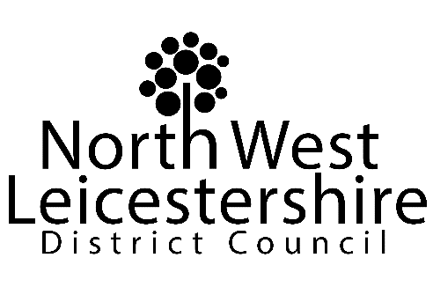

AUDITED FINAL STATEMENT OF ACCOUNTS,
ANNUAL GOVERNANCE STATEMENT AND NARRATIVE REPORT
2021/22

North West Leicestershire District Council apologises that the final, audited Statement of Accounts, Annual Governance Statement and Narrative for the 2021/22 financial year are not yet available for review.

The Council has experienced a delay in the publication of the audited Statement of Accounts for 2020/21 as the Council concludes responses to queries from the external auditors regarding the Council’s Property, Plant and Equipment (PPE) records. The Council has also taken this opportunity to extend the scope of the initial audit sampling to ensure a full and complete exercise is undertaken to avoid any further or future delays in this area. Due to this work and the subsequent delay in completion of the audit of the 2020/21 Accounts, it is necessary to delay publication of the Council’s 2021/22 Draft Statement of Accounts for public inspection, which subsequently has delayed the audit of the accounts.

Further notifications will be placed on the website once the audit of 2020/21 is complete and the 2021/22 Draft Statement of Accounts is available for public inspection.

Glenn Hammons
Interim Head of Finance and Section 151 Officer
North West Leicestershire District Council

glenn.hammons@nwleicestershire.gov.uk

