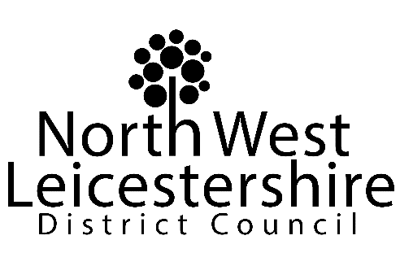

AUDITED FINAL STATEMENT OF ACCOUNTS,
ANNUAL GOVERNANCE STATEMENT AND NARRATIVE REPORT
2020/21

North West Leicestershire District Council apologises that the final, audited Statement of Accounts, Annual Governance Statement and Narrative for the 2020/21 financial year are not yet available for review.

At the time of writing this notice, the ongoing pandemic and the subsequent impact this has had on the auditors’ resources has affected the ability to conclude the external audit.

The auditors anticipate completing the audit in December 2021 and we will therefore not be able to publish the audited 2020/21 statement of accounts by 30 September 2021 deadline.

Dan Bates
Head of Finance and Section 151 Officer
North West Leicestershire District Council

dan.bates@nwleicestershire.gov.uk

