North West Leicestershire District Council (Off-Street Parking Places) Order 2021 (Amendment No. 2) Order 2024

Notice of Proposal
NOTICE is hereby given that North West Leicestershire District Council wishes to make a variation to the Order, North West Leicestershire District Council (Off-Street Parking Places) Order 2021, under its powers contained in sections 32 and 35 (1) and (3) of the Road Traffic Regulation Act 1984 (“the 1984 Act”), and of all other enabling powers and after consultation with the Chief Officer of Police in accordance with Part III, Schedule 9 of the 1984 Act relating to the Council’s off-street car parks within the District. The effect of which will be to:

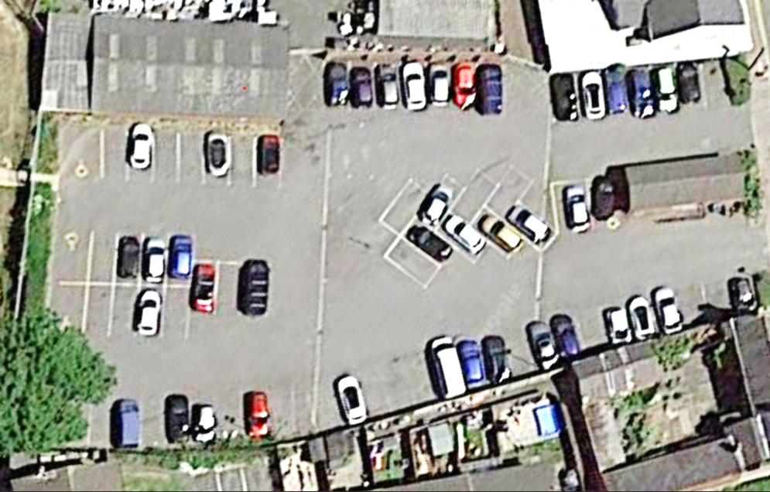
- Convert 25 existing parking places (bays – marked in red on plan below) into three-hour maximum stay parking places (bays) with no return within one hour at the High Street Car Park, Ibstock, Leicestershire, LE67 6LG.

- The hours of operation for the time restricted bays above at (a) will be between 8am until 5pm Monday to Saturday (except bank holidays).

The proposed variation to the Order will come into effect on 11 March 2024.

The proposed variation to the Order may be examined at the Customer Service Centre, Belvoir Shopping Centre, Coalville, Leicestershire, LE67 3XF between the hours of 9.00 a.m. and 5.00 p.m. Monday to Friday (4pm on Thursdays). The proposed variation to the Order can also be viewed on the Council’s website at www.nwleics.gov.uk.

Any objections must be made in writing. If you wish to object to the proposed variation to the Order, you should send the grounds of your objection in writing to the Head of Community Services, using the below contact details, by no later than 29 February 2024

Paul Sanders
Head of Community Services
North West Leicestershire District Council
PO Box 11051
Coalville, LE67 0FW
paul.sanders@nwleicestershire.gov.uk

Objections must specify the grounds on which the objection is being made and should include a return address.
1 February 2024

