NWL Virtual Awards categories

- Junior team - Sponsored by Oakland International
Criteria: A junior team that has displayed excellence in their chosen sport. Details of rankings and achievements during the qualifying period must be given. Demonstration of dedication and commitment from the team members and those involved in supporting the team (e.g. coaches) should be evidenced. Must be under 18 years old during qualifying period. Team must have a home venue, pitch or facility within North West Leicestershire. If you team or club has not been able to train or complete a season this year but you have adapted in other ways, please consider the club of the year award.

- Disabled sportsperson- Sponsored by EMH group
Criteria: Sports person with a learning and/or physical disability who has excelled and/or exceeded all expectations in their performances during the qualifying period. Demonstrations of individuals who have shown resilience and determination to continue to train displaying excellence or have adapted in other ways to stay physically active during lockdown and post lockdown. Examples of acting as a role model to club members and the community.

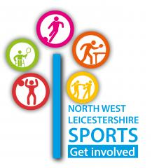
- Club of the year- Sponsored by NWL sport
Criteria: We are looking for clubs that have engaged well with their local community and members during a difficult pandemic period. That actively encourages members that have adapted during pandemic restrictions to continue to provide opportunities for members to remain active and engaged. A club that has demonstrated support for the wellbeing of their members. The nominated club can demonstrate commitment to the development of the members of their club, including participants, coaches and volunteers. Are a club providing a sport(s) recognised by Sport England. Committed to raising standards and have achieved, or at least be working towards, sport specific ClubMark, or an equivalent. The club should have a pre-existing and effective management structure that will sustain the club in the future. The club must have a home venue, pitch, or facility within North West Leicestershire.

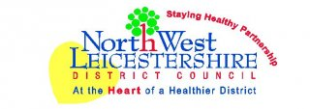
- Healthy Lifestyle- Sponsored by Staying Healthy Partnership
Criteria: This award is for nominees that have made a positive change to their health and overall lifestyle. This can be through their own motivation or by participating on the NWLDC Exercise Referral Scheme, or other intervention schemes. They may have made positive lifestyle changes despite periods of isolation and a lack of provision. Nominees must live within North West Leicestershire

- School of the year- NJR
Criteria: This award is for both primary and secondary schools that have demonstrated a focus on PE, school sport and physical activity within the qualifyingperiod. This includes provision for children that spent lockdown at home/in school and since schools fully reopened in March. This can be providing opportunities for increasing participation, promoting the health benefits of sport and physical activity and creating sport for all across the school. Nominees should have created a number of sporting opportunities during the qualifying period. Nominees should also engage with school sports partnership, NGB’s, local/regional and national partners. This award is for all schools located

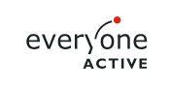
- Junior activator - Everyone Active
Criteria: This award recognises the important work carried out by young coaches, volunteers, officials. Determination and commitment to continued professional development through completion of courses and/or workshops as a volunteer or coach/official should be evidenced where possible. Demonstration of the support and adapting in order to continue this support and inspire others despite restriction (where possible) should be provided. They should be considered an inspiration and positive role model for other young people, acting in a responsible and professional manner. Must be under 18 years old during qualifying period. Nominees must live, attend school or represent a club/ session/ group within North West Leicestershire.

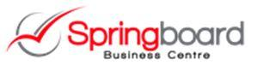
- Senior activator - Springboard Business centre
Criteria: This award recognises an individual or group who have had positive impact on others as a result of giving their time, either coaching, volunteering or officiating, free within sport and physical activity. Contribution of nominee to encourage more people to start, stay or succeed in physical activity. They must have demonstrated a significant commitment to the community throughout lockdown. Should be considered an inspiration and positive role model for participants and their peers, and have built strong relationships and links with clubs, schools and/ or othercommunity organisations. Nominees must live or coach/volunteer within North West Leicestershire

- Outstading contribution- Simon Coope Karate
Criteria: This special award recognises an individual who has made an outstanding contribution to sport and physical activity in North West Leicestershire over a number of years showing exceptional commitment – a real unsung hero. They will have ‘gone over and above’ the call of duty. A true role model for others. Nominees must live or support a club/physical activity within North West Leicestershire.

