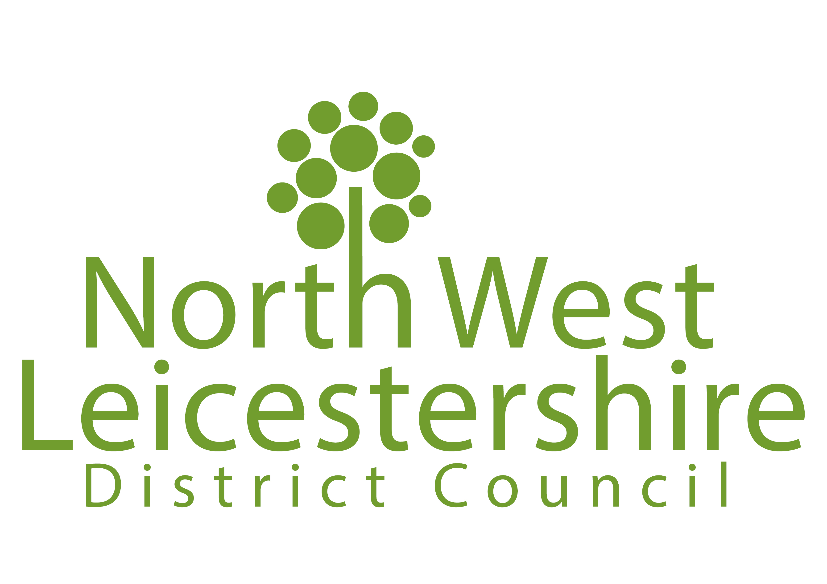
Ref:

(For official use only)
HUGGLESCOTE AND DONINGTON LE HEATH NEIGHBOURHOOD PLAN
Submission Consultation – Response Form

Hugglescote and Donington le Heath Parish Council have submitted the Hugglescote and Donington le Heath Neighbourhood Plan to North West Leicestershire District Council. In accordance with Section 16 of the Neighbourhood Planning (General) Regulations 2012*, we are now consulting on the neighbourhood plan, and would like your comments. The consultation period will run for six weeks from Friday 12 March until the end of Friday 23 April 2021.

The submission plan and supporting documents can be viewed at https://www.nwleics.gov.uk/pages/hugglescote_neighbourhood_plan

You can make representations to the Neighbourhood Plan by completing the form below and emailing it to planning.policy@nwleicestershire.gov.uk or posting it to Planning Policy, North West Leicestershire District Council, Council Offices, Whitwick Road, Coalville LE67 3FJ.

All responses must be received by the District Council by the end of 23 April 2021.

*Including amendment regulations; The Neighbourhood Planning (General) (Amendment) Regulations 2015 and The Neighbourhood Planning (General) and Development Management Procedure (Amendment) Regulations 2016.

PART A – Personal Details

If you are responding on behalf of yourself, or your own organisation, please fill in all the ‘Personal Details’ fields. If an agent is appointed, please complete only the Title, Name and Organisation boxes in the Personal Details column, but complete all the ‘Agent’s Details’ fields.

 | Personal Details | Agent’s Details (if applicable)
Title
First Name
Last Name
Job Title (where relevant)
Organisation (where relevant)
Address Line 1
Address Line 2
Address Line 3
Address Line 4
Postcode
Telephone
Email address

Do you wish to be notified of the Council’s decision on the Neighbourhood Plan proposal?

 | Yes |  | No

PART B – Your Representation
In the left column below, please state which part of the Neighbourhood Plan your representation relates to (for example which section, page or policy). In the right column, please submit your comments.
You can comment on as many different parts of the Neighbourhood Plan as you wish (please add more lines if required).

Section, page or Policy (please specify for each comment) | Comments

Declaration
I understand that all comments submitted will be considered in line with this consultation, and that my comments will be made publically available and may be identifiable to my name / organisation.
I acknowledge that I have read and accept the information and terms specified under the Data Protection and Freedom of Information Statement.

Signed:

Date:

DATA PROTECTION AND FREEDOM OF INFORMATION STATEMENT
The personal information you provide on this form will be processed in accordance with the requirements of the Data Protection Act. It will be used only for the preparation of the Hugglescote and Donington le Heath Neighbourhood Plan as required by the Neighbourhood Planning (General) Regulations 2012*, save for requests of such information required by way of enactment. Your name, organisation and representations will be made publicly available when displaying and reporting the outcome of this statutory consultation stage, and cannot be treated as confidential. Other details, including your address and signature, will be treated as confidential.
You should not include any personal information in your comments that you would not wish to be made publicly available.

*Including amendment regulations; The Neighbourhood Planning (General) (Amendment) Regulations 2015 and The Neighbourhood Planning (General) and Development Management Procedure (Amendment) Regulations 2016.

Please send completed forms to planning.policy@nwleicestershire.gov.uk or
Planning Policy Team, NWLDC, Council Offices, Whitwick Road, Coalville LE67 3FJ

The deadline for responses is the end of Friday 23 April 2021

